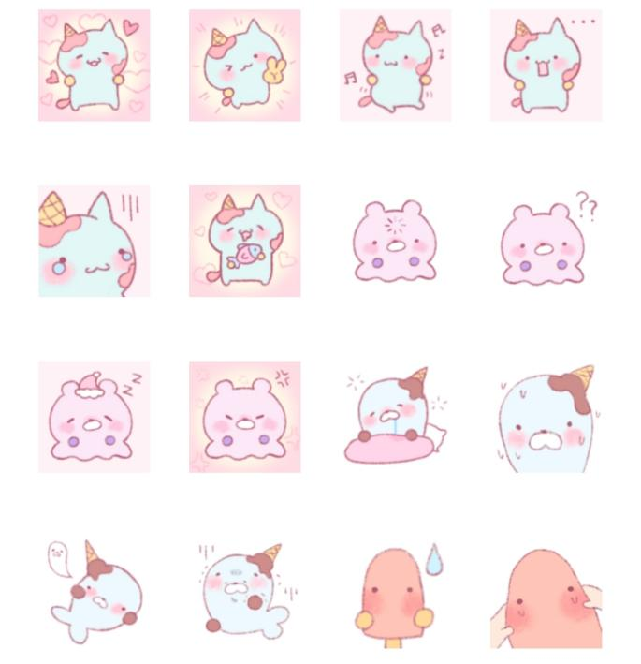
爱心:https://i.postimg.cc/vmgK8XgM/file3.png
耶:https://i.postimg.cc/s2QLfKQR/file4.png
跳舞:https://i.postimg.cc/VNrhs4rw/file5.png
无语:https://i.postimg.cc/hGzY4Mzc/file6.png
泪目了:https://i.postimg.cc/7LGRPXGZ/file7.png
好香:https://i.postimg.cc/YSGP28Gj/file8.png
宕机:https://i.postimg.cc/k56HMw64/file9.png
问号:https://i.postimg.cc/vmgK8XgT/file10.png
晚安:https://i.postimg.cc/0NM45ZMb/file11.png
生气:https://i.postimg.cc/g0X7c4XL/file12.png
还没睡醒:https://i.postimg.cc/wByrxFyD/file13.png
汗流浃背:https://i.postimg.cc/hGzY4Mz9/file14.png
升天:https://i.postimg.cc/1zndRMnG/file15.png
撑不住了:https://i.postimg.cc/YSGP28GN/file16.png
流汗:https://i.postimg.cc/yNgG6ngy/file17.png
捏捏:https://i.postimg.cc/d0bxhdrZ/file18.png

