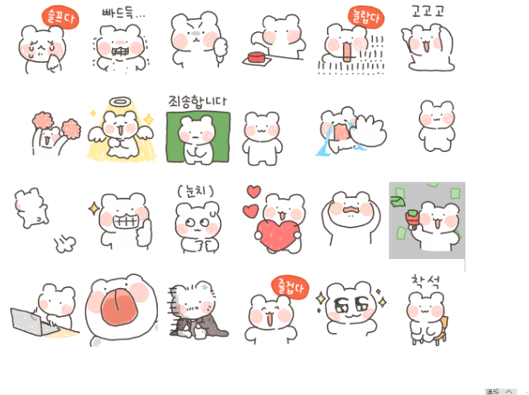
好难过:https://i.postimg.cc/wjbs6xB9/wnx1.gif
咯吱咯吱…（咬牙）:https://i.postimg.cc/SxtzyQKy/wnx2.gif
皱眉不爽/挑衅:https://i.postimg.cc/Z5DyTYqY/wnx3.gif
赞同/狂按按钮:https://i.postimg.cc/SxtzyQKS/wnx4.gif
吓一跳 / 惊呆了:https://i.postimg.cc/0yHJ85NQ/wnx5.gif
冲冲冲:https://i.postimg.cc/DwYb2fzz/wnx6.gif
加油（应援）:https://i.postimg.cc/MprjWZGp/wnx7.gif
天使/感恩中:https://i.postimg.cc/HkP7pWLn/wnx8.gif
乖巧｜对不起:https://i.postimg.cc/x1Fb0jdq/wnx9.gif
？？？？（疑惑）:https://i.postimg.cc/cL58s1Jr/wnx10.gif
(大哭)｜爆哭｜不要a~｜挽留:https://i.postimg.cc/RZbnMC0W/wnx11.gif
贿赂:https://i.postimg.cc/g0XLr9wm/wnx12.gif
(溜走)｜偷偷开溜:https://i.postimg.cc/nLj9M8sr/wnx13.gif
嘿嘿坏笑/呲牙大笑点赞:https://i.postimg.cc/25bL3pq3/wnx14.gif
察言观色、看眼色｜心虚:https://i.postimg.cc/1znV4xgF/wnx15.gif
사랑해｜我爱你:https://i.postimg.cc/LsYghdqf/wnx16.gif
哈！（大吃一惊）｜懊悔｜懊恼:https://i.postimg.cc/zfbH3mLn/wnx17.gif
撒钱:https://i.postimg.cc/g0XLr9w3/wnx18.gif
工作状态:https://i.postimg.cc/s2QG1FBK/wnx19.gif
舔你/谄媚:https://i.postimg.cc/5tYQjcHn/wnx20.gif
乞丐/落魄:https://i.postimg.cc/25sbZHvh/wnx21.gif
好开心:https://i.postimg.cc/MGCMQsR1/wnx22.gif
两眼放光｜心动｜星星眼:https://i.postimg.cc/CK3BqvDN/wnx23.gif

