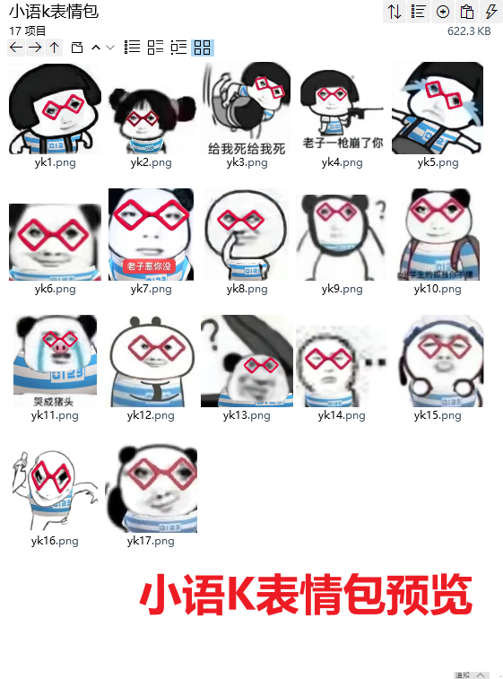
后撤/后仰:https://imgbed.heliar.top/i/tKEydqXbvMZ884RP_yk1.png
萌妹版无语:https://imgbed.heliar.top/i/bcwKbBDvTK5LRj-Z_yk2.png
给我死啊（后背摔）:https://imgbed.heliar.top/i/09etY9qlFTf4n5r8_yk3.png
老子一枪崩了你:https://imgbed.heliar.top/i/IBAOaJGqgly-aJCo_yk4.png
倒地大哭:https://imgbed.heliar.top/i/rogWENGH_aiEQ733_yk5.png
绷不住笑/努力绷住:https://imgbed.heliar.top/i/DxuBRk6xLv5p1CAm_yk6.png
老子惹你没:https://imgbed.heliar.top/i/hkO20ZJ4T3avIpK7_yk7.png
哦那咋了/不屑/抠鼻:https://imgbed.heliar.top/i/wYLbC1OSJSMpRcVx_yk8.png
疑惑/问号/？:https://imgbed.heliar.top/i/wesywlDlGryCxFEx_yk9.png
小学生的孤独你不懂:https://imgbed.heliar.top/i/89gL_BEdf6ITKXGu_yk10.png
哭成猪头:https://imgbed.heliar.top/i/Wt4uD0BBkPBP44gG_yk11.png
努力憋住笑地发出疑问:https://imgbed.heliar.top/i/-KhoO4CuUdgq6DUW_yk12.png
在下水道口发出疑问:https://imgbed.heliar.top/i/HwdMii25-bxa0TlG_yk13.png
无语……/……:https://imgbed.heliar.top/i/9Er6_0NQ1-oFzr1F_yk14.png
亲你/嘟嘴:https://imgbed.heliar.top/i/C5qz2t2bNYaxhL45_yk15.png
拿小刀准备暗鲨！:https://imgbed.heliar.top/i/lxoq-D5B9PTkWWJU_yk16.png
耍帅叉腰撇嘴:https://imgbed.heliar.top/i/1Juvn-36PObGdem-_yk17.png

