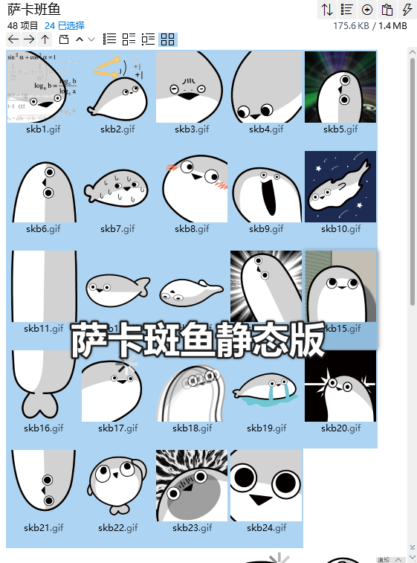
思索中:https://i.postimg.cc/43fKHnQ5/skb1.gif
加一/同意:https://i.postimg.cc/GmJ8pvGN/skb2.gif
呃/无语:https://i.postimg.cc/dVmk0GrS/skb3.gif
这:https://i.postimg.cc/Sx72KcC1/skb4.gif
懂了:https://i.postimg.cc/k5JVRDvw/skb5.gif
鱼头:https://i.postimg.cc/s2jBG14m/skb6.gif
流汗/紧张/心虚:https://i.postimg.cc/3w8y0WFn/skb7.gif
脸红:https://i.postimg.cc/rpVdRzNf/skb8.gif
呀哈/震惊:https://i.postimg.cc/Zqb9v0xf/skb9.gif
冲:https://i.postimg.cc/QM8BKVJY/skb10.gif
鱼身:https://i.postimg.cc/cJxKt6B5/skb11.gif
懵逼:https://i.postimg.cc/VNfS05Wh/skb12.gif
躺了:https://i.postimg.cc/xdfkNq37/skb13.gif
察觉:https://i.postimg.cc/JhryHt5v/skb14.gif
无辜:https://i.postimg.cc/rpVdRzNv/skb15.gif
鱼尾:https://i.postimg.cc/bvyGSdRX/skb16.gif
过载:https://i.postimg.cc/8CpFfsbQ/skb17.gif
恍惚:https://i.postimg.cc/0Nk6KrCs/skb18.gif
哭:https://i.postimg.cc/HLYJ8jtC/skb19.gif
灵光一闪:https://i.postimg.cc/GpLBT9jR/skb20.gif
探头:https://i.postimg.cc/jjxWnCht/skb21.gif
挠头:https://i.postimg.cc/rpVdRz9V/skb22.gif
盯—:https://i.postimg.cc/R0S3JqTC/skb23.gif
啊:https://i.postimg.cc/YSr4Ljxq/skb24.gif

