Ganadi 表情包 可以二传二改~ by：世界上最幸运的人

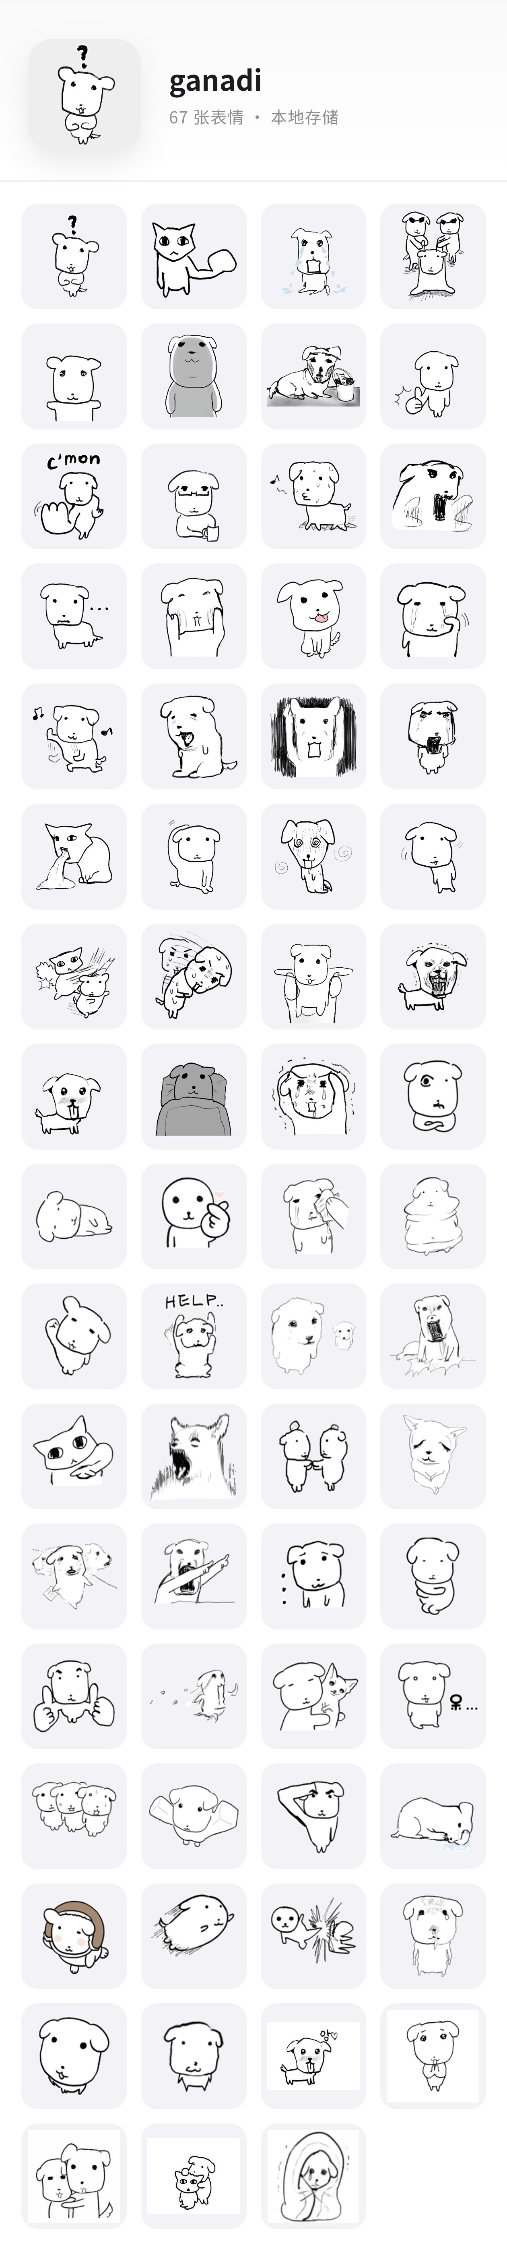

?： https://i.ibb.co/Nn7Nf44f/DM-20260915213503-001.png
拳头硬了： https://i.ibb.co/mdZrp56/DM-20260915213503-003.png
爆哭： https://i.ibb.co/GQHJbzgB/DM-20260915213503-004.png
拖走： https://i.ibb.co/QFJTntz6/DM-20260915213503-005.png
抱抱你： https://i.ibb.co/mVDsHsP0/DM-20260915213503-006.png
憨憨盯： https://i.ibb.co/dww2mXxF/DM-20260915213503-007.png
颓废喝一杯： https://i.ibb.co/FkGV4kS0/DM-20260915213503-008.png
点个赞： https://i.ibb.co/MDnvMzg5/DM-20260915213503-009.png
过来： https://i.ibb.co/bjSGJ9Tz/DM-20260915213503-010.png
喝水围观： https://i.ibb.co/zVrPpq0R/DM-20260915213503-011.png
心虚走开： https://i.ibb.co/MJwD7sh/DM-20260915213503-012.png
发疯尖叫： https://i.ibb.co/XTF0bLN/DM-20260915213503-013.png
...： https://i.ibb.co/q3HpZX71/DM-20260915213503-014.png
捏脸脸： https://i.ibb.co/tMdfg5LM/DM-20260915213503-015.png
吐舌卖萌： https://i.ibb.co/nNRs3chG/DM-20260915213503-016.png
擦眼泪： https://i.ibb.co/NgDHRBS0/DM-20260915213503-017.png
开心蹦跶： https://i.ibb.co/k2w0BVn9/DM-20260915213503-018.png
啊...： https://i.ibb.co/Rk7Fbn4m/DM-20260915213503-019.png
震惊： https://i.ibb.co/qYq2MbQn/DM-20260915213503-020.png
我破防了： https://i.ibb.co/7xPgy63L/DM-20260915213503-021.png
呕吐： https://i.ibb.co/MxnxrV3Y/DM-20260915213503-022.png
挠头： https://i.ibb.co/ccKHYBP0/DM-20260915213503-023.png
晕了： https://i.ibb.co/7NBgPVpd/DM-20260915213503-025.png
摇头晃脑： https://i.ibb.co/27CS8vC4/DM-20260915213503-026.png
打你头： https://i.ibb.co/v4LrBhkJ/DM-20260915213503-027.png
鞠躬道歉： https://i.ibb.co/G3FGZvxt/DM-20260915213503-028.png
抱起来： https://i.ibb.co/sd9Nmwq3/DM-20260915213503-029.png
应激： https://i.ibb.co/0RhCGCmF/DM-20260915213503-030.png
心动： https://i.ibb.co/b5KmtyhR/DM-20260915213503-031.png
睡觉觉： https://i.ibb.co/TMLgFs7T/DM-20260915213503-032.png
抱头流泪： https://i.ibb.co/pTTYpDW/DM-20260915213503-033.png
抱臂怀疑： https://i.ibb.co/PG2XKBWL/DM-20260915213503-034.png
生无可恋： https://i.ibb.co/vCPmtfxx/DM-20260915213503-035.png
比心： https://i.ibb.co/vCRhhPKL/DM-20260915213503-036.png
擦泪： https://i.ibb.co/0jY7y2JN/DM-20260915213503-037.png
胖成一坨： https://i.ibb.co/ymyLbP3R/DM-20260915213503-038.png
举手： https://i.ibb.co/x8tm8Js9/DM-20260915213503-039.png
救命： https://i.ibb.co/rGswKVVv/DM-20260915213503-040.png
大狗带小狗： https://i.ibb.co/7Jx1v63C/DM-20260915213503-041.png
拍桌尖叫： https://i.ibb.co/dsKPR2Dj/DM-20260915213503-042.png
猫猫指你： https://i.ibb.co/Vc36zCsL/DM-20260915213503-043.png
仰天尖叫： https://i.ibb.co/G4pRSzL7/DM-20260915213503-044.png
拉拉手： https://i.ibb.co/rRz3MX7r/DM-20260915213503-045.png
猫猫乖巧： https://i.ibb.co/S4NBSW4V/DM-20260915213503-046.png
哪里哪里？： https://i.ibb.co/Gf50LBPG/DM-20260915213503-047.png
无语...： https://i.ibb.co/Q7kqFv3m/DM-20260915213503-049.png
抱紧自己： https://i.ibb.co/nqbb8gxc/DM-20260915213503-050.png
双手点赞： https://i.ibb.co/cXK9jknV/DM-20260915213503-051.png
哭着跑掉： https://i.ibb.co/tw0frB2m/DM-20260915213503-052.png
抱猫猫： https://i.ibb.co/wNvprvZd/DM-20260915213503-053.png
呆...： https://i.ibb.co/FkJvQr3j/DM-20260915213503-054.png
三狗紧张： https://i.ibb.co/0ppLWTL9/DM-20260915213503-055.png
帕瓦power： https://i.ibb.co/Xx7t4MXR/DM-20260915213503-056.png
敬礼： https://i.ibb.co/gFP43NKG/DM-20260915213503-057.png
倒地大哭： https://i.ibb.co/fYBByT7j/DM-20260915213503-058.png
飞扑向你： https://i.ibb.co/KzRxyv48/DM-20260915213503-060.png
踹飞你： https://i.ibb.co/cSGFc4h2/DM-20260915213503-061.png
委屈哭哭： https://i.ibb.co/MyPDK7Lf/DM-20260915213503-062.png
歪头卖萌： https://i.ibb.co/tp96PM5r/DM-20260915213503-063.png
乖巧： https://i.ibb.co/9k375rZc/DM-20260915213503-064.png
拜托拜托： https://i.ibb.co/zV0884dQ/DM-20260915213503-066.jpg
抱你： https://i.ibb.co/C5Y39BX2/DM-20260915213503-067.jpg
啃你猫头： https://i.ibb.co/CsXQxFJF/DM-20260915213503-068.jpg
躲被窝哭： https://i.ibb.co/ns3w1tZQ/DM-20260915213503-069.jpg
鼓掌：https://i.ibb.co/h1yZ7dDp/image.png
拜托拜托：https://i.ibb.co/LDnJnNyf/image.png
我不听：https://i.ibb.co/6pBSBjt/image.png

