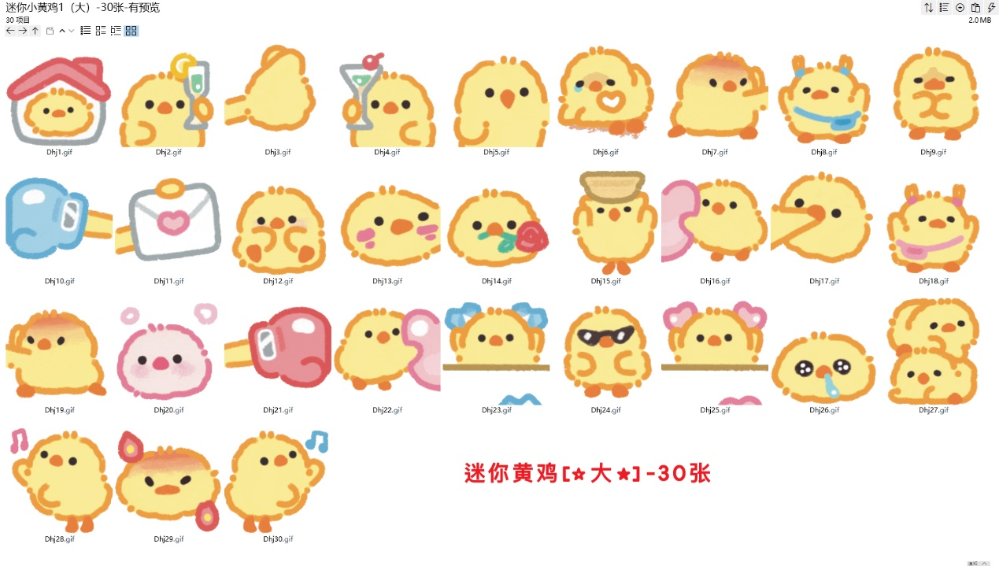
等你回家叽:https://imgbed.heliar.top/i/4pMM1TvhanCiel0Z_Dhj1.gif
敬你一杯:https://imgbed.heliar.top/i/0Rc7paeFQQc-H2gl_Dhj2.gif
要钱:https://imgbed.heliar.top/i/JlTQWFAYJHEvkvBS_Dhj3.gif
干杯:https://imgbed.heliar.top/i/hVNHzUGYUejubjqj_Dhj4.gif
嚼嚼嚼:https://imgbed.heliar.top/i/2R1rBg_ItfPAZ59A_Dhj5.gif
心里空空的:https://imgbed.heliar.top/i/GYOREQ6HKj18m2EN_Dhj6.gif
吃我一掌/我会武功别小瞧气我:https://imgbed.heliar.top/i/IRbLmZL_diSEIXtv_Dhj7.gif
蹦蹦跳跳/开心:https://imgbed.heliar.top/i/y6HfcORN-6lksQpS_Dhj8.gif
双手环胸 你再说一遍？｜你说什么:https://imgbed.heliar.top/i/6s1wMpJh_0zVj5GU_Dhj9.gif
那拳头打你/右一拳:https://imgbed.heliar.top/i/GlQiX7ewG4p8YDXi_Dhj10.gif
给你写信/信息来喽:https://imgbed.heliar.top/i/pz9AcqMuny8BXgj9_Dhj11.gif
雀跃:https://imgbed.heliar.top/i/Y0xXxq1_kVDxgjP7_Dhj12.gif
扯你脸蛋子:https://imgbed.heliar.top/i/vQDpWSTHmjh8mSCF_Dhj13.gif
掉玫瑰花送给我最爱的人/吊着玫瑰花wink:https://imgbed.heliar.top/i/WZvgIBUENMzp3RUc_Dhj14.gif
稳住！:https://imgbed.heliar.top/i/kS8Dj9lKD9xVt7ni_Dhj15.gif
挤爱心:https://imgbed.heliar.top/i/72xdrTpmT_q9KcmY_Dhj16.gif
别走/理理我嘛~:https://imgbed.heliar.top/i/029d42PqPN-V5v3y_Dhj17.gif
我回来喽:https://imgbed.heliar.top/i/M5B6S9WZrL7nnq2s_Dhj18.gif
见招拆招/接你一招:https://imgbed.heliar.top/i/IraLHSsNXQRYWGIt_Dhj19.gif
赶路中:https://imgbed.heliar.top/i/tK_NI0CQE19M69QH_Dhj20.gif
左一拳:https://imgbed.heliar.top/i/GkJ6j0xrWqsXfvYO_Dhj21.gif
送爱心:https://imgbed.heliar.top/i/BjkmMXqPTgaZ5ULN_Dhj22.gif
蓝色爱心攻击:https://imgbed.heliar.top/i/slHytnMkFNaHgcM9_Dhj23.gif
摆pose:https://imgbed.heliar.top/i/tMj3eePeyhgKimpz_Dhj24.gif
粉色爱心攻击:https://imgbed.heliar.top/i/zNRQ7aSlpnoj4gPz_Dhj25.gif
可怜兮兮叽:https://imgbed.heliar.top/i/9RrI4_nS1OoRrY-W_Dhj26.gif
压着你:https://imgbed.heliar.top/i/FR6EW1a-c4BvQWVs_Dhj27.gif
左边扭扭跳舞:https://imgbed.heliar.top/i/-rx_iJbnZiG3Gcf-_Dhj28.gif
火冒三丈叽:https://imgbed.heliar.top/i/hTmdwaYh69w3Ok0N_Dhj29.gif
右边扭扭跳舞:https://imgbed.heliar.top/i/BysYUi37xiozB7oX_Dhj30.gif

