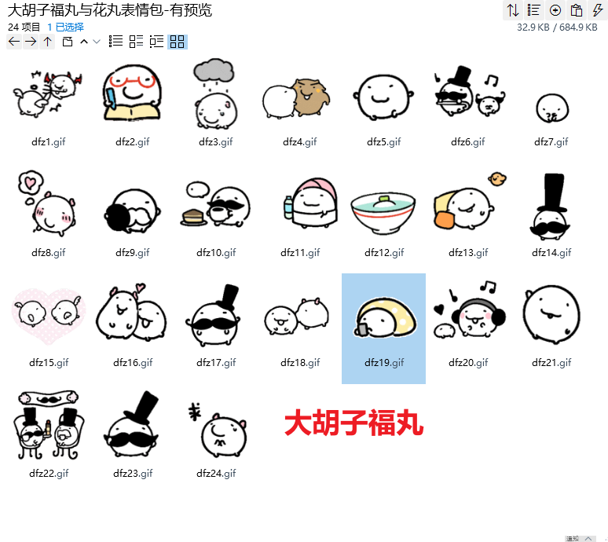
天使恶魔在打架:https://imgbed.heliar.top/i/WpBKUjPJXEFbPSbp_dfz1.gif
学习/记本本:https://imgbed.heliar.top/i/YIrNPUlGS1UgSKrx_dfz2.gif
头顶有乌云下雨/伤心:https://imgbed.heliar.top/i/D_GxWx4jjmsl_E7x_dfz3.gif
用力抱你:https://imgbed.heliar.top/i/k9l1xzS-igdSFR_m_dfz4.gif
蹬腿:https://imgbed.heliar.top/i/TTPCW0ELbzAMIhRW_dfz5.gif
跳舞/开心:https://imgbed.heliar.top/i/DvVsbWBq_C5jqjHz_dfz6.gif
表白:https://imgbed.heliar.top/i/mpccPJ_eS7nRiO76_dfz7.gif
爱你:https://imgbed.heliar.top/i/wJ1K6uhO11kmFiiS_dfz8.gif
敬礼:https://imgbed.heliar.top/i/6sGxjPTZUhvNaKRd_dfz9.gif
喝茶:https://imgbed.heliar.top/i/R-bpjLt4unKpsbfz_dfz10.gif
你好啊:https://imgbed.heliar.top/i/DFDWtndMIHFfwd67_dfz11.gif
泡澡:https://imgbed.heliar.top/i/sfCEuNh1NEik2-7l_dfz12.gif
悠哉:https://imgbed.heliar.top/i/fYMqGRgkOBBfNZ60_dfz13.gif
疑惑:https://imgbed.heliar.top/i/EDnxqMT_c7wdHgv2_dfz14.gif
围绕着亲嘴啵啵:https://imgbed.heliar.top/i/ZYVRzXKx56Cd3nvS_dfz15.gif
互相亲昵蹭蹭:https://imgbed.heliar.top/i/-cfphOxeQwMLRk3-_dfz16.gif
震惊:https://imgbed.heliar.top/i/Ou-HgB6gdqIVBgWp_dfz17.gif
嘬你一大口:https://imgbed.heliar.top/i/sBVo3gOG7k-wVjQs_dfz18.gif
玩手机:https://imgbed.heliar.top/i/v2P66LsjHDLaBC7K_dfz19.gif
听歌:https://imgbed.heliar.top/i/VX8CTtGVdJXeXZZB_dfz20.gif
快来呀:https://imgbed.heliar.top/i/yrzwv4HF6vEeB3AW_dfz21.gif
品鉴中:https://imgbed.heliar.top/i/ccX-O7pybC3LxzOL_dfz22.gif
拉拉胡子:https://imgbed.heliar.top/i/ISfq6SaQnwTvW4Tx_dfz23.gif
求求你:https://imgbed.heliar.top/i/tkEMRDuHDV71cIBv_dfz24.gif

