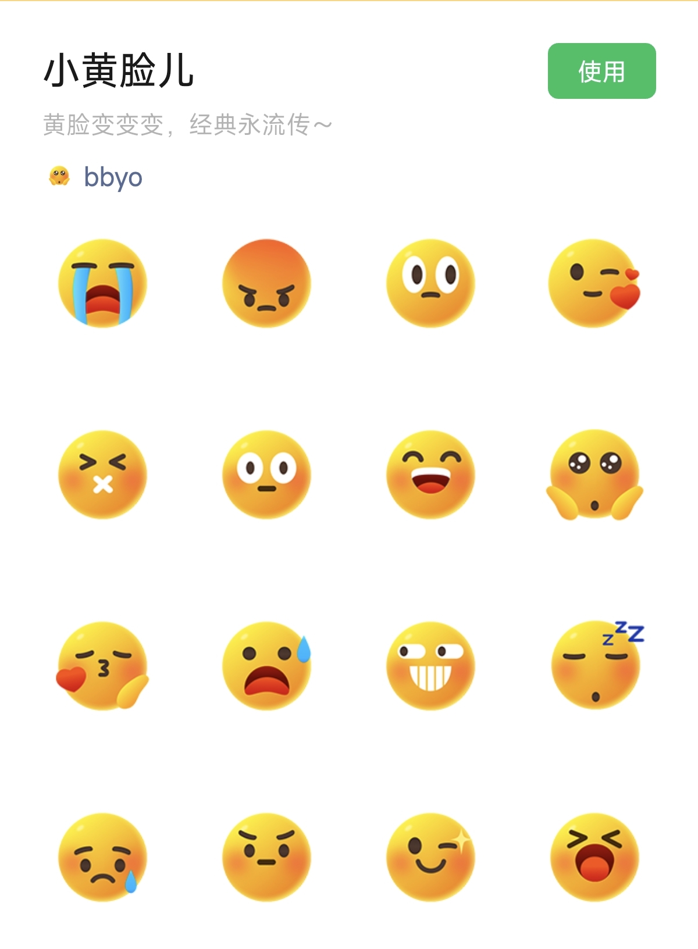
大哭:https://i.postimg.cc/T36xs6Qy/xhl1.gif
怒:https://i.postimg.cc/13QSdQMV/xhl2.gif
盯:https://i.postimg.cc/Vk8wh84b/xhl3.gif
感谢:https://i.postimg.cc/4xQGkSFx/xhl4.gif
住口:https://i.postimg.cc/YCz7Ksyq/xhl5.gif
呆:https://i.postimg.cc/8zmGQ0n5/xhl6.gif
大笑:https://i.postimg.cc/Z5xmtMDq/xhl7.gif
眼巴巴:https://i.postimg.cc/fRfsnrgk/xhl8.gif
亲亲:https://i.postimg.cc/GmxRw5SH/xhl9.gif
吃惊:https://i.postimg.cc/6pfKJm18/xhl10.gif
呲牙:https://i.postimg.cc/52SJdRkH/xhl11.gif
打盹:https://i.postimg.cc/wjQz8Gby/xhl12.gif
大委屈:https://i.postimg.cc/DwPhkMY4/xhl13.gif
皱眉:https://i.postimg.cc/NjktqzPH/xhl14.gif
耶:https://i.postimg.cc/mgy4f56F/xhl15.gif
张嘴大笑:https://i.postimg.cc/BnB39VwF/xhl16.gif

