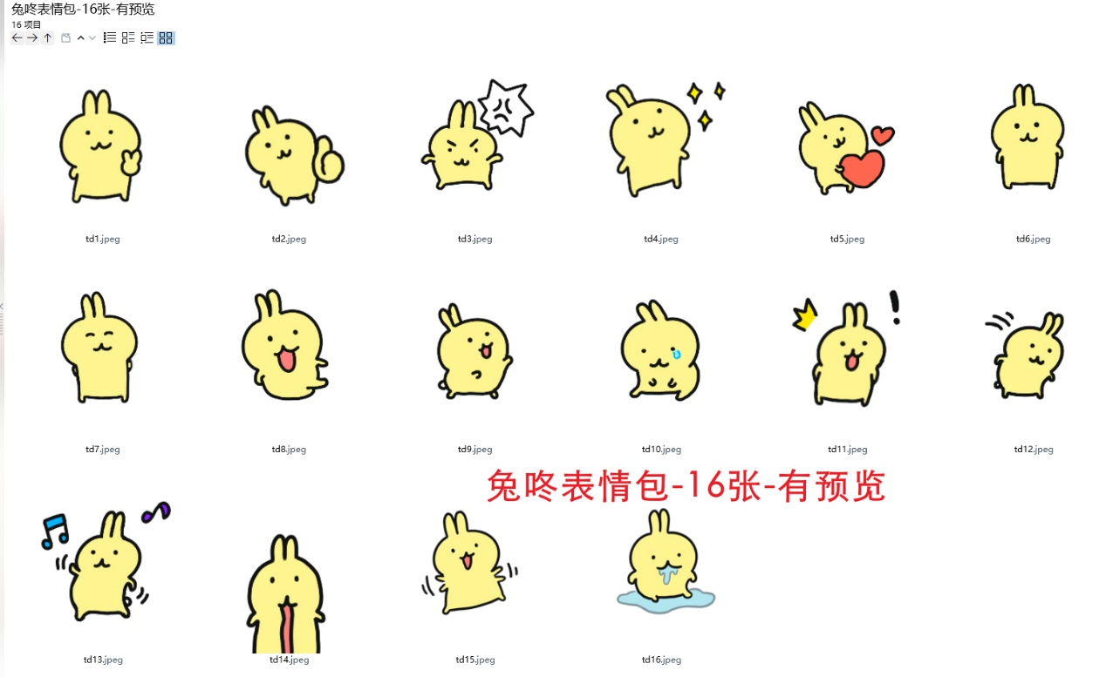
耶:https://imgbed.heliar.top/i/5HHUxIWbulgQF9C8_td1.webp
赞:https://imgbed.heliar.top/i/X_kN9RmLq0CYM1ZA_td2.webp
怒:https://imgbed.heliar.top/i/txqu2nqwM-R5cjFa_td3.webp
哇:https://imgbed.heliar.top/i/z8j7HzOq2AxA1QSL_td4.webp
爱心:https://imgbed.heliar.top/i/TtoO1-8W9ZSihh6u_td5.webp
平静:https://imgbed.heliar.top/i/gBu6mBfcotBt1QtA_td6.webp
嘻嘻:https://imgbed.heliar.top/i/LiwkTKgxL0WSCaTq_td7.webp
额:https://imgbed.heliar.top/i/kqVOtrEviKhJWlVh_td8.webp
展示:https://imgbed.heliar.top/i/HSRgnQ91LR9lnOKw_td9.webp
哭:https://imgbed.heliar.top/i/XHB9B6a7_6PDM71G_td10.webp
吓:https://imgbed.heliar.top/i/bARODkHDDUARI1G-_td11.webp
鞠躬:https://imgbed.heliar.top/i/JU06uBM7S67qtLZf_td12.webp
跳舞:https://imgbed.heliar.top/i/6ZlgaA7jHVD4r6ZN_td13.webp
惊掉下巴:https://imgbed.heliar.top/i/PsqPTu4dVdDeyGEL_td14.webp
跳:https://imgbed.heliar.top/i/2xM4EaWeGXD-ndEo_td15.webp
呆:https://imgbed.heliar.top/i/O1YIPTJOfJrB-1X__td16.webp

