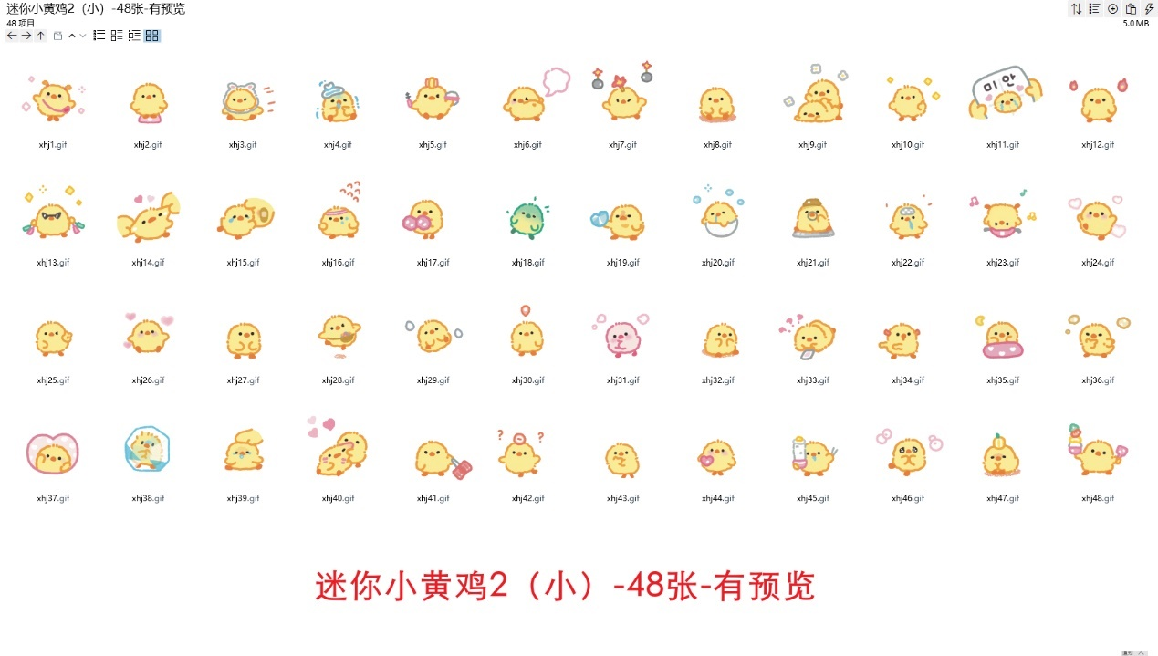
超级变身:https://imgbed.heliar.top/i/i4yewOxRUtSe0mbT_xhj1.gif
称体重:https://imgbed.heliar.top/i/AH-pVfXhwYEgqGr5_xhj2.gif
我来了！:https://imgbed.heliar.top/i/Ass6xJDBo_OrQqBG_xhj3.gif
感冒了:https://imgbed.heliar.top/i/mc6Sgw43lnUCvzqJ_xhj4.gif
化妆中:https://imgbed.heliar.top/i/ZE3ksRwCuC5aaBdQ_xhj5.gif
放屁:https://imgbed.heliar.top/i/qOl7rSaMpWo-fv7m_xhj6.gif
扔炸弹:https://imgbed.heliar.top/i/2Z-fmfqFv7ATE8EN_xhj7.gif
吃美了/晃脚丫:https://imgbed.heliar.top/i/1UDLX_YXGoEgj04p_xhj8.gif
给你捶捶:https://imgbed.heliar.top/i/8MPnO__XAy2JBMeZ_xhj9.gif
律动中:https://imgbed.heliar.top/i/0vRy1RJeL0wcb542_xhj10.gif
对不起:https://imgbed.heliar.top/i/meIvHNlsAI8S76yc_xhj11.gif
雄心斗志/燃起来了:https://imgbed.heliar.top/i/8JDoY0vsJFZJjaq0_xhj12.gif
购物:https://imgbed.heliar.top/i/rl6M-QhAgqJ-5dnr_xhj13.gif
扯你脸蛋:https://imgbed.heliar.top/i/wKwQQPCCG8jRIjoR_xhj14.gif
揉揉不哭:https://imgbed.heliar.top/i/OS9Tjb_-8PCaOv-w_xhj15.gif
努力:https://imgbed.heliar.top/i/KVyhke06H1pzQvAv_xhj16.gif
啦啦操:https://imgbed.heliar.top/i/SKpVTOO6lisliQZ8_xhj17.gif
好像有点要归西了/中毒了:https://imgbed.heliar.top/i/alYwm35qXz62xwbm_xhj18.gif
掏出爱心:https://imgbed.heliar.top/i/ulSqG92Z6PZ8j04H_xhj19.gif
困困的/迷糊:https://imgbed.heliar.top/i/yHP6_e8hfvwv4o-3_xhj20.gif
思索:https://imgbed.heliar.top/i/4bSS2GTTicqY63F3_xhj21.gif
脑袋空空:https://imgbed.heliar.top/i/GC5fs2EdiT9tbuE__xhj22.gif
跳街舞:https://imgbed.heliar.top/i/0EdqAAajgucL7UPX_xhj23.gif
扮笑脸:https://imgbed.heliar.top/i/iJX_wAdjG7r622Zl_xhj24.gif
耶:https://imgbed.heliar.top/i/fSO6Chm5Dn3zgE9W_xhj25.gif
要抱抱:https://imgbed.heliar.top/i/fXqln9bJOK_3cVAV_xhj26.gif
被吓到了:https://imgbed.heliar.top/i/0_56oHKsAs87KnMu_xhj27.gif
撒花花:https://imgbed.heliar.top/i/o3_V9PJcDobjsPHk_xhj28.gif
滚来滚去/好无聊:https://imgbed.heliar.top/i/5PmldQkWLDcJPv_-_xhj29.gif
在哪呢在哪呢:https://imgbed.heliar.top/i/Xb61jY92ZlAEPJD8_xhj30.gif
害羞/扭捏:https://imgbed.heliar.top/i/2GdC_e_qYD3ZKHtT_xhj31.gif
左右瞅瞅:https://imgbed.heliar.top/i/TjsHih3_Ru0LIgu__xhj32.gif
等信息:https://imgbed.heliar.top/i/JQjjGsQmsmMaqAhm_xhj33.gif
晚安飞吻:https://imgbed.heliar.top/i/1kWxKYoDfZnO3DJ3_xhj34.gif
让我大脑思考一下:https://imgbed.heliar.top/i/C_ymQCJShm5qKcWC_xhj35.gif
左右摇摆:https://imgbed.heliar.top/i/gq_6YgZSakDlx8Ts_xhj36.gif
记得想我哦:https://imgbed.heliar.top/i/u7pac0H8UHmpdS8u_xhj37.gif
冻住/好冷:https://imgbed.heliar.top/i/J0JqVXuCvabcY6or_xhj38.gif
拍拍你的脑袋/清醒一点:https://imgbed.heliar.top/i/qxZuH5GdNVDPO65A_xhj39.gif
咬你咬你咬你咬你叽:https://imgbed.heliar.top/i/pUcM_qFfnihNCRV-_xhj40.gif
小心我锤你:https://imgbed.heliar.top/i/CZs7J4L8AvwS25En_xhj41.gif
现在几点啦:https://imgbed.heliar.top/i/fy4tkBpwRf90mmTF_xhj42.gif
加载中/等你:https://imgbed.heliar.top/i/3FrP-KGA1UWS5ADM_xhj43.gif
心跳扑通扑通叽:https://imgbed.heliar.top/i/Zer2d_wCZJyQGz42_xhj44.gif
好饿开饭:https://imgbed.heliar.top/i/i9OY_5mOhkTpuKhs_xhj45.gif
感动:https://imgbed.heliar.top/i/WSyarNB9IjcvnJfJ_xhj46.gif
泄气/叹气:https://imgbed.heliar.top/i/ZBbq567RehsTjwDh_xhj47.gif
米饭呢:https://imgbed.heliar.top/i/LgI-0rUV7rYqt_GQ_xhj48.gif

