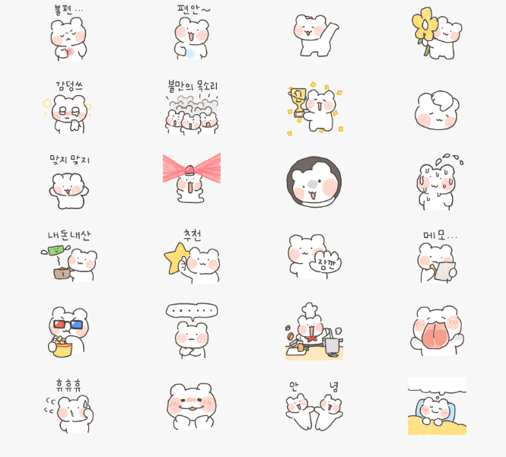
肚子不舒服…:https://i.postimg.cc/Qxwn073h/nolzagom1.gif
舒服多了/安心～:https://i.postimg.cc/sDq0wWrr/nolzagom2.gif
扭腰:https://i.postimg.cc/28MX2WDf/nolzagom3.gif
送你花花:https://i.postimg.cc/rF3YQ4kc/nolzagom4.gif
感动擦泪:https://i.postimg.cc/jdmkZfbR/nolzagom5.gif
发出不满的声音/抗议:https://i.postimg.cc/65g1YZX9/nolzagom6.gif
获奖:https://i.postimg.cc/L6w0NPp9/nolzagom7.gif
挠头/摸脑袋:https://i.postimg.cc/gkQBNhWc/nolzagom8.gif
没错没错/疯狂点头:https://i.postimg.cc/nhmS5LFb/nolzagom9.gif
尖叫警报:https://i.postimg.cc/vZn2jmYd/nolzagom10.gif
让我看看/怀疑的凝视:https://i.postimg.cc/BnF7yvSf/nolzagom11.gif
冒汗/心虚:https://i.postimg.cc/mg9pqrLR/nolzagom12.gif
我的钱钱飞走了/没钱:https://i.postimg.cc/2SW9J5kk/nolzagom13.gif
推荐:https://i.postimg.cc/L8PQ7s9J/nolzagom14.gif
等一下:https://i.postimg.cc/rw4ZbpVz/nolzagom15.gif
记笔记…:https://i.postimg.cc/P5DVcqXP/nolzagom16.gif
看电影:https://i.postimg.cc/rw4ZbpVd/nolzagom17.gif
……:https://i.postimg.cc/sgWH82jG/nolzagom18.gif
做饭:https://i.postimg.cc/P5DVcqXD/nolzagom19.gif
闭眼张大嘴舔你:https://i.postimg.cc/jSf39jxP/nolzagom20.gif
心虚吹口哨:https://i.postimg.cc/dVCNX0s2/nolzagom21.gif
嘿嘿嘿嘿/谄媚:https://i.postimg.cc/RZtp80S1/nolzagom22.gif
你好/欢迎光临:https://i.postimg.cc/7ZztcLHM/nolzagom23.gif
做梦/睡觉:https://i.postimg.cc/bvjVjjrD/nolzagom24.gif

