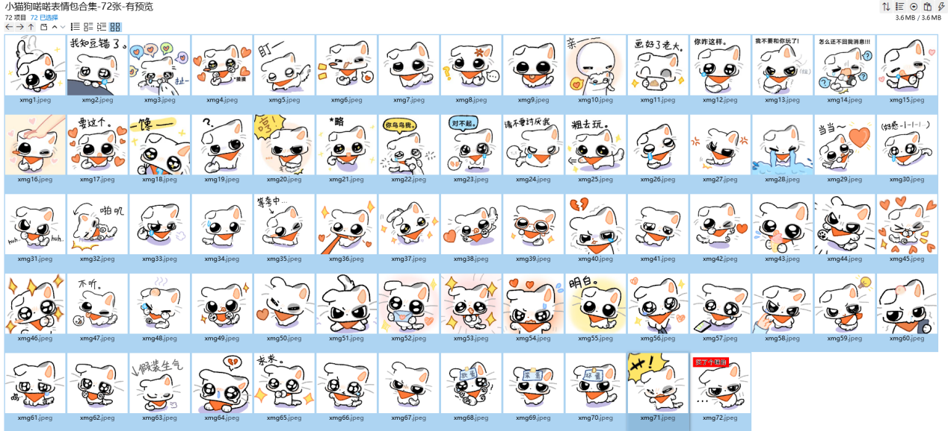
扭扭:https://i.postimg.cc/pXHt0CMv/xmg1.png
知道错了:https://i.postimg.cc/vHsdPhwB/xmg2.png
别走:https://i.postimg.cc/4NgT8PRx/xmg3.png
摸摸:https://i.postimg.cc/28DfHGNV/xmg4.png
盯:https://i.postimg.cc/X7b02L6r/xmg5.png
开心:https://i.postimg.cc/15QZWB1q/xmg6.png
看着你:https://i.postimg.cc/RVBzPdxw/xmg7.png
生气疑惑:https://i.postimg.cc/4NgT8PR5/xmg8.png
吐舌:https://i.postimg.cc/HsgCSz1z/xmg9.png
亲亲:https://i.postimg.cc/VLWP2tzn/xmg10.png
画好了（画一坨可爱的大便）:https://i.postimg.cc/vHtwCnGL/xmg11.png
你咋这样:https://i.postimg.cc/QxJZv7jn/xmg12.png
不和你好:https://i.postimg.cc/ncGfNmnS/xmg13.png
快回消息:https://i.postimg.cc/rFN274qH/xmg14.png
好吃:https://i.postimg.cc/3JFQzG3V/xmg15.png
摸摸头:https://i.postimg.cc/DyP3RG2T/xmg16.png
要这个:https://i.postimg.cc/ht4RnGGH/xmg17.png
馋:https://i.postimg.cc/qvBHr77F/xmg18.png
疑问:https://i.postimg.cc/sgfCz22b/xmg19.png
哼:https://i.postimg.cc/13R1Sztx/xmg20.png
略:https://i.postimg.cc/pLVMvdTP/xmg21.png
理理我:https://i.postimg.cc/Gm3nRp23/xmg22.png
对不起:https://i.postimg.cc/0y51vNQN/xmg23.png
别讨厌我:https://i.postimg.cc/8zkgGC5c/xmg24.png
出去玩:https://i.postimg.cc/529WJt0F/xmg25.png
可怜:https://i.postimg.cc/XYN6WvJG/xmg26.png
生气:https://i.postimg.cc/wjW8jdyq/xmg27.png
大哭:https://i.postimg.cc/P56s5kpr/xmg28.png
当当:https://i.postimg.cc/Z5ft5hB5/xmg29.png
好感减一:https://i.postimg.cc/mgdfgGzr/xmg30.png
使坏:https://i.postimg.cc/4x8kxT7n/xmg31.png
摔倒:https://i.postimg.cc/t4rQ4HZ1/xmg32.png
赌气:https://i.postimg.cc/bw6cwjDD/xmg33.png
心虚:https://i.postimg.cc/2SHRSfbL/xmg34.png
等夸:https://i.postimg.cc/Qd6Gdr9W/xmg35.png
可爱:https://i.postimg.cc/GmMwm18y/xmg36.png
期待:https://i.postimg.cc/HkSDkCc5/xmg37.png
喜欢:https://i.postimg.cc/rwhXwL0x/xmg38.png
卖萌:https://i.postimg.cc/qvmVvdh8/xmg39.png
心碎:https://i.postimg.cc/Mps2p8M7/xmg40.png
委屈:https://i.postimg.cc/9Qx5QjRP/xmg41.png
比心:https://i.postimg.cc/cLDyLNgM/xmg42.png
舔:https://i.postimg.cc/SxZFxp2f/xmg43.png
踹:https://i.postimg.cc/Bnh9nGLp/xmg44.png
兴奋:https://i.postimg.cc/mgdfgGz8/xmg45.png
求求:https://i.postimg.cc/NjNqjw9C/xmg46.png
不听:https://i.postimg.cc/PqPGLFYm/xmg47.png
被打:https://i.postimg.cc/fbJ43gmc/xmg48.png
Hi:https://i.postimg.cc/PqPGLFYz/xmg49.png
爱心:https://i.postimg.cc/MGvkcrVm/xmg50.png
坏:https://i.postimg.cc/pdpN91zC/xmg51.png
送你:https://i.postimg.cc/25VpqXh0/xmg52.png
期待:https://i.postimg.cc/25VpqXhX/xmg53.png
害羞:https://i.postimg.cc/fbJ43gmP/xmg54.png
明白:https://i.postimg.cc/g0n9wB85/xmg55.png
扯:https://i.postimg.cc/yNkqJrc2/xmg56.png
等你消息:https://i.postimg.cc/0Nbg6HDL/xmg57.png
不想理:https://i.postimg.cc/jjLVWkPp/xmg58.png
坏点子:https://i.postimg.cc/jjLVWkyV/xmg59.png
被揍:https://i.postimg.cc/5t6cHk8d/xmg60.png
呜:https://i.postimg.cc/xdcrkFLV/xmg61.png
抱抱:https://i.postimg.cc/FK7tfn0Q/xmg62.png
假装生气:https://i.postimg.cc/d0LM7SGF/xmg63.png
心碎:https://i.postimg.cc/pdpN91Kx/xmg64.png
求求:https://i.postimg.cc/k5BrVhWq/xmg65.png
哼:https://i.postimg.cc/d0LM7SGJ/xmg66.png
别扭:https://i.postimg.cc/d0LM7SGs/xmg67.png
软蛋:https://i.postimg.cc/9fS6ytYv/xmg68.png
笨蛋:https://i.postimg.cc/W4KB06wB/xmg69.png
坏蛋:https://i.postimg.cc/TPSznqcM/xmg70.png
草:https://i.postimg.cc/8C32LBbg/xmg71.png
汪了个咪:https://i.postimg.cc/wBPCDckd/xmg72.png

