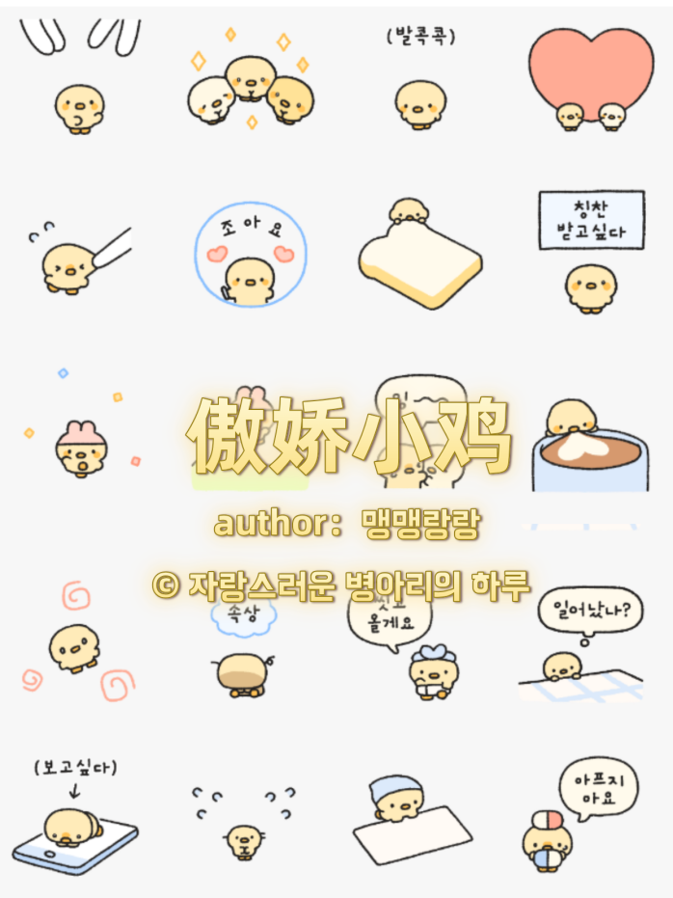
乖巧打招呼:https://i.postimg.cc/DfjzJSWV/chick1.gif
三倍可爱:https://i.postimg.cc/XNHvGrrt/chick2.gif
戳戳|扭捏|别扭:https://i.postimg.cc/Pf3qpCCc/chick3.gif
爱心贴贴:https://i.postimg.cc/mZXrzPP0/chick4.gif
扯你脸颊:https://i.postimg.cc/QN4M9FBr/chick5.gif
喜欢哦:https://i.postimg.cc/05WNMz6P/chick6.gif
让我啃啃:https://i.postimg.cc/m2PgQT9n/chick7.gif
想要夸奖|等夸:https://i.postimg.cc/05WNMz6s/chick8.gif
开心走路:https://i.postimg.cc/VsGNrJSw/chick9.gif
蹦跳:https://i.postimg.cc/658pdBZF/chick10.gif
哭着抱抱|委屈:https://i.postimg.cc/vH4ZWGnp/chick11.gif
嗦咖啡:https://i.postimg.cc/QxFdpj5Z/chick12.gif
放空|天使:https://i.postimg.cc/FsYHjhSM/chick13.gif
流汗|思考:https://i.postimg.cc/Wbd1Msrv/chick14.gif
生气|恶魔:https://i.postimg.cc/tCs4h9Pb/chick15.gif
躲被窝|不想起床:https://i.postimg.cc/HsrkQT5p/chick16.gif
晕乎乎:https://i.postimg.cc/vH4ZWG9T/chick17.gif
难过|掉小珍珠:https://i.postimg.cc/PrC5mdZx/chick18.gif
我在走啦|等我洗个澡:https://i.postimg.cc/9FDQGcTr/chick19.gif
醒了吗？|早安:https://i.postimg.cc/SNnxWm8z/chick20.gif
想你等你消息:https://i.postimg.cc/SNnxWm89/chick21.gif
紧张冒汗:https://i.postimg.cc/BQjnxJDK/chick22.gif
勤劳干活:https://i.postimg.cc/Gh6hK6Jp/chick23.gif
不舒服|敷药:https://i.postimg.cc/kXLXsLFG/chick24.gif

