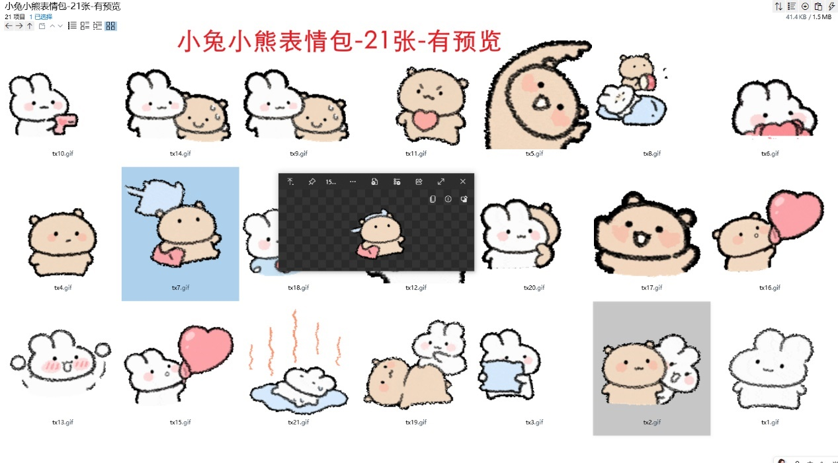
接爱心/被爱心击中/喜欢/心动:https://imgbed.heliar.top/i/rE55tkkS44t_14sb_tx1.gif
让我看看/别挡着我:https://imgbed.heliar.top/i/E_0CR2YFC6NVoaTR_tx2.gif
小兔丢枕头/扔你:https://imgbed.heliar.top/i/ipCo0JD03xjBbbao_tx3.gif
小熊敬礼:https://imgbed.heliar.top/i/olJQO4xYn8ZMcLE-_tx4.gif
小熊比心:https://imgbed.heliar.top/i/GODdLIK5qSMFOdjb_tx5.gif
爱心花花:https://imgbed.heliar.top/i/vBKQRbegqGBREnSJ_tx6.gif
躲避枕头攻击:https://imgbed.heliar.top/i/P6J-X1NNp2pFX7aE_tx7.gif
别睡啦:https://imgbed.heliar.top/i/t_QNF5gDLPAx8yBC_tx8.gif
心虚冒汗/被抓了:https://imgbed.heliar.top/i/_xRlYyLwtdJmt7vl_tx9.gif
拿枪发射爱心:https://imgbed.heliar.top/i/ioqbkbIqRF9Q_l8Y_tx10.gif
被爱心击中心脏:https://imgbed.heliar.top/i/NAcA4YfXaEpUFN-N_tx11.gif
小兔子比心:https://imgbed.heliar.top/i/s3FxyC5_284zq_YP_tx12.gif
快来快来:https://imgbed.heliar.top/i/t655PH3L1EeByY4O_tx13.gif
小兔吹泡泡:https://imgbed.heliar.top/i/tWEVqEZGy0pO8A2B_tx14.gif
小熊吹泡泡:https://imgbed.heliar.top/i/MJlBZ6sCGNBDLOX5_tx15.gif
左脸蹭蹭:https://imgbed.heliar.top/i/7W45yQpxdEXl-18k_tx16.gif
双双展示爱心:https://imgbed.heliar.top/i/oDtG-XTNJZ5ZtZVP_tx17.gif
揉捏你肚子:https://imgbed.heliar.top/i/f_tCTtWcBitMGmr3_tx18.gif
让我瞧瞧:https://imgbed.heliar.top/i/6ueFqwtcNkcWUUlW_tx19.gif
躺在地上没精打采:https://imgbed.heliar.top/i/OCgVDJphk-NRUbSk_tx20.gif

