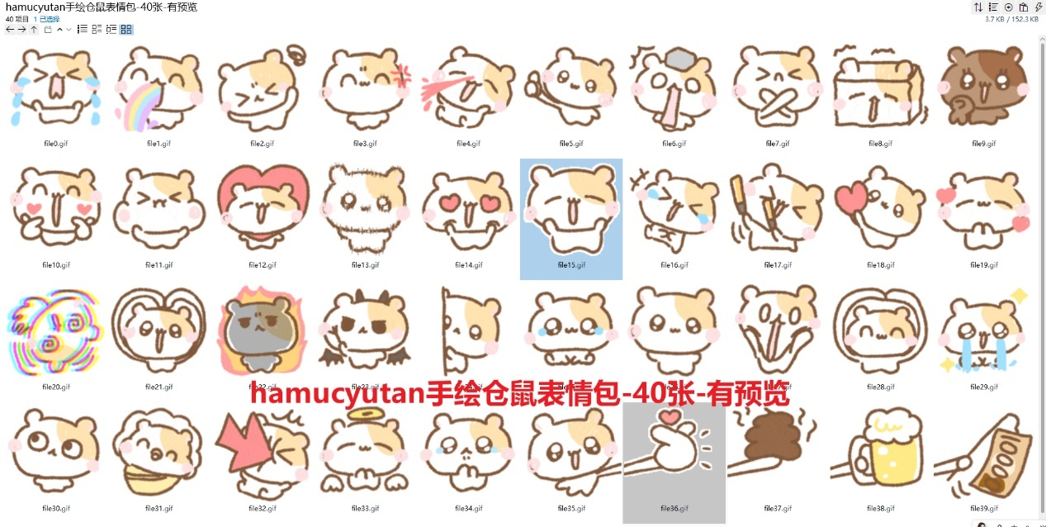
大哭:https://imgbed.heliar.top/i/Njg-cfPvpAVbG7NA_file0.gif
吐彩虹:https://imgbed.heliar.top/i/TpcsEWzmBiXmoFKI_file1.gif
脑子好晕:https://imgbed.heliar.top/i/MV9yhL45pyhdpbZ__file2.gif
微笑生气:https://imgbed.heliar.top/i/mejAfn25-nqBM5A9_file3.gif
喷鼻血:https://imgbed.heliar.top/i/CnsednDodR0eAGNv_file4.gif
点赞:https://imgbed.heliar.top/i/9KykT_PzmFr1QzKB_file5.gif
石化:https://imgbed.heliar.top/i/yXjasVxB4RLAqVT7_file6.gif
拒绝/不要:https://imgbed.heliar.top/i/trtgMaWK3xgkVn_8_file7.gif
颤抖:https://imgbed.heliar.top/i/ZpHaXX6qXGz1l-ob_file8.gif
比耶:https://imgbed.heliar.top/i/JPV-acqm74Pl1F9a_file9.gif
双手比心:https://imgbed.heliar.top/i/q1TbKRLdvyNhvWSp_file10.gif
气鼓鼓:https://imgbed.heliar.top/i/4mYT2gZh2AdvVB3u_file11.gif
爱心展示:https://imgbed.heliar.top/i/TICpj2KWLCp74-r6_file12.gif
卖萌:https://imgbed.heliar.top/i/_m3b5UcmOuCgo7_w_file13.gif
两眼冒爱心:https://imgbed.heliar.top/i/cMMj3aJFdnqvPHXV_file14.gif
托着脸颊笑:https://imgbed.heliar.top/i/aAEDpR3VVyOrbZj8_file15.gif
笑的肚子疼/笑哭:https://imgbed.heliar.top/i/uHZDlGsTC0ZPVO_s_file16.gif
应援/加油:https://imgbed.heliar.top/i/e1rjv1VcfrIW12uN_file17.gif
送你爱心:https://imgbed.heliar.top/i/Y9njWUCrW9pr7bTv_file18.gif
幸福呢:https://imgbed.heliar.top/i/SuxrFDNst9jLmxg9_file19.gif
晕厥:https://imgbed.heliar.top/i/ETpoq7uJHr3XVVJ9_file20.gif
收收到头顶比心:https://imgbed.heliar.top/i/q7oSpiFhLE5mew16_file21.gif
怒火中烧/生气:https://imgbed.heliar.top/i/GhhvcajpXWOTX8nq_file22.gif
恶魔:https://imgbed.heliar.top/i/MxB91F07ET2e39LU_file23.gif
偷看:https://imgbed.heliar.top/i/yOBC0YZsKG83gtwX_file24.gif
眼含泪水:https://imgbed.heliar.top/i/WltjsjB3lmj_LFrz_file25.gif
无辜:https://imgbed.heliar.top/i/lU307mDXLNLyj7sX_file26.gif
惊恐:https://imgbed.heliar.top/i/NjYC4TEpCZHddiH-_file27.gif
笑着双手举到头顶比心:https://imgbed.heliar.top/i/Our7XtJIMMPJUzeV_file28.gif
泪如泉涌:https://imgbed.heliar.top/i/l9wzHdOoGmQJDrN3_file29.gif
偷偷看/瞅瞅:https://imgbed.heliar.top/i/2IfxiPa9YgAWZMzX_file30.gif
好舒服/我要当宝宝:https://imgbed.heliar.top/i/B2688k-nKJSIQXLf_file31.gif
被攻击了/被中伤/被箭头砸了:https://imgbed.heliar.top/i/6-zGP3qRABZ-fAXx_file32.gif
天使:https://imgbed.heliar.top/i/Gng-bDpabibE2Z0J_file33.gif
可怜巴巴/求你:https://imgbed.heliar.top/i/HmYyUqVhI-yA4vMW_file34.gif
伸手给你:https://imgbed.heliar.top/i/Di80Fd2dg9Fq-4c1_file35.gif
给你比心:https://imgbed.heliar.top/i/F0jjivzPureO7u4Y_file36.gif
给你大便:https://imgbed.heliar.top/i/aTtFcUk4Xi8bonH6_file37.gif
给你啤酒:https://imgbed.heliar.top/i/Di9WZUrerF9VuRZs_file38.gif
给你钱:https://imgbed.heliar.top/i/ypKQRDr3vv_WNKNg_file39.gif

