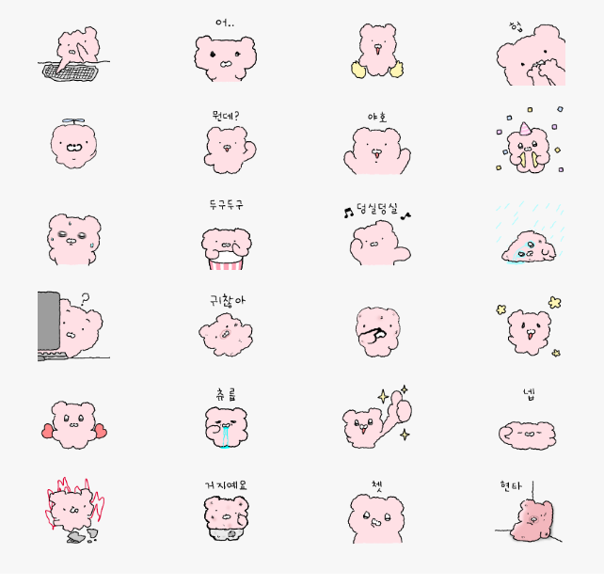
狂敲键盘:https://i.postimg.cc/3Ncrr0rw/xtt1.gif
呃..:https://i.postimg.cc/0jB55K5j/xtt2.gif
应援/加油:https://i.postimg.cc/C5QMMnM1/xtt3.gif
捂嘴惊讶:https://i.postimg.cc/pr6VV5VX/xtt4.webp
打招呼:https://i.postimg.cc/qBbvxSsb/xtt5.gif
怎么了？:https://i.postimg.cc/DfjwPHrC/xtt6.gif
呀呼/大叫一声:https://i.postimg.cc/T273JFVH/xtt7.gif
庆祝:https://i.postimg.cc/ZY75x28s/xtt8.gif
冒汗:https://i.postimg.cc/BQjQYppz/xtt9.gif
咚咚咚打鼓/吵你/打退堂鼓:https://i.postimg.cc/PrCr3yyB/xtt10.gif
躺在雨中哭泣/淋雨:https://i.postimg.cc/sDMD6mKF/xtt11.gif
看电脑疑惑:https://i.postimg.cc/BQjQYpN9/xtt12.gif
好烦哦……:https://i.postimg.cc/wT1Tf2FB/xtt13.gif
抠鼻孔/不在意/不屑:https://i.postimg.cc/DySyj65Z/xtt14.gif
耶/蹦跳:https://i.postimg.cc/rFDFnjgz/xtt15.gif
挥着爱心:https://i.postimg.cc/02z2WnZ6/xtt16.gif
流口水:https://i.postimg.cc/gk1cfhB3/xtt17.gif
棒棒的/点赞！:https://i.postimg.cc/9FsXv9Nd/xtt18.gif
是的/yes sir！:https://i.postimg.cc/WbxpQZfZ/xtt19.gif
发火/全身刺挠:https://i.postimg.cc/3JzrPGbZ/xtt20.gif
嘘/吹口哨/努嘴巴:https://i.postimg.cc/BQRZdFwz/xtt21.gif
晕倒/靠墙瘫坐:https://i.postimg.cc/nh7VZL6G/xtt22.gif

