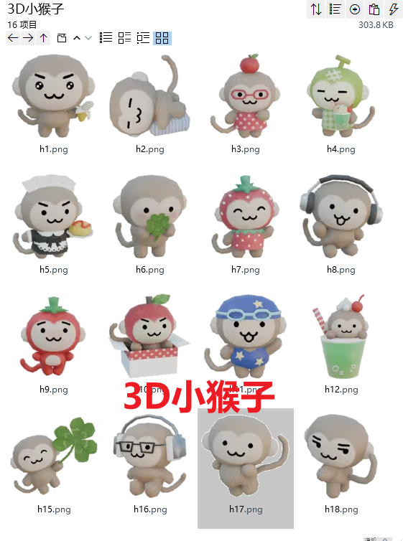
萌萌哒看着你:https://imgbed.heliar.top/i/FY_jileacOVaQ0d5_h1.png
累累的/困困的/瘫:https://imgbed.heliar.top/i/EO6JLuFT-PH_kGXZ_h2.png
可爱:https://imgbed.heliar.top/i/iE54xurep0JiyL0I_h3.png
舒适:https://imgbed.heliar.top/i/CSgjW4A8JSSIquY2_h4.png
您好，您的仆人已上线/请问需要仆人做什么:https://imgbed.heliar.top/i/NeTb4s-D-1-vVn4a_h5.png
害羞:https://imgbed.heliar.top/i/XyNBnEYN7nxqItyX_h6.png
笑:https://imgbed.heliar.top/i/pShd2-dFc0o12iK5_h7.png
听歌:https://imgbed.heliar.top/i/G0TvcQ3x3iwZZYi3_h8.png
苦涩/皱眉:https://imgbed.heliar.top/i/9VSkhzl-NX_JR3nN_h9.png
哟吼:https://imgbed.heliar.top/i/a8bcZjBmC2iJ3m9s_h10.png
打招呼/猪呢比游泳:https://imgbed.heliar.top/i/ydMskzCvmAv6EOt2_h11.png
呆萌:https://imgbed.heliar.top/i/6dHmMBn_DQCzLKnx_h12.png
走喽:https://imgbed.heliar.top/i/CuOh7bqngEkDXviI_h15.png
认真/严肃:https://imgbed.heliar.top/i/jdZ2QlaM5yvQ2m-z_h16.png
挺腰！:https://imgbed.heliar.top/i/CYtCJUQl5htdv_rA_h17.png
偷笑:https://imgbed.heliar.top/i/5uzJFr_fou-Wyb1d_h18.png

