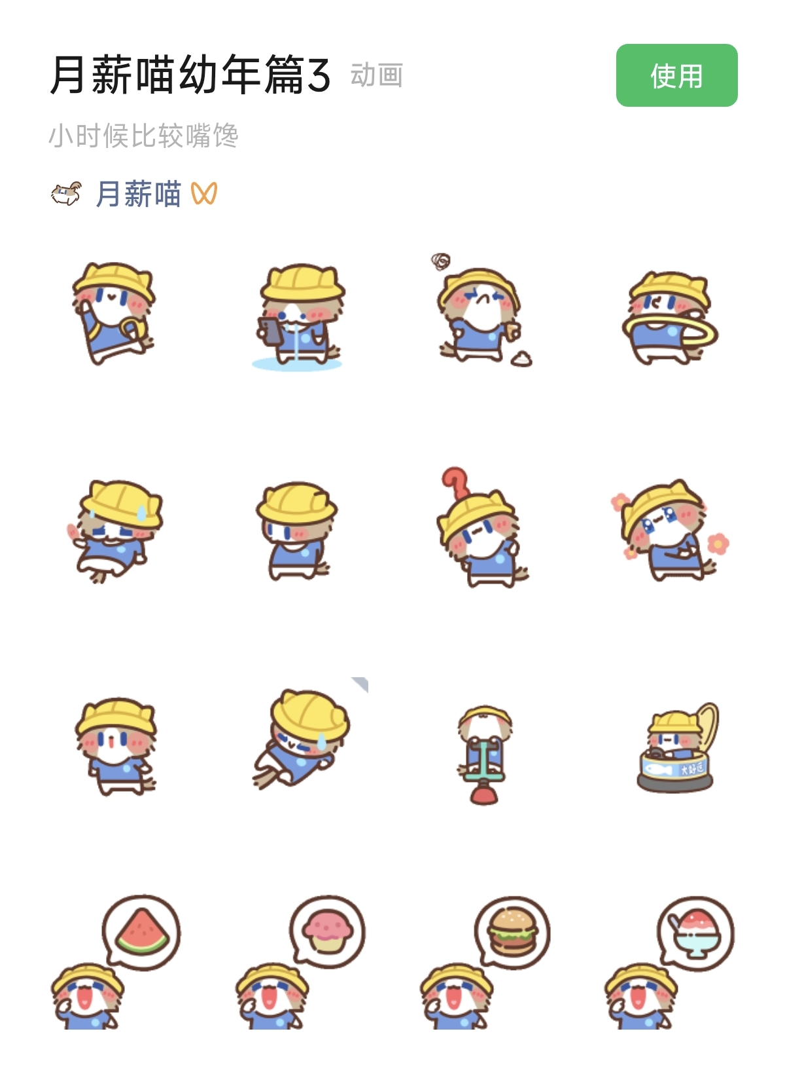
快快快:https://i.postimg.cc/JhTWtB8D/yxmyn1.gif
馋嘴/流口水:https://i.postimg.cc/25Hf3BYL/yxmyn2.gif
烦:https://i.postimg.cc/mrdGhF4c/yxmyn3.gif
减肥/摇呼啦圈:https://i.postimg.cc/pd0tynvK/yxmyn4.gif
累/流汗:https://i.postimg.cc/8CyVsrGd/yxmyn5.gif
没/羞涩:https://i.postimg.cc/QM6rVWDT/yxmyn6.gif
怎么了/什么:https://i.postimg.cc/85jgvPkj/yxmyn7.gif
撒娇:https://i.postimg.cc/cHrG341v/yxmyn8.gif
真的假的:https://i.postimg.cc/MTvJBKZf/yxmyn9.gif
已读乱爬:https://i.postimg.cc/3RdQGJrG/yxmyn10.gif
亲亲:https://i.postimg.cc/d1LcCtQr/yxmyn11.gif
碰大运/碰瓷你:https://i.postimg.cc/fLJQdTWY/yxmyn12.gif
想吃西瓜:https://i.postimg.cc/hjfRmP4M/yxmyn13.gif
想吃蛋糕:https://i.postimg.cc/vBcwnH8v/yxmyn14.gif
想吃汉堡:https://i.postimg.cc/d1LcCtQ5/yxmyn15.gif
想吃甜点:https://i.postimg.cc/RFNxtVCX/yxmyn16.gif

