1.Postgres Deployment

1.1 Create ConfigMap for Postgres



1.2 Create PersistentColume (5Gi)

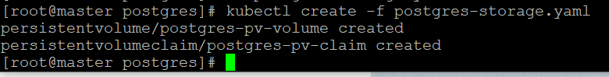

1.3 Create Deployment (1 replicas)



1.4 Create Service



1.5 Checking

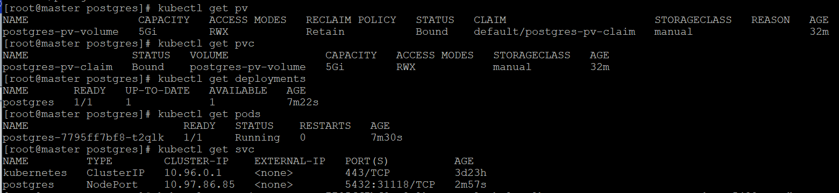

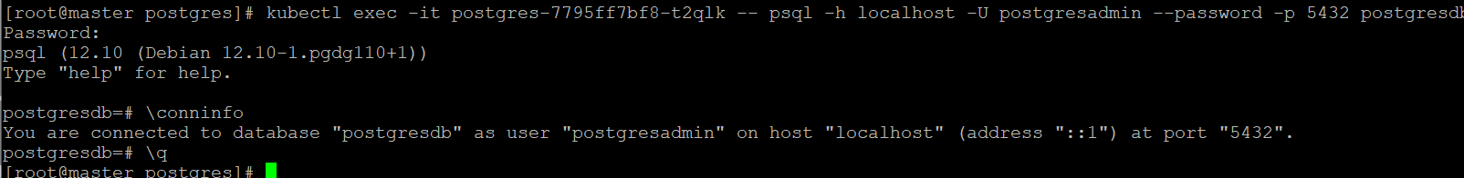

1.6 If we assume that it was the master Postgres server, then for the Slave Postgres we need to do the same

2.Replication of Postgres DataBase

2.1 Set a password for the postgres user



2.2 We need to make changes to pg_hba.conf and postgresql.conf files. Because postgres works within a pod, we can't do it directly. There are several ways to do this - it takes extra time for me to implement this. In theory:

For pg_hba.conf – find string «If you want to allow non-local connections, you need to add more» and add:

host replication postgres REPLICA_INTERNAL_IP/32 md5

(We allow the postgres user to connect to this server from Replica)

Changes for postgres.conf:

listen_addresses = 'localhost, MASTER_INTERNAL_IP'

wal_level = hot_standby

archive_mode = on

archive_command = 'cd .'

max_wal_senders = 8

hot_standby = on

2.3 Restart postgres

service postgresql restart

2.4 Changes for Replica server:

service postgresql stop

pg_hba.conf - host replication postgres MASTER_INTERNAL_IP/32 md5

postgresql.conf:

listen_addresses = 'localhost, REPLICA_INTERNAL_IP'

wal_level = hot_standby

archive_mode = on

archive_command = 'cd .'

max_wal_senders = 8

hot_standby = on

2.5 Create new DB for Replica:

su – postgres

cd DBDIR (Directory with DB)

rm -rf main; mkdir main; chmod go-rwx main

pg_basebackup -P -R -X stream -c fast -h MASTER_INTERNAL_IP -U postgres -D ./main (DB from master)

exit

service postgresql start

2.6 Check replication:

On Master side we will create table and will add string to DB:

su - postgres

psql -c "CREATE TABLE test_table (id INT, name TEXT);"

psql -c "INSERT INTO test_table (id, name) VALUES (1, 'test');"

On Slave side we have to see it.

su - postgres

psql -c "SELECT * FROM test_table;"

But DB on the Slave side must be ReqdOnly – if we try to create table we will get error.

psql -c "CREATE TABLE test_table2 (id INT, name TEXT);"

We have to see error message