Installing Prometheus and Grafana with Helm

1. Helm installation

curl -fsSL -o get_helm.sh <https://raw.githubusercontent.com/helm/helm/master/scripts/get-helm-3>

chmod 700 get_helm.sh

./get_helm.sh

helm version

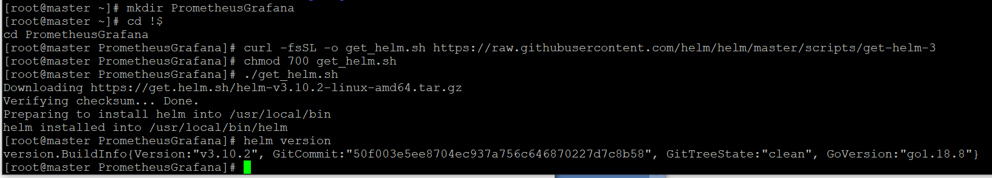

1. Prometheus installation
   1. Get repositories.

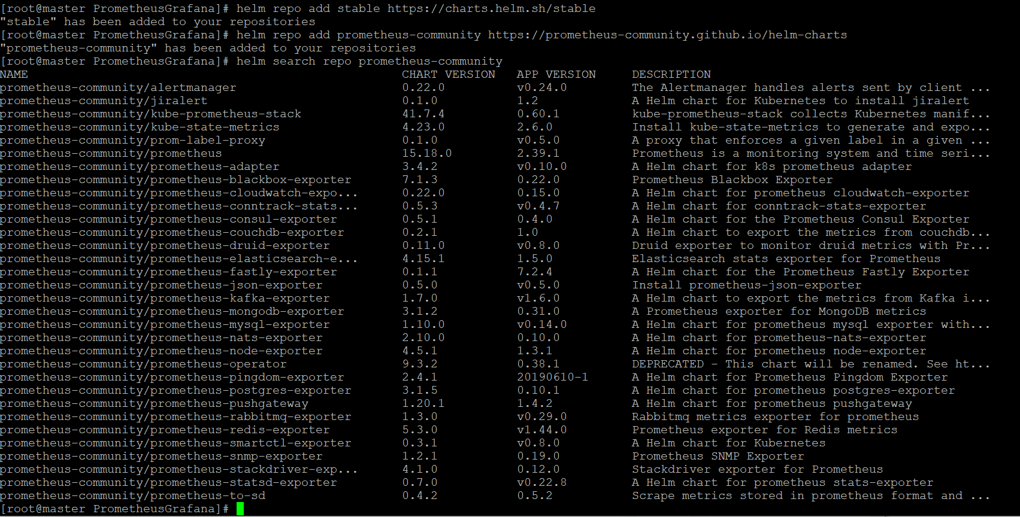

* 1. Install stable version of prometheus-community / kube-prometheus-stack

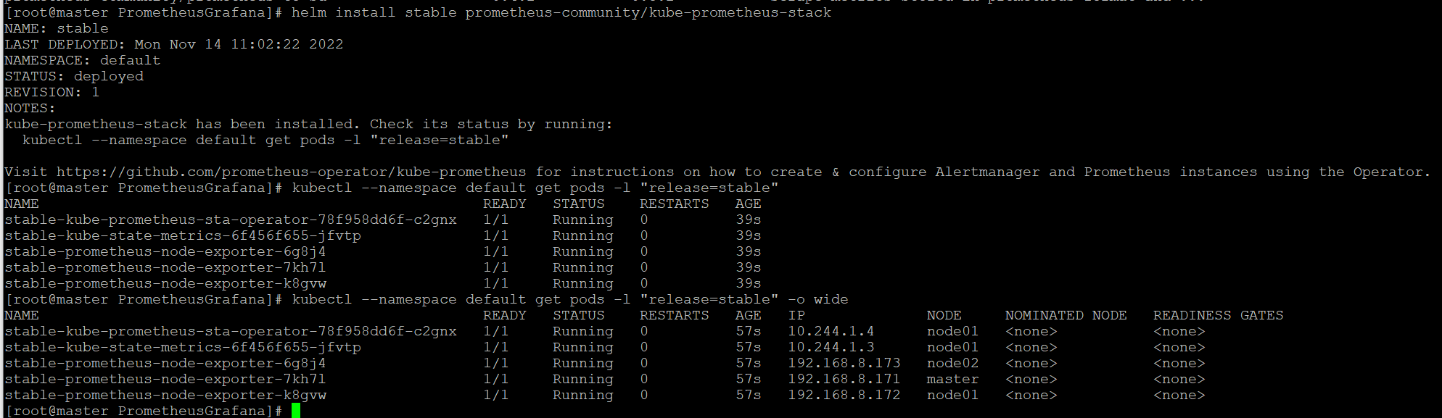

* 1. Access to Prometheus

Change Type ClusterIP to NodePort:

kubectl edit svc stable-kube-prometheus-sta-prometheus

and check

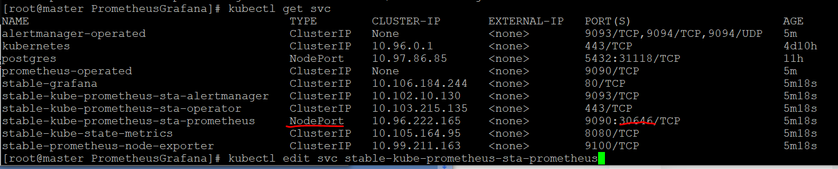

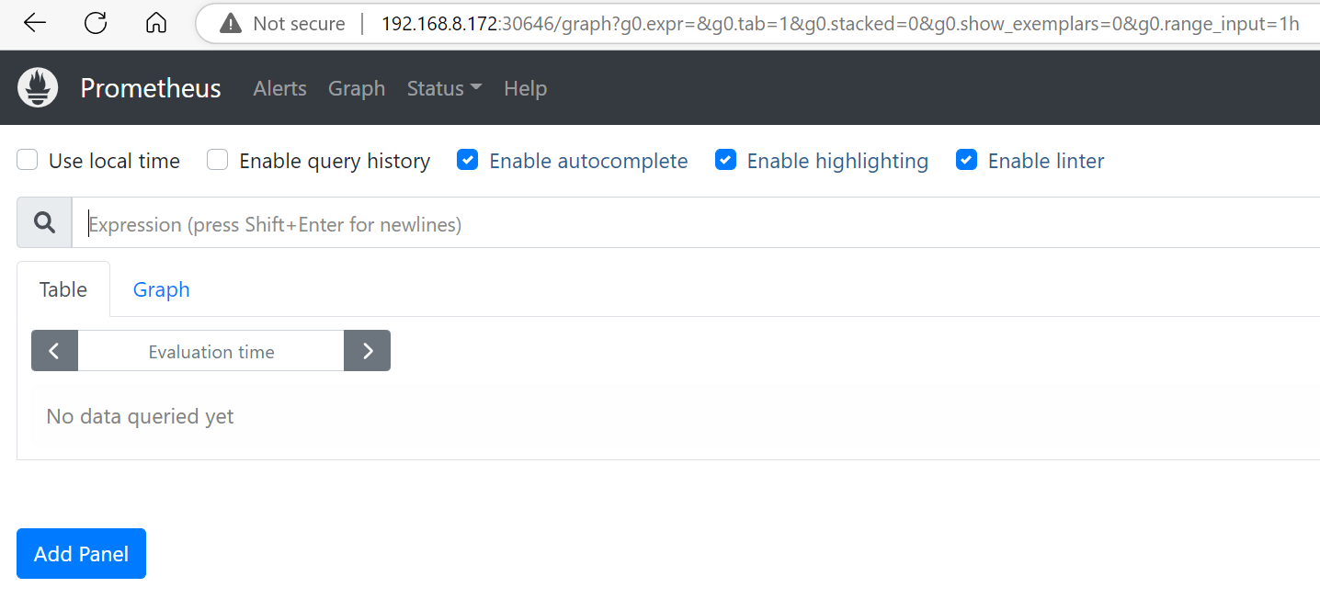

* 1. Access to Grafana

Change ClusterIP to NodePort

kubectl edit svc stable-grafana

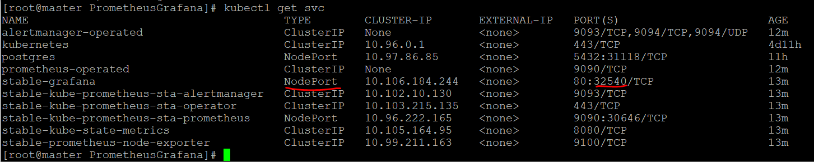

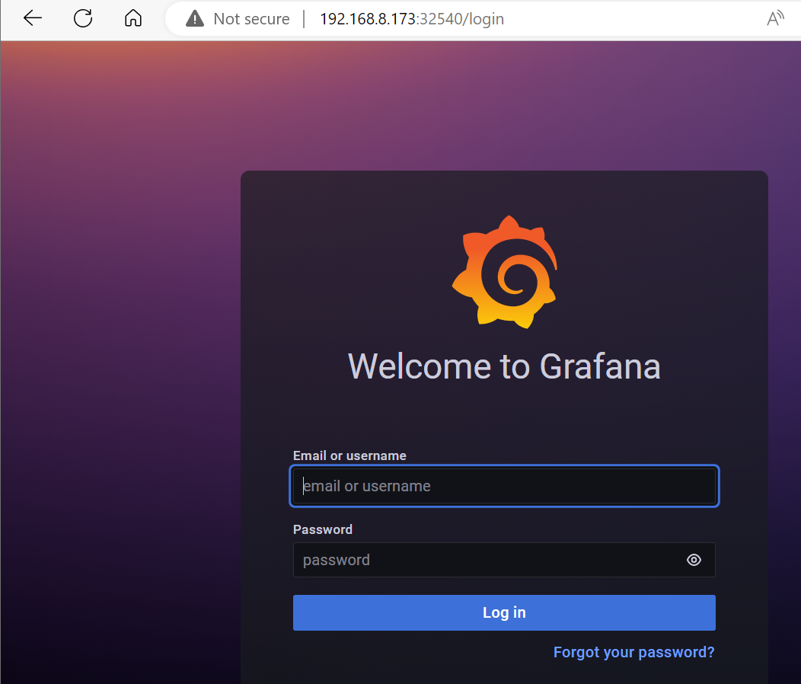

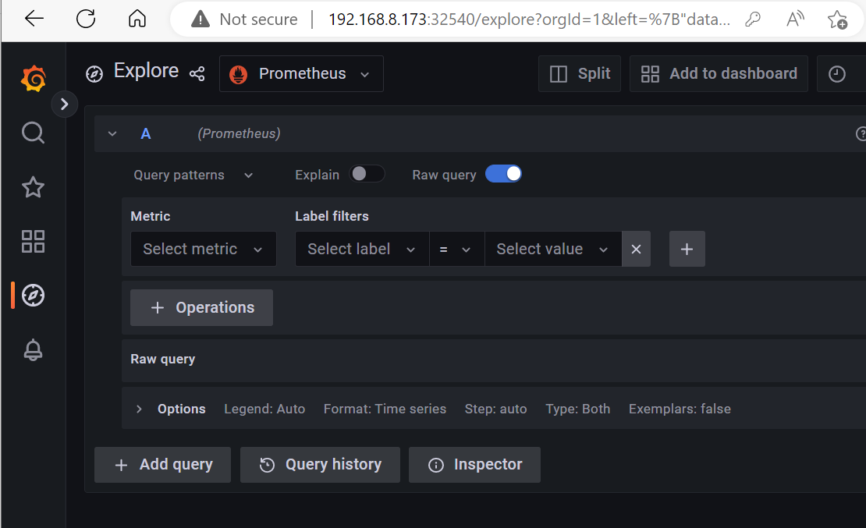

Unfortunately, due to lack of time, I did not set up data collection….