PHASE 6 — PROJECT TESTING

INTRODUCTION :
Team ID : SWTID-2026-8402
Team Leader : Pugalenthi M
MAIL ID: pugalenthi4831@gmail.com

Team members :
NAME | MAIL ID
Raja M | Raja2208devi@Gmail.Com
Samselvakumar M | Samoffi07@Gmail.Com
Sanjay K | Sanjayk200678@Gmail.Com

API Test Cases
Test | Endpoint | Observed Result | Status
Registration | POST /api/auth/register | 201 Created — User registered successfully | PASS
Login | POST /api/auth/login | 200 OK — Login successful; token returned | PASS
FAQ Creation | POST /api/faqs | 201 Created — FAQ created successfully | PASS
FAQ Search | GET /api/faqs/search?q=configure | 200 OK — matching FAQ records returned | PASS
AI FAQ Generation | POST /api/ai/generate-faq | 503 high-demand service-unavailable response recorded | RETRY

Testing Screenshots
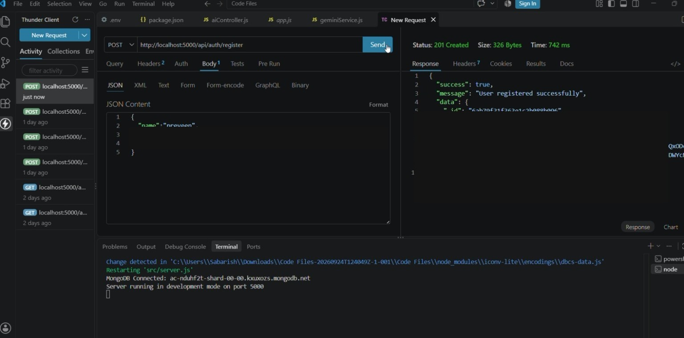
Registration test
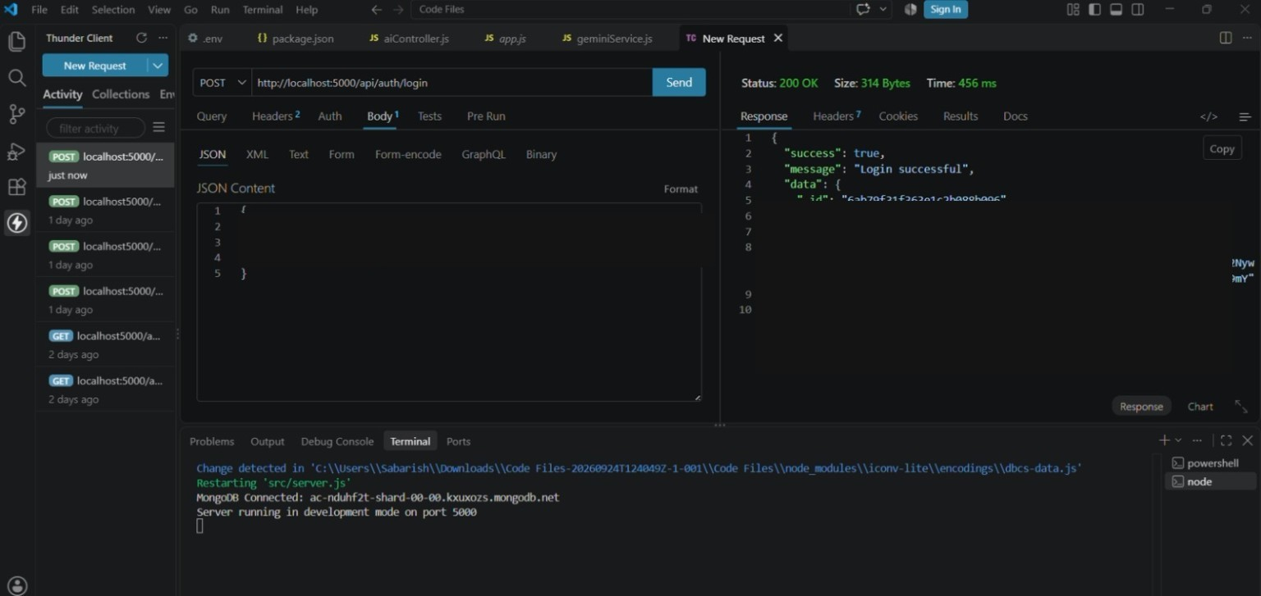
Login test
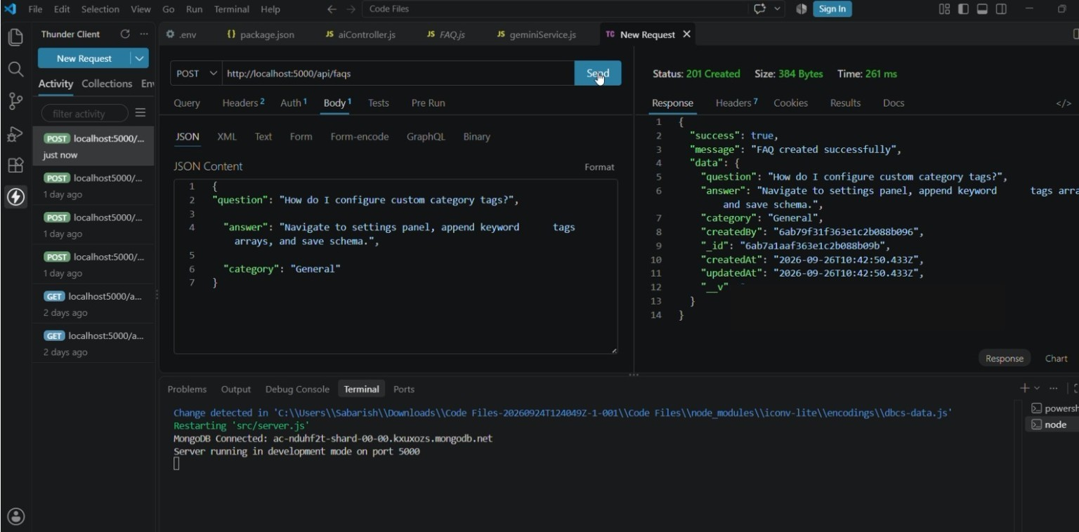
FAQ creation test
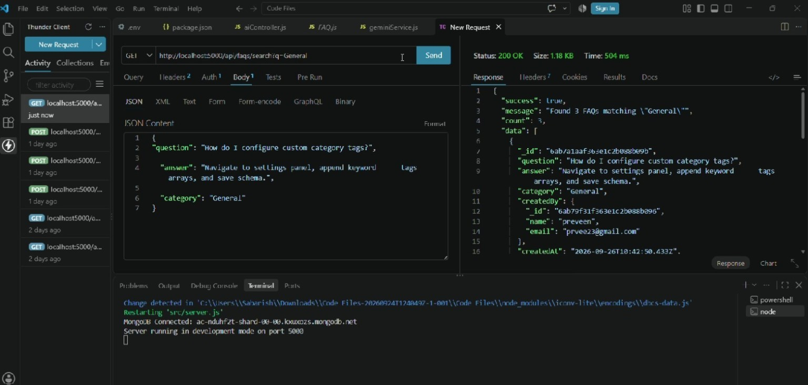
FAQ search test
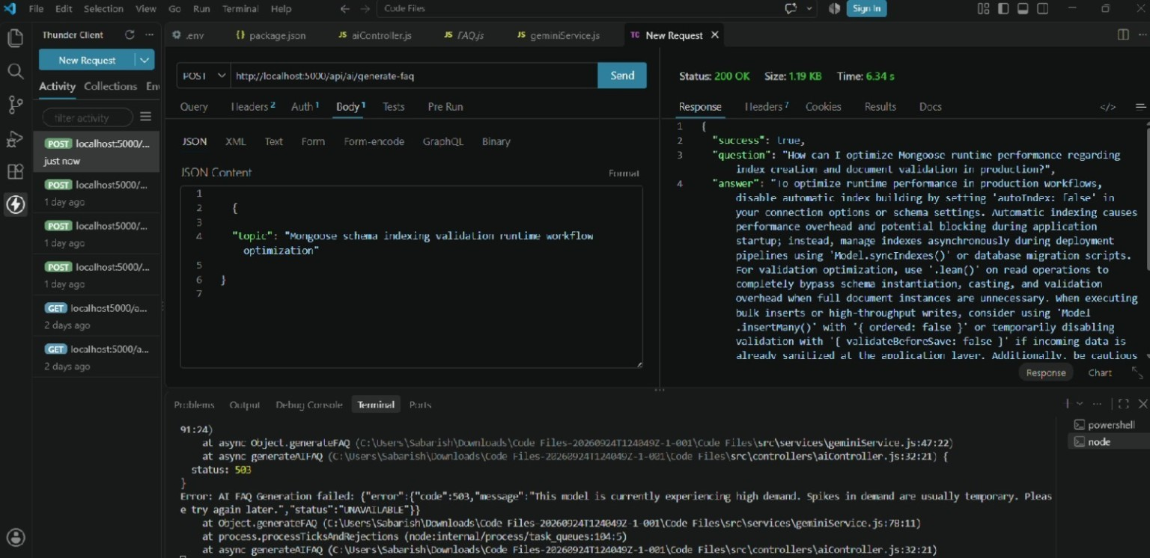
AI FAQ generation test / service-availability evidence
Note: The AI generation screenshot records the observed temporary high-demand/service-unavailable response. It is kept as testing evidence.

