PHASE 8 — PROJECT DEMONSTRATION

INTRODUCTION :
Team ID : SWTID-2026-8402
Team Leader : Pugalenthi M
MAIL ID: pugalenthi4831@gmail.com
Team members :
NAME | MAIL ID
Raja M | Raja2208devi@Gmail.Com
Samselvakumar M | Samoffi07@Gmail.Com
Sanjay K | Sanjayk200678@Gmail.Com

8.1 Purpose of the Demonstration
The final demonstration shows the AnswerBot project working from server execution through API requests and responses. The demonstration should use screen sharing and the student's voice-over to explain the project name, purpose, benefits, execution process and final output.
8.2 Demo Video Flow
- Project Name — AnswerBot: AI-powered FAQ and customer support automation.
- Purpose — automate FAQ creation, management, search and AI-assisted support content.
- Technology — Node.js, Express.js, MongoDB/Mongoose, JWT, bcrypt and Google Gemini AI.
- Execution — start the backend and show the API environment running.
- Registration & Login — demonstrate authentication and token generation.
- FAQ Workflow — create an FAQ, show the response and search for the FAQ.
- AI Workflow — demonstrate the AI FAQ generation endpoint and explain the result.
- Final Output — summarize the working APIs, security, database, search and AI capabilities.
8.3 Demonstration Procedure
Step | Action | What to Explain
1 | Start the backend server. | Show that the API is running on the development environment.
2 | Register a user. | Explain that registration creates a user account.
3 | Log in. | Explain successful authentication and token generation.
4 | Create an FAQ. | Explain the question, answer and category fields.
5 | Search FAQs. | Explain how the search endpoint returns matching FAQ records.
6 | Generate an FAQ using AI. | Explain the topic/logic input and generated question/answer output.
7 | Show final responses. | Explain what the JSON response demonstrates.
8.4 Actual API Demonstration Screenshots
Only the project screenshots supplied with the AnswerBot materials are included below. Each screenshot is placed under the corresponding demonstration step; no unrelated architecture or design images are included in Phase 8.
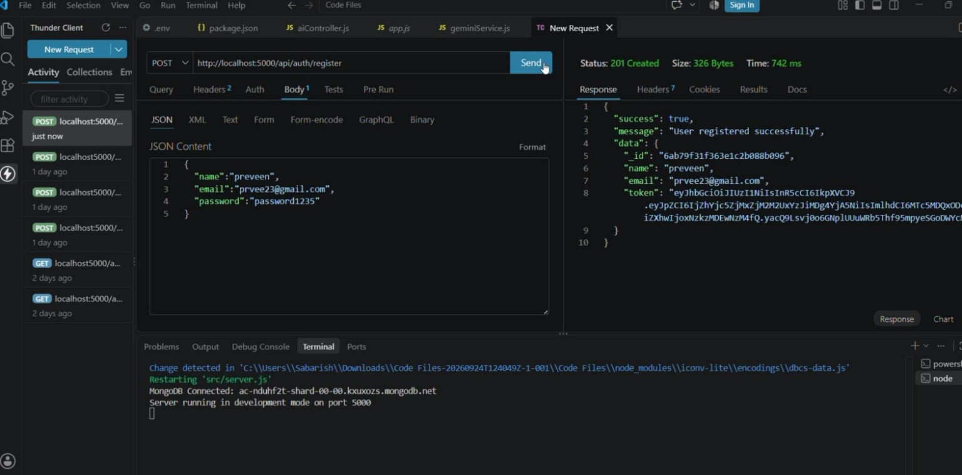
Figure 8.1 — User Registration API: POST /api/auth/register
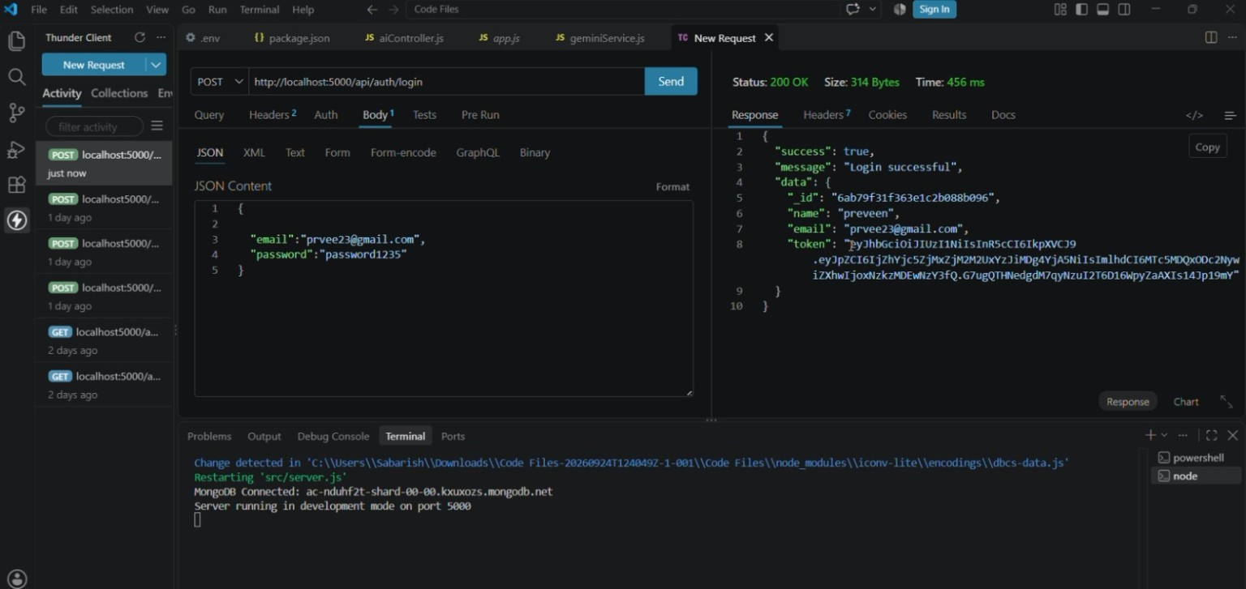
Figure 8.2 — User Login API: POST /api/auth/login
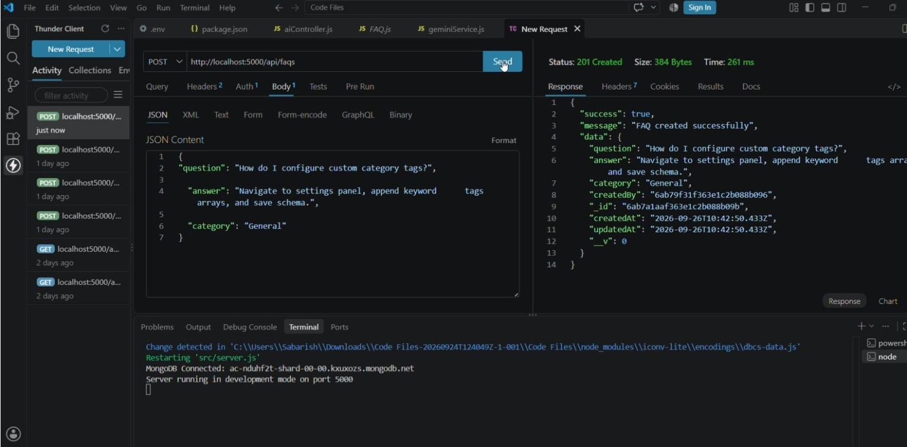
Figure 8.3 — FAQ Creation API: POST /api/faqs
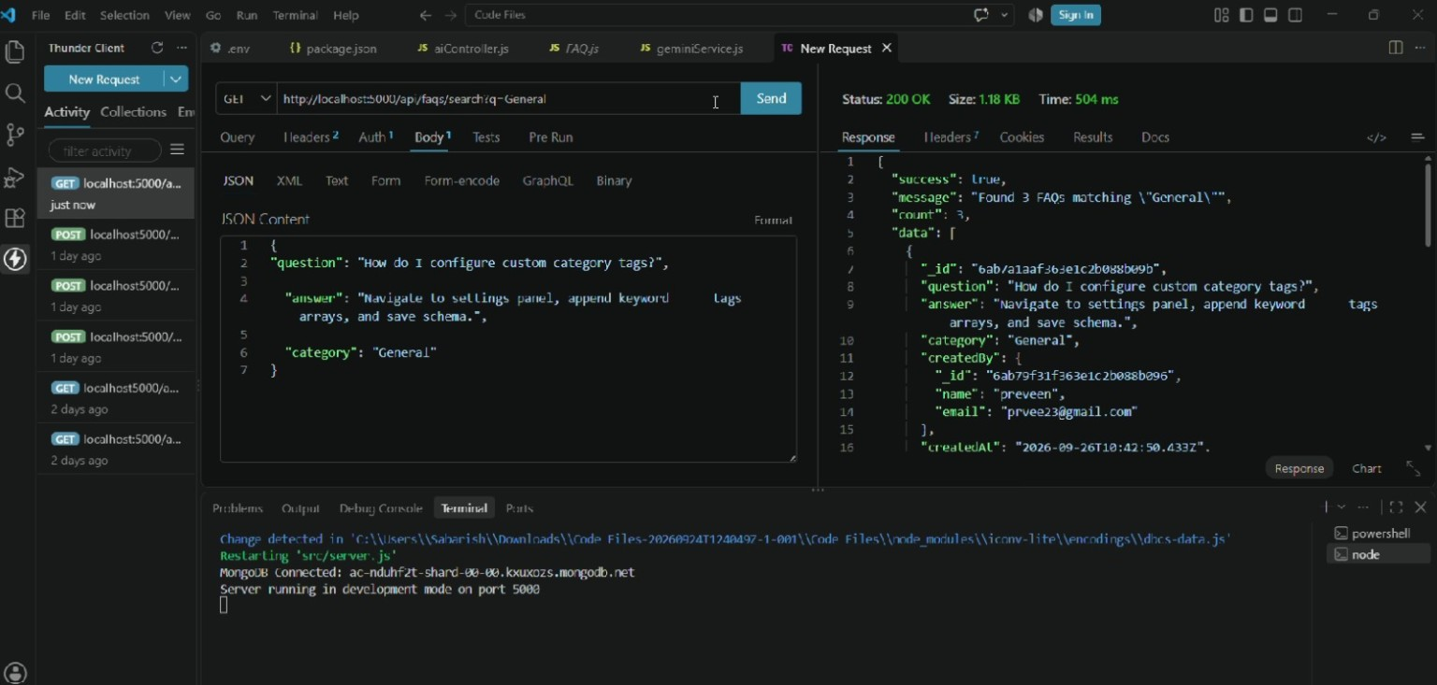
Figure 8.4 — FAQ Search API: GET /api/faqs/search?q=General
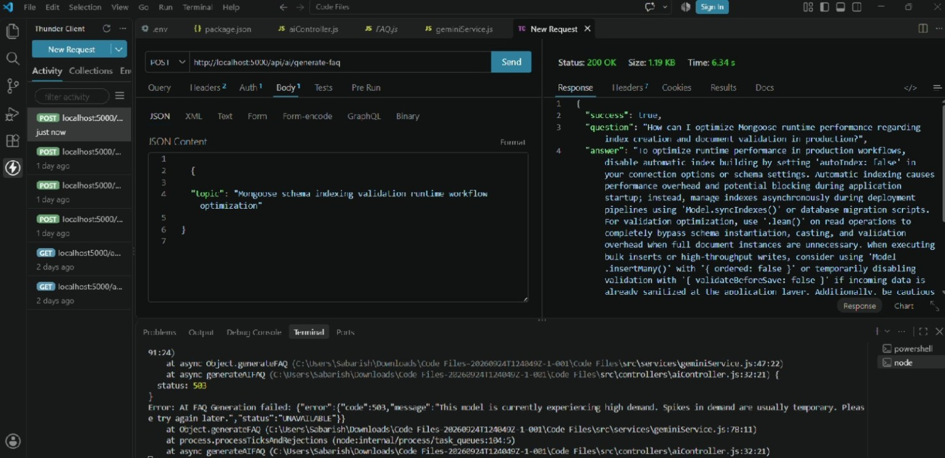
Figure 8.5 — AI FAQ Generation API: POST /api/ai/generate-faq
8.5 What the Screenshots Demonstrate
Screenshot | Demonstrated Feature | Evidence
Figure 8.1 | Registration | Successful registration response is shown in Thunder Client.
Figure 8.2 | Login | Successful login response and returned token are shown.
Figure 8.3 | FAQ Creation | FAQ question, answer and category are submitted and a created response is returned.
Figure 8.4 | FAQ Search | A search request returns matching FAQ records.
Figure 8.5 | AI FAQ Generation | The AI FAQ endpoint is executed and the response/console evidence is shown.
8.6 Suggested Voice-Over
“Good morning/afternoon. Our project is AnswerBot, an AI-powered FAQ and customer support automation system. The purpose of this project is to automate FAQ creation, management and search and to provide AI-assisted FAQ generation. The backend uses Node.js and Express.js, MongoDB/Mongoose for data storage, JWT and bcrypt for authentication and security, and Google Gemini AI for AI-assisted content generation. First, I will demonstrate registration and login. Next, I will create and search an FAQ. Finally, I will demonstrate the AI FAQ generation API and show the final response.”
8.7 Final Output to Explain
- User registration response.
- User login response and authentication token.
- FAQ creation response.
- FAQ search results.
- AI FAQ generation response.
- Overall working flow from authentication to FAQ and AI operations.
8.8 Demo Video Requirements
- Record the complete demonstration with screen sharing.
- Use the student's voice-over to explain the working process.
- Clearly state the project name and purpose.
- Explain the use/benefits of the project.
- Show the actual project execution and API responses.
- Show the final output.
- Upload the demo video to Google Drive and set sharing to Anyone with the link / Viewer before submission.
8.9 Submission Links
The project documentation requires a public Google Drive link for the API-testing/demo video. Insert the final public links below after confirming the Drive sharing setting.
Submission Item | Final Link
API Testing / Demo Video | ____________________________________________
Project Demonstration Video | ____________________________________________
8.10 Final Submission Checklist
- Public GitHub repository with eight phase-wise folders.
- Complete project source code and supporting files.
- Testing evidence and screenshots.
- Final project documentation/report.
- Google Drive demo video set to Anyone with the link / Viewer.
- Project name, purpose, benefits, working process and final output explained in the video.
8.11 Final Project Flow
Idea → Requirements → Design → Planning → Development → Testing → Documentation → Demonstration
8.12 Conclusion
Phase 8 provides the final demonstration evidence for AnswerBot. The screenshots document the actual API workflow from registration and login through FAQ creation, FAQ search and AI FAQ generation. The final video should combine these working steps with a clear voice-over and final output.

