**Mandatory Handson_PLSQL**

**Exercise 1: Control Structures**

**Scenario 1:** The bank wants to apply a discount to loan interest rates for customers above 60 years old.

* + **Question:** Write a PL/SQL block that loops through all customers, checks their age, and if they are above 60, apply a 1% discount to their current loan interest rates.

**Code:**  
BEGIN

  FOR cust IN (SELECT CustomerID FROM Customers WHERE MONTHS_BETWEEN(SYSDATE, DOB)/12 > 60) LOOP

    UPDATE Loans

    SET InterestRate = InterestRate - 1

    WHERE CustomerID = cust.CustomerID;

  END LOOP;

END;

/

**Output**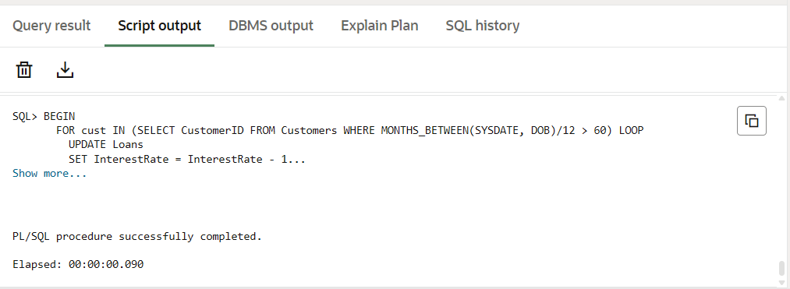

**Scenario 2:** A customer can be promoted to VIP status based on their balance.

* + **Question:** Write a PL/SQL block that iterates through all customers and sets a flag IsVIP to TRUE for those with a balance over $10,000.

**Code:**  
ALTER TABLE Customers ADD IsVIP VARCHAR2(5);

BEGIN

    FOR cust_rec IN (SELECT CustomerID, Balance FROM Customers) LOOP

        IF cust_rec.Balance > 10000 THEN

            UPDATE Customers

            SET IsVIP = 'TRUE'

            WHERE CustomerID = cust_rec.CustomerID;

        ELSE

            UPDATE Customers

            SET IsVIP = 'FALSE'

            WHERE CustomerID = cust_rec.CustomerID;

        END IF;

    END LOOP;

    COMMIT;

END;

/

**Output:**  
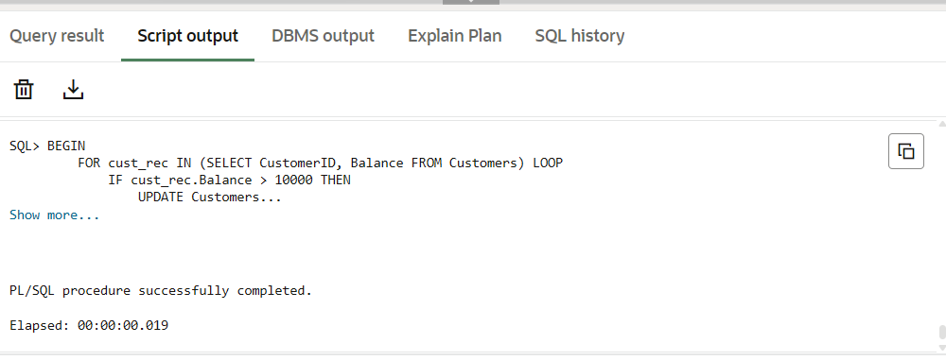

**Scenario 3:** The bank wants to send reminders to customers whose loans are due within the next 30 days.

* + **Question:** Write a PL/SQL block that fetches all loans due in the next 30 days and prints a reminder message for each customer.

**Code:**

DECLARE

CURSOR loan_due_cursor IS

SELECT L.LoanID, L.CustomerID, L.EndDate, C.Name

FROM Loans L

JOIN Customers C ON L.CustomerID = C.CustomerID

WHERE L.EndDate BETWEEN SYSDATE AND SYSDATE + 30;

BEGIN

FOR loan_rec IN loan_due_cursor LOOP

DBMS_OUTPUT.PUT_LINE('Reminder: Loan ID ' || loan_rec.LoanID ||

' for customer ' || loan_rec.Name ||

' is due on ' || TO_CHAR(loan_rec.EndDate, 'DD-MON-YYYY'));

END LOOP;

END;

/

**Output:**

Reminder: Loan ID 1 for customer John Doe is due on 25-JUL-2025

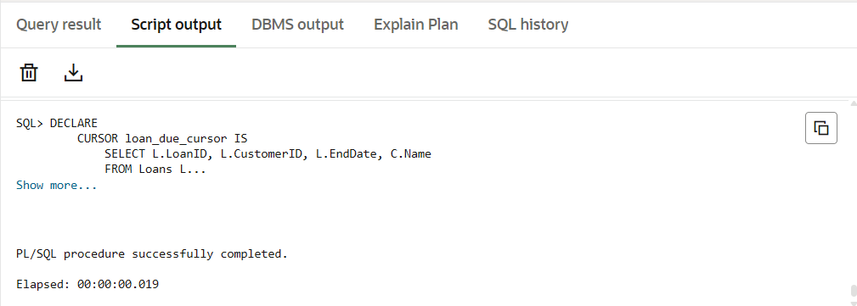

**Exercise 3: Stored Procedures**

**Scenario 1:** The bank needs to process monthly interest for all savings accounts.

* + **Question:** Write a stored procedure **ProcessMonthlyInterest** that calculates and updates the balance of all savings accounts by applying an interest rate of 1% to the current balance.

.

Code:  
CREATE OR REPLACE PROCEDURE ProcessMonthlyInterest IS

BEGIN

    UPDATE Accounts

    SET Balance = Balance + (Balance * 0.01)

    WHERE AccountType = 'Savings';

    COMMIT;

END;

/

**Output:**  
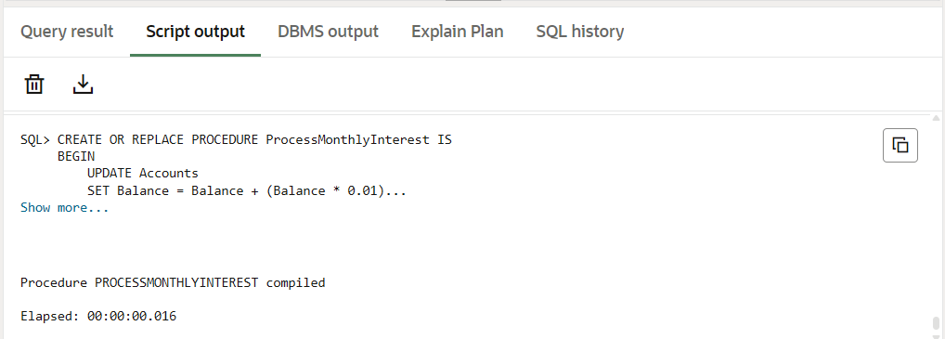

**Scenario 2:** The bank wants to implement a bonus scheme for employees based on their performance.

* + **Question:** Write a stored procedure **UpdateEmployeeBonus** that updates the salary of employees in a given department by adding a bonus percentage passed as a parameter.

**Code:**

CREATE OR REPLACE PROCEDURE UpdateEmployeeBonus(

    p_department     IN VARCHAR2,

    p_bonus_percent  IN NUMBER

) IS

BEGIN

    UPDATE Employees

    SET Salary = Salary + (Salary * p_bonus_percent / 100)

    WHERE Department = p_department;

    COMMIT;

END;

/

**Output:**  
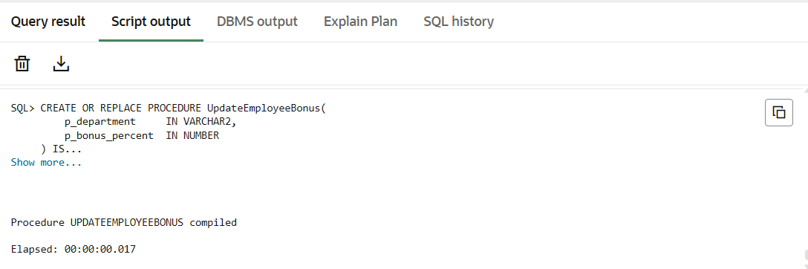

**Example Output:**

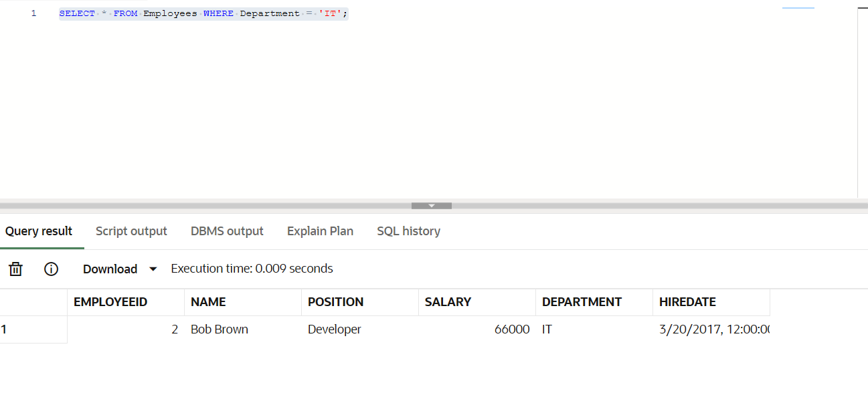

**Scenario 3:** Customers should be able to transfer funds between their accounts.

* + **Question:** Write a stored procedure **TransferFunds** that transfers a specified amount from one account to another, checking that the source account has sufficient balance before making the transfer.

**Code:**

CREATE OR REPLACE PROCEDURE TransferFunds(

    p_from_account_id IN NUMBER,

    p_to_account_id   IN NUMBER,

    p_amount          IN NUMBER

) AS

    v_balance NUMBER;

BEGIN

    SELECT Balance INTO v_balance

    FROM Accounts

    WHERE AccountID = p_from_account_id

    FOR UPDATE;

    IF v_balance < p_amount THEN

        RAISE_APPLICATION_ERROR(-20001, 'Insufficient balance in source account');

    END IF;

    UPDATE Accounts

    SET Balance = Balance - p_amount

    WHERE AccountID = p_from_account_id;

    UPDATE Accounts

    SET Balance = Balance + p_amount

    WHERE AccountID = p_to_account_id;

    COMMIT;

EXCEPTION

    WHEN NO_DATA_FOUND THEN

        DBMS_OUTPUT.PUT_LINE('One of the accounts does not exist');

        ROLLBACK;

    WHEN OTHERS THEN

        DBMS_OUTPUT.PUT_LINE('Unexpected error: ' || SQLERRM);

        ROLLBACK;

END;

/

**Output:**