Practical No:1

Aim: Design a simple linear neural network model

WRITE-UP – A) Design a simple linear neural network model
Aim: To design a simple linear neural network model and understand how input data is processed to produce an output.
Theory: A neural network consists of interconnected processing units. The model receives input sequences, processes them through a neural layer and produces an output using an activation function.
Result: The simple neural network model is designed and trained successfully.

Source Code:
import tensorflow as tf
from tensorflow.keras.models import Sequential
from tensorflow.keras.layers import SimpleRNN,Dense, Input #
Import Input layer
import numpy as np # Import numpy
text="This is GeeksforGeeks a software training institute" chars=sorted(list(set(text)))
char_to_index={char:i for i, char in enumerate(chars)} # Fixed variable name
index_to_chars={i:char for i, char in enumerate(chars)} # Fixed variable name
seq_length =3
sequences=[] # Fixed typo 'sequqnces' labels=[]
for i in range(len(text)-seq_length): seq=text[i:i+seq_length] # Fixed typo 'tex' label=text[i+seq_length] # Corrected assignment for label sequences.append([char_to_index[char] for char in seq]) labels.append(char_to_index[text[i+seq_length]]) x=np.array(sequences)
y=np.array(labels)
X_one_hot=tf.one_hot(x,len(chars)) # Fixed variable name Y_one_hot=tf.one_hot(y,len(chars)) # Fixed variable name model = Sequential()
# Add an Input layer explicitly to resolve the UserWarning model.add(Input(shape=(seq_length, len(chars)))) model.add(SimpleRNN(50, activation ='relu')) # Removed

input_shape as it's now handled by Input layer model.add(Dense(len(chars), activation='softmax')) model.compile(optimizer='adam',loss
='categorical_crossentropy',metrics=['accuracy'])
model.fit(X_one_hot,Y_one_hot,epochs=100)

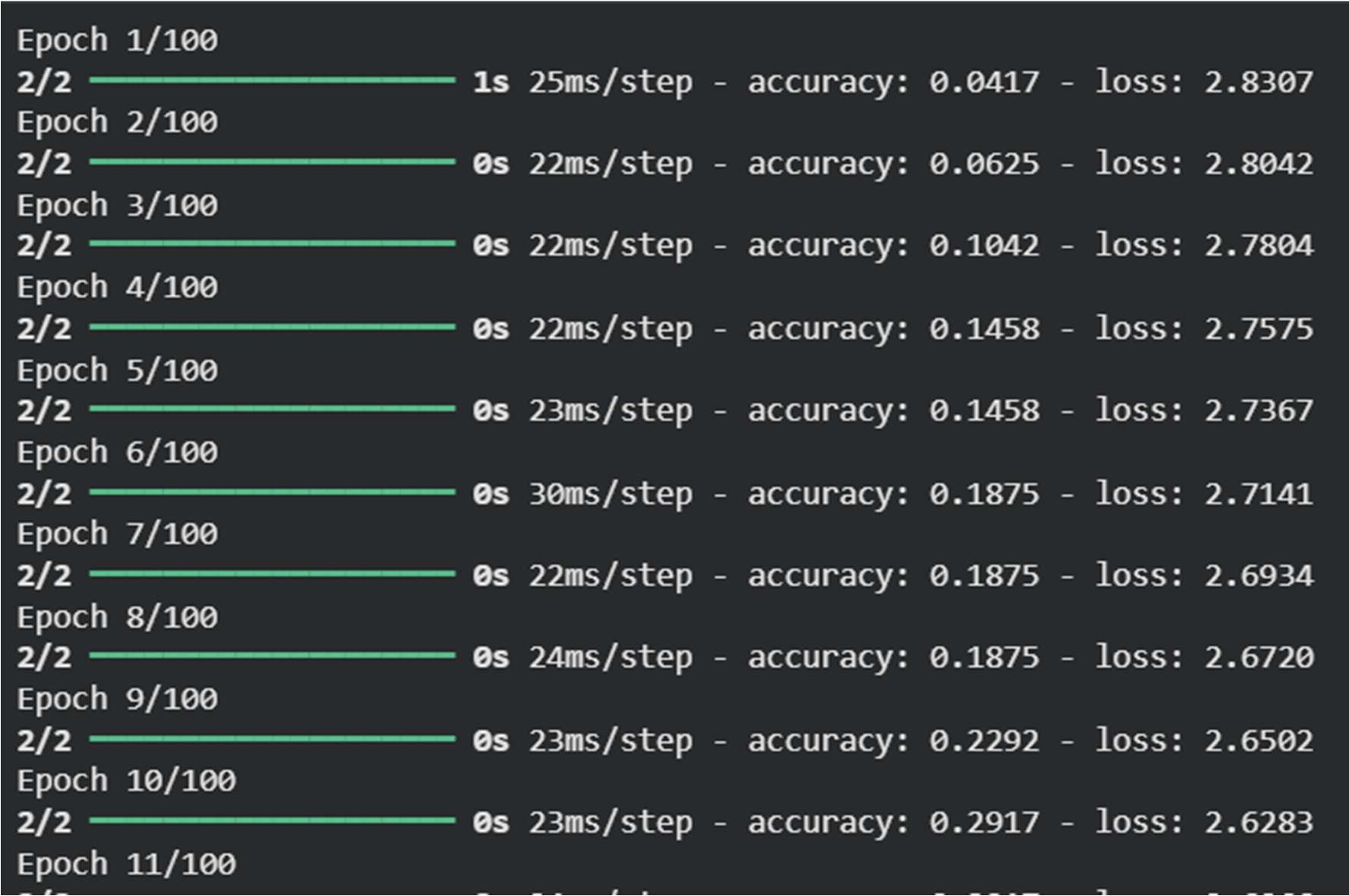
OUTPUT:

B) Calculate the output of neural network using both binary G bipolar sigmoidal function
WRITE-UP – B) Binary and bipolar sigmoidal function
Aim: To calculate the output of a neural network using binary and bipolar sigmoid functions.
Theory: Sigmoid functions convert the net input of a neuron into an output value. Binary sigmoid gives values in the positive range, while bipolar sigmoid represents output around positive and negative values. Result: The neural network output is calculated using the specified sigmoid functions.

CODE:

start_seq="This is G" generated_text=start_seq for i in range(50):
x=np.array([[char_to_index[char]for char in generated_text[-seq_length:]]]) X_one_hot=tf.one_hot(x,len(chars))
prediction=model.predict(X_one_hot) next_index=np.argmax(prediction)

next_char=index_to_chars[next_index] generated_text+=next_char print("Generated Text:") print(generated_text

OUTPUT:
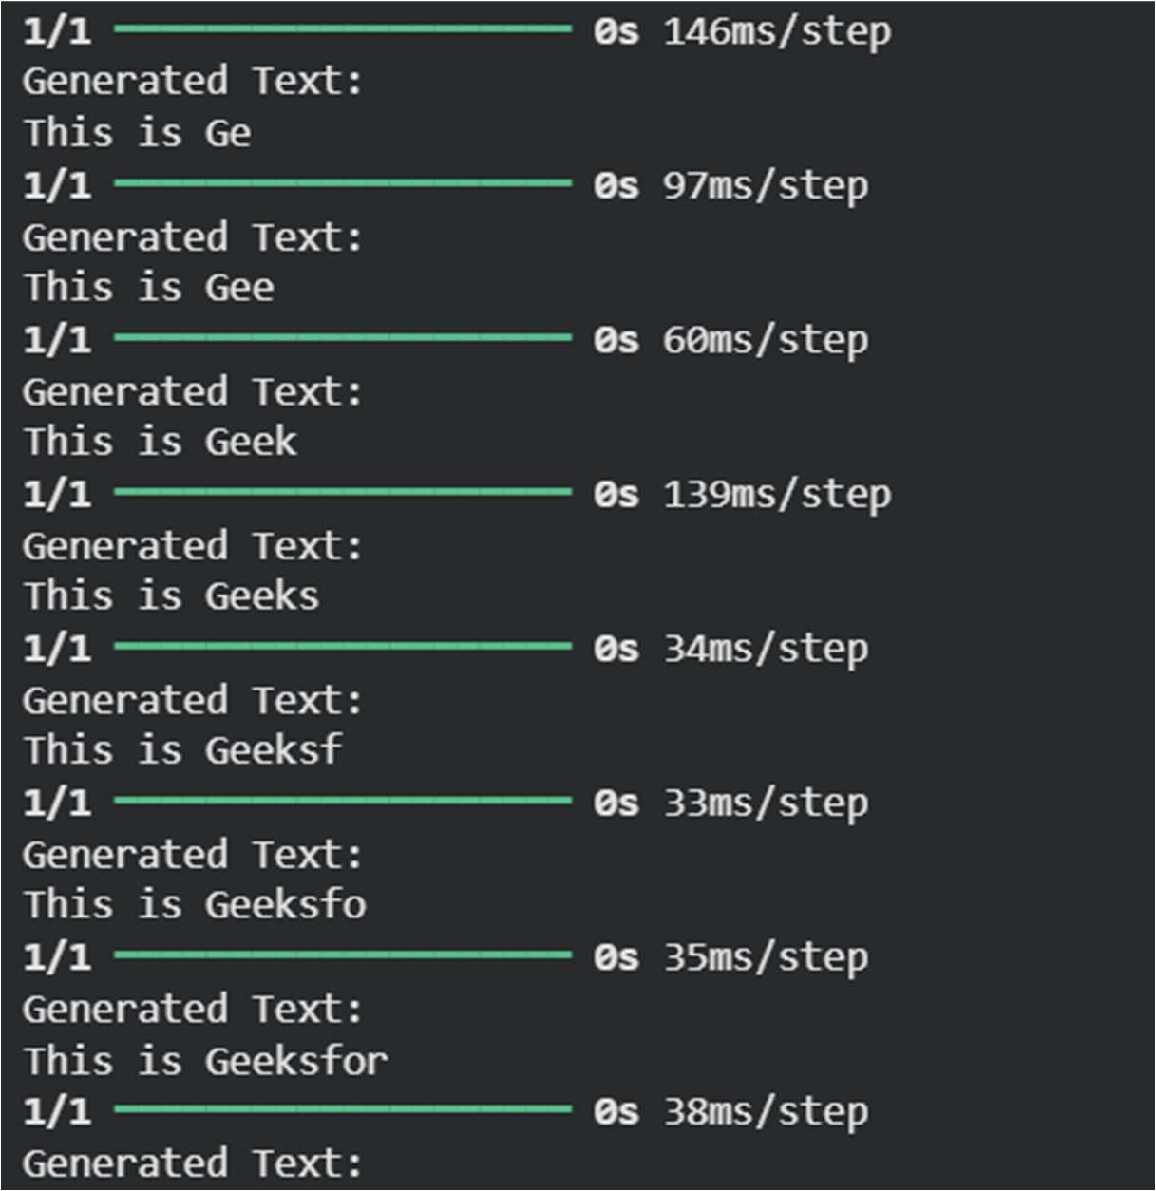

PRACTICAL: 2
WRITE-UP – A) AND/OR using McCulloch-Pitts neuron
Aim: To implement the AND/OR logical function using a McCulloch-Pitts neuron.
Theory: The McCulloch-Pitts neuron is a threshold-based neuron. It calculates a weighted sum of binary inputs and produces an output when the threshold condition is satisfied.
Result: The required logical output is generated for the given binary inputs.
- Implement AND/OR Function using McCulloch-pitts neuron (Use binary data and in presentation)

CODE:
num_ip=int(input("Enter the number of inputs: ")) #Step 2:Weights
w1=1 w2=2
print(f"For the{num_ip}inputs,calculate the net input using Yin=x1*w1+x2*w2")
#Step 3:Collect inputs x1=[]
x2=[]
for j inrange(num_ip):
ele1 =int(input(f"x1[{j+1}]="))
ele2 =int(input(f"x2[{j+1}]=")) x1.append(ele1) x2.append(ele2) print("x1=",x1)
print("x2=",x2)
#Step 4: Weighted inputs(elementwise multiplication) n=[val * w1 forvalin x1] m=[val*w2 forvalin x2]
#Step 5: Net input calculation(excitatory weights) Yin=[n[i]+m[i]foriinrange(num_ip)] print("Yin(excitatory)=", Yin)
#Step 6: Net input calculation(one excitatory, one inhibitory) Yin_inhib=[n[i]-m[i]
for print("Yin(one inhibitory)="
#Step 7: Activation function(threshold at 1) Y=[] foriinrange(num_ip):
If Yin_inhib[i]>=1: Y.append(1) else: Y.append(0)
print("Final Output Y="

OUTPUT:

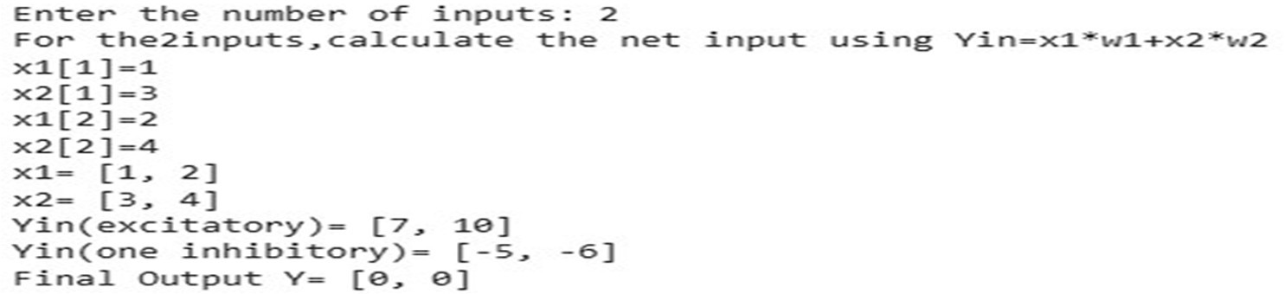

WRITE-UP – B) XOR using McCulloch-Pitts neural network
Aim: To generate the XOR function using a McCulloch-Pitts neural network.
Theory: XOR is not linearly separable, so a network with hidden neurons is used to combine the required logical conditions and generate the final output.
Result: The network generates the XOR output for the given input combinations.

Generate XOR function using McCulloch-pitts neuron network. CODE:
import numpy as np print("Enter the Weight") w11=int(input("Weight w11=")) w12=int(input("Weight w12=")) w21=int(input("Weight w21=")) w22=int(input("Weight w22= ")) v1=int(input("Weight v1=")) v2=int(input("Weight v2="))
print("Enter the threshold value") theta=int(input("theta="))
#XOR trurh table inputs and outputs x1=np.array([0,0,1,1])
x2=np.array([0,1,0,1])
z=np.array([0,1,1,0]) con=1 y1=np.zeros((4,))
y2=np.zeros((4,))
y=np.zeros((4,)) while con==1:
#Hidden layer weighted sums zin1=x1*w11+x2*w21
zin2=x1*w12+x2*w22 #Fixed:use w12 here instead of w21 print("z1=",zin1)
print("z2=",zin2)
#Apply threshold to hidden layer neurons for i in range(4):
y1[i]=1 if zin1 [i]>=theta else 0

y2[i]=1 if zin2[i]>=theta else 0 #output neuron calculation yin =y1*v1+y2*v2
for i in range(4):
y[i]=1 if yin[i]>=theta else 0 print("yin=",yin) print("Output of Net") y=y.astype(int)
print("y=",y)
print("z=",z)
#Check if output matches XOR if np.array_equal(y,z):
con=0 else:
print("Net is not learning, enter another set of weights and threshold value")
w11=int(input("Weight w11=")) w12=int(input("Weight w12=")) w21=int(input("Weight w21= ")) w22=int(input("Weight w22= ")) v1=int(input("Weight v1=")) v2=int(input("Weight v2=")) theta=int(input("theta="))
print("McCulloch-Pits Net for XOR function") print("Weights of Neuron Z1:w11=",w11,"w21=",w21) print("Weights of Neuron Z2:w12=",w12,"w22=",w22) print("Weights of Neuron Y:v1=",v1,"v2=",v2) print("Threshold value:",theta)

OUTPUT:
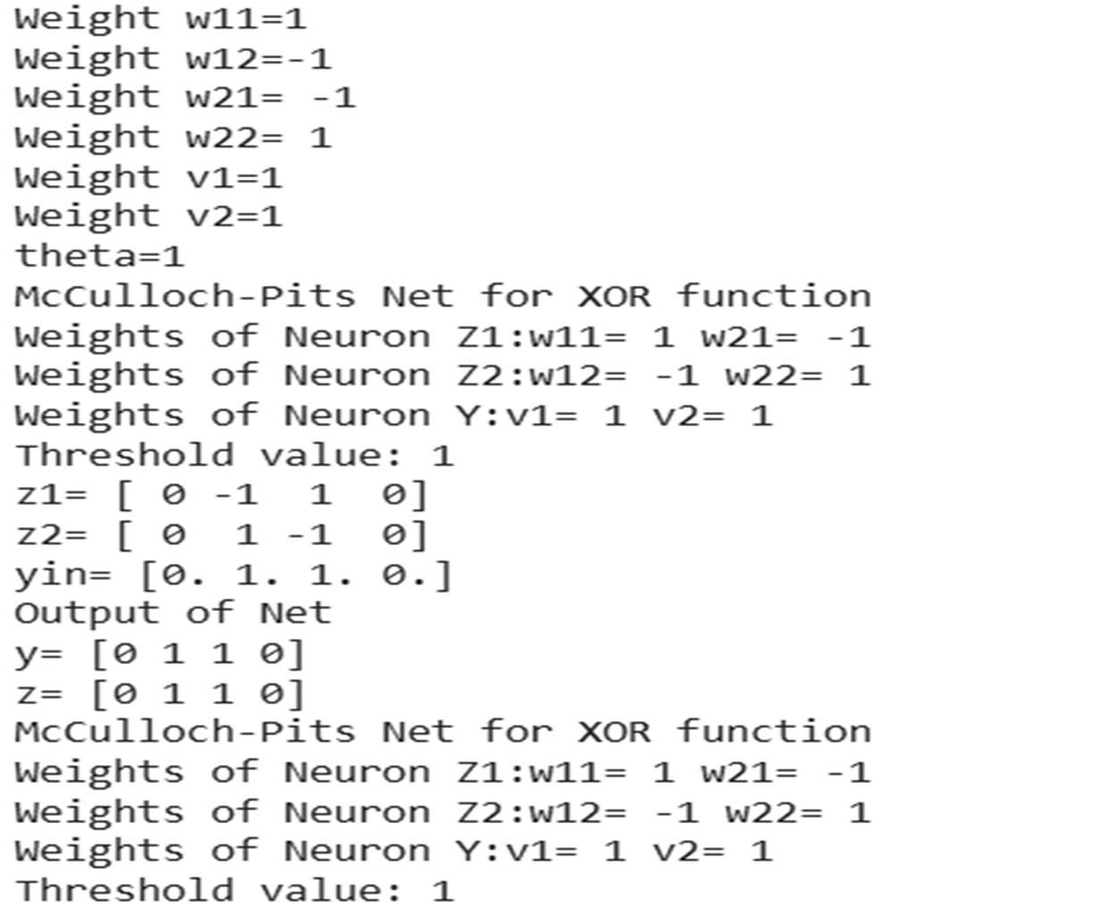

PRACTICAL: 3
WRITE-UP – A) Hebb's Rule
Aim: To implement Hebb's learning rule.
Theory: Hebbian learning updates connection weights according to the input and neuron response. Connections between simultaneously active neurons become stronger.
Result: New weight values are calculated using Hebb's learning rule.
A) Implement Hebb’s Rule

CODE:
x1= float(input("enter value for x1:")) x2= float(input("enter value for x2:")) w1= float(input("enter value for w1:")) w2= float(input("enter value for w2:")) yin= float(1+(x1*w1+x2*w2)) print("value of yin is:", yin)
y= float(1/1+(2.178*yin)) print("value of y is:",y) w3= float(y*x1)
w4= float(y*x2)
print("value of 1 new weigth is :",w3) print("value of 2 new weight is:", w4) ynew= float(1+(x1*w1+x2*w4)) print("new value of y is :",ynew) OUTPUT:
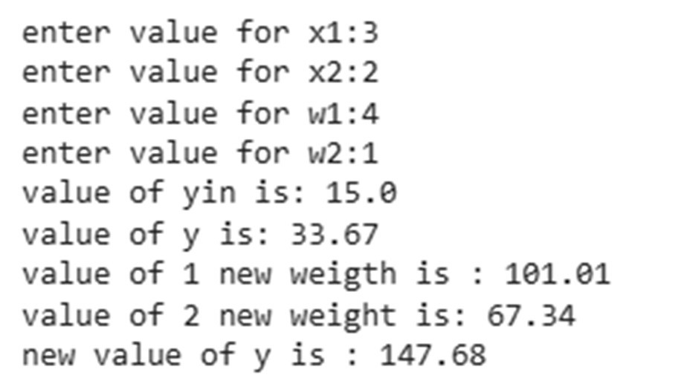

WRITE-UP – B) Delta Learning Rule
Aim: To implement the Delta learning rule.
Theory: The Delta rule is a supervised learning method in which weights are adjusted using the difference between desired and actual output.
Result: The learning calculation is performed for the supplied input values.

3b) Implement Delta Learning rule. CODE:
x1= float(input("enter value of x1:")) x2= float(input("enter value of x2:"))

e= float(input("enter value of e:")) eq= float(x1*x2)
print("value of y:", eq) if (eq>=1):
print("learning is supervised") else:
print("learning is unsupervised")

OUTPUT:
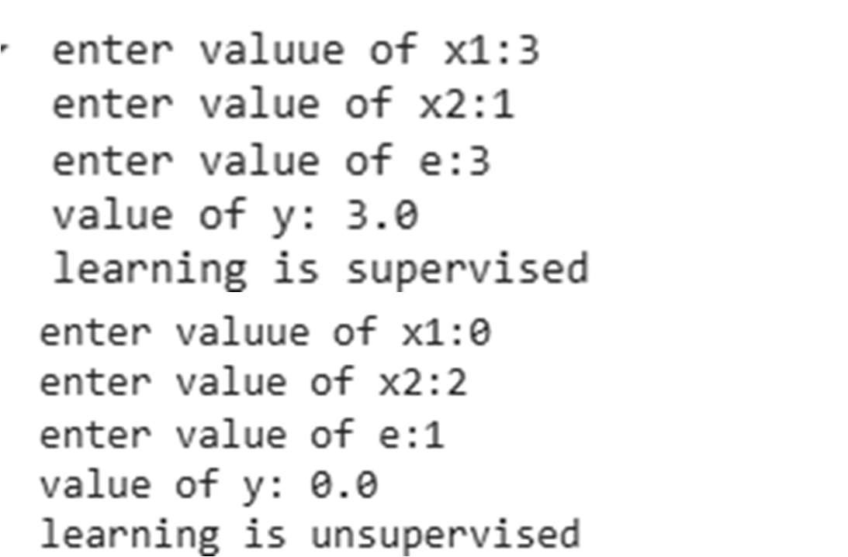

PRACTICAL: 4
WRITE-UP – A) Back Propagation Algorithm
Aim: To implement the backpropagation algorithm.
Theory: Backpropagation is a supervised learning technique. The network performs forward propagation, calculates output error and propagates the error backward to update weights.
Result: The network learns by repeatedly updating its parameters and produces a learned response.

Write a program for backpropagation algorithm Source Code
import numpy as np
import matplotlib.pyplot as plt
from matplotlib.colors import ListedColormap

maze = np.array([
[0, 1, 1, 1, 1, 1, 1, 1, 1, 1],
[0, 0, 0, 0, 1, 0, 0, 0, 0, 1],
[1, 1, 1, 0, 1, 0, 1, 1, 0, 1],
[1, 0, 0, 0, 0, 0, 1, 0, 0, 1],
[1, 0, 1, 1, 1, 1, 1, 0, 1, 1],
[1, 0, 1, 0, 0, 0, 0, 0, 1, 1],
[1, 0, 1, 0, 1, 1, 1, 0, 1, 1],
[1, 0, 1, 0, 1, 0, 0, 0, 1, 1],
[1, 0, 1, 0, 1, 0, 1, 0, 0, 1],
[1, 1, 1, 0, 1, 1, 1, 1, 0, 0]
])
start = (0, 0)
goal = (9, 9)
num_episodes = 5000
alpha = 0.1
gamma = 0.9
epsilon = 0.5
reward_fire = -10
reward_goal = 50
reward_step = -1
actions = [(0, -1), (0, 1), (-1, 0), (1, 0)]
Ǫ = np.zeros(maze.shape + (len(actions),)) def is_valid(pos):
r, c = pos
if r < 0 or r >= maze.shape[0]: return False

if c < 0 or c >= maze.shape[1]:
return False
if maze[r, c] == 1:
return False return True
def choose_action(state):
if np.random.random() < epsilon:
return np.random.randint(len(actions)) else:
return np.argmax(Ǫ[state])
# Train the Agent with Ǫ-Learning Algorithm rewards_all_episodes = []
for episode in range(num_episodes): state = start
total_rewards = 0 done = False while not done:
action_index = choose_action(state) action = actions[action_index]
next_state = (state[0] + action[0], state[1] + action[1]) if not is_valid(next_state):
reward = reward_fire done = True
elif next_state == goal: reward = reward_goal done = True
else:
reward = reward_step
old_value = Ǫ[state][action_index]
next_max = np.max(Ǫ[next_state]) if is_valid(next_state) else 0 Ǫ[state][action_index] = old_value + alpha * (reward + gamma
* next_max - old_value)
state = next_state total_rewards += reward
epsilon = max(0.01, epsilon * 0.995) rewards_all_episodes.append(total_rewards)

# Extract the Optimal Path after Training
def get_optimal_path(Ǫ, start, goal, actions, maze, max_steps=200):
path = [start] state = start visited = set()
for _ in range(max_steps): if state == goal:
break visited.add(state) best_action = None best_value = -float('inf')
for idx, move in enumerate(actions):
next_state = (state[0] + move[0], state[1] + move[1]) if (0 <= next_state[0] < maze.shape[0] and
0 <= next_state[1] < maze.shape[1] and maze[next_state] == 0 and
next_state not in visited):
if Ǫ[state][idx] > best_value: best_value = Ǫ[state][idx] best_action = idx
if best_action is None: break
move = actions[best_action]
state = (state[0] + move[0], state[1] + move[1]) path.append(state)
return path
optimal_path = get_optimal_path(Ǫ, start, goal, actions, maze) # Visualize the Maze, Robot Path, Start and Goal
def plot_maze_with_path(path):
cmap = ListedColormap(['#eef8ea', '#a8c79c']) plt.figure(figsize=(8, 8))
plt.imshow(maze, cmap=cmap)
plt.scatter(start[1], start[0], marker='o', color='#81c784', edgecolors='black',
s=200, label='Start (Robot)', zorder=5)

plt.scatter(goal[1], goal[0], marker='*', color='#388e3c', edgecolors='black',
s=300, label='Goal (Diamond)', zorder=5) rows, cols = zip(*path)
plt.plot(cols, rows, color='#60b37a', linewidth=4, label='Learned Path', zorder=4)
plt.title('Reinforcement Learning: Robot Maze Navigation') plt.gca().invert_yaxis()
plt.xticks(range(maze.shape[1])) plt.yticks(range(maze.shape[0])) plt.grid(True, alpha=0.2) plt.legend()
plt.tight_layout() plt.show()
plot_maze_with_path(optimal_path) # Plot Rewards per Training
def plot_rewards(rewards): plt.figure(figsize=(10, 5)) plt.plot(rewards)
plt.title('Total Rewards per Episode') plt.xlabel('Episode')
plt.ylabel('Total Reward') plt.grid(True)
plt.show() plot_rewards(rewards_all_episodes)

OUTPUT:

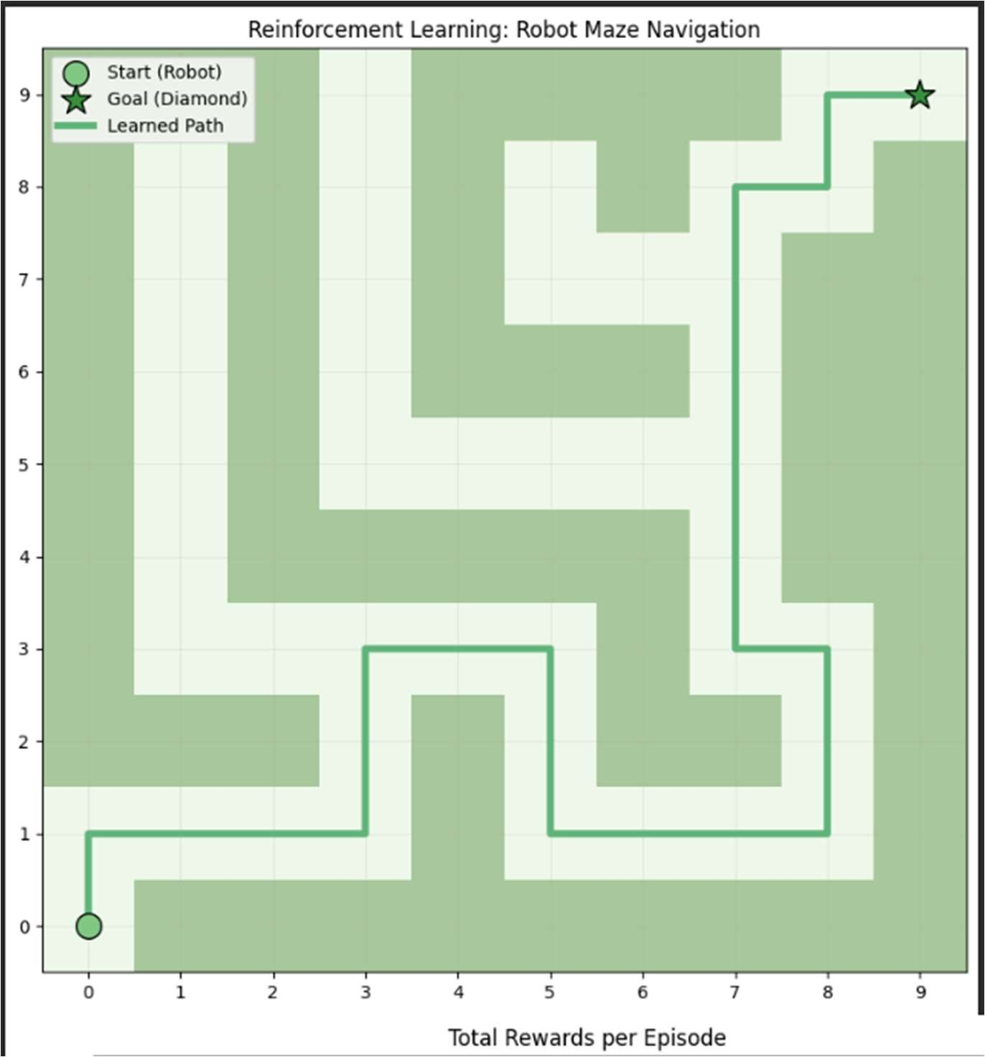
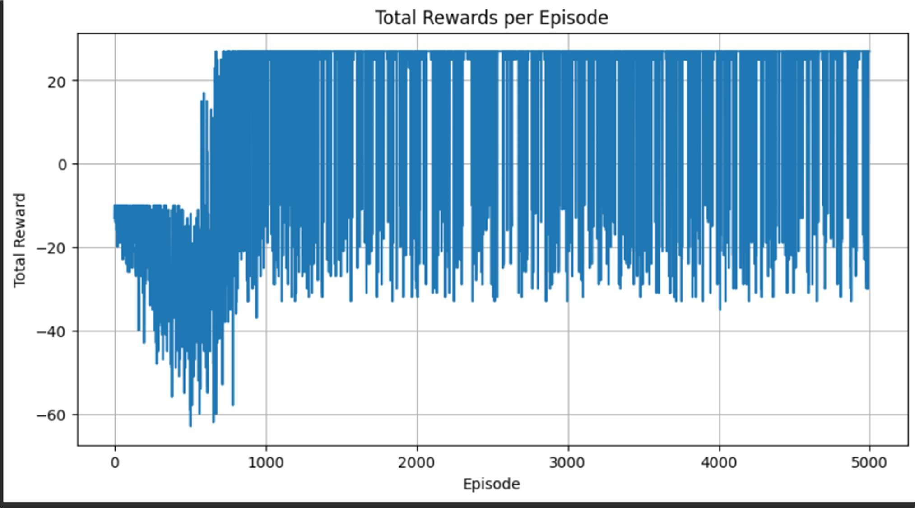

- Error Backpropagation Algorithm
WRITE-UP – B) Error Backpropagation
Aim: To implement the error backpropagation algorithm.
Theory: Error backpropagation minimizes the difference between target and predicted outputs by calculating the error and distributing it backward through the network for weight adjustment.
Result: The error is used to update the network weights during learning.

Source Code-import numpy as np
import matplotlib.pyplot as plt from sklearn import datasets
from sklearn.semi_supervised import LabelPropagation from sklearn.metrics import accuracy_score

iris = datasets.load_iris() X = iris.data[:, :2]
y = iris.target

labels = np.copy(y)
rng = np.random.RandomState(42) mask = rng.rand(len(y)) < 0.1 labels[~mask] = -1
print(f"Labeled: {np.sum(mask)}, Unlabeled: {np.sum(~mask)}")

model = LabelPropagation() model.fit(X, labels)
y_pred = model.transduction_
acc_labeled = accuracy_score(y[mask], y_pred[mask]) acc_overall = accuracy_score(y, y_pred)
print(f"Acc (on original labeled subset): {acc_labeled:.3f}") print(f"Acc (overall after propagation): {acc_overall:.3f}")
fig, ax = plt.subplots(1, 2, figsize=(12, 4)) ax[0].scatter(X[:, 0], X[:, 1], c='lightgray', s=30)
ax[0].scatter(X[mask, 0], X[mask, 1], c=y[mask], cmap='viridis', s=60) ax[0].set_title("Before propagation — few labels")

ax[1].scatter(X[:, 0], X[:, 1], c=y_pred, cmap='viridis', s=60) ax[1].set_title("After propagation — all labeled")

plt.tight_layout() plt.show()

OUTPUT:

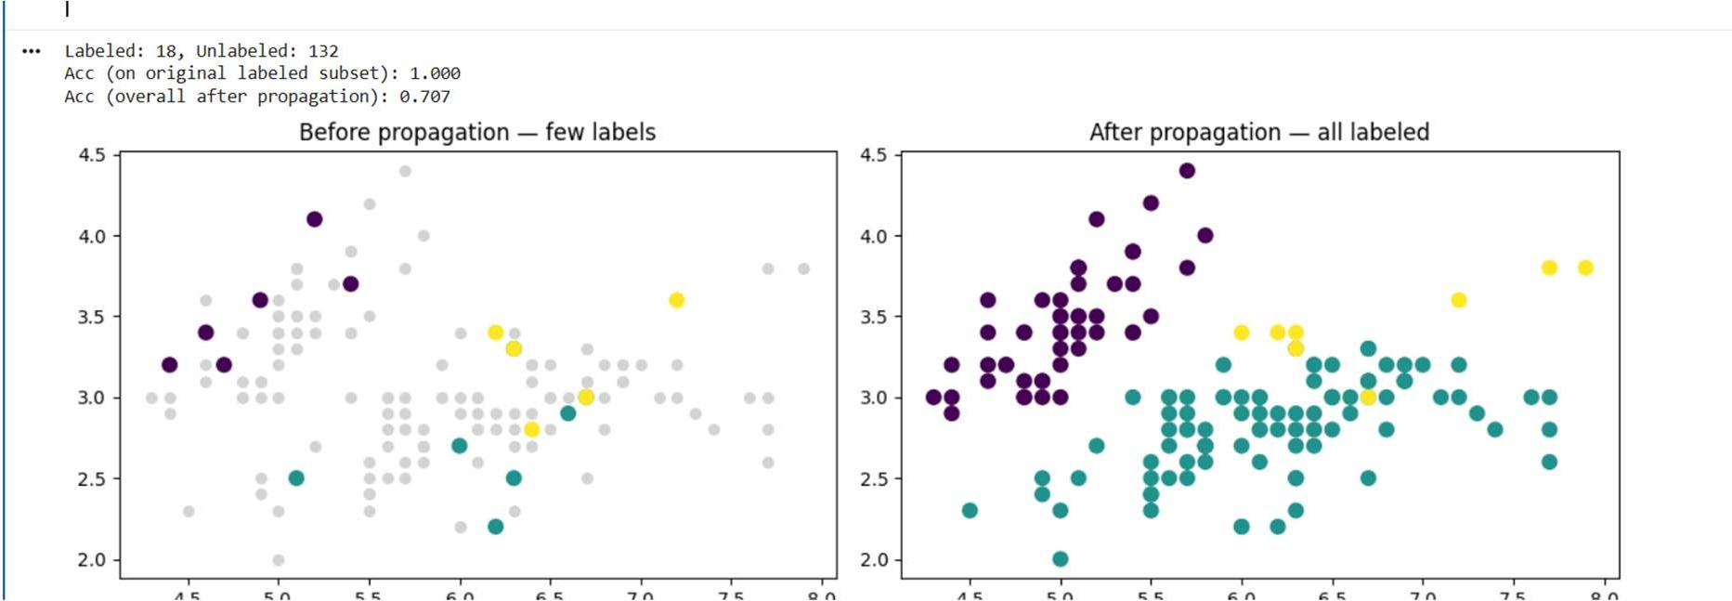

PRACTICAL: 5
- Hopfield Network
Aim: To implement a Hopfield network.
Theory: A Hopfield network is a recurrent neural network used for associative memory. Patterns are stored as stable states and the network can converge to a stored pattern from a related input.
Result: The Hopfield network stores and recalls patterns as associative memories.

SOURCE CODE:
import numpy as np

patterns = np.array([ [1, -1, 1, -1],
[-1, 1, -1, 1]
])

n = patterns.shape[1] weights = np.zeros((n, n))

for p in patterns:
weights += np.outer(p, p)

np.fill_diagonal(weights, 0) weights = weights / n

print("Weight Matrix:") print(weights)

input_pattern = np.array([1, -1, -1, -1]) output = input_pattern.copy()

for _ in range(10):
for i in range(n):
net = np.dot(weights[i], output) output[i] = 1 if net >= 0 else -1

print("Input Pattern:", input_pattern) print("Recalled Pattern:", output) OUTPUT:
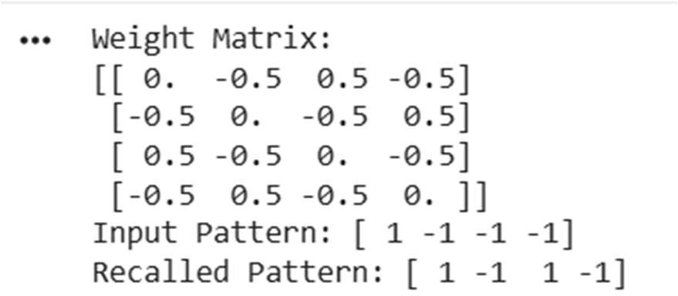

PRACTICAL: 7
WRITE-UP – A) Linear Separation
Aim: To implement linear separation.
Theory: Linear separation determines whether different classes of points can be divided by a straight decision boundary. Points on different sides of a suitable line belong to different classes.
Result: Candidate separating lines are plotted and the separation of the given points is demonstrated.

A) Linear separation
Source Code:
import numpy as np
import matplotlib.pyplot as plt
def create_distance_function(a, b, c): def distance(x, y):
nom = a * x + b * y + c if nom == 0:
pos = 0
elif (nom < 0 and b < 0) or (nom > 0 and b > 0): pos = -1
else:
pos = 1
return (np.absolute(nom) / np.sqrt(a**2 + b**2), pos) return distance
# Corrected coordinate tuple syntax points = [(3, 5), (1, 8), (1.1, 3.9)]
fig, ax = plt.subplots() ax.set_xlabel("sweetness") ax.set_ylabel("sourness") ax.set_xlim([-1, 6])
ax.set_ylim([-1, 8])
X = np.arange(-0.5, 5, 0.1)
size = 10
for index, (x, y) in enumerate(points): if index == 0:
ax.plot(x, y, "o", color="darkorange", markersize=size) else:
ax.plot(x, y, "oy", markersize=size) step = 0.05
for x_val in np.arange(0, 1 + step, step): slope = np.tan(np.arccos(x_val))

dist4line1 = create_distance_function(slope, -1, 0)
Y = slope * X results = []
for point in points: results.append(dist4line1(*point))
if results[0][1] != results[1][1]:
ax.plot(X, Y, "g-") else:
ax.plot(X, Y, "r-") plt.show()

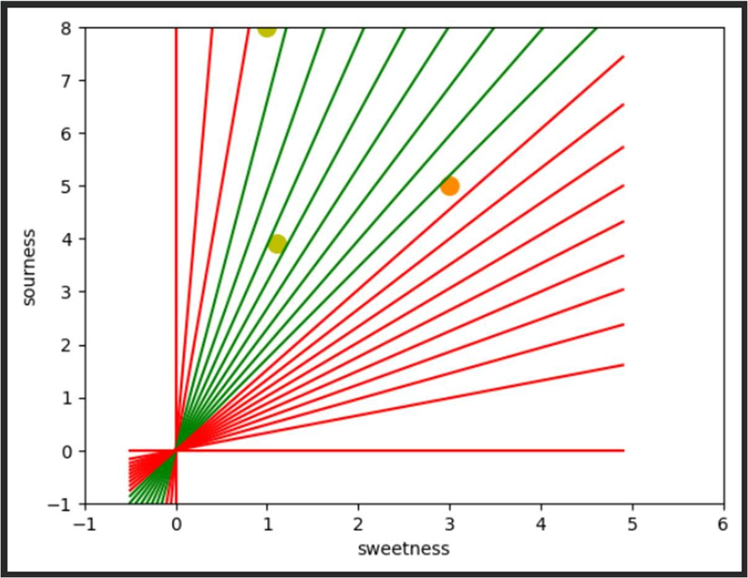
OUTPUT:
- Hopfield Network Model for Associative Memory
Aim: To implement a Hopfield network model for associative memory.
Theory: Associative memory stores patterns in the network and retrieves a related stored pattern when a noisy or incomplete version is presented.
Result: The required pattern is stored and can be recalled through associative memory.

PRACTICAL: 8
WRITE-UP – A) Membership Operators: in, not in
Aim: To implement membership operators 'in' and 'not in'.
Theory: Membership operators test whether an element exists in a collection. 'in' returns True when an element is present, while 'not in' returns True when it is absent.
Result: The program determines whether the specified lists contain matching elements.

  - Membership and identity operators in, not in

CODE:
def overlapping(list1,list2):
for i in range(0,len(list1)):
for j in range(0,len(list2)):
if list1[i]==list2[j]:
return True return False
n=int(input("Input number of elements for list1:")) m=int(input("Input number of elements for list2:")) list1=[]
list2=[]
for i in range(0,n):
l1=float(input("Enter List1 value"+str(i)+"=")) list1.append(l1)
for i in range(0,m):
l2=float(input("Enter List2 value"+str(i)+"=")) list2.append(l2)
if(overlapping(list1,list2)): print("List are Overlapping")

else:
print("List are not Overlapping")

OUTPUT:
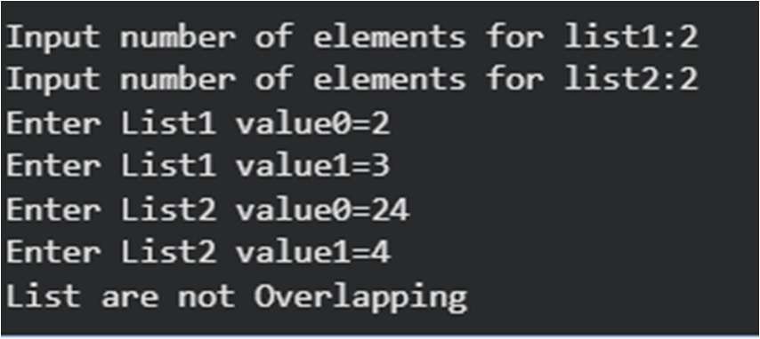

  - Identity Operators: is, is not
Aim: To implement identity operators 'is' and 'is not'.
Theory: Identity operators compare object identity. 'is' checks whether two references point to the same object, while 'is not' checks that they do not.
Result: The identity relationship between the given objects is determined.

PRACTICAL: G
WRITE-UP – A) Find Ratios using Fuzzy Logic
Aim: To find similarity ratios between strings using fuzzy matching techniques.
Theory: Fuzzy string matching calculates similarity between text values using different comparison measures such as complete, partial and token-based ratios.
Result: Similarity ratios and the best matching string are obtained for the given inputs.
    - Find ratios using Fuzzy logic

CODE:
from fuzzywuzzy import fuzz, process s1 = "I Love Fuzzys For Fuzzy"
s2 = "I Am Loving Fuzzys For Fuzzy"
print("FuzzyWuzzy Ratio:",fuzz.ratio(s1.lower(), s2.lower())) print("FuzzyWuzzy Partial Ratio",fuzz.partial_ratio(s1.lower(), s2.lower())) print("Fuzz Wuzzy TokenSort Ratio:",
fuzz.token_sort_ratio(s1.lower(), s2.lower())) print("FuzzWuzzy TokenSet Ratio: ", fuzz.token_set_ratio(s1.lower(), s2.lower()))
print("fuzzywuzzy WRatio:", fuzz.WRatio(s1.lower(), s2.lower())) query='Fuzzy For Fuzzy'
choices=['Fuzzy For Fuzzy', 'Fuzzy Fuzzy', 'g. For Fuzzy'] print("List Of Ratios:")
print(process.extract(query, choices),"\n")
print("Best Among The Above List:", process.extractOne(query, choices))

OUTPUT:

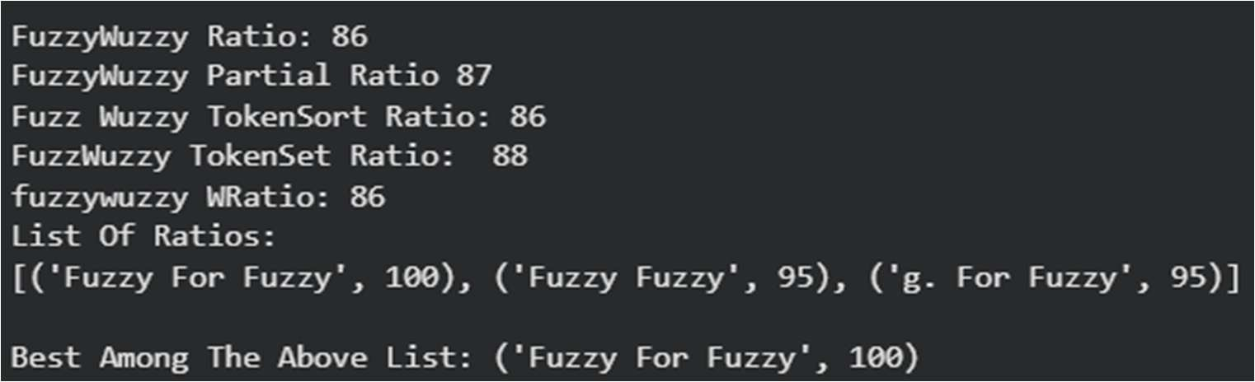

WRITE-UP – B) Tipping Problem using Fuzzy Logic
Aim: To solve the tipping problem using fuzzy logic.
Theory: Fuzzy logic represents food quality and service quality using membership functions. Fuzzy rules are then applied to determine an appropriate tip level.
Result: The fuzzy system produces a tip value based on the quality and service inputs.

Solve Tipping problem using fuzzy logic

Source Code:
!pip install scikit-fuzzy import numpy as np import skfuzzy as fuzz
from skfuzzy import control as ctrl
#New Antecedent/Consequent objects hold universe variables and membership
#functions
quality= ctrl. Antecedent(np.arange(0, 11, 1), 'quality') service = ctrl. Antecedent(np.arange(0, 11, 1), 'service') tip = ctrl.Consequent(np.arange(0, 26, 1), 'tip')
#Auto-membership function population is possible with automf(3, 5, or 7)
quality.automf(3) service.automf(3)
#custom membership functions can be built interactively with a familiar,
#Pythonic API
tip['low'] = fuzz.trimf(tip.universe, [0, 0, 13]) tip['medium'] = fuzz.trimf(tip.universe, [0,13,25]) tip['high'] = fuzz.trimf(tip.universe, [13, 25, 25]) """

To help understand what the membership looks like, use the ''view'' methods.
"""
#you can see how these look with view() quality['average'].view()
"""
..image:: PLOT2RST.current_figure """
service.view() """
..image:: PLOT2RST.current_figure """
tip.view() """
..image:: PLOT2RST.current_figure """

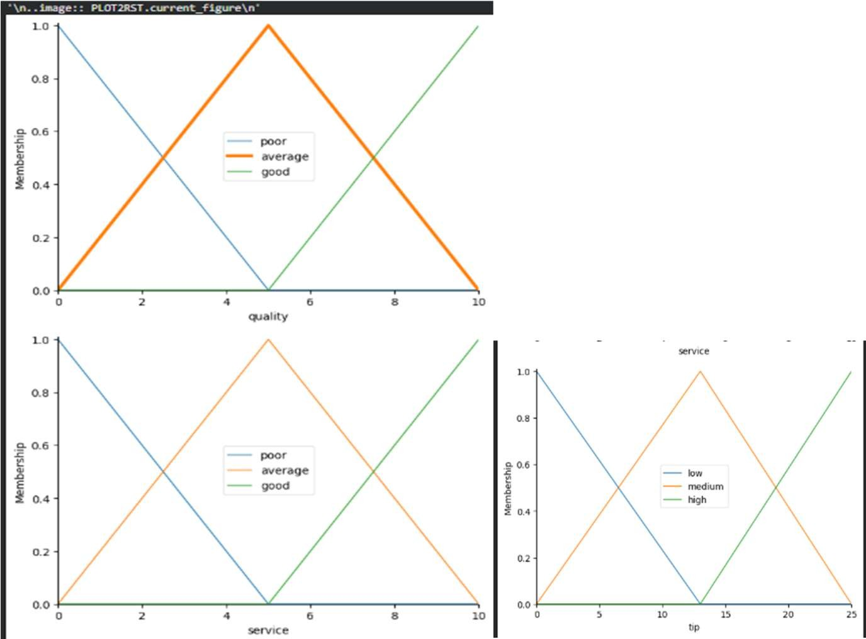
OUTPUT:

PRACTICAL 10
WRITE-UP – A) Simple Genetic Algorithm
Aim: To implement a simple genetic algorithm.
Theory: A genetic algorithm searches for a good solution using a population of candidate solutions. It uses fitness evaluation, selection, mating and mutation to produce improved generations.
Result: The population evolves toward the specified target solution.
- Implement of simple genetic algorithm

CODE:
import random
# Number of individuals in each generation POPULATION_SIZE = 100
# Valid genes GENES =
"abcdefghijklmnopqrstuvwxyzABCDEFGHIJKLMNOPǪRSTUVWXYZ 1234567890,-;:_!#%C/()=?@${[]}"
# Target string to be generated TARGET = "I love SIES College" class Individual(object):
"""
Class representing individual in population """
def init (self, chromosome): self.chromosome = chromosome self.fitness = self.cal_fitness()
@classmethod
def mutated_genes(cls): """
Create random genes for mutation """
global GENES
gene = random.choice(GENES) return gene
@classmethod
def create_gnome(cls): """

Create chromosome or string of genes """
global TARGET gnome_len = len(TARGET)
return [cls.mutated_genes() for _ in range(gnome_len)] def mate(self, par2):
"""
Perform mating and produce new offspring """
# chromosome for offspring child_chromosome = []
for gp1, gp2 in zip(self.chromosome, par2.chromosome): # random probability
prob = random.random()
# if prob is less than 0.45, insert gene from parent 1 if prob < 0.45:
child_chromosome.append(gp1)
# if prob is between 0.45 and 0.90, insert gene from parent 2 elif prob < 0.90:
child_chromosome.append(gp2)
# otherwise insert random gene(mutate), for maintaining diversity else:
child_chromosome.append(self.mutated_genes())
# create new Individual (offspring) using generated chromosome return Individual(child_chromosome)
def cal_fitness(self): """
Calculate fitness score, it is the number of characters in string which differ from target string. """
global TARGET fitness = 0
for gs, gt in zip(self.chromosome, TARGET): if gs != gt:

fitness += 1 return fitness
# Driver code def main():
global POPULATION_SIZE # current generation generation = 1
found = False population = []
# create initial population
for _ in range(POPULATION_SIZE): gnome = Individual.create_gnome() population.append(Individual(gnome))
while not found:
# sort the population in increasing order of fitness score population = sorted(population, key=lambda x: x.fitness) # if the individual having lowest fitness score is 0,
# then we know that we have reached the target and break the loop if population[0].fitness <= 0:
found = True break
# Otherwise generate new offsprings for new generation new_generation = []
# Perform Elitism, that means 10% of fittest population goes to the next generation
s = int((10 * POPULATION_SIZE) / 100)
new_generation.extend(population[:s])
# From 50% of fittest population, individuals will mate to produce offspring
s = int((90 * POPULATION_SIZE) / 100)
for _ in range(s):
parent1 = random.choice(population[:50]) parent2 = random.choice(population[:50]) child = parent1.mate(parent2)

new_generation.append(child) population = new_generation
print("Generation: {}\tString: {}\tFitness: {}".format( generation,
"".join(population[0].chromosome), population[0].fitness
))
generation += 1
print("Generation: {}\tString: {}\tFitness: {}".format( generation,
"".join(population[0].chromosome), population[0].fitness
))
if name == " main ": main()

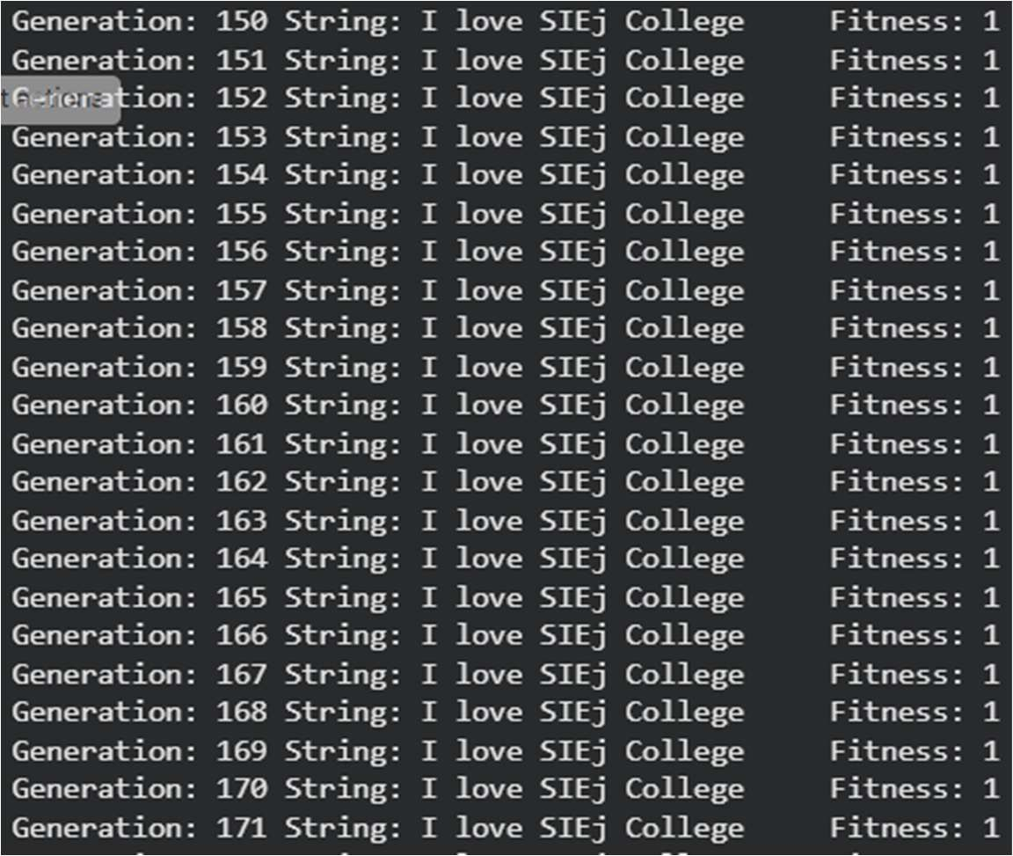
OUTPUT:

WRITE-UP – B) City and Fitness Classes using Genetic Algorithm
Aim: To create City and Fitness classes for a genetic-algorithm-based solution.
Theory: The City class represents a candidate city or route, while the Fitness class evaluates the quality of that candidate. Genetic operations can then be applied to improve the solution.
Result: Candidate solutions are evaluated using fitness and better solutions can be selected.

Create two classes: City and fitness using genetic algorithm
CODE:

import numpy
# 1. Parameter initialization genes = 2
chromosomes = 10
mating_pool_size = 6
offspring_size = chromosomes - mating_pool_size lb = -5
ub = 5
population_size = (chromosomes, genes) generations = 4
# 2. Population initialization
population = numpy.random.uniform(lb, ub, population_size) for generation in range(generations):
print(f"\n--- Generation: {generation + 1} ---")
# Calculate fitness (minimizing or maximizing x^2 + y^2; here we show the sum of squares)
fitness = numpy.sum(population * population, axis=1) print("Current Population:\n", population) print("Fitness Values:\n", fitness)
# 3. Selection: Extract the best parents
parents = numpy.empty((mating_pool_size, population.shape[1])) temp_fitness = fitness.copy()
for p in range(mating_pool_size):
# Find index of the fittest chromosome fittest_index = numpy.argmax(temp_fitness) parents[p, :] = population[fittest_index, :]
# Set its fitness to negative infinity so it is not selected again in this generation
temp_fitness[fittest_index] = -numpy.inf print("\nSelected Parents:\n", parents)
# 4. Crossover (Single-point crossover)
offspring = numpy.empty((offspring_size, genes)) for k in range(offspring_size):
parent1_idx = k % mating_pool_size

parent2_idx = (k + 1) % mating_pool_size crossover_point = genes // 2
offspring[k, 0:crossover_point] = parents[parent1_idx, 0:crossover_point]
offspring[k, crossover_point:] = parents[parent2_idx, crossover_point:] # 5. Mutation: Modify a random gene of each offspring
for index in range(offspring_size):
random_index = numpy.random.randint(0, genes) random_value = numpy.random.uniform(lb, ub, 1)[0]
offspring[index, random_index] = offspring[index, random_index] + random_value
print("\nOffspring after Mutation:\n", offspring)
# 6. Create new population (Elitism: replace the worst individuals with offspring)
population[0:parents.shape[0], :] = parents population[parents.shape[0]:, :] = offspring
print("\nNew Population for next generation:\n", population) # Final Evaluation
fitness = numpy.sum(population * population, axis=1) best_index = numpy.argmax(fitness)
best_individual = population[best_index, :] best_fitness = fitness[best_index] print("\n===================================")
print("Best Individual:\n", best_individual) print("Best Individual's Fitness:\n", best_fitness)

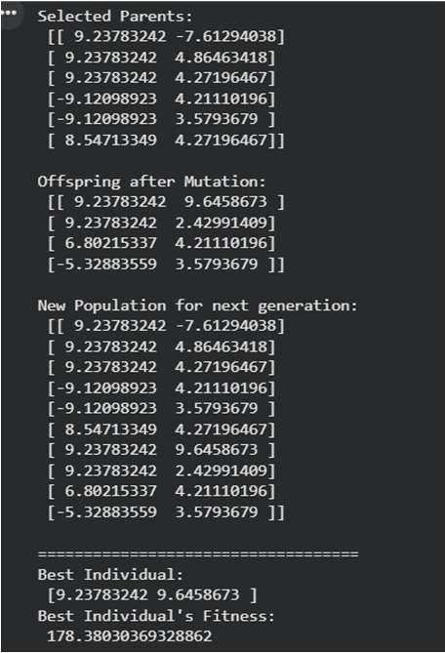
OUTPUT:

