ACKNOWLEDGEMENT
We express our sincere gratitude to the management of P B College of Engineering for providing us with the opportunity and facilities to complete the project titled “Swift Ship Tracker.” The support and encouragement given by the institution helped us understand the practical aspects of developing a cloud-based application.
We thank our Head of the Department and our project guide for their valuable guidance, suggestions and continuous encouragement throughout the project. Their feedback helped us organize the project work, understand Salesforce concepts and improve the overall design.
We also thank the faculty members of the department for sharing their knowledge and helping us whenever we faced technical difficulties. We are grateful to our team members for their cooperation and contribution during requirement analysis, configuration, testing and documentation. Finally, we thank our parents, friends and everyone who encouraged us directly or indirectly.

ABSTRACT
Swift Ship Tracker is a cloud-based parcel management and tracking prototype developed using the Salesforce platform. It aims to organize parcel, sender, receiver and delivery information in a centralized environment. Traditional parcel tracking may involve repeated calls to customer support, scattered records and delayed communication. This project demonstrates how Salesforce data management, automation and conversational artificial intelligence can make parcel information easier to access.
The application uses Salesforce custom objects such as Parcel, Delivery, Sender and Receiver. The Parcel record stores important details including a parcel identifier, status, weight and estimated delivery date. Delivery records support the management of current-location and delivery information. Relationships connect the records and help maintain a structured data model.
Salesforce Flow is used to retrieve parcel records based on a parcel identifier and pass relevant information to the response process. Prompt Builder provides a structured parcel-summary prompt. Agentforce AI is configured with an agent experience and an associated Flow action so that a user can ask a parcel-related question in natural language.
The prototype is configured and tested in a Salesforce Developer Edition environment. Testing focuses on record retrieval, Flow activation, agent configuration, permissions and responses to parcel-tracking queries. Production deployment, live GPS integration and external courier integration are outside the implemented prototype and are identified as future enhancements.

INDEX
PRELIMINARY: Acknowledgement; Abstract; Index.
CHAPTER 1 – INTRODUCTION: Project Overview; Background; Problem Statement;
Objectives; Scope; Users; Benefits.
CHAPTER 2 – SYSTEM STUDY: Existing System; Limitations; Proposed System; Feasibility Study; Functional Requirements; Non-Functional Requirements; Technology Study.
CHAPTER 3 – SYSTEM DESIGN: Architecture; Modules; Data Model; Object Relationships; Data Flow; AI Tracking Flow; User Interface; Security Design.
CHAPTER 4 – IMPLEMENTATION: Development Environment; Salesforce Setup; Custom Objects; Tabs; Fields; Prompt Builder; Flow; Agentforce; Permissions.
CHAPTER 5 – TESTING: Testing Strategy; Test Cases; Flow Testing; Prompt and Agent Testing; Security Testing; Results; Limitations.
CHAPTER 6 – CONCLUSION. CHAPTER 7 – FUTURE ENHANCEMENT. REFERENCES AND APPENDICES.

CHAPTER 1

INTRODUCTION

1.1 PROJECT OVERVIEW
Swift Ship Tracker is a Salesforce-based parcel management prototype designed to support parcel information management and tracking assistance. It brings important shipment details into a common cloud platform rather than keeping them in separate registers or disconnected files. The project focuses on connecting parcel details with sender, receiver and delivery information.
The system demonstrates the parcel journey from booking information to dispatch, in-transit status, out-for-delivery status and delivery confirmation. A parcel identifier is used to locate the corresponding record and retrieve information such as status, weight and estimated delivery date.

1.2 BACKGROUND OF THE PROJECT
Parcel and courier services are used by individuals, educational institutions, shops and businesses. As the number of shipments increases, customers expect clear information about booking, movement and delivery. They also expect support teams to answer questions quickly and accurately.
In a manual process, parcel details may be entered in registers or spreadsheets. Tracking information may be stored separately from customer contact details. When a customer asks for an update, staff may need to search multiple records or contact another department. This can increase response time and create inconsistent information.
Cloud-based CRM platforms provide a way to maintain connected records and automate routine tasks. Salesforce offers custom objects, relationships, automation tools, security settings, reporting features and AI capabilities. Swift Ship Tracker uses these features to model a parcelmanagement process.

1.3 PROBLEM STATEMENT
Customers may face difficulty when they need to book a parcel, find its current status or obtain an estimated delivery date. In some processes, they must contact support staff repeatedly or use more than one application. This makes the tracking experience less convenient.
Delivery staff also need a consistent way to maintain parcel status. If updates are handled through disconnected methods, information available to customers and administrators may not be updated at the same time. Managers may find it difficult to review parcel movement when records are scattered.
The problem addressed is the lack of a centralized and convenient method for organizing parcel information and retrieving tracking details. The prototype explores how Salesforce data modelling, Flow automation and an AI agent can reduce manual searching. It does not claim to obtain live GPS information from courier vehicles.

1.4 OBJECTIVES OF THE PROJECT
The primary objective is to develop a centralized parcel-management prototype using Salesforce. The system is intended to make parcel information easier to organize, retrieve and maintain.
Specific objectives are to create custom objects for Parcel, Delivery, Sender and Receiver; define suitable fields and relationships; store Parcel ID, Status, Weight and Estimated Delivery Date; configure a Prompt Builder template; create a Flow that retrieves parcel information using the identifier; configure an Agentforce agent and associate the Flow action; apply appropriate permissions; and test the prototype in a Developer Edition environment.
The project also aims to provide practical experience in cloud application development, data modelling, low-code automation, prompt design and AI agent configuration.

1.5 SCOPE OF THE PROJECT
The scope covers the design and configuration of a Salesforce parcel-management prototype. It includes custom objects, fields, tabs and relationships for parcel, sender, receiver and delivery information. It also covers a prompt template and an auto-launched Flow for retrieving parcel details.
The AI component demonstrates how Agentforce can receive a parcel-related request, identify the relevant topic and invoke an associated Flow action. The Flow uses a parcel identifier as input, retrieves the matching Parcel record and passes the generated response through an output variable.
The project is tested in the Developer Edition organization. Live GPS tracking, external courier APIs, payment processing and production deployment are not included in the current implementation. These boundaries should be stated clearly in the final report.

1.6 USERS AND RESPONSIBILITIES
Customer or Sender: provides parcel-booking information and needs access to the parcel identifier, shipment status and estimated delivery date. In a full deployment, the customer could use a portal or AI assistant.
Receiver: the person or organization expected to receive the parcel. Receiver information supports delivery reference and communication.
Delivery Agent: handles assigned parcels and records delivery progress. A future operational version may provide a dedicated interface for status updates.
Support Staff: assist customers with parcel-related questions. Centralized records can help them find information without searching multiple sources.
Administrator: configures objects, fields, automation, agent access and security settings. The exact access available in the academic prototype depends on the Salesforce profiles and permission sets configured.

1.7 BENEFITS AND SIGNIFICANCE
A centralized data model reduces the need to maintain separate parcel and delivery records. Sender and receiver details can be associated with the parcel so authorized users can understand the shipment context.
Flow automation can reduce repeated manual steps. Once a parcel identifier is supplied, the Flow searches for the corresponding record and provides selected details to the response process. Prompt Builder helps format the retrieved information in a readable way.
Conversational AI provides another way to request information. A user can ask a parcel-tracking question in ordinary language. This can improve convenience when the agent is correctly configured and has access to the required data.
The project is significant as a learning exercise because it combines CRM data modelling, lowcode development, prompt design, agent configuration and testing.

CHAPTER 2

SYSTEM STUDY

2.1 INTRODUCTION
System study is the process of understanding the current problem, identifying user needs and examining possible solutions. It helps developers understand how information is created, stored, accessed and updated. A proper study reduces confusion during design and implementation.
For Swift Ship Tracker, the study focuses on recording parcel details, connecting sender and receiver information, maintaining delivery information and answering tracking questions. It considers customers, delivery agents, support staff and administrators.

2.2 EXISTING SYSTEM
In a basic existing process, parcel details may be recorded using paper forms, spreadsheets or separate software applications. A customer may receive a tracking number and contact customer support to ask about the shipment. Staff may need to search a record, check with a delivery team or consult another system before replying.
Sender details, receiver details and delivery information may be maintained separately. When records are not linked, it can take additional effort to confirm that the correct delivery information belongs to the correct parcel. Manual updates may also be delayed.
This description is a general problem baseline, not a claim that every courier company uses manual systems. Many commercial services already have digital tracking platforms.

2.3 LIMITATIONS OF THE EXISTING APPROACH
Common limitations can include scattered information, manual searching, delayed status updates, repeated support requests, inconsistent data and limited operational visibility.
If parcel, sender, receiver and delivery details are stored separately, staff may need additional time to connect them. Manual entry can introduce spelling mistakes or incorrect identifiers.
Managers may also find it difficult to review delivery activity without consolidated reports.
Access control can be challenging when information is shared through paper files or common spreadsheets. A configured CRM platform can provide object, record and field-level permissions, although these controls must be designed and tested correctly.

2.4 PROPOSED SYSTEM
The proposed system uses Salesforce as the central platform for parcel information. Custom objects represent Parcel, Delivery, Sender and Receiver data. Fields store the required information, and relationships connect the records.
A parcel identifier is used to search for a parcel record. A Salesforce Flow receives the identifier, retrieves the matching Parcel record and makes selected information available to the response process. A Prompt Builder template formats the parcel summary with Parcel ID, Status, Weight and Estimated Delivery Date.
Agentforce provides a conversational interface for parcel-related requests. The agent is configured with a topic or subagent and a Flow action. A customer-facing portal, notifications and dashboards can be added after further configuration and testing.

2.5 FEASIBILITY STUDY
Technical feasibility: The project uses Salesforce Developer Edition and built-in tools such as custom objects, Flow Builder, Prompt Builder and Agentforce. These tools support the academic prototype without a separate database server.
Operational feasibility: The system follows familiar parcel-management concepts. Users work with parcel identifiers and shipment details. A conversational tracking option can make record retrieval easier.
Economic feasibility: The prototype is developed in an educational environment. A business deployment would require a review of licensing, usage limits, integration costs, support and maintenance expenses.
Schedule feasibility: Work can be divided into requirement analysis, data modelling, configuration, prompt creation, Flow development, agent setup and testing. The prototype is feasible as an academic demonstration.

2.6 FUNCTIONAL REQUIREMENTS
FR-01: Store parcel information in a Parcel custom object. FR-02: Maintain sender information in a Sender object. FR-03: Maintain receiver information in a Receiver object. FR-04: Maintain delivery-related information in a Delivery object.
FR-05: Provide a parcel identifier to locate a record. FR-06: Store parcel status, weight and estimated delivery date. FR-07: Support relationships between parcel and delivery records. FR08: Accept a parcel identifier as Flow input and search for the matching parcel.
FR-09: Present selected parcel fields in a consistent prompt response. FR-10: Configure the Agentforce agent to use the parcel-retrieval action. FR-11: Restrict access according to configured permissions.

2.7 NON-FUNCTIONAL REQUIREMENTS
Usability: use understandable field labels and simple navigation. The tracking response should present important parcel details clearly.
Security: grant access only to users who require it. Profiles, permission sets, sharing settings and field-level security should be reviewed.
Reliability: retrieve the correct parcel record when a valid identifier is provided. Incorrect or missing identifiers should not return unrelated information.
Performance: record retrieval and agent responses should complete within a reasonable time under the limits of the Salesforce environment.
Maintainability: administrators should be able to update fields, Flow logic, prompt instructions and agent topics. Scalability: the data model should allow additional parcel records and future integrations.

2.8 HARDWARE AND SOFTWARE REQUIREMENTS
Hardware requirements include a desktop computer or laptop, a modern web browser and a stable internet connection. A smartphone may be used to view the application, but a computer is more convenient for configuration.
Software requirements include an operating system capable of running a supported browser. Salesforce Developer Edition is the main development platform. Setup and Object Manager are used to create objects and fields; Flow Builder configures automation; Prompt Builder creates the parcel-summary template; Agentforce Builder configures the conversational agent.
Google Docs or Microsoft Word may be used for report preparation. Spreadsheet software may be used for planning fields, requirements and test cases. Internet access is required because Salesforce is cloud-based.

2.9 TECHNOLOGY STUDY – SALESFORCE
Salesforce is a cloud-based customer relationship management platform. It provides tools for managing customer information, business processes, automation, reporting and application development.
A Salesforce object is similar to a database table, a record is similar to a row and a field is similar to a column. Standard objects are provided by the platform, while custom objects are created for application-specific needs. Swift Ship Tracker uses custom objects for Parcel, Delivery, Sender and Receiver.
Salesforce provides security controls to manage user access. Profiles define baseline permissions, while permission sets grant additional access. Record sharing and field-level security help control which records and fields a user can view or modify.

2.10 TECHNOLOGY STUDY – FLOW, PROMPT BUILDER AND
AGENTFORCE
Salesforce Flow is a declarative automation tool. A Flow contains elements such as variables, Get Records, Assignment, Decision and Action. It can collect input, retrieve records, perform logic and return output.
Prompt Builder creates reusable prompt templates. In this project, the template summarizes selected Parcel fields in a consistent format. Resource mapping makes relevant Salesforce record fields available to the prompt.
Agentforce supports AI-powered conversational experiences. An agent can be configured with instructions, topics or subagents and actions. In this prototype, an action is associated with the parcel-retrieval Flow.
These technologies perform different roles: Salesforce objects store data, Flow retrieves it, Prompt Builder formats the response and Agentforce manages the conversational interaction.

CHAPTER 3

SYSTEM DESIGN

3.1 INTRODUCTION
System design converts requirements into a technical structure. It explains application components, information stored by each component, relationships between records and the sequence of operations.
The design separates the data layer, automation layer, AI interaction layer and security layer. This makes the system easier to understand and maintain. It also distinguishes implemented prototype functions from features proposed for a later deployment.

3.2 SYSTEM ARCHITECTURE
The architecture begins with users such as customers, delivery agents, support staff and administrators. Users interact with the Salesforce Lightning interface or, in a future extension, a customer-facing Experience Cloud site.
The data layer contains Parcel, Delivery, Sender and Receiver custom objects. The automation layer contains Salesforce Flow and related actions. The AI layer contains Prompt Builder and the Agentforce agent. The security layer controls access through profiles, permission sets, object permissions and field-level security.
The parcel retrieval Flow accepts an identifier, uses Get Records to find the Parcel record, invokes the prompt-related action and assigns the resulting text to an output variable. Reports and dashboards can provide operational summaries when configured.

3.3 MODULE DESCRIPTION
Parcel Management Module: stores the parcel identifier, status, weight and estimated delivery date. It is the main module used when a tracking query is received.
Sender Management Module: stores sender-related details such as name, address, contact number and email. Receiver Management Module: stores receiver details and delivery reference information.
Delivery Management Module: stores delivery information such as current location, estimated delivery date and the related parcel.
Parcel Retrieval Module: uses Flow to locate a Parcel record by its identifier. AI Tracking Module: uses Prompt Builder and Agentforce to support natural-language parcel queries.
Administration and Security Module: manages permissions and configuration.

3.4 DATA MODEL DESIGN
The data model is based on Parcel__c, Delivery__c, Sender__c and Receiver__c. The suffix “__c” indicates a Salesforce custom object API name.
Parcel__c stores the main shipment record. Important fields include Name, Parcel_ID__c, Status__c, Weight__c, Estimated_Delivery_Date__c and a relationship to sender information. The Parcel ID is configured as an auto-number field with a format similar to P-{000}.
Delivery__c stores delivery-specific information such as current location, estimated delivery and relationships to parcel and sender records. Sender__c stores sender address, contact and email. Receiver__c stores receiver address, contact and email.
Confirm exact API names and relationship types against the final Salesforce organization before submission.

3.5 OBJECT RELATIONSHIPS
Relationships connect records that belong to the same business process. Parcel is the central record. Sender and Receiver records identify the two ends of the shipment. Delivery records contain information about movement or delivery.
A relationship field allows a user or automation to navigate from one record to another. A Parcel record can reference a Sender record so sender details do not need to be copied into every parcel field.
Salesforce supports lookup and master-detail relationships. A lookup provides a flexible link. A master-detail relationship creates a stronger dependency and supports features such as roll-up summaries in suitable cases. The selected relationship type should match ownership, deletion and sharing requirements.

3.6 DATA FLOW DESIGN
Normal information flow: Customer or Sender → Parcel Booking → Parcel Record → Sender and Receiver Information → Delivery Record → Parcel Status and Current Location → Tracking Request → Flow Retrieval → Prompt Summary → Agent Response.
The process begins with a parcel record containing an identifier and shipment fields. Sender, receiver and delivery information is connected through relationship fields. When a tracking request arrives, the Flow searches for the parcel using its identifier.
The retrieved record is passed to the prompt action. The generated summary is returned to the agent and displayed to the user. This is the data retrieval path demonstrated by the prototype; live GPS updates are not included.

3.7 AI TRACKING FLOW DESIGN
The AI tracking process begins when a user enters a request such as “Track parcel P-12345” in the agent preview. Agentforce uses its configured topic or subagent to identify that the request relates to parcel tracking.
The agent invokes the associated Flow action. The Flow receives the parcel identifier through an input variable. A Get Records element searches the Parcel object and compares the Parcel ID field with the supplied value.
The matching Parcel record is made available to the prompt action. Prompt Builder prepares a summary. Assignment stores the prompt response in an output variable. The Flow reaches End and returns the response to the agent.
If no matching record exists, the design should be extended to provide a clear not-found message. Tests should use valid parcel identifiers that exist in Salesforce.

3.8 USER INTERFACE DESIGN
The Salesforce Lightning interface provides the main working environment for administrators and staff. Custom tabs make Parcel, Delivery, Sender and Receiver objects easier to open from the application navigation bar.
A clear record page should display important fields near the top. For Parcel records, these include Parcel ID, Status, Weight and Estimated Delivery Date. Related lists can display connected sender, receiver and delivery information.
The Agentforce preview is used during development to test conversational requests. A customerfacing portal can be considered later after Experience Cloud pages, login access and recordsharing rules are configured.

3.9 SECURITY DESIGN
Security is important because parcel records may contain names, addresses, email addresses, contact numbers and delivery information. Users should receive only the access required for their responsibilities.
Profiles provide baseline object and system permissions. Permission sets grant additional permissions to selected users or the Agentforce user. Object permissions control read, create, edit and delete operations. Field-level security controls visibility and editability of individual fields.
Record-level access can be controlled through organization-wide defaults, role hierarchy, sharing rules and manual sharing. Customers should only access their own shipment information in a real customer portal.
The project includes a permission set for the agent user and object access for Parcel, Delivery, Sender and Receiver. Apply the principle of least privilege.

3.10 DATA VALIDATION DESIGN
Data validation helps maintain accurate records. Parcel ID should be unique or generated automatically. Weight should contain a valid numeric value and should not be negative.
Estimated delivery date should use a valid date.
Status values should follow a controlled list, for example Booked, In Transit, Out for Delivery and Delivered. Consistent values make filtering, reporting and automation easier.
Sender and receiver contact fields should be checked for completeness where required. Relationship fields should point to valid records. Salesforce validation rules can prevent invalid entries and should be tested with both valid and invalid data.

CHAPTER 4

IMPLEMENTATION

4.1 INTRODUCTION
Implementation converts the design into a working application. Swift Ship Tracker was configured in Salesforce Developer Edition. The work includes creating custom objects, configuring fields and relationships, creating the prompt template and Flow, setting agent permissions and activating the Agentforce experience.
The following sections describe the main configuration stages. Menu labels may vary slightly according to Salesforce interface updates and permissions.

4.2 DEVELOPMENT ENVIRONMENT
The project uses a Salesforce Developer Edition organization. It provides access to Salesforce Setup, Object Manager, Flow Builder, Prompt Builder and Agentforce configuration features enabled for the account.
The administrator signs in to the Developer organization, opens Setup and uses Quick Find to locate configuration pages. Object Manager creates and maintains custom objects. Tabs creates navigation entries. Fields & Relationships adds fields and defines relationships.
The development environment is used for configuration and academic testing. It is not a production environment connected to a courier company's live operations.

4.3 CREATION OF CUSTOM OBJECTS
Four custom objects are used: Parcel, Delivery, Sender and Receiver. To create an object, open Setup, select Object Manager and choose Create followed by Custom Object.
For Parcel, enter the label as Parcel and plural label as Parcels. Configure the record name as Parcel Name with a text data type. Enable options such as Allow Reports, Allow Search and Track Field History where required.
Repeat the process for Delivery, Sender and Receiver. Their record names can be Delivery Name, Sender Name and Receiver Name. Save each object and confirm that it appears in Object Manager.

4.4 CREATION OF CUSTOM TABS
Custom tabs provide a convenient way to open custom objects from the Salesforce navigation interface. Open Setup and search for Tabs in the Quick Find box.
Under Custom Object Tabs, select New. Choose the Parcel object and a suitable tab style. Continue through profile and application settings and save the tab.
Repeat the procedure for Delivery, Sender and Receiver. Add the tabs to the Swift Ship Tracker application navigation menu if they are not already visible. Confirm that each tab opens the correct object.

4.5 PARCEL OBJECT FIELDS
The Parcel object stores the main shipment details. Parcel ID is configured as an Auto Number field with a format similar to P-{000}. Salesforce generates a parcel reference for each new record.
Other fields include Status, Weight and Estimated Delivery Date. Status can be a picklist with approved shipment stages. Weight should use a suitable numeric field type. Estimated Delivery Date should use the Date field type.
A relationship field can connect Parcel with Sender. Additional relationships can connect the parcel to receiver and delivery information. Check labels, API names, data types and field-level security. Create a sample record to confirm the fields work.

4.6 DELIVERY, SENDER AND RECEIVER FIELDS
Delivery contains information related to the delivery process. The project design includes Current Location as a Geolocation field, along with estimated delivery information and relationships to Parcel and Sender.
Sender stores sender address, contact number and email. Receiver stores receiver address, contact number and email. Contact and email fields should use suitable data types so information can be validated and used for communication.
Confirm that every relationship field points to the intended object. Record field labels and API names because Flow Builder and Prompt Builder use API names when referencing fields.

4.7 CONFIGURATION OF PROMPT BUILDER
Prompt Builder is used to create a reusable prompt template for retrieving and presenting parcel details. In Salesforce Setup, open Prompt Templates and create a new template of the appropriate type.
The project template is labelled “Retrieve Parcel Details” and uses an API name such as Retrieve_Parcel_Details. Its description explains that it retrieves parcel information based on the parcel identifier.
The prompt instructions request a structured summary containing parcel name, Parcel ID, Status, Weight and Estimated Delivery Date. Add the Parcel object and required fields as resources.
Save and activate the template, then test it with an existing Parcel record.

4.8 CREATION OF PARCEL RETRIEVAL FLOW
Open Setup, search for Flows and select New Flow. The project uses an Auto-Launched Flow because it is invoked by an agent action rather than started directly by a user through a screen.
Create a text input variable to receive the parcel identifier and mark it Available for Input. Create a text output variable to store the response and mark it Available for Output.
Add a Get Records element labelled Get Parcel Records. Search the Parcel object where the Parcel ID field equals the input variable. Configure the element to store the matching record for use by the next action.
Connect the Flow to the prompt action and an Assignment element. Assignment stores the prompt response in the output variable. The sequence is Start → Get Records → Action → Assignment → End.

4.9 SAVING AND ACTIVATING THE FLOW
After connecting the elements, check the Flow for configuration errors. Save it with a meaningful name such as Parcel Details and activate it so that it can be selected by the agent action.
Confirm that input and output variables have the correct data types and availability settings. The Get Records filter must compare the correct Parcel ID field with the input variable. The prompt action must reference the retrieved Parcel record.
Test using a parcel identifier that exists in the Parcel object. The output should contain the expected parcel details. If the Flow returns a blank result, check the input value, field API name, record availability and action mapping.

4.10 CONFIGURATION OF AGENTFORCE
Agentforce is configured from Salesforce Setup. Required Einstein and Agentforce features must be enabled where available in the Developer Edition organization. Open Agentforce Agents and use Agent Builder to configure the agent.
Create a subagent or topic for parcel tracking. Its description and instructions should explain that it handles parcel-related questions and uses the appropriate Flow action to retrieve information.
Create an Agent Action with Flow as the action type. Select the Parcel Details Flow as the reference Flow. Map the input and output values so that the agent passes the parcel identifier and receives the response.
Add the action to the relevant subagent or topic. Save and activate the agent. The final label may be SwiftShip Tracker or Parcel Tracking Agent depending on the configuration.

4.11 AGENT PERMISSIONS AND ACCESS
The Agentforce user requires permission to run the configured Flow and read the relevant parcel fields. Create a permission set and assign it to the agent user. The project setup notes describe a permission set labelled Swift Ship or SwiftShip.
Within Object Settings, review Parcel, Delivery, Sender and Receiver. Enable Read access and the required field visibility. Create or Edit access should only be granted if the agent needs to create or update records.
Assign the permission set to the Einstein or Agentforce user through Permission Set Assignments. Test the agent again to confirm that the Flow can access the required data.
Follow least privilege. Do not grant delete access or broad access to sensitive contact information unless a documented requirement exists.

4.12 IMPLEMENTATION SUMMARY
The implementation creates a connected Salesforce environment for parcel information management. Custom objects represent the main entities, and fields store the information needed for tracking. Tabs support navigation between objects.
Prompt Builder provides a reusable format for the parcel summary. Flow Builder retrieves the record using the parcel identifier and passes the prompt response through an output variable. Agentforce provides a conversational way to invoke the Flow action.
The main result is an academic prototype demonstrating record retrieval through an AI-assisted interaction. Live GPS tracking, external courier integration, full customer portal deployment and production-grade monitoring are not completed functions unless separately implemented and verified.

CHAPTER 5

TESTING

5.1 INTRODUCTION
Testing checks whether the configured system behaves according to its requirements. It helps identify errors in data entry, object relationships, Flow logic, prompt configuration, agent actions and permissions.
The Swift Ship Tracker prototype is tested within Salesforce Developer Edition. Testing focuses on the configured parcel retrieval path and the ability of Agentforce to use the associated Flow action.

5.2 TESTING STRATEGY
First, each custom object and its fields are checked. Sample records are created to verify that data can be saved and searched. Relationship fields are checked by opening related records.
The Prompt Builder template is tested to confirm that it uses the correct Parcel fields. The Flow is tested with a valid parcel identifier to confirm that Get Records retrieves the intended record and the output variable receives the prompt response.
The Agentforce agent is tested in Preview or Try It Out mode. A parcel-related query is entered and the response is compared with the values stored in Salesforce. Testing is limited to the development environment; production-linked user acceptance testing is outside the academic scope.

5.3 SAMPLE TEST CASES
Test 1 – Object creation. Input: create Parcel object. Expected: object is saved and appears in Object Manager.
Test 2 – Parcel ID generation. Input: create a Parcel record. Expected: Salesforce generates an ID in the configured format.
Test 3 – Field entry. Input: enter status, weight and estimated delivery date. Expected: valid values are saved.
Test 4 – Related records. Input: associate sender or delivery information. Expected: relationship is visible on the record.
Test 5 – Prompt template. Input: run the prompt with a valid Parcel record. Expected: summary displays selected fields.
Test 6 – Flow retrieval. Input: supply a valid Parcel ID. Expected: Get Records retrieves the matching record.
Test 7 – Agent query. Input: “Track parcel P-12345” using an existing test ID. Expected: agent invokes the action and returns parcel information.

5.4 FLOW TESTING
Test the Flow independently before connecting it to the agent. Open Flow Builder and use the available debug or test option. Supply a valid parcel identifier as the input value.
Check that Get Records searches the Parcel object and compares the Parcel ID field with the input variable. If a matching record is found, the record should be available to the prompt action.
Check that the prompt action receives the correct Parcel record. Assignment should copy the action response into the output variable. Review the final output to confirm that the required fields are included.
If the Flow does not return the expected result, check API names, variable types, input/output availability, record filter, action configuration and activation status.

5.5 PROMPT BUILDER AND AGENT TESTING
Test the Prompt Builder template using a Parcel record that contains known values. Compare the generated summary with the actual Salesforce record. Check Parcel ID, Status, Weight and Estimated Delivery Date.
Test the Agentforce agent through Preview or Try It Out mode. Enter a request such as “Track parcel P-12345”, using an identifier that exists in the organization. Observe whether the agent identifies the parcel-tracking topic and invokes the Flow action.
The response should match the stored record. If it is incomplete, review topic instructions, action association, prompt resources and Flow output mapping. Repeat the test with more than one sample parcel.

5.6 SECURITY AND PERMISSION TESTING
Security testing checks whether the agent user has the required access to the Parcel object and its fields. Review the permission set assignment in the user record. Check Object Settings to confirm Read access and field visibility.
Verify that the Flow can execute under the intended access context. If the agent cannot retrieve a record, review object permissions, field-level security, record sharing and Flow access.
Access should also be tested from a user without administrative permissions. The objective is to confirm that users cannot access unrelated or restricted parcel information. A production system requires additional security and privacy review.

5.7 TEST RESULTS AND OBSERVATIONS
The project test process verifies custom object availability, parcel field creation, prompt template activation, Flow activation, agent action association and access permissions.
For a valid test parcel, the intended result is that the Flow finds the matching Parcel record and returns a structured summary through the agent. Compare the response with the stored Salesforce values rather than relying only on the wording of the response.
The testing environment is a Salesforce Developer Edition organization. Results demonstrate prototype functionality under configured test conditions. They do not establish production-level availability, GPS accuracy or performance under many simultaneous users.
Insert screenshots of object records, Flow configuration, prompt template settings, agent preview and test responses as evidence.

5.8 LIMITATIONS IDENTIFIED DURING TESTING
The prototype depends on accurate parcel records. If the identifier is incorrect or the record does not exist, the Flow cannot retrieve the intended information.
The agent response depends on the configured topic, action, prompt and Flow. Changes to field API names or Flow variables may require updates to prompt resource mapping and agent action configuration.
The Developer Edition environment does not represent a complete production logistics system. Live GPS tracking, external courier APIs, customer identity verification and production-scale performance testing are not included.
These limitations provide directions for future development and define what the current project has demonstrated.

CHAPTER 6

CONCLUSION
Swift Ship Tracker demonstrates how Salesforce can be used to build a centralized parcelmanagement and tracking prototype. The project organizes parcel, sender, receiver and delivery information through custom objects and relationships. It uses a parcel identifier as the main reference for locating shipment information.
The project combines Salesforce Flow, Prompt Builder and Agentforce to demonstrate AIassisted parcel retrieval. The Flow receives an identifier, retrieves the matching Parcel record and makes selected information available to the prompt response. The agent provides a conversational method for requesting the information.
The work provided practical experience in cloud application configuration, data modelling, automation, prompt design, agent setup, permission management and testing. It also highlighted the importance of accurate data, clear requirements and secure access control.
The prototype is suitable for academic demonstration in Salesforce Developer Edition. It is not a complete production courier platform. Live GPS tracking, external logistics integration, full customer portal deployment and formal production testing remain future enhancements.

CHAPTER 7

FUTURE ENHANCEMENT
- Live GPS tracking: integrate a trusted location service or delivery-agent mobile application so authorized users can view updated shipment locations.
- External courier integration: connect Salesforce with courier partner APIs to receive booking, dispatch and delivery events automatically.
- Customer portal: develop an Experience Cloud site where customers can securely sign in and view only their own parcel records.
- Automated notifications: configure email or messaging notifications for booking confirmation, dispatch, in-transit updates, out-for-delivery and delivery completion.
- Delivery-agent mobile interface: provide a mobile-friendly page for agents to view assigned parcels and submit status updates.
- Exception handling: add processes for failed delivery, address correction, delayed shipment and customer support cases.
FUTURE ENHANCEMENT – ADVANCED FEATURES
- Better analytics: create reports and dashboards for parcel volume, delivery time, delayed shipments and delivery-agent activity.
- Improved AI assistance: extend the Agentforce topic to answer additional questions about delivery stages, support requests and parcel policies.
- Stronger validation: add rules for parcel weight, mandatory contact details, valid status transitions and estimated delivery dates.
- Audit and monitoring: maintain field history and automation logs to help administrators investigate unexpected changes or failed processes.
- Production deployment: introduce sandbox testing, deployment approvals, backup planning and a controlled release process.
- Multilingual support: provide tracking responses in multiple languages. Each enhancement should be designed, implemented and tested separately before being added to a live application.

BIBLIOGRAPHY
- Salesforce. “Salesforce Platform: Custom Objects and Fields.” Salesforce Help. https://help.salesforce.com/s/articleView?id=platform.custom_object.htm&language=en_US&ty pe=5
- Salesforce. “Create Custom Tabs.” Salesforce Help. https://help.salesforce.com/
- Salesforce. “Flow Builder.” Salesforce Help. https://help.salesforce.com/s/articleView?id=platform.flow.htm&language=en_US&type=5
- Salesforce Developers. “Get Started with Prompt Builder.” Agentforce Developer Guide.
https://developer.salesforce.com/docs/ai/agentforce/guide/get-started-prompt-builder.html
- Salesforce. “Create a Custom Action.” Salesforce Help.
https://help.salesforce.com/s/articleView?id=ai.agent_actions_custom.htm&language=en_US&t ype=5
- Salesforce. “Best Practices for Agent User Permissions.” Salesforce Help.
https://help.salesforce.com/s/articleView?id=ai.agent_user.htm
- Salesforce Trailhead. “Give Your Agent More Information with Flows, Actions, and
Permissions.” https://trailhead.salesforce.com/content/learn/modules/programmatic-instructionsin-agentforce/give-your-agent-more-information-with-flows-actions-and-permissions
- Salesforce. “Salesforce Security Guide.” Salesforce Help. https://help.salesforce.com/
- Swift Ship Tracker Project Team. Project implementation notes, Salesforce configuration records, sample parcel records and testing observations. Unpublished project materials, 2026.
Note: Online sources were consulted for the Salesforce platform features described in this report. Accessed on 31 October 2026. The project-team materials refer to the team's own implementation and testing.

APPENDIX A – DATA DICTIONARY
Parcel__c: main custom object for shipment information. Important fields include Name, Parcel_ID__c, Status__c, Weight__c and Estimated_Delivery_Date__c.
Delivery__c: custom object for delivery information. The design includes Current_Location__c, estimated delivery information and relationship fields to connect the delivery with the relevant parcel.
Sender__c: custom object for sender details, including sender name, address, contact number and email.
Receiver__c: custom object for receiver details, including receiver name, address, contact number and email.
The API names shown above follow the project documentation and should be checked against the actual Salesforce organization. Update this appendix if the final configuration uses different names.

APPENDIX B – SCREENSHOTS TO INCLUDE
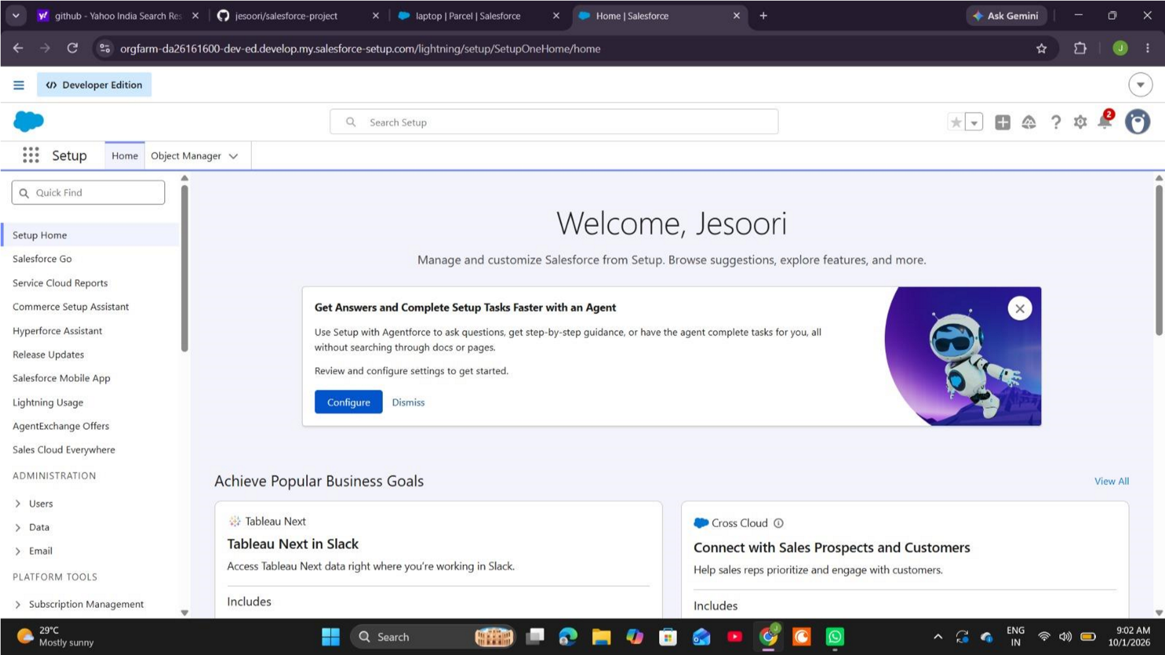

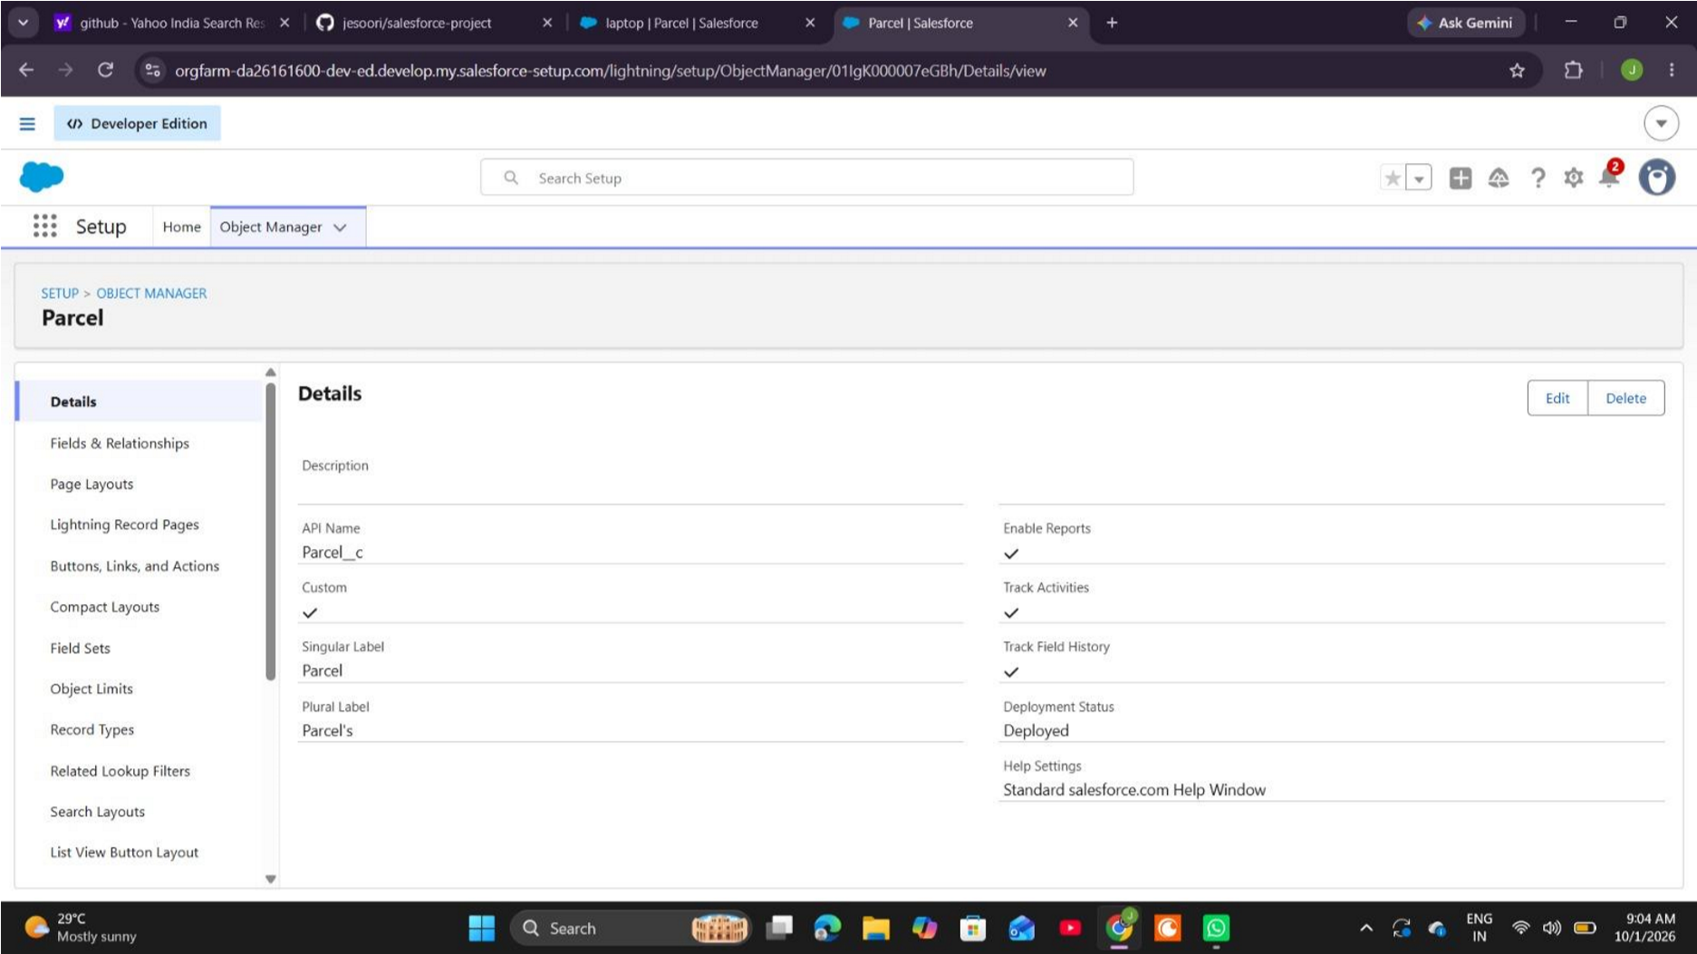
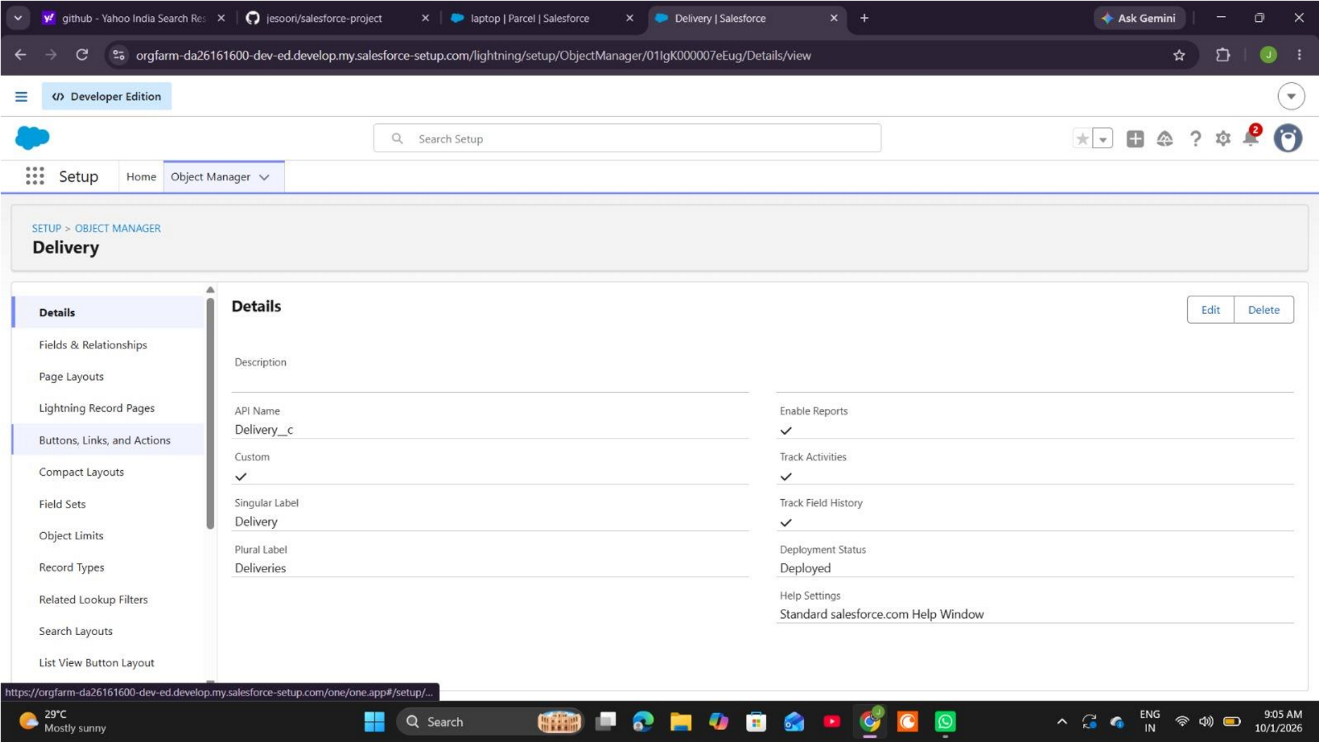

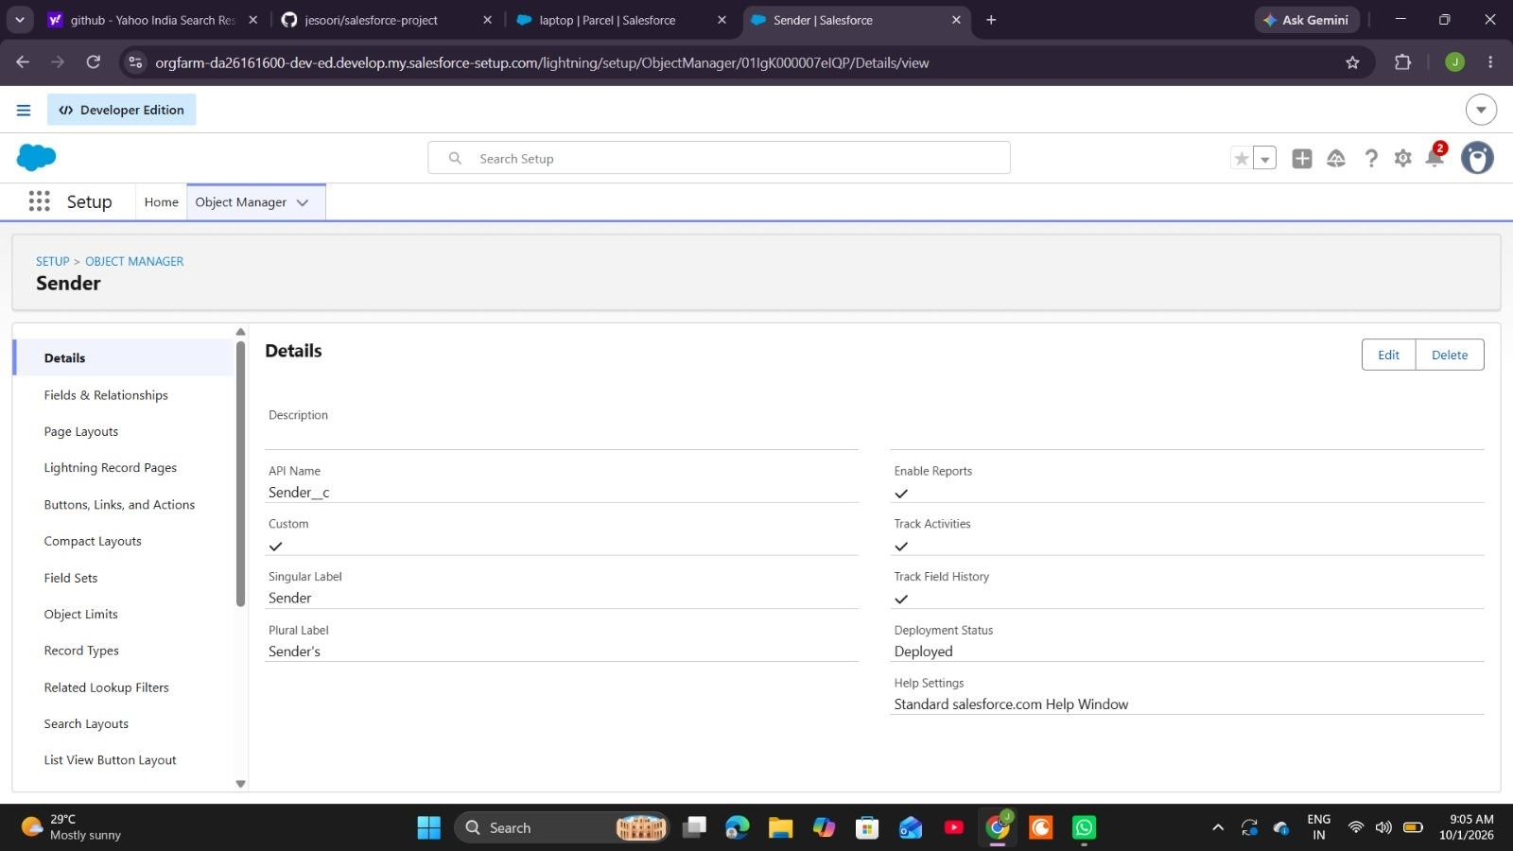
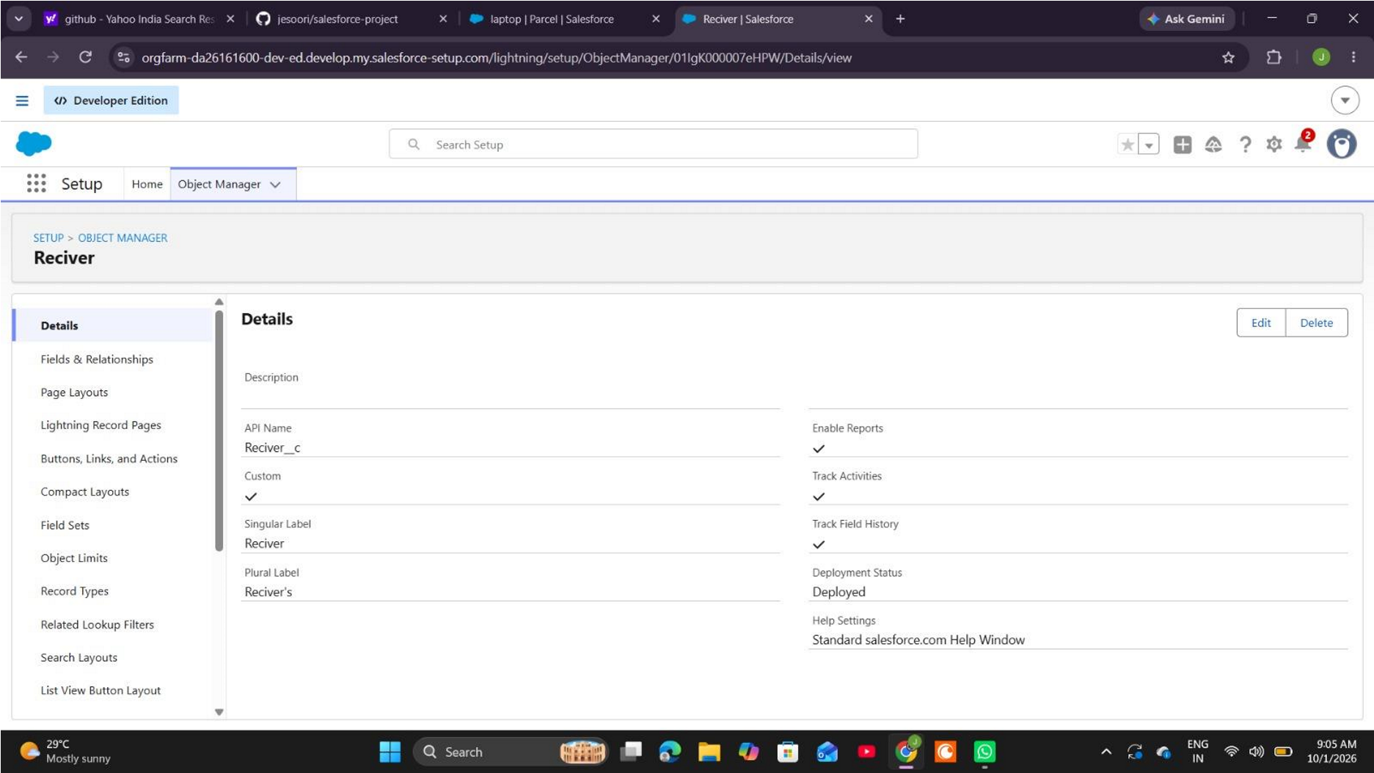

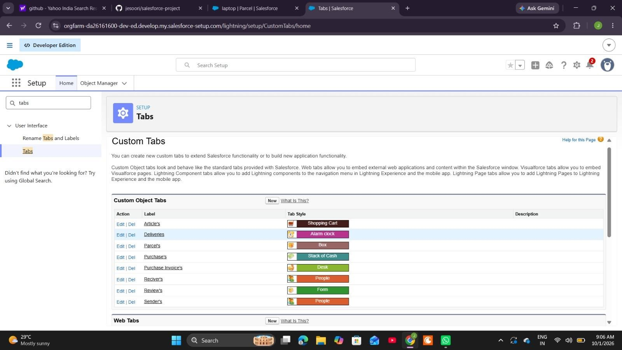

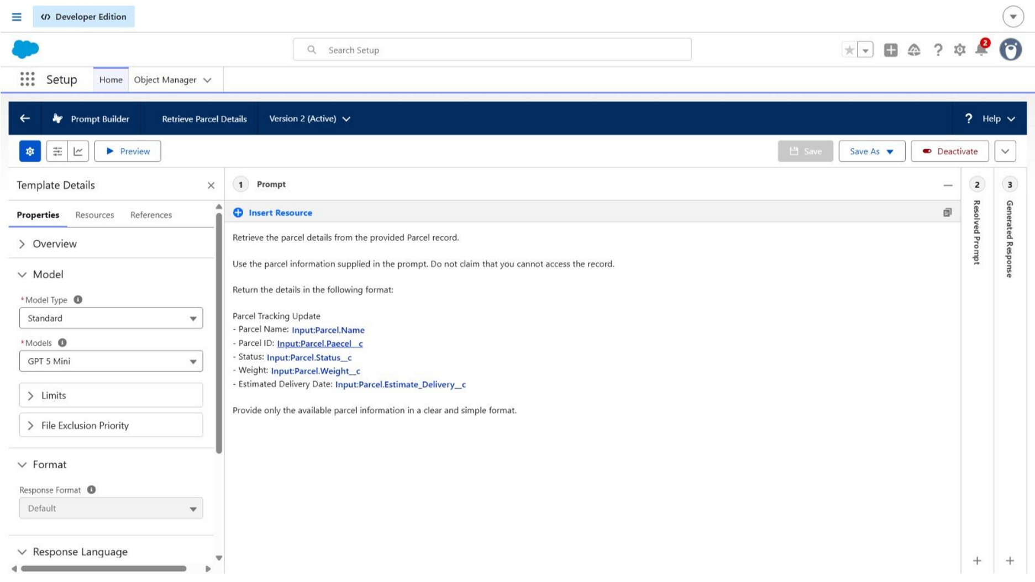

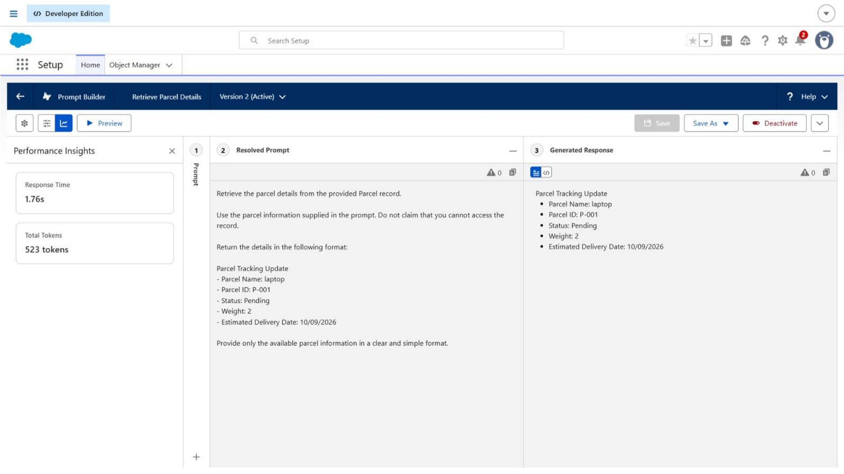
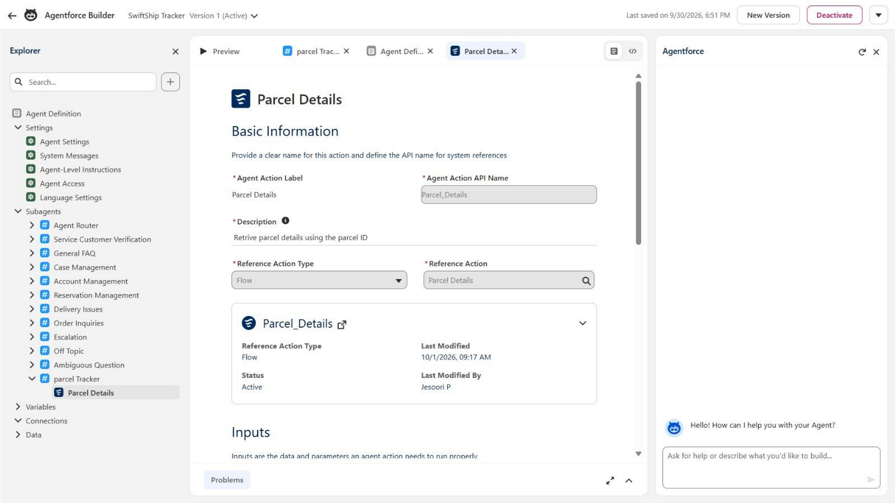

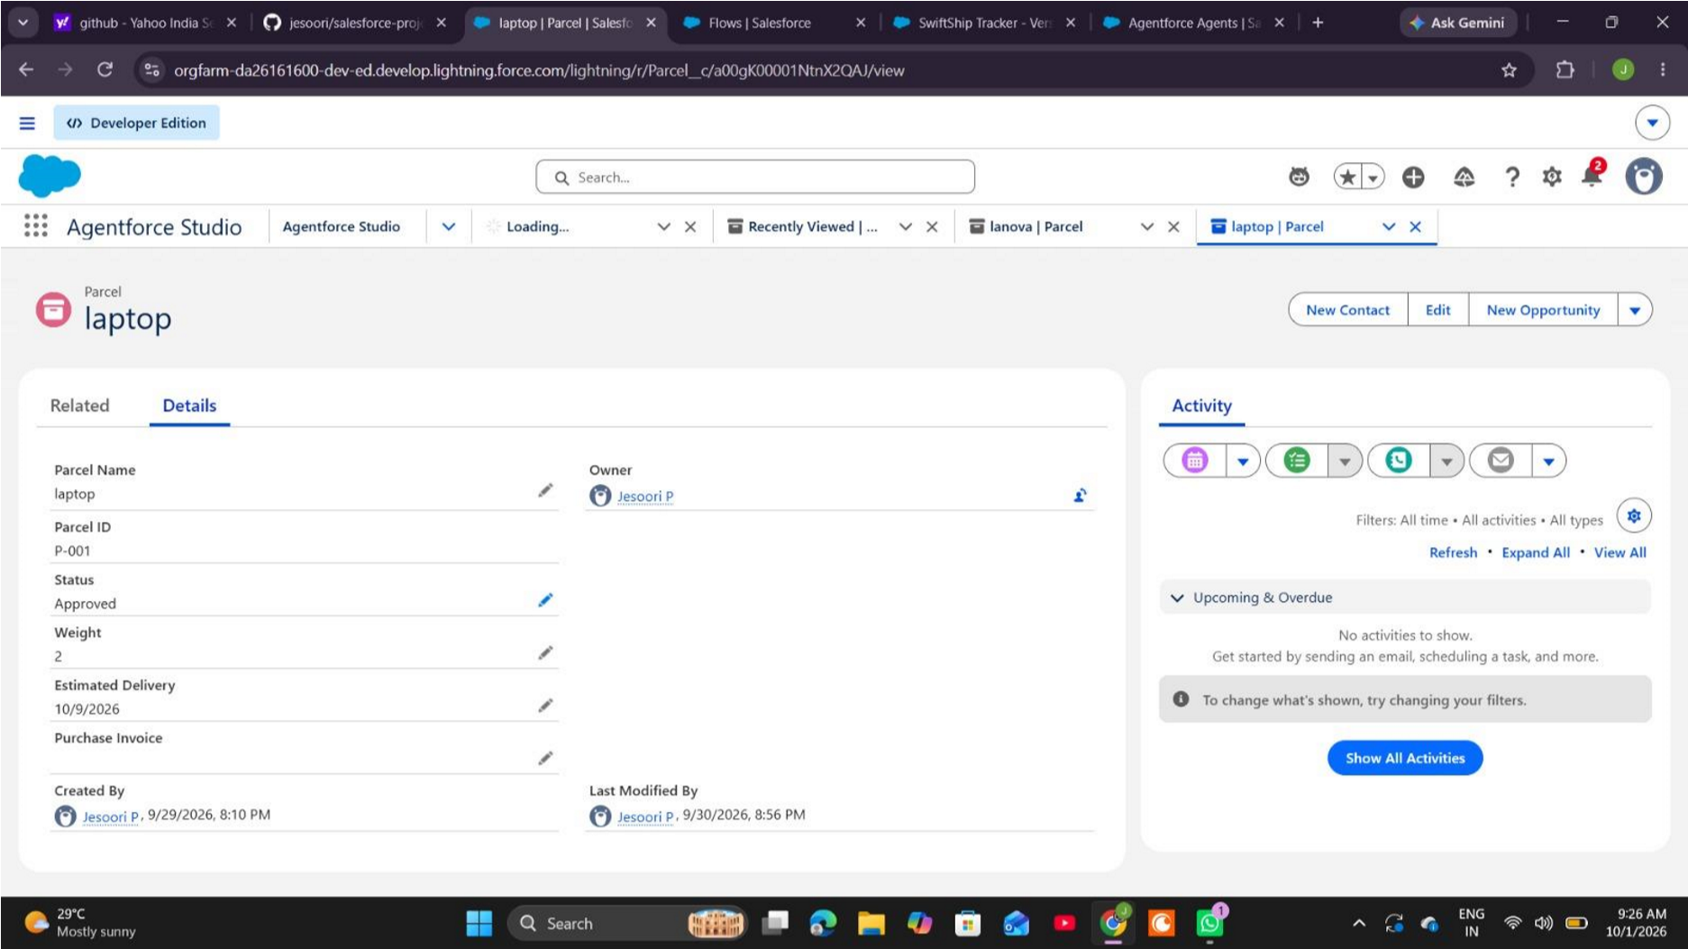

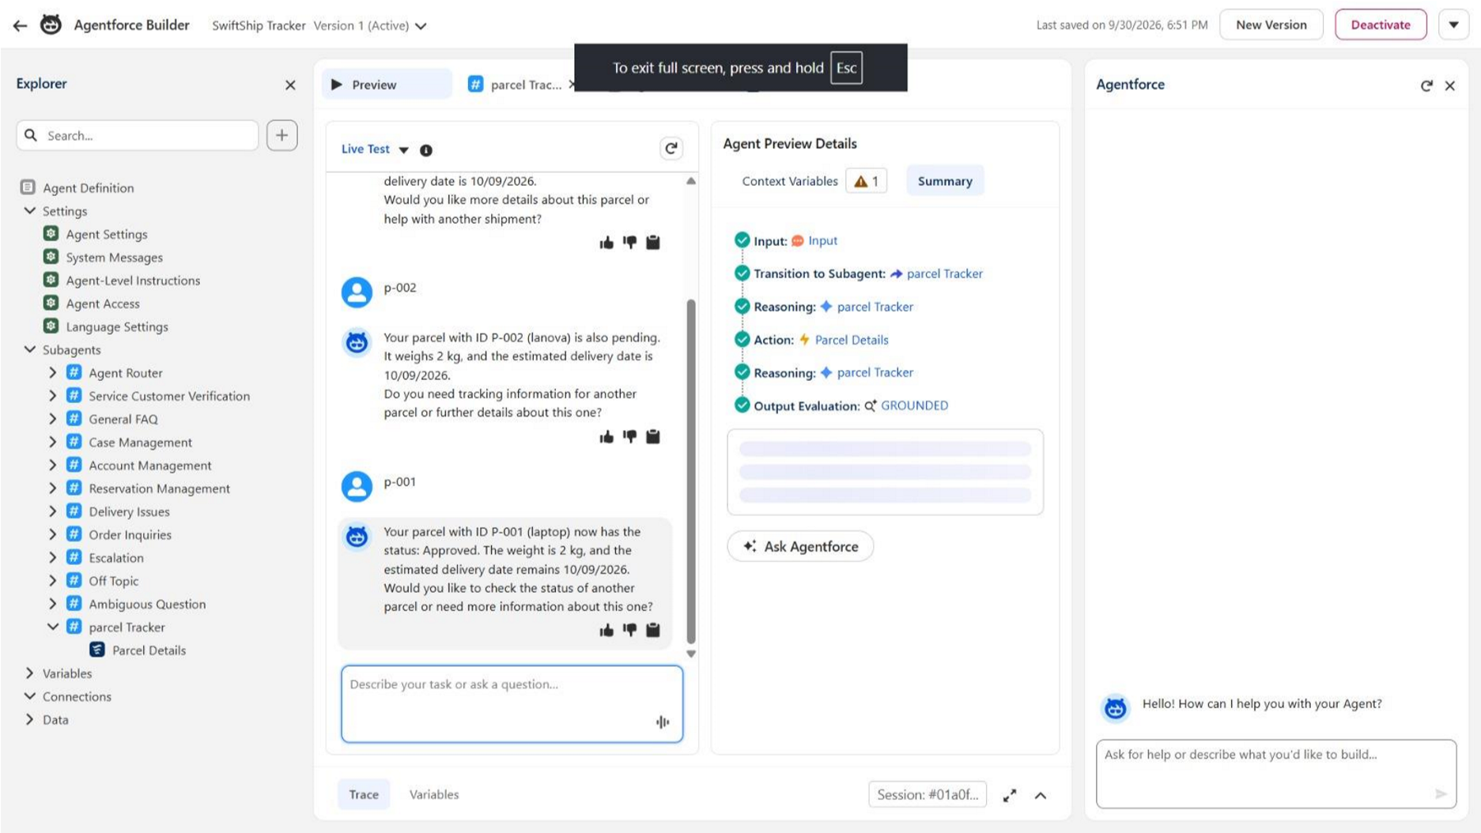

APPENDIX C – SAMPLE USER INTERACTION
User: Track parcel P-12345.
Agent: I will check the parcel information using the parcel identifier.
System action: The agent invokes the parcel-retrieval Flow and passes the identifier as input.
Flow: Get Records searches Parcel__c for a record whose Parcel_ID__c matches the supplied value.
Prompt action: The selected Parcel record is used to generate a summary containing Parcel ID, Status, Weight and Estimated Delivery Date.
Agent response: The response is returned to the user in a readable format. Replace the sample identifier with a real test record when capturing evidence.

APPENDIX D – PROJECT TEAM
Project Title: Swift Ship Tracker. Institution: P B College of Engineering. Team ID: SWTID2026-7193. Team Size: 4.
Team Leader: Pugazhanthi M.
Team Members: MohanSundar E, Neelu Sakthi Priyan S, Barath RV.
Suggested work areas include requirement analysis and report coordination; Salesforce object and field configuration; Flow and prompt configuration; Agentforce setup and permission testing; and screenshot collection and final documentation.
Update the task allocation according to the work actually performed by each member. All members should review the final report so it accurately represents the completed project.

