**Contamination simulation**

The fraction of contaminated units and concentration of dioxins in the compound feeds or milk at different stages were estimated in Table 4.

**Low and mid fractions of contamination scenarios**

Feed mills stage:

At feed mill stage, 100 feed mills were evenly distributed among 10 regions. It was assumed that the low and middle level of fraction of contaminated feed mills (1% and 5%) were all localized in the same region. Then in the simulation, one region were randomly selected, and in the selected region, 1 or 5 feed mills were randomly chosen as the contaminated feed mills.

At farm stages, 20000 dairy farms were evenly distributed among 10 regions. Based on assumption that each farm only collected compound feeds from one feed mill (i.e. one feed mill connects to 200 farms) in the same region, the farms were ranked by the connection with feed mills among 10 regions. Then in the simulation, one region were randomly selected, and in the selected region 1 or 5 groups of farms (each group contain 200 farms connected to one feed mill and these farms were spatial correlated) were randomly selected as contaminated farms.

At dairy truck and processing plant stages, 5000 dairy trucks and 100 processing plants (with 25 silos per plant) were evenly distributed among 10 regions. Here the connection from dairy farms to processing plants through trucks were assumed to be not transparent, and the contaminated trucks and silos were randomly generated among 10 regions with the estimated fraction (in Table 4).

**High fraction of contamination scenario**

It was assumed that 10% of feed mills were all localized in two random regions (in our case, the extreme situation were assumed with 2% and 8% separately). As described above, 2 and 8 groups of dairy farms (each group contain 200 farms connected to one feed mill) were randomly selected in these 2 regions. Then with estimated contamination fractions, the contaminated trucks and silos were randomly selected among the 10 regions.

The corresponding R codes were available and one example of low contamination fraction scenario was shown in Figure 1 and one example of sampling strategies with 20 samples was shown in Figure 2.

: one contaminated feed mill; : 200 contaminated dairy farms connected to one feed mill; : one contaminated dairy truck; : one contaminated storage silo.

**Figure 1.** Contamination distribution in each dairy chain stage with original contamination F1%C7.5: (a) contamination distribution at feed mill; (b) contamination distribution at dairy farms; (c) contamination distribution at dairy trucks; (d) contamination distribution at milk silos in plants.

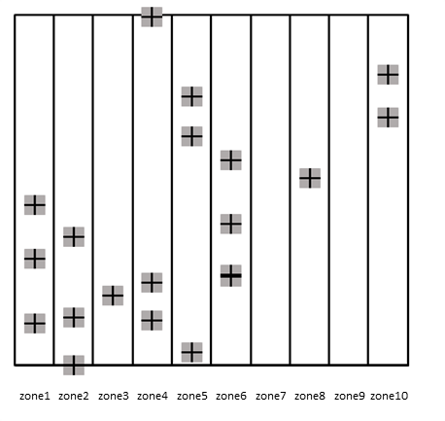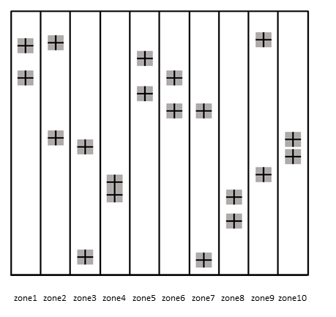

(a)SRS (b)STRS

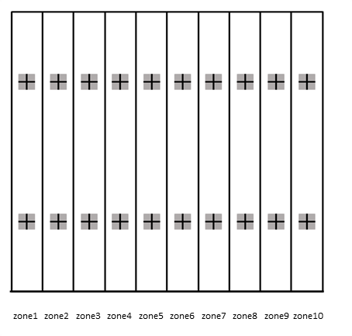: one sample collected among target production units

(c)SS

**Figure 2.** Sampling strategies application to sampling 20 units among 10 regions. (a) simple random sampling (SRS), (b) stratified random sampling (STRS), (c) systematic sampling (SS).