Unzip the ZIP file and Import the VM with Windows Hyper-V manager
VM setup for GPU pass-through Instructions (Step 2 to Step 5): https://github.com/puichuentam/dxgkrnl_ubuntu
After setup for GPU pass-through, On VM:
- Then do the following:
  - “docker run -it -v riva-model-repo:/data ubuntu”
  - “apt-get update”
  - “apt-get install nano”
  - “cd /data/models/tts_preprocessor-English-US”
  - “nano config.pbtxt”
  - Change the value of max_input_length to 4096
  - Change the value of max_sequence_length to 4096
  - Ctrl + X --> Y --> Enter to save changes
  - “exit”
  - “cd files”
  - “bash riva_start.sh” (then you should notice your host GPU memory is eaten up by this)
  - Riva should listen to port 50051 by default
- Check your vm’s local IP address with
  - “ip addr”
  - Then replace your IP address on Line 21 and Line 127 of the attached Python script
- Execute
  - “OLLAMA_HOST=VM’s IP address:11434 ollama serve”
  - ollama should listen to port 11434 by default

- VM should be ready (You should have 2 Terminal windows opened: one for viewing the logs from ollama, and another for running “bash riva_start.sh”, see the photo next page)

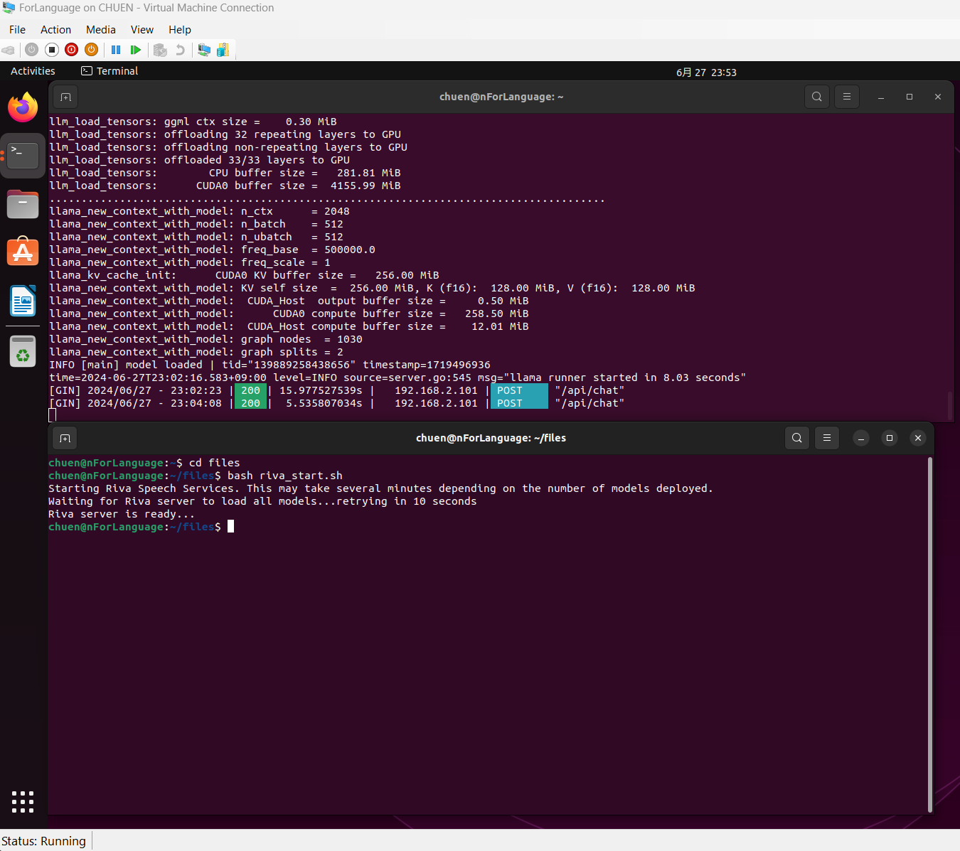

On Host Machine:
- Install Python (if not yet installed)
- Install all the necessary Python packages to run the Python script
  - “pip install nvidia-riva-client”
  - “pip install requests”
  - “pip install ollama”
- Open cmd or Powershell for Terminal
- Navigate to the folder where the script was downloaded
- Check your input and output device with the following
  - “python .\local_chatbot.py --list-input-devices” (mine is 1)
    - Remember the number of the correct device
  - “python .\local_chatbot.py --list-output-devices”
    - Remember the number of the correct device (mine is 3)
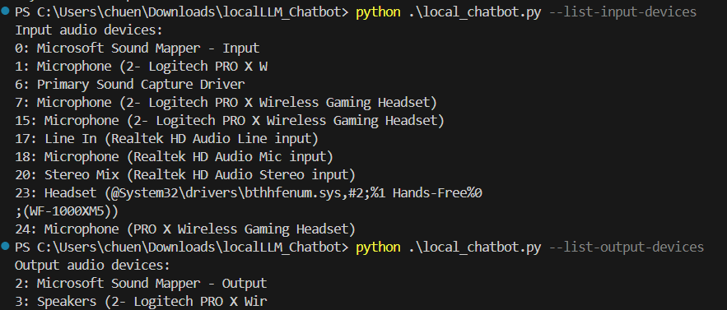
- Execute
  - “python .\local_chatbot.py --input-device 1 --output-device 3”
- Speak “Hello” to initiate the chat
- Ask a question that tells Lllama3 to answer it in a very simple way
  - Because we’ve set NVIDIA Triton model to have a maximum input text length of 4096
- Wait for about 20-30 seconds (depending on GPU power) to receive an audio answer.
- When finished
  - Ctrl + C to exit the Python script

From scratch, below are the steps and script to reproduce the result shown in my video
On VM:
- Ubuntu 22.04 + Hyper V + Enhanced Session mode + XRDP PulseAudio
- VM setup for GPU pass-through Instructions
- On VM, Login to NVIDIA NGC Catalog and download NGC CLI Instructions
- Create an API key
- Execute the following command on VM terminal, enter your API key when prompted:
  - “ngc config set”
- Execute the following command to download Riva
  - “ngc registry resource download-version nvidia/riva/riva_quickstart:2.15.1”
- Navigate to the folder riva_quickstart_v2.15.1, and execute the following command
  - “bash riva_init.sh” (it will take about 15-20 minutes to finish the setup)
- After the setup is finished
  - “docker run -it -v riva-model-repo:/data ubuntu”
  - “apt-get update”
  - “apt-get install nano”
  - “cd /data/models/tts_preprocessor-English-US”
  - “nano config.pbtxt”
  - Change the value of max_input_length to 4096
  - Change the value of max_sequence_length to 4096
  - Ctrl + X --> Y --> Enter to save changes --> type “exit” Enter
  - “bash riva_start.sh” (then you should notice your host GPU memory is eaten up by this)
  - Riva should listen to port 50051 by default
- On Terminal of the VM, install Ollama with
  - “curl -fsSL https://ollama.com/install.sh | sh”
- Execute the following
  - “ollama pull llama3:instruct”
(This will download llama3:8b instruct to your VM)
- Check your vm’s local IP address with
  - “ip addr” Then replace your IP address on Line 21 and Line 127 of the attached Python script
- Execute
  - “OLLAMA_HOST=VM’s IP ADDRESS:11434 ollama serve”
ollama should listen to port 11434 by default
- VM should be ready (You should have 2 Terminal windows opened: one for viewing the logs from ollama, and another for running “bash riva_start.sh”
On Host Machine:
- Install Python (if not yet installed)
- Install all the necessary Python packages to run the Python script
  - “pip install nvidia-riva-client”
  - “pip install requests”
  - “pip install ollama”
- Open cmd or Powershell for Terminal
- Navigate to the folder where the script was downloaded
- Check your input and output device with the following
  - “python .\local_chatbot.py --list-input-devices” (mine is 1)
    - Remember the number of the correct device
  - “python .\local_chatbot.py --list-output-devices”
    - Remember the number of the correct device (mine is 3)
- Execute
  - “python .\local_chatbot.py --input-device 1 --output-device 3”
- Speak “Hello” to initiate the chat
- Ask a question that tells Lllama3 to answer it in a very simple way
  - Because we’ve set NVIDIA Triton model to have a maximum input text length of 4096
- Wait for about 20-30 seconds (depending on GPU power) to receive an audio answer.
- When finished
  - Ctrl + C to exit the Python script

