OPTICS in Clean
Authors
Patrick Uiterwijk
Robin Smit

Abstract
Text body

Previous work
The interesting thing about this project is that a lot of descriptions can be found on the internet. All of these, however, target imperative implementations. What we will try to do is to provide a functional implementation of the OPTICS algorithm for clustering.

Method
As for many programs, it's generally a good idea to make sure one has a clear understanding of what the program to be implemented should accomplish, and the way in which that result should be achieved.

Test case
We though of a test case that would provide us with an input allowing us to easily see the results of our algorithm. We took a diagram from the web and extracted it's color values. Our functional OPTICS algorithm should then be able to cluster these values into main colors, generating an image that looks like the original one. Below is an example of such a diagram and it's original color plot:
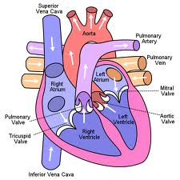
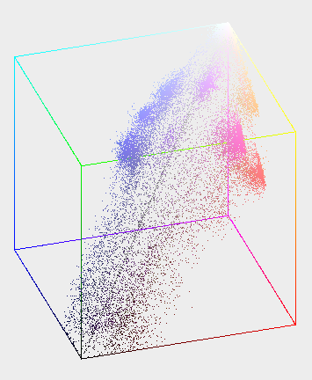

Main results
We have implemented the OPTICS algorithm in Clean – a functional language. The program itself can be found in the appendix to this report. Following is a description of how the algorithm works.
Data
First, what we need is a form of Euclidean distance between two points

Analysis
Text body

Evaluation

Project outcome
Text body

Expectations
Text body

Future directions

Appendix

