**Follow the steps to configure the MySQL server/installation:**

1. From the given locations, delete MySQL folders (If Available)

"C:\Program Files (x86)"

"C:\Program Files"

“C:\ProgramData\”

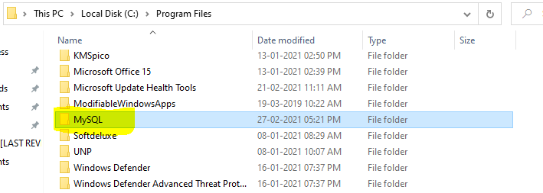

Important note: ProgramData is a hidden folder in most of the systems.

Write down the following path in the search bar (image attached)

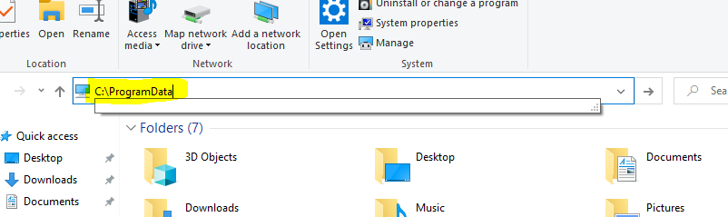

1. **From the given link, download the file selected in the image attached. Link: (**[**Link**](https://dev.mysql.com/downloads/installer/)**)**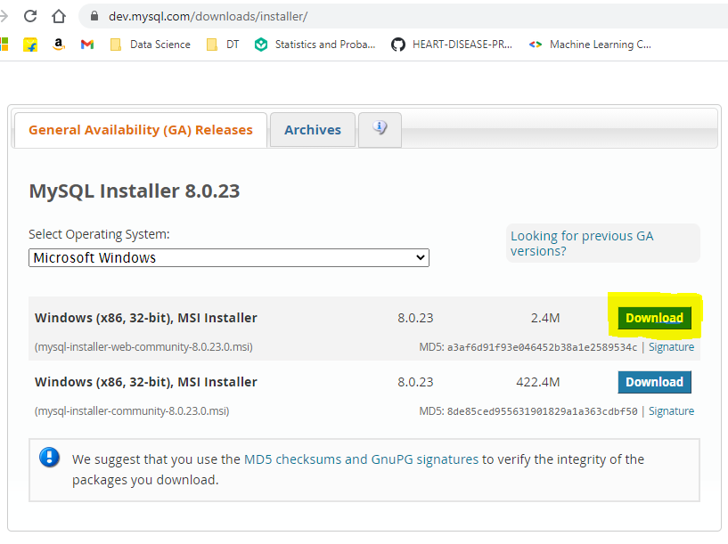
2. After Opening the downloaded file, if you see a screen similar to the image attached, click on the Add option. (There might be applications already added)

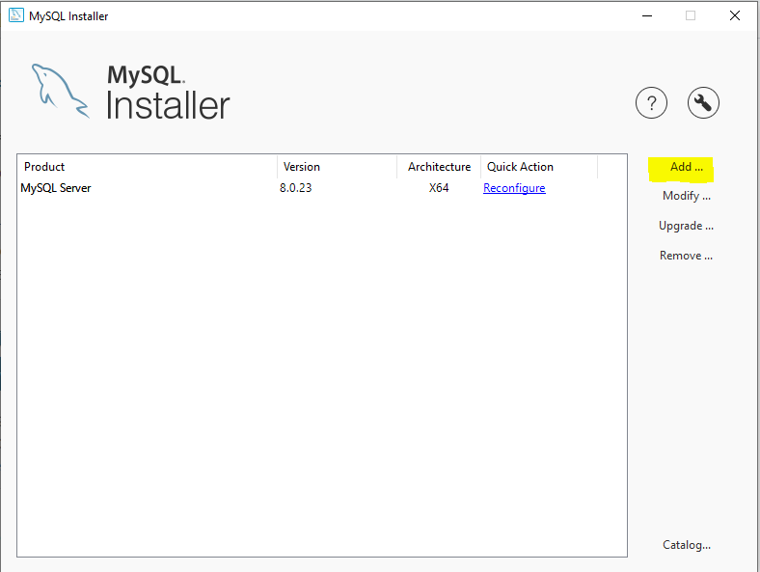

1. The Add option will open the interface as shown in the image, now you need to manually select the application you want to install. Once you select the application, click on the arrow key to add in the installation list.

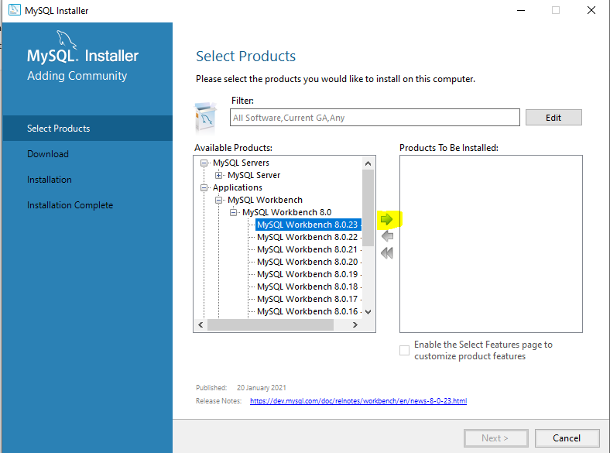

1. Select all the programs from the applications selected in the right installation application list. (Refer the image to select the applications)

After selection, click on the next button.

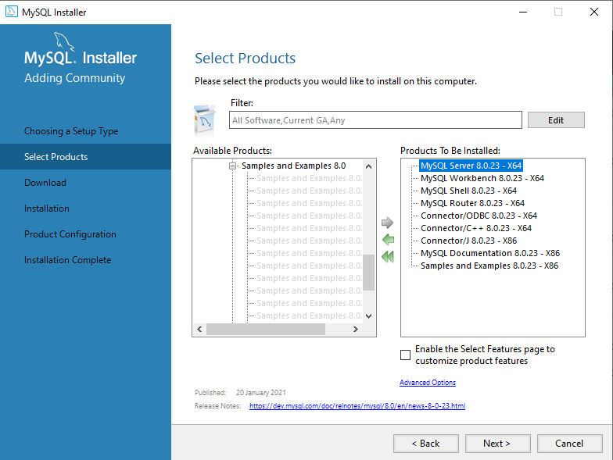

1. After clicking next, this application box will open, click on execute 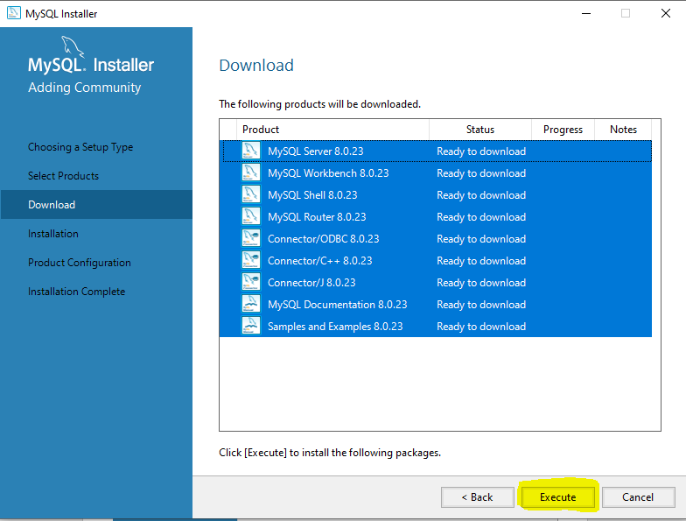
2. this will start downloading the application setup from the servers. If any download fails, do not do anything, it will start again automatically. Once done, click on Next.

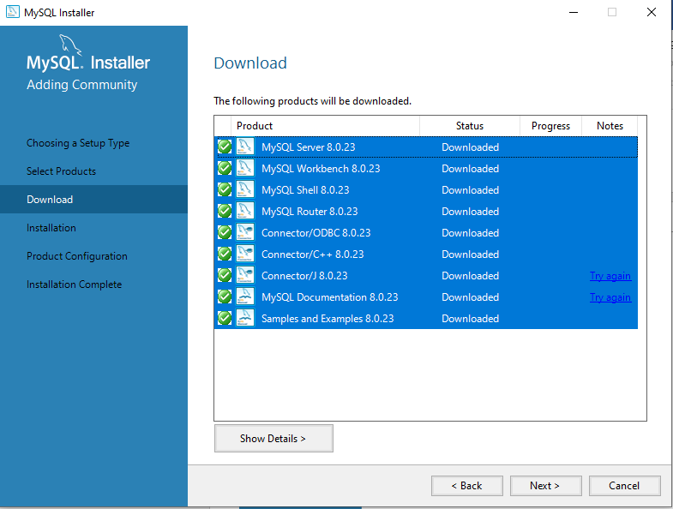

1. After clicking Next, you then have to click on execute to install all these applications. (this may take a while so do not close the application)

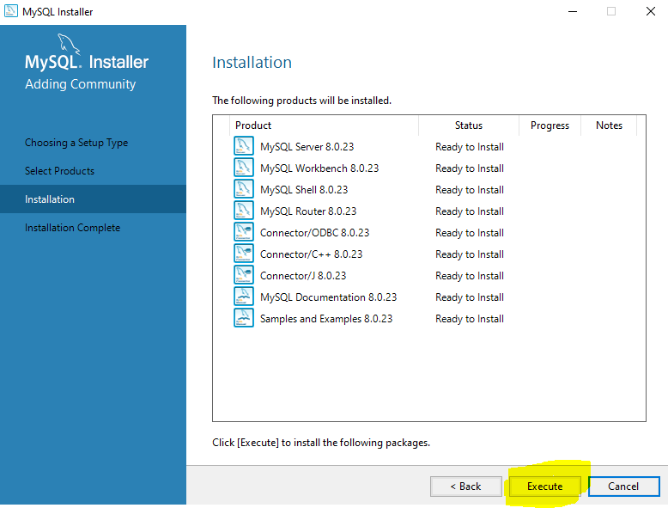

1. After the installation is done, click on the next button as shown in the image below.

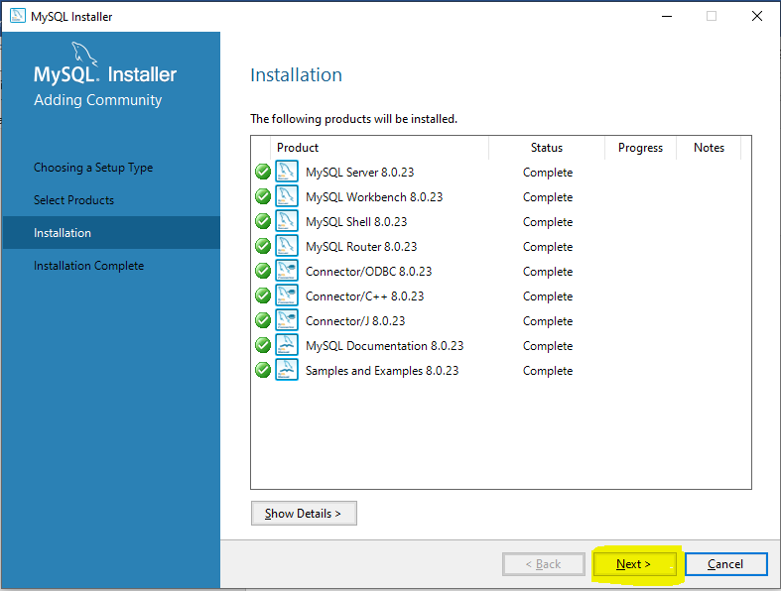

1. After previous step, the completion of installation will appear. Click on the finish button. (This may open multiple MySQL applications, close them all to proceed to the next step)

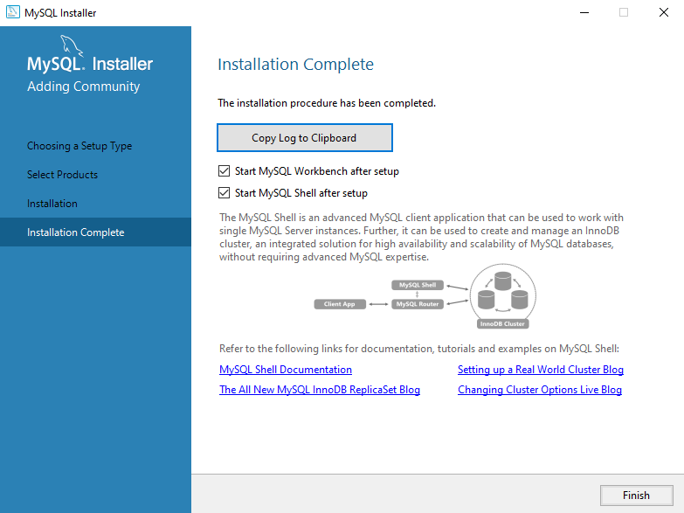

1. Double-Click on the installer package you downloaded to open it. Now we need to configure the applications we have installed. Use the following order to configure:

* MySQL Server
* MySQL Router
* Sample and Examples

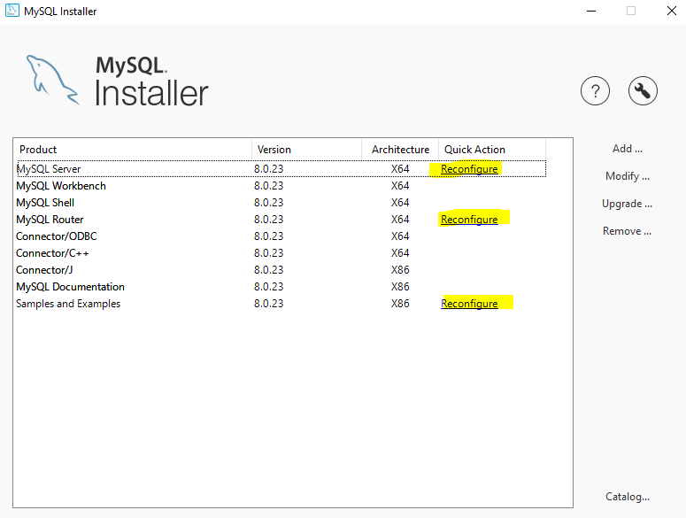

1. After clicking on the reconfigure option, the given window will open, You don’t have to select any options here. Simply, click on next.

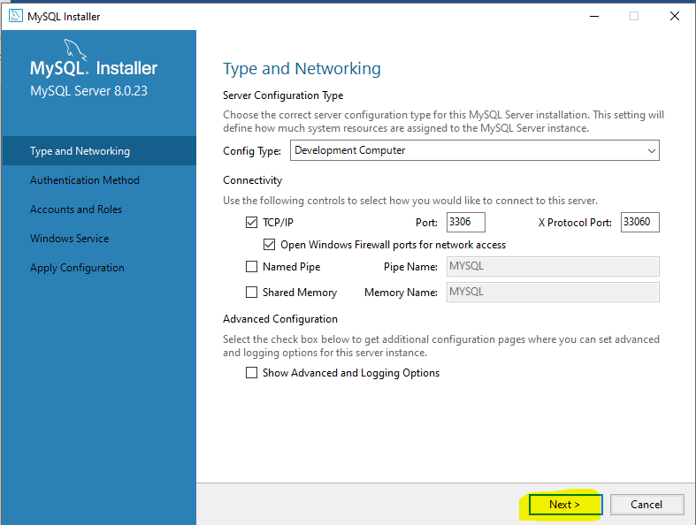

1. After the previous step, authentication method window will open, keep the options as it is, click on the next.

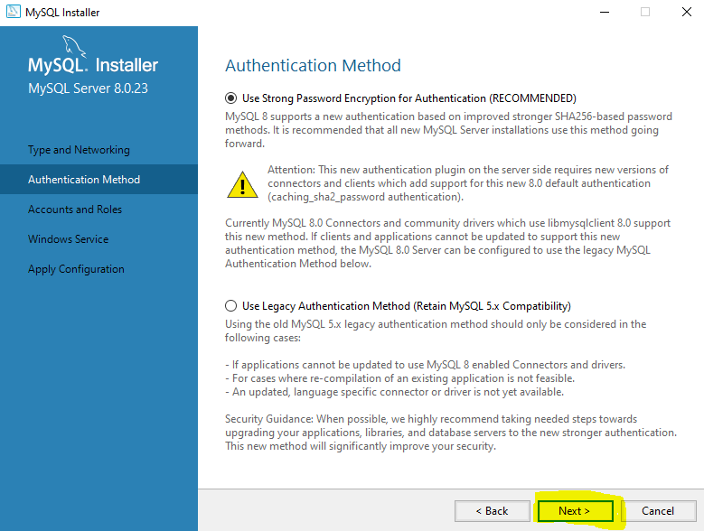

1. Now, you need to enter the MySQL password (Keep it simple), click on the next option.

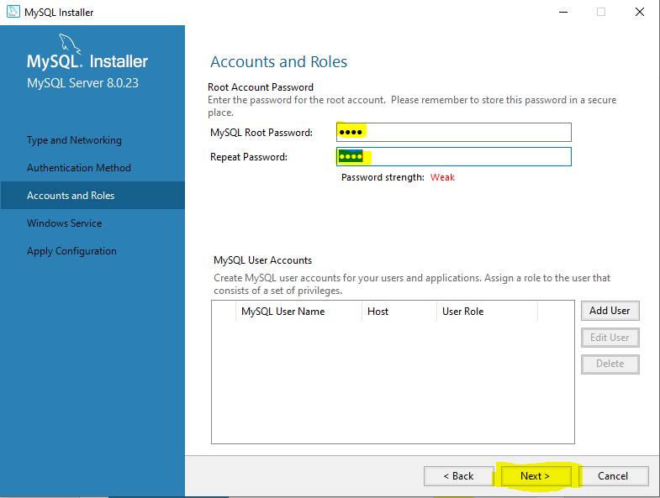

1. Click on the next option. (no need to select any option, use the default settings).

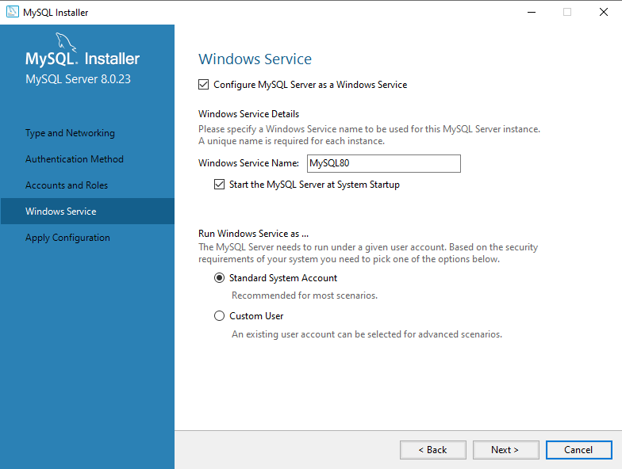

1. Click on Execute. (DO NOT CLOSE THIS WINDOW, IT MAY TAKE SOME TIME TO CONFIGURE)

Once the configuration is done, click on finish.

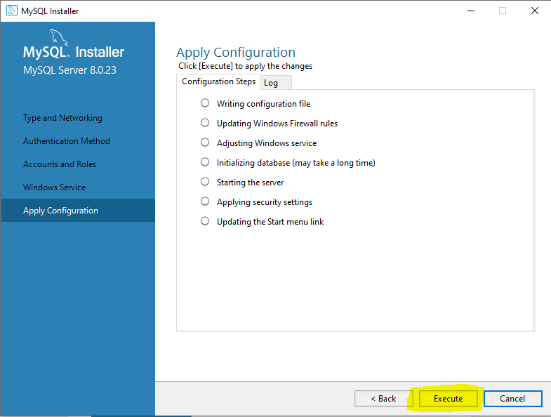

1. Click on the highlighted option on Installer.

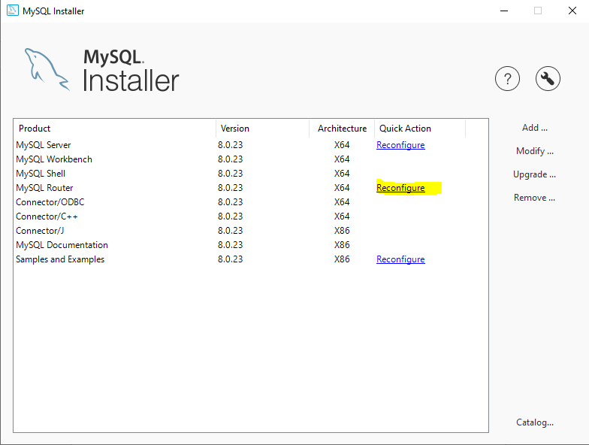

1. Click on the Finish button. (No need to make any modification)

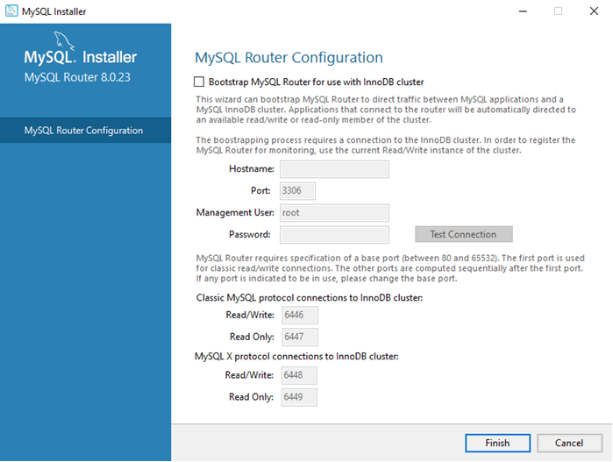

1. Click on the Reconfigure option from the installer.

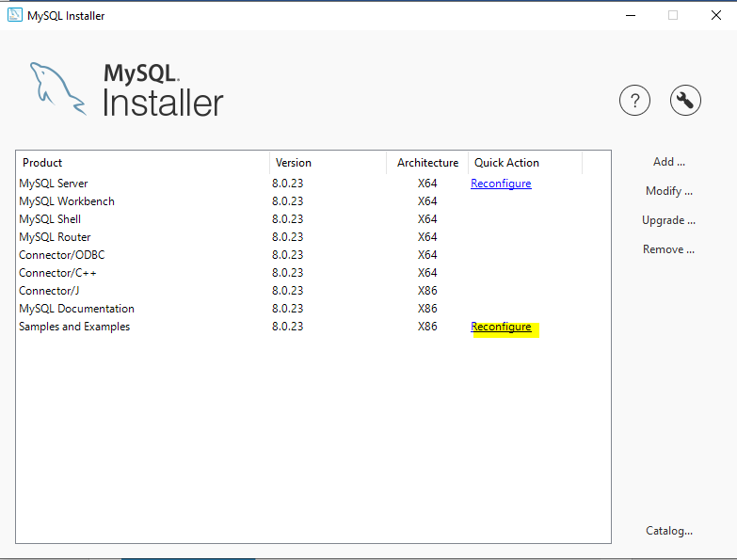

1. At the bottom, enter your MySQL password, click on the check. Once done, click on next.

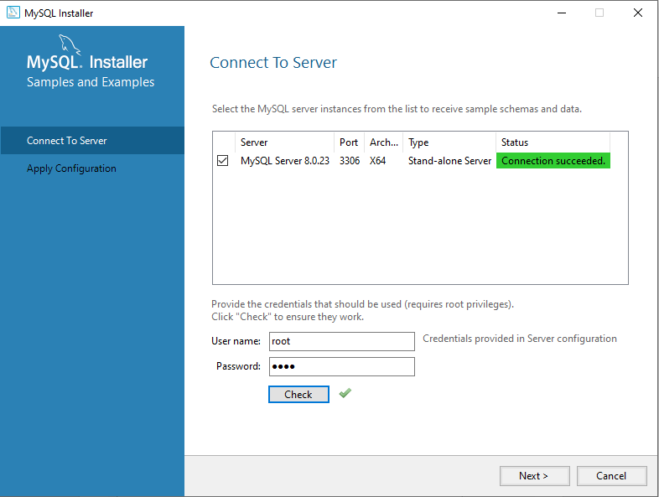

1. Click on execute. (this may take some time to configure, do not close the installation)

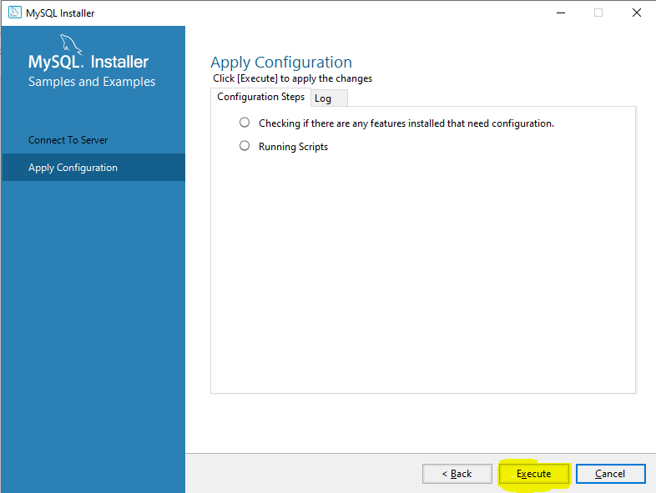

1. Once done, click on finish.

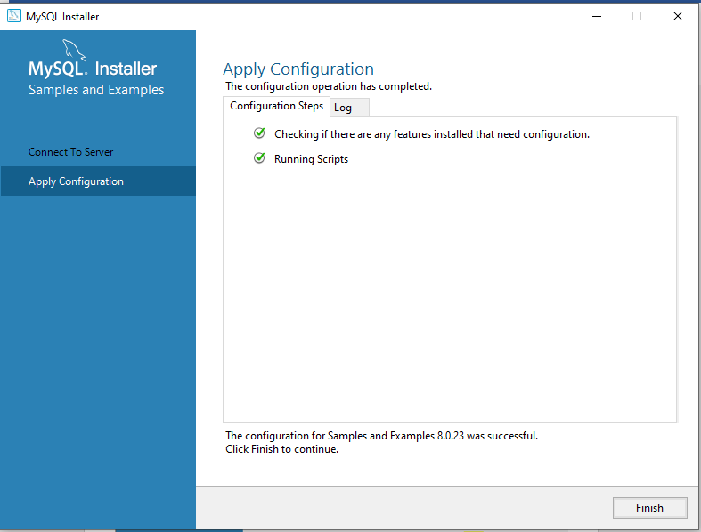

Now the MySQL installation is complete, To test if the application has installed successfully, follow the below steps.

1. On windows search bar, write down the highlighted text and open the Application.

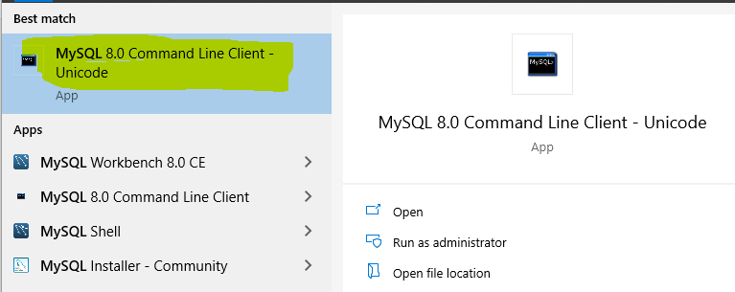

1. The application will open a command line prompt like window, you need to enter the MySQL password and press Enter. This will open the MySQL command line interface.

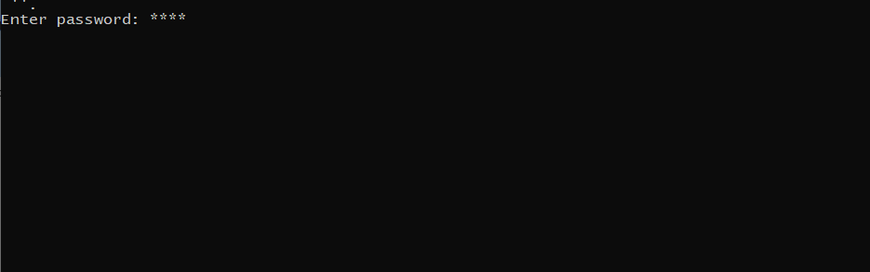

MySQL command line interface

