**SP24: CMPE-277 Sec 48 - Smartphone App Dev**

**Assignment #2:** Implicit Intent - WebLinkAndPhoneCallApp

**Prof Name:** Chandrasekar Vuppalapati

**Student Name:** Puja Kumari

**Student ID:** 017460157

**Learning Objective**: the goal of the assignment is to apply implicit intent concepts and invoke web link & phone calls.

GitHub link –

Screenshots-

* The main activity page gets launched while opening the app. It contains 2 implicit intent features –Web URL launch and Phone calls

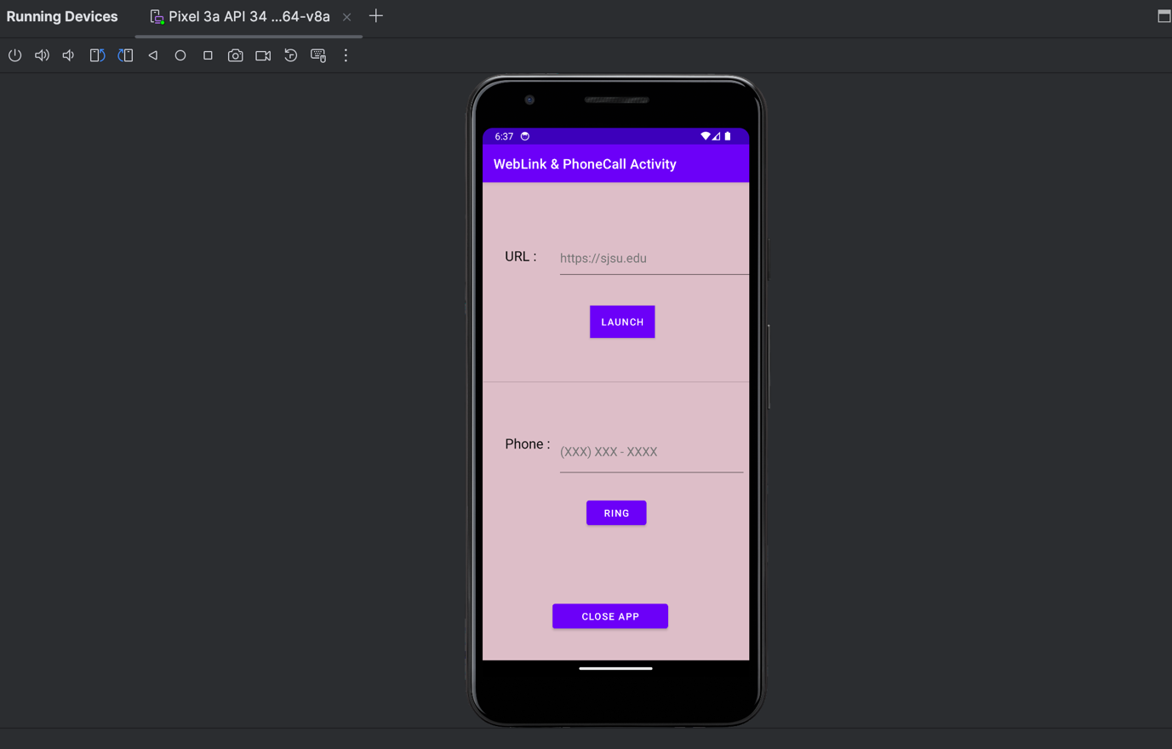

* Type the website link in the URL text box and click on the launch button.

Entered URL – “www.google.com”

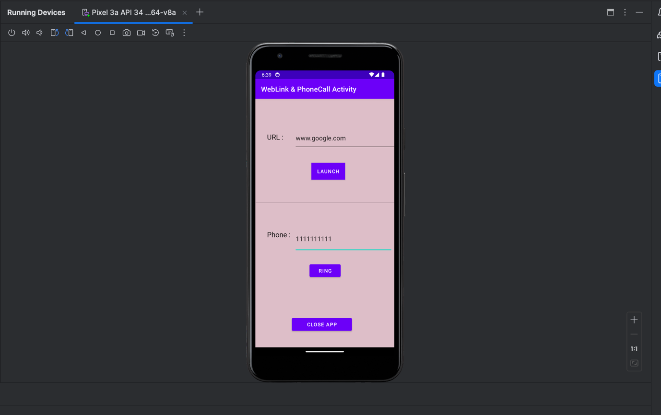

* After entering the URL and clicking on the launch button, the Google Chrome app gets launched and it loads the requested URL webpage.

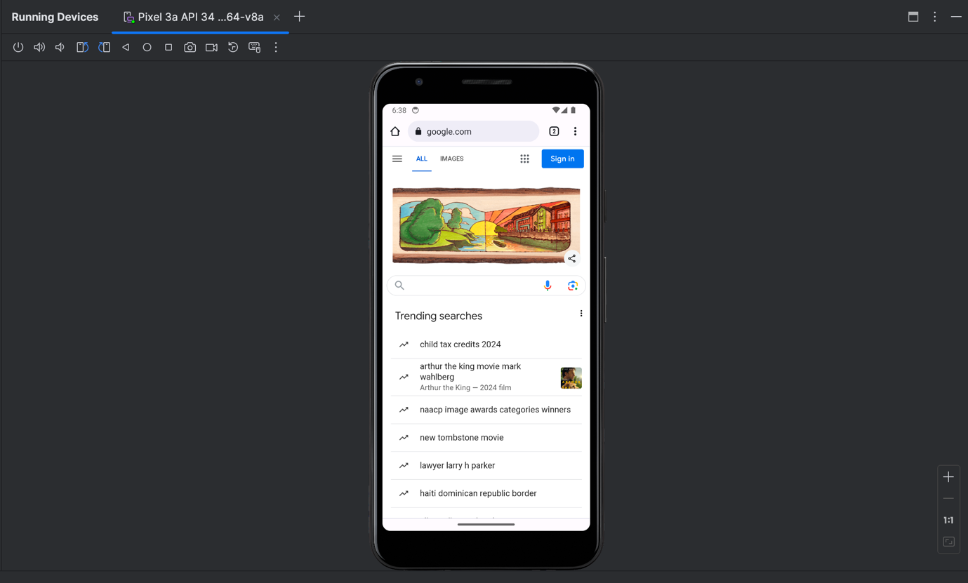

* Type the Phone Number in the Phone text box and click on the RING button



* After clicking on the RING button, it opens the dialer and calls the entered number.

