RESUME

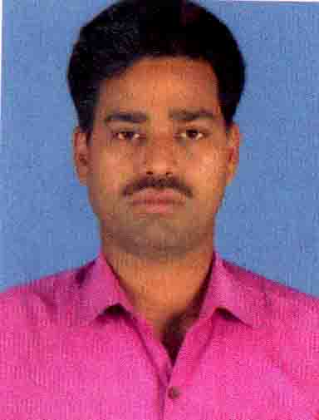
NAME- SUSHANTA KUMAR NAYAK
S/O-NURSINGH CHARAN NAYAK
At-TALADUMUKA
PO-NANDAPUR
P.S- Tihidi
Dist- Bhadrak
State-ODISHA
Pin-756138
Mobile-7008525229
Mail Id-marriotsushanta@gmail.com
CAREER OBJECTIVES: `

- To work in an environment this is conductive to the professional advancement in which I can apply my skills and professional experience and to give the organization the maximum return for the investment it has made for me and to prove myself as an asset for this organization.

ACADEMIC QUALIFICATION:

Examination Passed | Name of The Board/ University | Year of Passing | percentage
10th | BSE | 1998 | 68%
+2 Arts | CHSE ODISHA | 2000 | 55%
EXPERIENCE
- Hotel marriot international (2012to2017) Oparation manager
- Hotel Green castle (2017to 2021) Restaurant manager
- Hotel Hello Bhadrak (2021to2022) F&B Manager
- Hotel Swaad Bhadrak (2022to2024) Restaurant manager
- Hotel Bilorin Bhubaneswar (2024to2025) Restaurant manager
STRENTH:-
- Self confidence
- Hardworking

PERSONAL DETAILS:

Father’s Name : Nrusingh Charan Nayak
Mother’s Name :Ramamani nayak
Date of Birth 18/08/1981
Sex : Male
Marital status : Married
Languages Known : Oriya, English,Bengali & Hindi
Nationality : Indian
Religion : Hindu

DECLARATION

I do hereby solemnly declare that all the above information is true with the best of my knowledge and belief.

Place: ( Sushanta Kumar Nayak )
Date:
Signature of the Candidate

