**Management Solution to the issues of water bodies in India**

**Overview**

It is a need of time that all our water bodies (streams, rivers, ponds, lakes, wells and groundwater) need some attention, and actions are required to resolve the problems of Exploitation, Encroachment and Pollution. Currently there is no solid information available which accurately categorize the water bodies as per location and the issue(s) associated with it. In general, it is said that all our water bodies are in danger. But this statement alone is not sufficient information to take corrective / constructive actions to save the water bodies and to take actions against the people who are reasons of these issues. It is required to have information of: what is the issue, what are reasons of the issue and who caused these issues, location and severity of the issues. So that actions can be planned and resources (money, manpower, time) will be better utilized to overcome issues.

**Management Problem**

There is no system available which has useful information to categorize the water bodies area wise and associated issue(s) wise. No system is available to find out reasons of dangers on any river.

No information available on:

* Which water body has issues
* Which water body has issues of which kind (Exploitation, Encroachment, Pollution)
* What are the severity levels of the issues for particular water body
* Who are responsible for creating issues to our water body
* In which geographical area, the issue exists
* What are the reasons (industrial waste, domestic waste, people using motor pumps for extracting water, builders have encroached the river area etc.)
* What kinds of actions are necessary to take in which geographical area
* Are there any local leaders or NGOs looking into the issues

**Management Solution**

We can have consolidated information on above mentioned points and plan to take necessary action. Resources like money, manpower and time can be allocated as per the situation. We can take help of digital technology to achieve the required information. We can create a Management Information System which will collect data and produce information to help management take corrective/constructive actions.

**Current Scope**

In version-1, we will target only one water body type – Rivers. Hence the next steps will be applicable to Rivers. River data will be collected from users and will be processed to fetch useful information to help resolve the water body problems.

**Proposed Solution**

Create a Riverbook application. It will have following functionalities:

1. User Registration (Secondary function)
2. User Login (Secondary function)
3. User enters a record for a river (Primary function)

It includes following fields:

* River name
* Location on that river
* The problems associated with that river. (Exploitation and/or Encroachment and/or Pollution)
* Severity of the issue (High / medium / low)
* Other fields like date and time, user name will be auto filled by the system)

1. User will be able to tag rivers of his interest
2. User will be able to tag people whose updates he wants to follow.
3. System will produce charts/ human understandable results in terms of severity of issues on any river location wise.

The technology will support to achieve this.

(Annexute-1 provides the details on the technology architecture, data structures and implementation).

Annexure – I

**Technology architecture**

Frontend: AngularJS (to create Mobile application with required user interfaces)

Database: Mongodb (To store information in NOSQL format)

API layer: Node.js (To access mongodb database)

Fig -1: Diagram for Technology Architecture

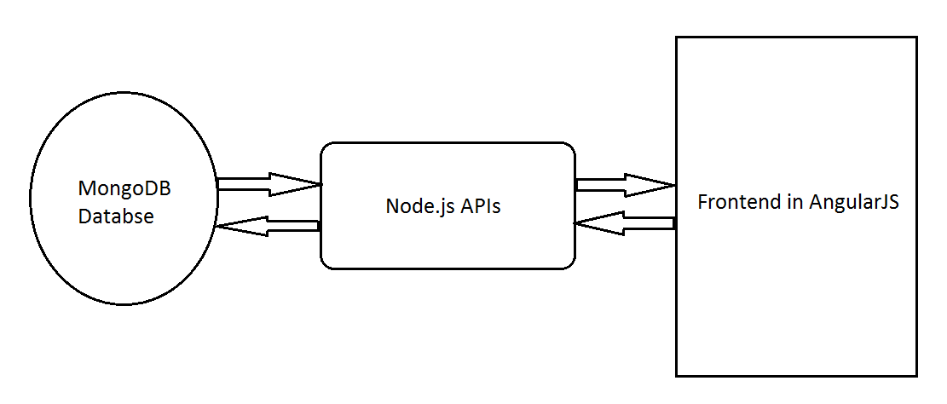

Fig -2: River Object structure:

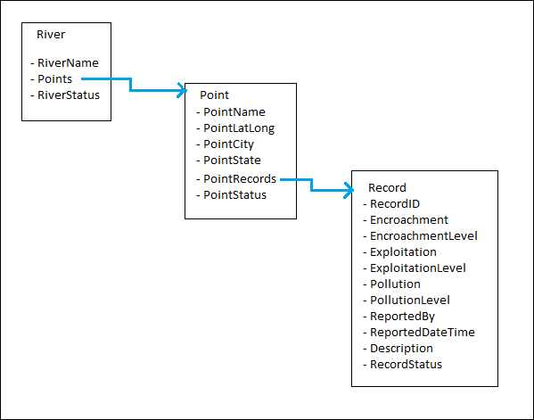

**Methodology to calculate/decide the color code of status for records, points and overall river**

As we saw that the status of the records, points and overall river are not entered by end user. This will be calculated by the application using following methodologies:

**Step 1: For status of Record**

* Green: If exploitation, encroachment and pollution are green for this record
* Orange: if any of exploitation, encroachment or pollution is orange but not red
* Red: if any of the exploitation, encroachment or pollution is red

**Step2: For status of Point**

This step uses record status calculated in step 1

* Green: if majority of the records for this point has status as green
* Orange: if majority of the records for this point has status as orange
* Red: if majority of the records for this point has status as red

Note: we can do mathematical calculations over here, like count all records for this point and then follow above procedure. This will be repeated as and when there is a new record entry.

**Step 3: For overall river status**

This step uses point status calculated in step 2

* Green: if majority of the points for this river has status as green
* Orange: if majority of the points for this river has status as orange
* Red: if majority of the points for this river has status as red

The significance of the color code of Overall river status is as follows:

* Green: Natural flow of water, no human intervention
* Orange: Human intervention
* Red: Severe human intervention

**Example of River Object with Points and Records:**

{

"rivers": [{

"name": "Mula Mutha",

"points": [ {

"pointName": "Mhatre bridge",

"pointCity": "Pune",

"pointState": "Maharashtra",

"pointRecords": [{

"encroachment": "1",

"encroachmentLevel": "low",

"exploitation": "2",

"exploitationLevel": "medium",

"pollution": "3",

"pollutionLevel": "high",

"reportedBy": "Some User1",

"reportedDateTime": "31/07/2019 10:22:00",

"Description": "Industrial waste",

"**recordStatus**": "**red**" //note - this is not entered by user. This is calculated from encroachment, exploitation and pollution levels for this point.

},

{

"encroachment": "1",

"encroachmentLevel": "low",

"exploitation": "1",

"exploitationLevel": "low",

"pollution": "1",

"pollutionLevel": "low",

"reportedBy": "Some User2",

"reportedDateTime": "31/07/2019 11:22:00",

"Description": "No human interference",

"**recordStatus**": "**green**" }

],

"**pointStatus**": "**red**" // This is calculated from the status of multiple records for this point

},

{

"pointName": "Lakdi pool",

"pointCity": "Pune",

"pointState": "Maharashtra",

"pointRecords": [{

"encroachment": "1",

"encroachmentLevel": "low",

"exploitation": "2",

"exploitationLevel": "medium",

"pollution": "1",

"pollutionLevel": "low",

"reportedBy": "Some User3",

"reportedDateTime": "31/07/2019 12:22:00",

"Description": "Exploited by motor pumps",

"**recordStatus**": "**orange**"

},

{

"encroachment": "1",

"encroachmentLevel": "low",

"exploitation": "1",

"exploitationLevel": "low",

"pollution": "1",

"pollutionLevel": "low",

"reportedBy": "Some User4",

"reportedDateTime": "31/07/2019 14:22:00",

"Description": "Highly polluted",

"**recordStatus**": "**green**"

}

],

"**pointStatus**": "**orange**"

}

],

"**overallStatus**": "**red**" // this is calculated from the status of multiple points for this river

}

]

}