Plant soil live monitoring using IoT with serveless cloud

Abhi Yelipeddi  Computer Engineering  San Jose State University  Santa Clara, USA  abhi.yelipeddi@sjsu.edu | Manoj Kumar  Computer Engineering  San Jose State University  Santa Clara, USA  manoj.kumar@sjsu.edu | Puja Kawale  Computer Engineering  San Jose State University  Santa Clara, USA  puja.kawale@sjsu.edu | Renato Cordeiro  Computer Engineering  San Jose State University  Santa Clara, USA  renato.silveiracordeiro@sjsu.edu
Shalini Narang
Computer Engineering
San Jose State University
Santa Clara, USA
shalini.narang@sjsu.edu

Abstract— The decreasing cost of sensors and chips have been contributing to a more general access to technologies that were before restricted to companies and wealthy individuals. This research presents a plant soil monitoring solution based on IoT devices powered by a serverless cloud architecture, allowing home users to have a live monitoring data of a plant soil and its environment.
Keywords—plants, soil, moisture, IoT, serverless, cloud, sensor, arduino, raspberry pi, monitoring

Introduction
Audrey Hepburn very rightly said "To plant a garden is to believe in tomorrow." Gardening is a great stress buster and improves one's mood. A nice garden or having some potted plants in any house enhances the look and feel of it. But it is not uncommon for these plants die due to one the following reasons:
- The plant owner forgets to water on time because of his busy schedule.
- The plant owner over-waters or under-waters the plant due to ignorance.
- A plant owner has many plants and it gets difficult for him to keep a track of individual plant needs.
Our team proposes a IoT mobile based project that can provide a way to overcome the issues mentioned above. The proposed solution, called Vaseuno, uses sensors to track the moisture level of the plant’s soil and the environment temperature and humidity around the plant. Those data are uploaded to a cloud serverless architecture, providing the end user with ubiquitous access to the plant’s information and also alerting when the current level of temperature or moisture require the plant to be watered.

The remaining of this paper is organized as Literature Review, Project Structure (which includes the equipment used and the hardware and software architecture), Results and Future work.

Literature Review
Soil monitoring has been a topic of significant research in the last years since it is the cornerstone for Precision agriculture [1].
[1] provided an overview of different technologies around soil monitoring sensors, including Potentiometric, Conductimetric/Impedance, Amperometric/Voltametric and Optical types.
[2] developed a plant monitoring system that measures soil moisture, temperature, humidity and light using an Arduino based microcontroller. Their system does not provide cloud integration or a mobile app to data visualization.
[3] created a distributed soil monitoring system where each sensor node was comprised of 9V battery powered PIC controller with a moisture sensor and a Zigbee transmitter. The central node was powered by a Raspberry Pi with Zigbee receiver. The central node sends and save the data in the cloud.

Project Structure

Project Organization
The project was structured in three separated components, which allowed the team to work on each of them simultaneously. The project components can be seen in the Fig. 1 below.
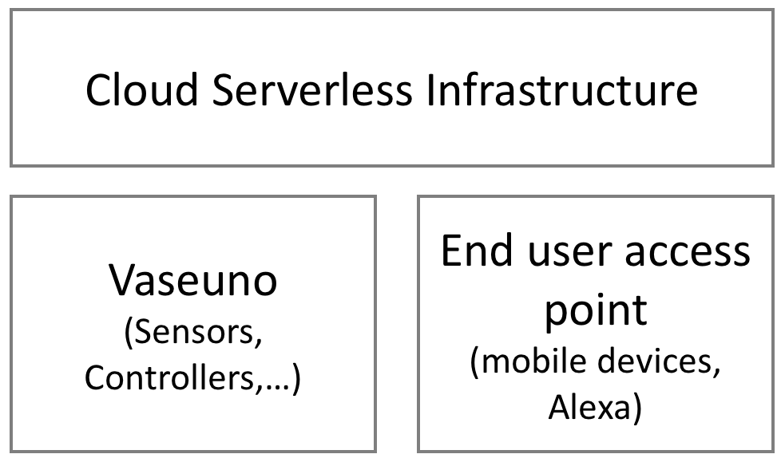
- Solution componets
The details of each component are provided in the following sections.

Vaseuno Component
This component includes all the hardware required to monitor the plant’s data and it is called Vaseuno, in reference to a plant’s vase merged with an Arduino. During project development we decided to also use a Raspberry Pi due to its enhanced capabilities like built-in WiFi and Bluetooth. The complete list of equipment used is showed on the Table I below.
- Equipments used for Vaseuno
Quantity | Name | Estimated Cost ($)
1 | Raspberry Pi 3 B+ | 50
1 | Battery pack for Raspberry Pi | 19
1 | Arduino Pro | 10
1 | Moisture Sensor | 1
1 | DHT11 Temperature and Humidity Sensor | 4
1 | Breadboard | 1
1 | Cable micro-USB to USB-A | 4
15 | Jumper wires | 1
Total |  | 90

At first look the use of both Raspberry Pi and Arduino appears to be redundant but that is required due to the fact that the soil moisture sensor only outputs an analog signal and the Raspberry Pi only has digital pins. Therefore, Arduino was used to read the analog data from the sensor, process it and send it to Raspberry Pi via USB serial communication at 115200 bits per seconds. Fig. 2 below shows the Raspberry Pi and Arduino used in this project and how they are connected.
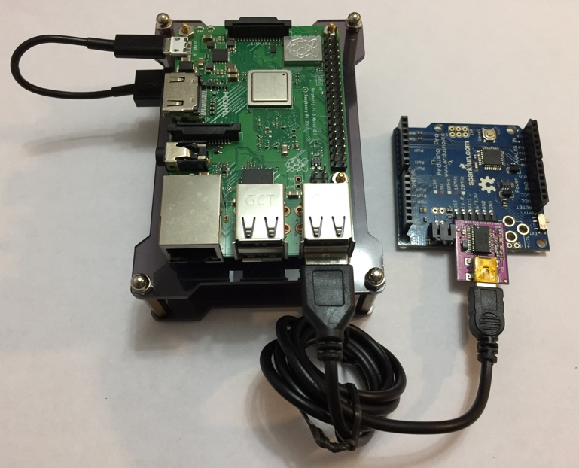
- Raspberry Pi and Arduino connected via USB
We decided to acquire and use a battery extension pack to Raspberry Pi so we can have the entire Vaseuno component totally free to move. The Raspberry Pi receives both data coming from the Arduino and from the temperature and humidity sensor and sends them to the cloud serverless infrastructure detailed on the next section. Fig. 3 below shows the two sensors used in this project.
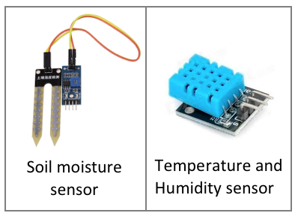
- Soil Moisture and Temperature and Humidity sensor
A breadboard was also used but just to facilitate the physical connections between components and therefore is not a required component. An external soil moisture measurement tool (iPower Soil pH Meter) was also used to validate the data acquired. The complete system solution can be seen in Fig. 4.
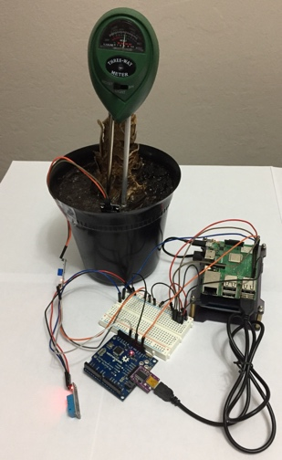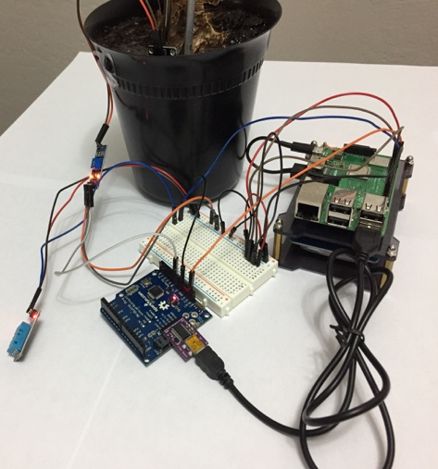
- Complete system solution
The Arduino code is very simple and direct and can be seen in Fig. 5 below.
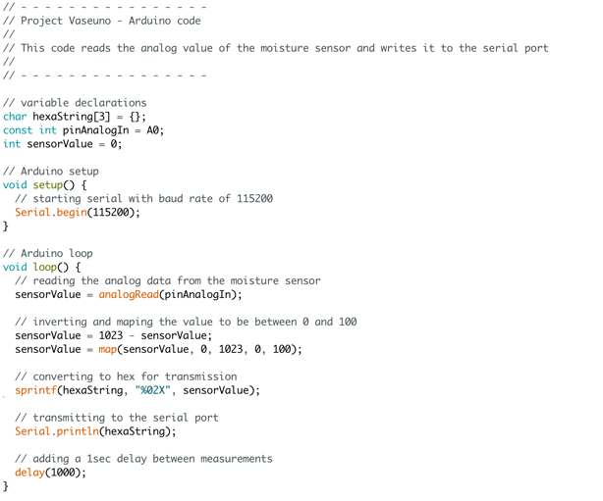
- Arduino code
The code responsible for receiving the plant and environment data running on Raspberry Pi was developed using Python language. It follows a continuously loop of data gathering and submission to the cloud as can be seen in Fig. 6 below. The data being monitored – soil moisture, temperature and humidity – doesn’t change quickly over a very small period of time; therefore, a delay of 3 seconds was added at the end of each loop in order to decrease the amount of that data being captured, transferred and stored in the cloud. That delay contributes to the system to save energy, which should always be a concern when developing for embedded systems. A condition check against the last submitted data is also executed on each loop in order to only send to the cloud data that is not repeated.
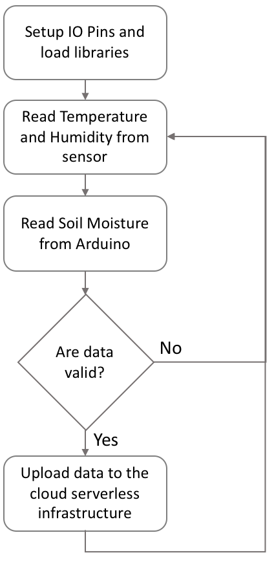
- Raspberry Pi main code flow

Cloud Serverless Infrastructure Component
This project used Google Cloud Firebase to receive the plant’s data. That data is also processed in Cloud Functions in order to identify when threshold was met and then notify the end user if the case. The availability of Google Cloud Firestore SDKs for both Raspberry Pi and mobile platforms (iOS and Android) was one the main factors that made us chose Google Cloud. That SDK allowed us to write to the Firestore noSQL database directly from the Raspberry Pi while making the read of those data also very easy on the mobile device. The Fig 7 below illustrates the Google Cloud infrastructure.
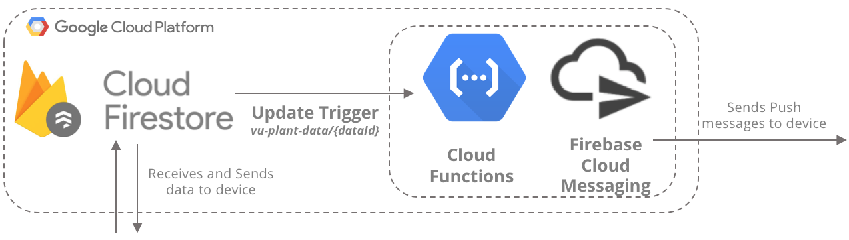
- Google Cloud Platform architecture
We also used AWS Lambda functions to add support to Amazon Alexa devices. When the end user asks our Alexa Skill for the plant’s data, the Lambda function gets the data directly from Google Cloud Firestore and Alexa returns it to the user. The architecture of the AWS infrastructure can be seen in Fig. 8 below.
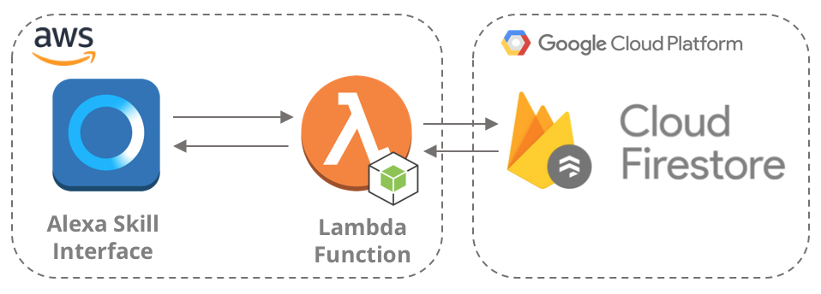
- AWS architecture

End User Component
The plant’s data is stored in the cloud and thus accessible from everywhere in the world where the user has access to internet. The data can be accessed using the Android mobile app developed specially for this project or via the Alexa Skill also created by the team. The Android mobile is detailed in greater extend in the next section.

Android Mobile App

Features
The Android app was developed from the beginning to have the following features:
- Security of data and communication
- Bluetooth Low Energy (BLE) communication
- Wireless internet connection
- Account Registration and Login
- Visualization of live plant’s data
- Ease of use

Security
Security was achieved by not only using HTTPS protocol for transferring data but also having a custom X.509 certificate inside that app that is used to sign all requests to the cloud serverless architecture. Due to the temporal nature of the data, we decided to not store them locally, reducing then the attack surface of the app.

Bluetooth Low Energy (BLE)
The Raspberry Pi requires internet connection to transmit the sensor data to the cloud. That creates a problem since the device would not know how to connect to the internet, i.e, which WiFi SSID and password it should use. To overcome that issue, Bluetooth protocol is used to allow the mobile app to provide the WiFi information to the Raspberry Pi. Since Vaseuno is battery constrained, BLE was used as an energy optimized alternative to the standard Bluetooth. The absence of pairing, which is usually a friction point for users – especially non-tech ones – is also a plus that influenced on its choice.
Although BLE doesn’t use pairing, the devices still need to create a connection between them in order to transfer data. The entity that has the data to be transferred is defined as the Peripheral device and the one that wants to receive the data is defined as the Central device [4]. In the presented system, the mobile app is the Central device and the Raspberry Pi is the Peripheral device as can be seen in Fig. 9 below.
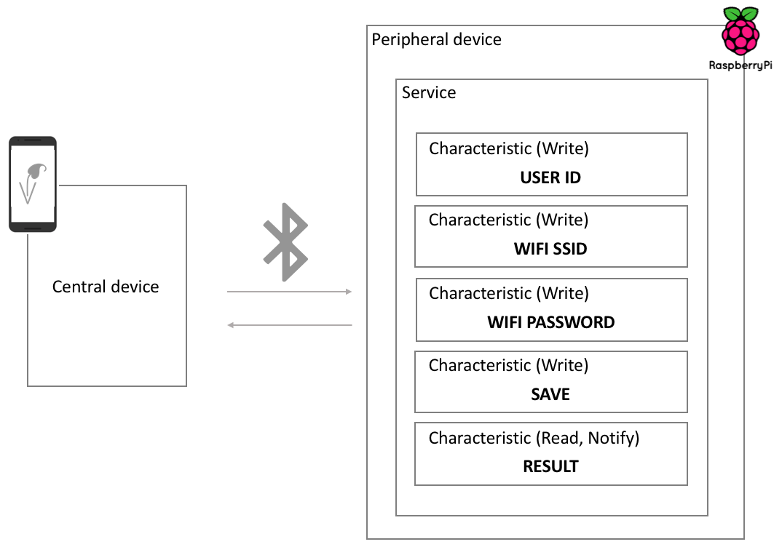
- Registration and Setup Wireframe Flow
The Peripheral device has one service with five characteristics. Four of those are writable and the remaining one is readable and can also be subscribed to. The characteristics UUID used, their respective descriptors value and a brief description is provided in Table II below.
- Peripheral Characteristics
Characteristic  UUID | Descriptor  Value | Description
0AE53426-EE5C-44F1-862B-82DD3DF3AD21 | User id | Receives the User Id logged in the app
18A7B15D-C9A7-45EE-8B72-FBAF5DA4B495 | WiFi SSID | Receives the WiFi SSID to connect to
23F7464D-AE0F-4854-B986-E0E5A204ADE1 | WiFi Password | Receives the WiFi password, if any
378B0CEA-275F-4F74-90CD-6D31D8F3298D | Save WiFi Credentials | Tries to connect to the supplied WiFi network
4F8387D5-0C8A-4CF4-8FA7-D6FC3402EA53 | WiFi connection result | Returns if the device was able to connect to the supplied WiFi network

The Bluetooth that creates the Peripheral device on the Raspberry Pi was developed using Node.JS with the Bleno library. A system service was created that runs that node.js code on boot, so the device starts broadcasting as soon as it is powered on and the system finished loading.

App Architecture
Based on the features described previously, the app was created under the architecture illustrated on Fig. 10 below.
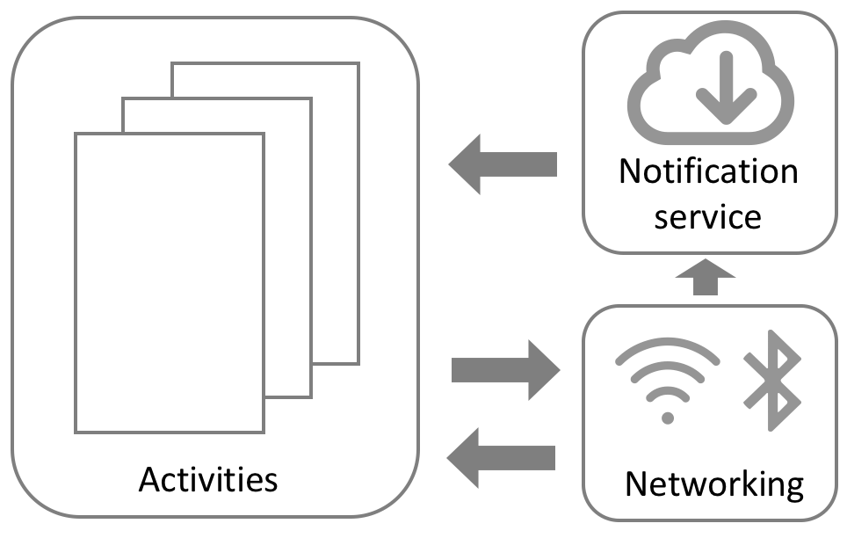
- App architecture
The Android mobile application is composed of a set of Activities that are used to receive user input and show data back to the user. A notification service runs in the background and is responsible for the plant’s live data update. Activities also communicates with different networking protocols to exchange information with the cloud infrastructure as well as with the Vaseuno system.

Registration and Setup Flow
After installed, the app prompts the user to create an account by asking for user, email address and password. That information is securely transferred over https to the cloud serverless infrastructure. Fig. 11 below illustrates the registration flow.
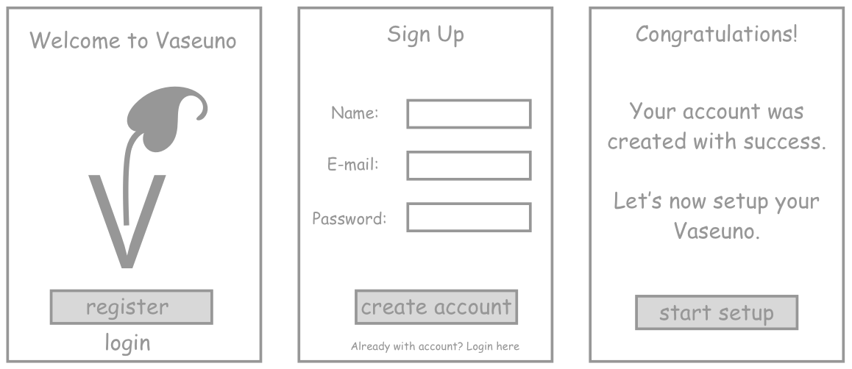
- Registration and Setup Wireframe Flow
After the registration, the user is asked to provide the WiFi SSID and password that would be sent to the Raspberry Pi via Bluetooth Low Energy. The Fig. 12 below shows the wireframe of the setup flow.
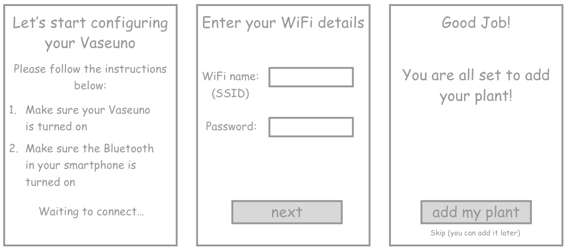
- Registration and Setup Wireframe Flow
The Raspberry Pi was configured to act as a BLE Peripheral with the advertisement name of Vaseuno with one Service composed of four characteristics with write properties and one with read and notify properties. A more detail explanation about the BLE configuration was provided on the previous section.

Normal Usage Flow
A user who has already an account created would enter the app by just entering his login credentials. The normal usage flow would then be applied. Those who don’t have a plant added would see a dashboard asking to add a new plant data. Fig. 13 below shows the flow of a user without plant.
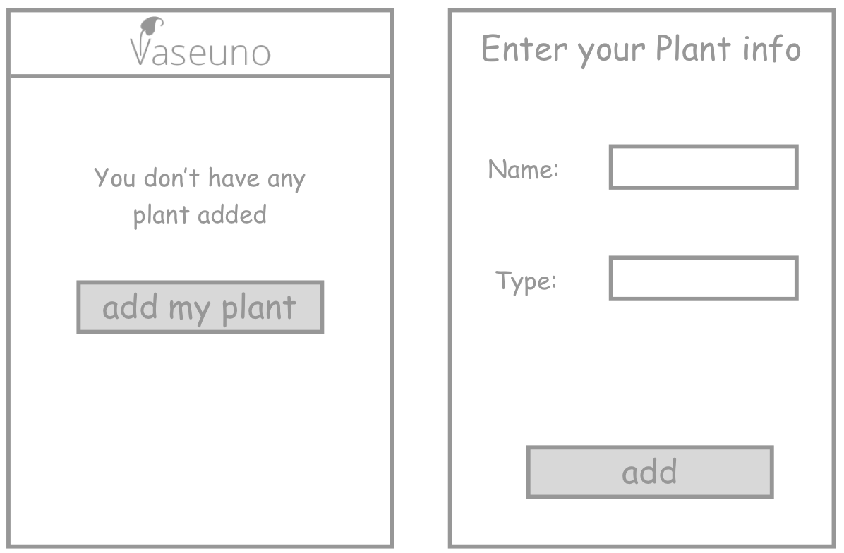
- Adding a new plant flow
Users with plants already added would be able to visualize the actual plants’ data, including soil moisture and environment temperature and humidity. The system supports live data streaming, so the user can see the plant’s information being updated in real time, without any need to manually ask for a refresh. The Fig. 14 below illustrates the sequence of screens that a user would go during normal usage.
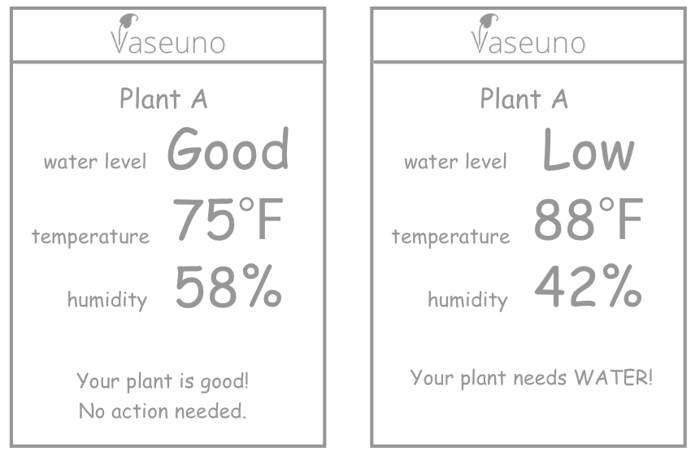
- Dashboard displaynig the plant’s data
The soil moisture data captured by the sensor is pre-processed on the Arduino to be always between 0 and 100. That processed value is then sent to Raspberry Pi which uploads it to the cloud. Instead of just showing that number to the end user, we decided to create three different water levels that are derived from the soil moisture value as shown on Table III below. We believe that doing that translation improves the user’s capability of identifying the real situation of the plant.
- Water Levels based on Soil Moisture Value
Water Level | Soil Moisture Value
Too Much | 90-100
Good | 50-89
Low | 0-49

Instead of using the Android mobile app, the user could also access the plant’s data using the Amazon Alexa device. An Alexa Skills was created using AWS Lambda functions that connect to the Google Cloud Firebase. Therefore, the backend for the Alexa is also a serverless infrastructure, since we only have to manage the Lambda functions and don’t need to worry about physical machines. A common example of interaction with an Alexa to get plant’s information is shown in Fig. 15 below.
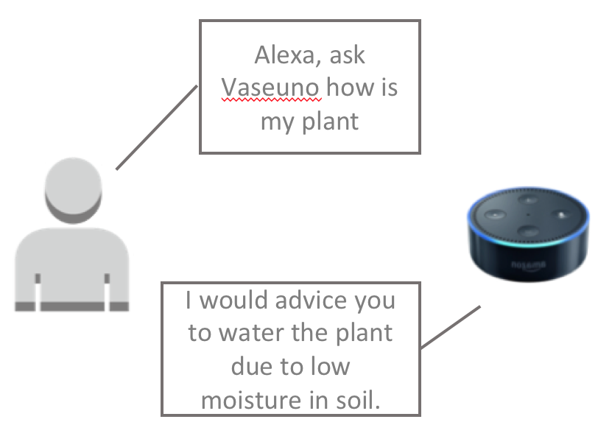
- User – Alexa interaction

Results
The temperature and moisture data reported by the sensors were compared to external measurement tools that served as a comparison check. Temperature data were similar and the moisture values presented an equal increasing pattern when water was added to the soil. Table II below shows a comparison between the soil moisture data provided by our solution and the external soil moisture tool used. The Fig. 16 illustrates the trends of both systems when water was added to the soil and served as a validation tool for our moisture sensor.

- Soil Moisture value comparison
Vaseuno | External measurement tool
62 | 4
71 | 5
76 | 6
83 | 7
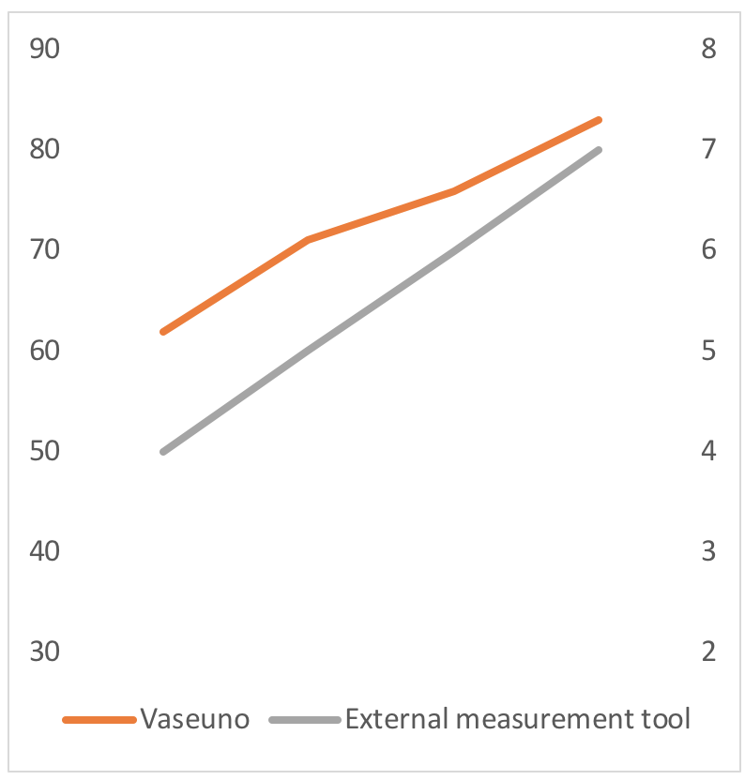
- Evolution of soil moisture when water was added to the vase

Future Work
The work presented in this research paper is just a workable concept of a project that could be turned in a real product. In order to achieve that, some future work should be done in improving both hardware and software, specially aiming in turning the solution smaller and cheaper.
The Arduino could be replaced by an ADC converter and Raspberry Pi could be replaced with a simpler microcontroller. Addition of an LCD display could be an interesting feature for those users that don’t have a smartphone or don’t want to have their plant’s data stored in the cloud. Extra sensors, such photocells, could be added to capture additional relevant data and even be integrated to other hardware that could automatically react to such information. For instance, a light could connect to the system in a way that it would automatically turn on or off depending on the intensity of light that the plant is receiving.
On the software side, the Bluetooth connection, that is now only being used for the initial setup, could also be used to transmit the plant data directly to the end user phone. Changes to support different BLE Peripheral Advertisement name is also interesting since it would allow users to have simultaneous systems at the same time, especially during setup. More Vaseuno settings customization, such as the delay between each measurement could be added in future versions.

References
[1] S. Marios and J. Georgiou, "Precision agriculture: Challenges in sensors and electronics for real-time soil and plant monitoring," 2017 IEEE Biomedical Circuits and Systems Conference (BioCAS), Torino, 2017, pp. 1-4. doi: 10.1109/BIOCAS.2017.8325180

[2] S. Dutta, A. Mitra, S. Chatterjee, S. Lodh and S. Mukherjee, "A sensor-based approach to monitor a specific plant sustainable environment with additional automated rehydration module," 2017 4th International Conference on Opto-Electronics and Applied Optics (Optronix), Kolkata, India, 2017, pp. 1-6. doi: 10.1109/OPTRONIX.2017.8349986

[3] A. M. Ezhilazhahi and P. T. V. Bhuvaneswari, "IoT enabled plant soil moisture monitoring using wireless sensor networks," 2017 Third International Conference on Sensing, Signal Processing and Security (ICSSS), Chennai, 2017, pp. 345-349. doi: 10.1109/SSPS.2017.8071618

[4] R. Karani et al., "Implementation and design issues for using Bluetooth low energy in passive keyless entry systems," 2016 IEEE Annual India Conference (INDICON), Bangalore, 2016, pp. 1-6.
doi: 10.1109/INDICON.2016.7838978

