TypeScript Tutorial

TypeScript(.ts)

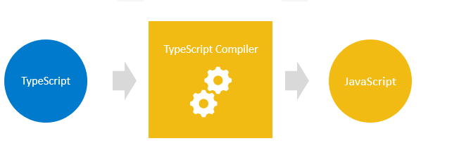
Typescript is a JavaScript with type checking.It helps to detect the errors early even at compile time no need to fully run the code.It is a superset of Javascript as it has everything of javascript and additional features.Any Javascript code is a valid typescript code.

TypeScript Types
TypeScript Types are categorized into two types:
- Primitive type
  - String :represents text data
  - Number :represents numeric data
  - Boolean :has true of false value
  - null :has one value:null
  - Undefined :has one value:undefined.It is default value for uninitialized variable
  - Symbol :represents a unique constant value.

- Objective type
  - Array
  - Function
  - Classes and so.on

Type Annotations(:type;)
Type annotations are used to enforce type checking. Type annotations help the compiler in checking types and helps avoid errors dealing with data types.
Example
Let variable :type;
Let number :int = value;
Let arryName :type[];

Typescript Inference
Type inference means typeScript chooses the best common type that satisfies the given variable.whereas in type annotations users explicitly define the type for the variable.In practices,type inference is widely used.

Typescript Number
All the numbers in typescript are either floating values or big integers(bigint).
Binary number :should be declare by using a leading zero followed by a lowercase or uppercase
letter “B” e.g., 0b or 0B
Octal number :should be declared by using leading zero followed by the letter ‘o’ eg:0o
Hexadecimal Number :should be declared by using leading zero followed by a lowercase or uppercase
letter X (0x or 0X).

Typescript String
- all strings get the string type.
- Like JavaScript, TypeScript uses double quotes ("), single quotes ('), and backtick (`) to surround string literals.

Typescript Boolean
We can declare boolean in a typescript using boolean keyword that has two values:either true or false
- Do not use Boolean type unless you have a good reason to do so.

Boolean Operator
And :&&
OR :||
NOT :!

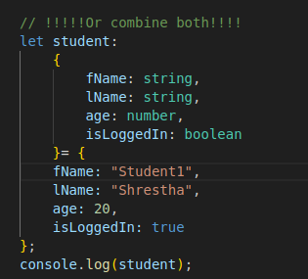
TypeScript Object Type

Object (uppercase O) VS object(lowercase o)
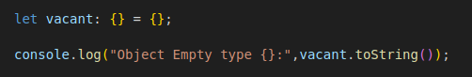
The main difference between these two is that object represents all non-primitive values while Object describes the functionality of all objects.The Object type has the toString() and valueOf() methods that can be accessible by any object.

Output:[object Object]

Typescript Array Type
Typescript array type and its basic operations
Syntax: let arrayName:type[];
:let arrayName :(type1|type2|......|typeN)[];
:let arrName : type[] =[];
All the array methods of JS can be used like push,pop,length,indexof() and so.on.

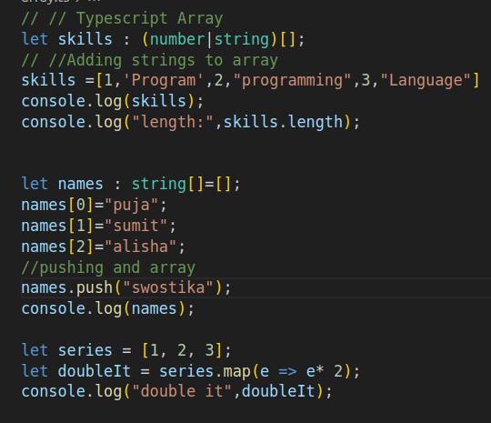
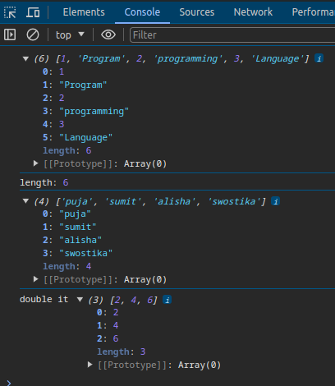

Typescript Tuple Types
Tuple is an array with additional considerations.The number of elements in an array is fixed. You can use tuple to represent a value as a pair.

A tuple can have optional elements specified using the question mark (?) postfix.
For example, you can define an RGBA tuple with the optional alpha channel value:
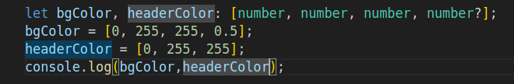

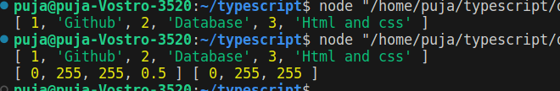

Typescript Enum Types
Enum is the grouped of named constant values
Syntax:enum variableName {constant1,constant2,.......,constantN};
Here constan1,constantN are members of enum
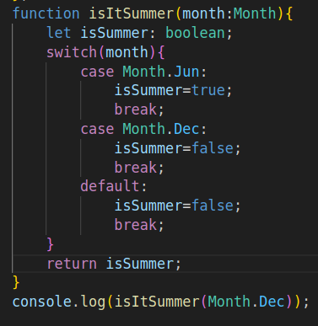
Enum should be used when you have a small set of fixed values that are closely related and these values are known during compile time.

Here we use the Month enum as a type
for month parameter

Typescript Any Type
If you declare a variable without specifying a type, TypeScript assumes that you use the any type.
- The TypeScript any type allows you to store a value of any type. It instructs the compiler to skip type-checking.
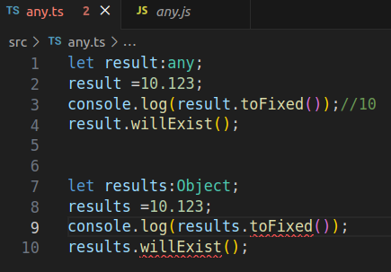
- Use the any type to store a value that you don’t actually know its type at the compile-time or when you migrate a JavaScript project over to a TypeScript project.

Advance Type
- Never type
- Union type Type aliases
- String Literal types

Typescript Never Type
- The never type contains no value.
- The never type represents the return type of a function that always throws an error or a function that contains an indefinite loop.
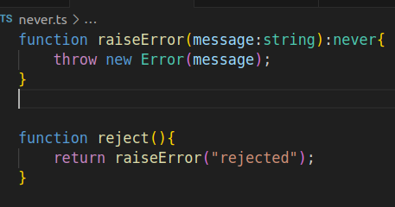
Typically, you use the never type to represent the return type of a function that always throws an error.If you have a function expression that contains an indefinite loop, its return type is also the never type.

Union Types
With Union Types we can give variable or function parameter more than one type

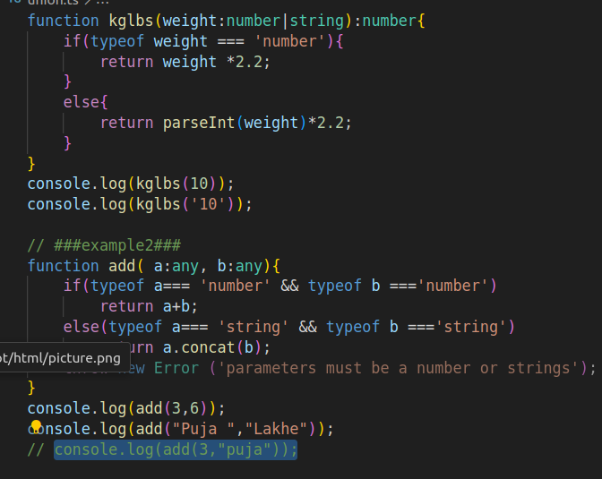

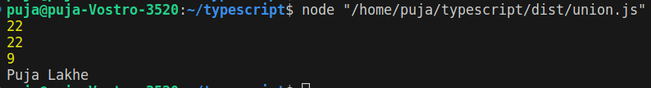

Type Aliases
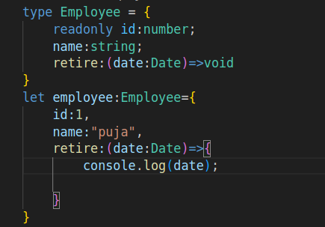
Using this we can define a custom type and reuse the custom type in multiple places.

String Literal Types
- A TypeScript string literal type defines a type that accepts specified string literal.
- Use the string literal types with union types and type aliases to define types that accept a finite set of string literals.
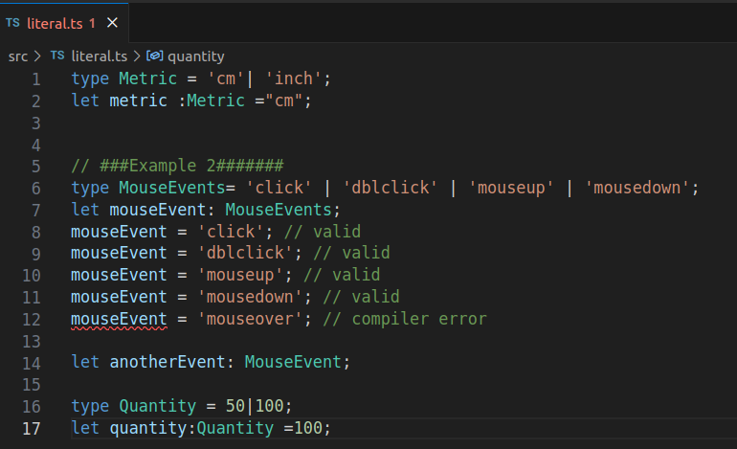

Loops and Iterations
- if else
- switch case
- For
- while
- do while
- break

Typescript Function

Function
Use function keyword to declare a function in TS.Unlike in javascript,TypeScript allows you to use type annotations in parameters and return the value of a function.
Example:
function add (a:number,b:number):number
{ return a+b;
}
The : number after the parentheses indicates the return type.

If a function does not return a value you can use void as a return type.

function echo(message: string): void {
console.log(message.toUpperCase());
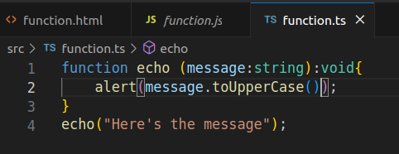
}

Function types
Inferring Function type
By using the type inference, you can significantly reduce the amount of code with annotations.
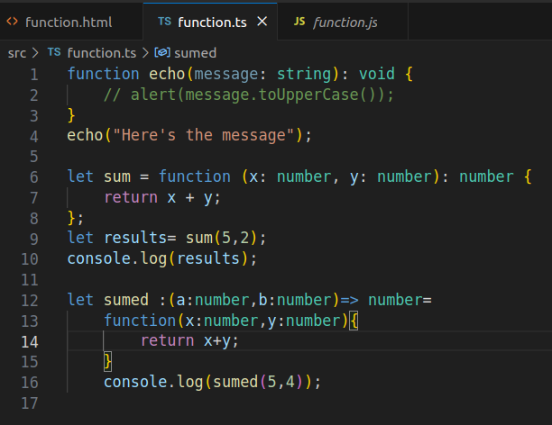

Optional Parameters
To make a function parameter optional, you use the ? after the parameter name.
The optional parameters must appear after the required parameters in the parameter list.
Syntax:parameter?: type

- Use the expression typeof(parameter) !== 'undefined' to check if the parameter has been initialized.

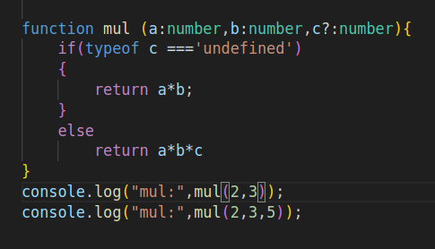

Default Parameter
Default parameters are optional.
To use the default initialized value of a parameter, you omit the argument when calling the function or pass the undefined into the function
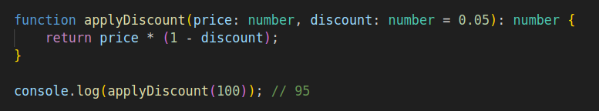
Syntax: parameter:=defaultValue

Rest Parameter
A rest parameter allows a function to accept zero or more arguments of the specified type. In TypeScript, the rest parameters follow these rules:
- A function has only one rest parameter.
- The rest parameter appears last in the parameter list.
- The type of the rest parameter is an array type.
Syntax:
To declare a rest parameter, you prefix the parameter name with three dots and use the array type as the type annotation:
Function fn (...rest:type[]){//}

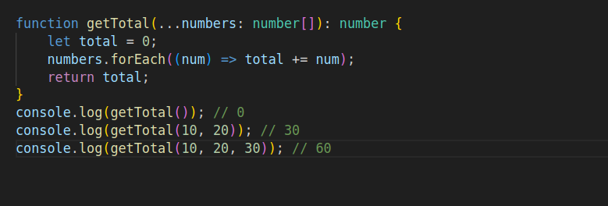

Function Overloading
Typescript provides the concept of method overloading.We can have multiple functions
- With same function function name and same no of parameters
- Different type and different return type
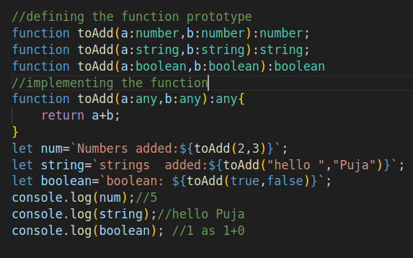

Assignment

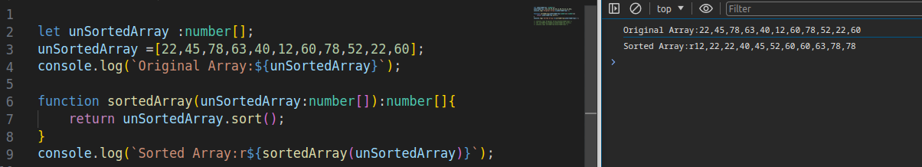
function to sort array

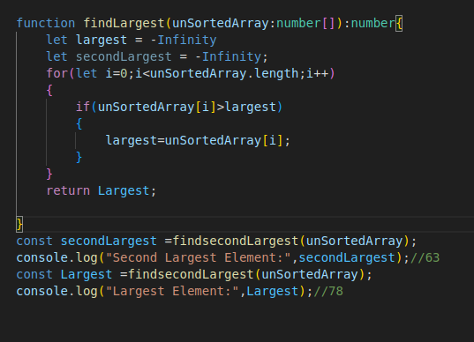
function to find 2nd largest number in array

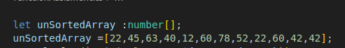
remove duplicate elements from the array

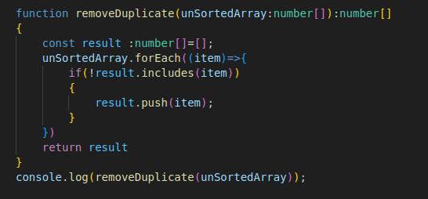

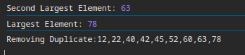

Typescript Classes

Classes
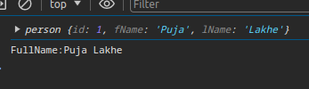
Use class keyword to define a class in typescript

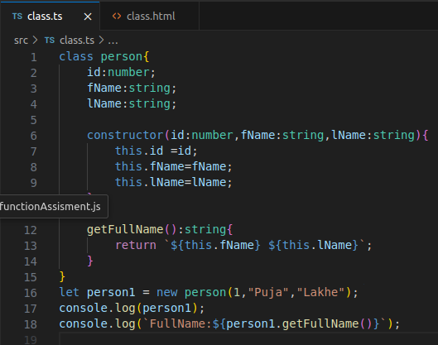

Access Modifiers
TypeScript provides three access modifiers to class properties and methods: private, protected, and public.
- The private modifier allows access within the same class.
- The protected modifier allows access within the same class and subclasses.
- The public modifier allows access from any location.

Public Access Modifier
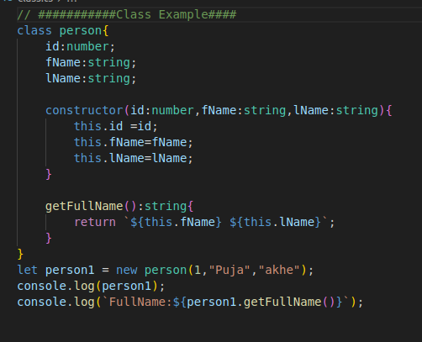

Private Access Modifier
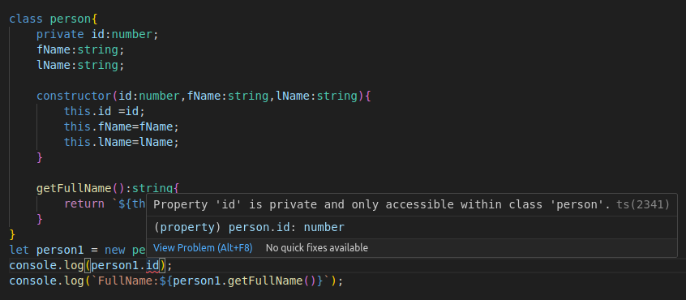

Can be solved by creating a method inside the class for private id property and accessing that method outside of the person class

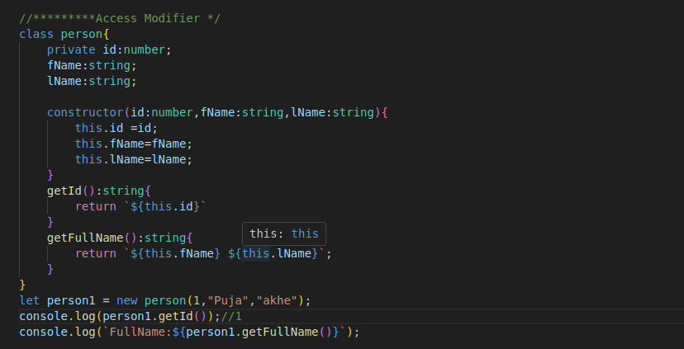

Protected Access Modifier
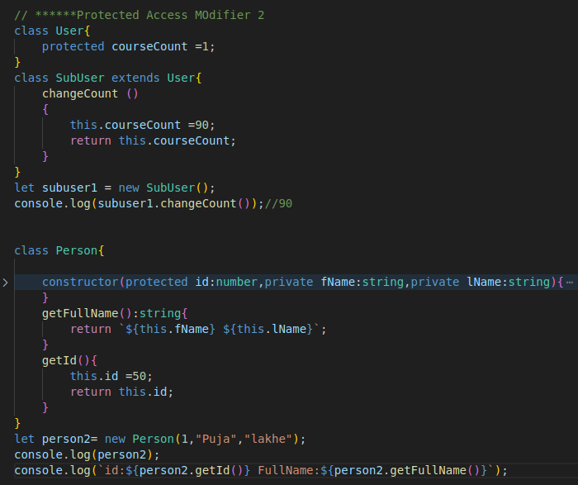
The id property now is protected. It will be accessible within the Person class and in any class that inherits from the Person class

Readonly Properties
To mark a property immutable(unchangeable/fixed/set/rigid) readonly keyword is used.
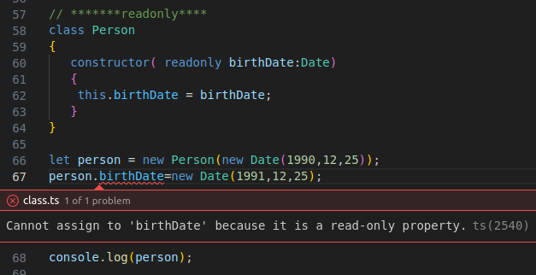
The property with this keyword can’t be changed.

Inheritances
Inheritance allows you to reuse the functionality of an existing class without rewriting it.To inherit the class extend keyword can be used.Also, use the super.methodInParentClass() syntax to invoke the methodInParentClass() in the method of the child class.
Syntax:
Class childclass extends parentclass
{
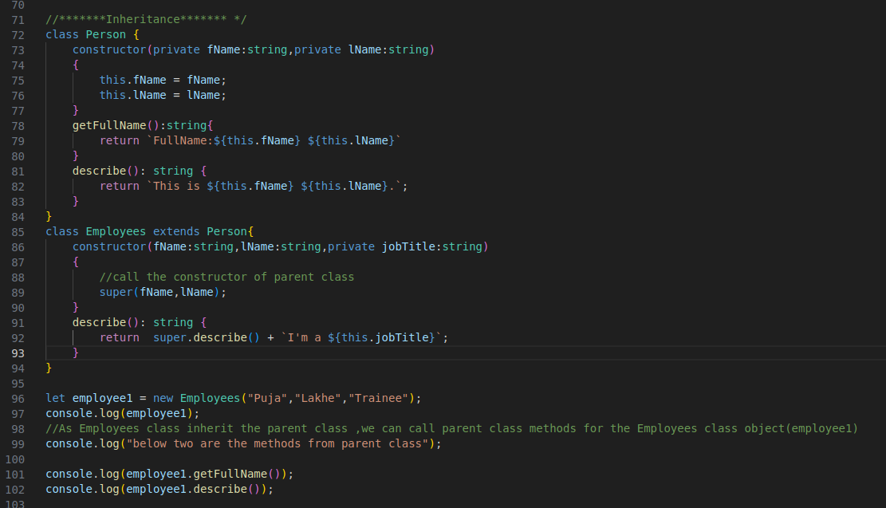
}

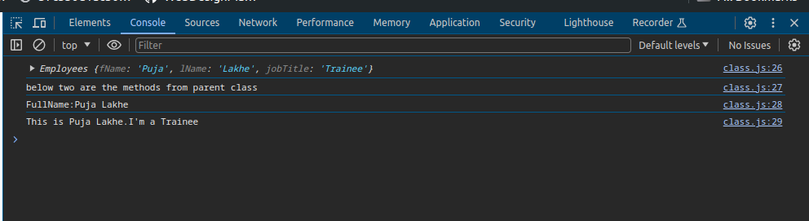

Typescript Static Methods and Properties

Static Properties
Static properties are shared among all the instances of the class.Use keyword static to declare a static property and className.prototypeName to access a static property.
Example:
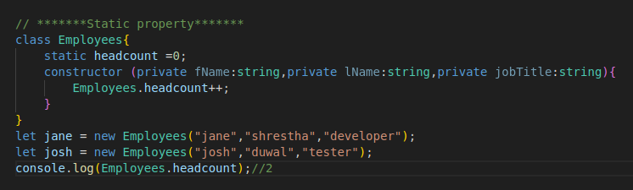

In this example, the headcount is a static property that is initialized to zero. Its value is increased by 1 whenever a new object is created.

Static Method

a static method is also shared across instances of the class. Use a static keyword before the method name.To call a static method, you use the className.staticMethod()
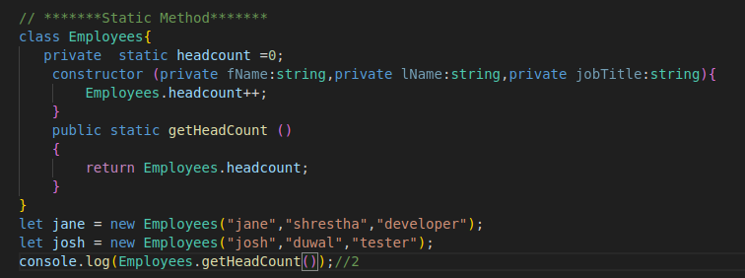

Abstract Classes
Abstract classes are usually used to define common behavior for derive classes to extend.
- Abstract classes cannot be instantiated.
- An Abstract class has at least one abstract method.
- To use an abstract class, you need to inherit it and provide the implementation for the abstract methods.

Syntax:use abstract keyword
Abstract class className
{///code}
Abstract method does not contains the implementation i.e. no methods body are declared.

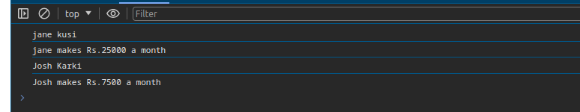

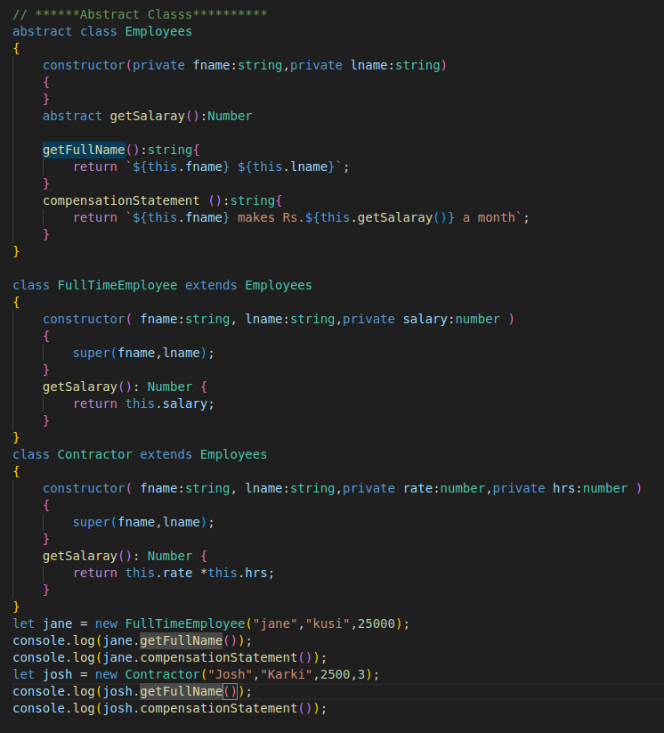

Interfaces
Inference is used to declare own self created annotations like built in annotation strings ,numbers,any etc

Function Interfaces
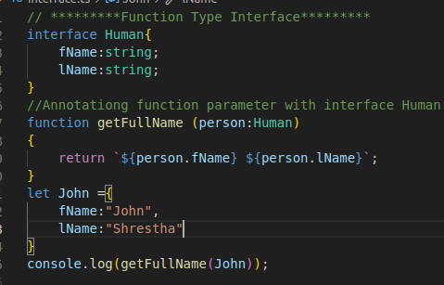
Here,

Optional Properties
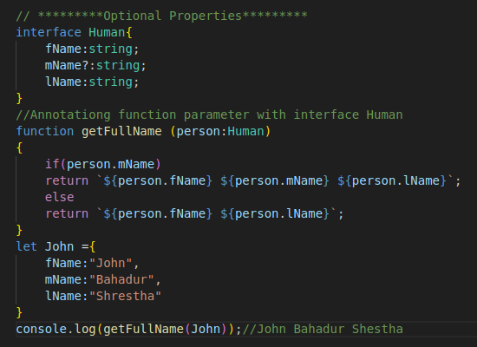
To declare optional property use (?) question mark

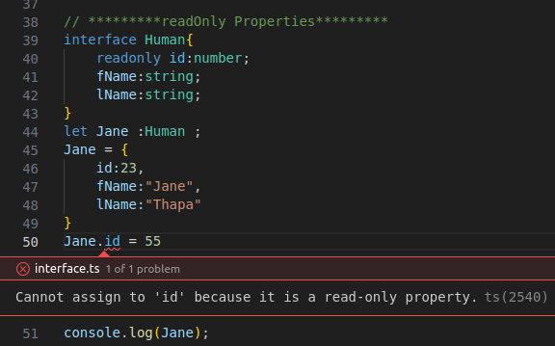
ReadOnly Properties

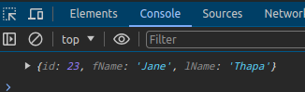

Function Types
To describe a function type, you assign the interface to the function signature that contains the parameter list with types and returned types. For example:
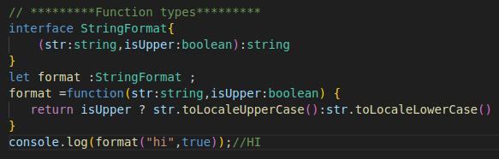

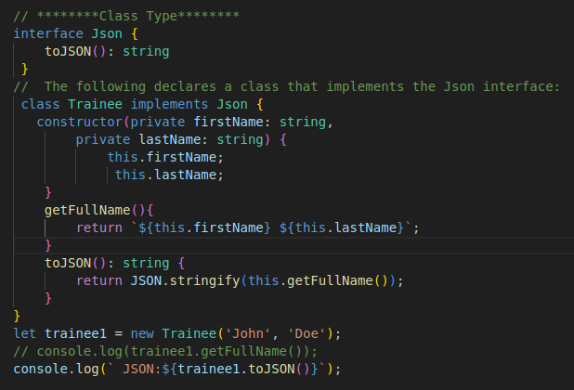
Class Type

Extending Interfaces
An interface can extend one or multiple existing interfaces.

Interface extending one interface
To extend an interface, you use the extends keyword with the following
syntax:
interface A {
a(): void
}
interface B extends A {
b(): void
}

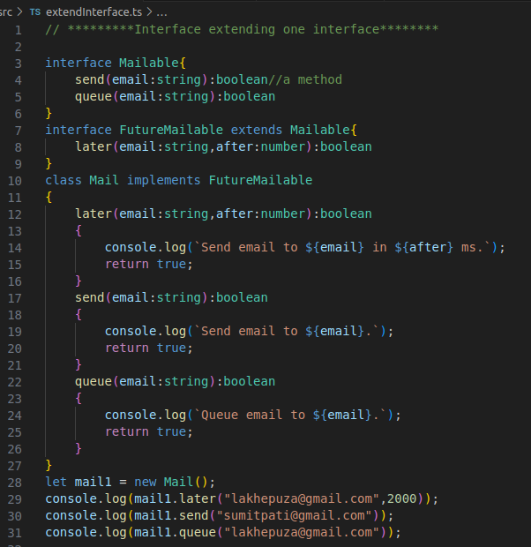

Interfaces extending multiple interfaces
An interface can extend multiple interfaces, creating a combination of all the interfaces. For example:
interface C {
c(): void
}
interface D extends B, C {
d(): void
}

Interface Extending classes

Advance Types

Intersection Types
An intersection type combines two or more types to create a new type that has all properties of the existing types.
Syntax: type typeAB = typeA & typeB i.re.this will have properties of both typeA and typeB
=typeA | type B i.e either typeA or typeB

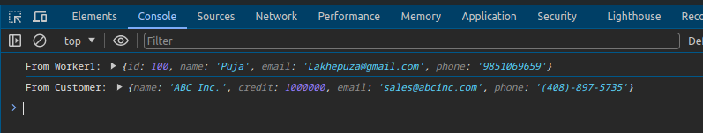

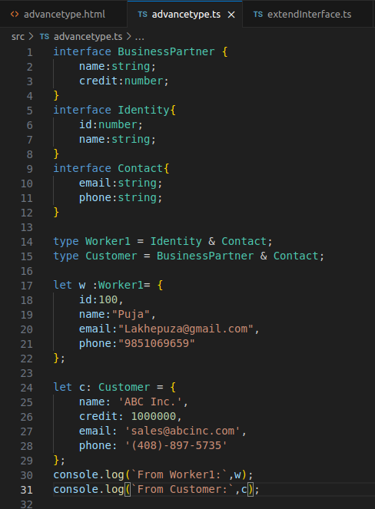

Type Guards
- Type guards narrow down the type of a variable within a conditional block.
- Use the typeof and instanceof operators to implement type guards in the conditional blocks

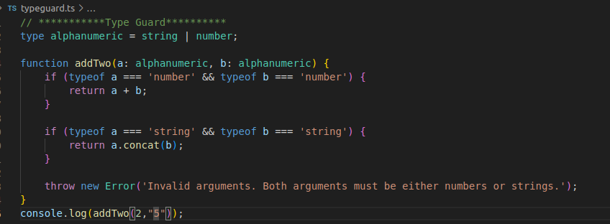
typeof

Instanceof
Check whether the obj is the instance of the class

in

Userdefined Type guard

Type Casting
Use the as keyword or <> operator for type casting
As
Syntax
let a: typeA;
let b = a as typeB;
OR
Syntax
let a: typeA;
let b = <typeB>a;

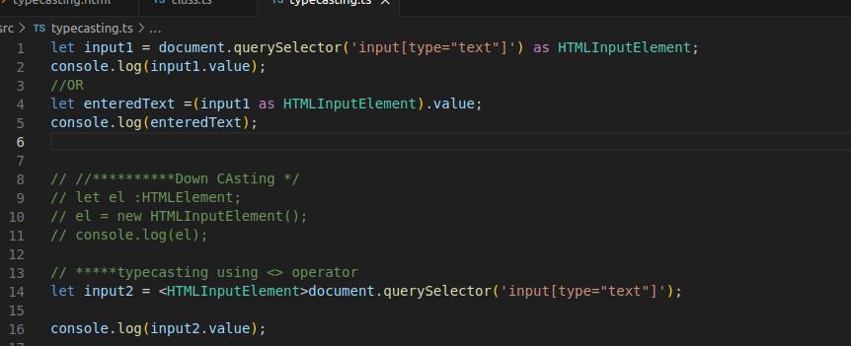

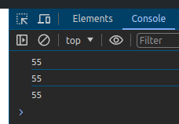

Type Assertions(type Narrowing)
- Type assertions instruct the compiler to treat a value as a specified type.
- Type assertions do not carry any type conversion.
- Type assertions use the as keyword or an angle bracket <> syntax.
Syntax:expression as targetType
OR
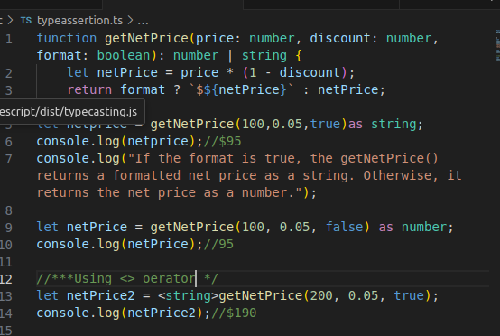
<targetType>value

Generics

TypeScript Generics
- Use TypeScript generics to develop reusable, generalized, and type-safe functions, interfaces, and classes.we can work with multiple data types in generic.
Syntax:
function identity<Type>(arg: Type): Type {
return arg;
}
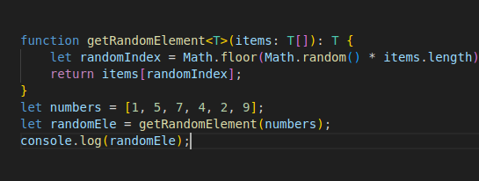

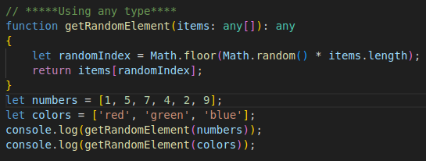
Using any type

Generic Constraints

Generic functions with multiple types
Syntax;
function merge<U, V>(obj1: U, obj2: V) {
return {
...obj1,
...obj2
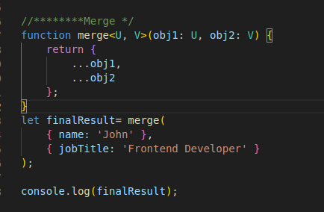
};
}

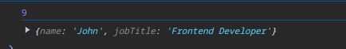

Generic Constraints
- Use extends keyword to constrain the type parameter to a specific type.
- Use extends keyof to constrain a type that is the property of another object.
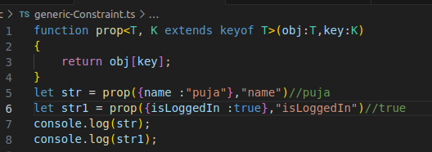

Generic Interfaces
Syntax:
interface interfaceName<T> {
// ...
}

Generic Classes
Syntax:
class className<T>{
//...
}

