Angular
Framework for Front End Web Application development.
Prerequisites: HTML, CSS, JS and TypeScript.

To install AngularJS, we need to install node js in our system first. To install node in linux, we can use the command below:
->$ sudo snap install node --classic
This will install the latest version of node.js in our system.
After installing node, we can install Angular using the command:
-> sudo npm install -g @angular/cli
This will install the latest version of Angular Cli.
We can create an Angular Project on our desktop after this step.

Now, to create a hello world project.
We create a new project by using the command:
->ng new project_name –no-standalone

Understanding Folder Structure in Brand New Angular Project:
There are various folders and file available in a brand new angular project, they can be as follow:
.vscode/ | Folder stores: extensions.json, launch.json, tasks.json which are for the vscode.
node_modules/ | Folder where your dependencies, devDependencies, packages, third party packages are installed.
src/ | Source files for the root application
 | app/ | Contains the main logical files for your app
 | assets/ | Contains all the assets like photos and videos that will be used in your project.
 | favicon.ico | Icon to display on the tab.
 | index.html | First index page to display when the user loads the app.
 | main.ts | Main entry point for the app where the appmodule is bootstrapped.
 | style.css | Global CSS file for all the files.
.editorconfig | Configuration for code editors, define coding standards.
.gitignore | List of files to be ignored by the git
angular.json | CLI configuration defaults of Angular
package-lock.json | Provides version information for all packages installed into node_modules
package.json | Contains the dependencies and dev-dependencies that get installed when we create a new project. Standard configuration file.
README.MD | Introductory document for the project
server.ts | Settings for the server
tsconfig.app.json
tsconfig.json | TypeScript compiler configuration
tsconfig.spec.json
Files in app/
app.config.ts | Defines the application config logic on how to assemble the application
app.component.ts | Defines the logic for the application’s root component, AppComponent.
app.component.html | Defines the html template for AppComponent
app.component.css | CSS file for AppComponent
app.component.spec.ts | Defines a unit test for the root AppComponent
app.module.ts | Defines the root module and where we add future modules.

NgModule:

Running project:
We can run a project by using the command:
->ng serve
Or, ->npm start

Component
A component is a part of the UI Element. Every angular element has at least one component, which is the root component and is called the app-component by convention. Every other component is the part of the root component. A component is composed of mainly four parts they are:
- HTML doc that specifies what is rendered in the browser (View).
- CSS file for the HTML file.
- A typescript file that defines the behaviour and logic of the view.
- Metadata that are stored as the Information and Decorator.

Creating a component in Angular CLI
To create a component in Angular CLI we can use the syntax:
-> ng generate component component_Name;
or , a shortcut as well:
->ng g c component_Name;
Above, command creates a directory named after the component and inside this folder the following files are created:
- A component file: component_Name.component.ts:
This file includes @Component decorator that allows a class to be marked as an Angular Component. This decorator stores all the metadata about the component. Some of the commonly available metadata are:
Selector: Provides a name to the component to be used as an html tag in the app component.
TemplateUrl: Provides an URL for the HTML docs or view of the component.
Template: Used when there is less amount of html code where we can specify the HTML code in the class itself.
StylesUrl: Provides an URL for the styles file for the view of the component.
Styles: Provide inline style to the HTML file. This is written in the form of an array separated by commas.
- A Template File: component_Name.component.html:
This file includes the html data for the view to be rendered by the browser whenever the custom HTML tag named in the selector is found.
- A Template CSS file: component_Name.component.css:
Includes all the styling for the View of this model.
- A testing file: component_Name.component.spec.ts:
This file is mainly used for the testing of the app we are building. Every.component.ts file has its responding .component.spec.ts file that is used while we give the command “ng test”.
Every time we create a new component, we have to declare the component in the app.module.ts file. This can be done by importing the component in that file and adding the component in the Declarations array of the @NgModule decorator of the module file. But if we create a module by using the Angular CLI, the CLI will do this work for us by itself. If we were to create the component manually, we have to include it inside the Declaration. Since, we don’t do that this is not so important and the CLI will do that for us.

To use this component in our website, we just have to use the custom HTML tag specified in the selector of the component file in the “app.component.html” file. This will display this component on our website.
Similarly, if we use a dot in the starting of the selector of the component file. We can use the component as a class in our html file. And if we specify the selector inside a square brackets we can use the component through a attribute in any html tag like for a div.
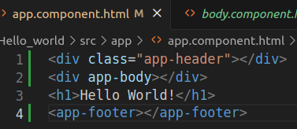
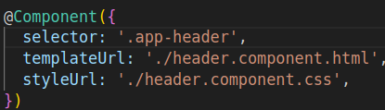
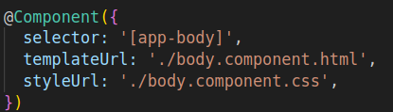

LifeCycle of the Component:
A Component passes through various phases of the component where it calls the certain methods of the class. The timeline of the call of the methods of the component are given below:
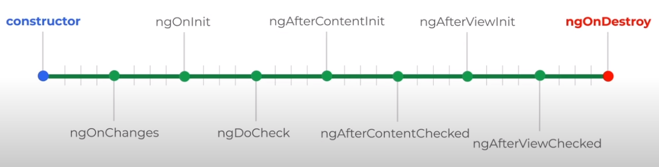

Constructor:
Constructor is the default method of the component that is called when the component is initialised. The constructor is used for the proper initialisation of fields in the class and it’s subclasses.

ngOnChanges():
ngOnChanges is the second most-hook that is called when the component is initialised. This hook is re-executed whenever there are some changes on any of the input property values.

ngOnInit():
This is used to initialise the Component or Directive after angular sets the initial display of data-bound properties and sets input properties. Mostly used hook.

ngDoCheck():
This method is called immediately after changes detected by ngOnChanges() and after the initial execution of ngOnInit(). This hook is called every time some components of the DOM are re-rendered.

ngAfterContentInit()
This method is called once after the first ngDoCheck(), and after Angular projects the content into the component’s View.

ngAfterContentChecked()
This method is similar to the ngDoCheck, that is it checks for any changes have been made in the content that is displayed in the component. It is initially called after ngAfterContentInit() and every ngDoCheck() except for the first one.

ngAfterViewInit():
This hook is called when the view of the hook is completely initialised and rendered. This is only called once after the first ngAfterContentChecked().

ngAfterViewChecked():
This hook is called when the view of the component and it’s child is completely initialised. It is initially called after the ngAfterViewInit() and after every ngAfterContentChecked() except for the first one.

ngOnDestroy():
This hook is the last hook to be called. This hook is called when the component’s view is destroyed or removed from the DOM.

View Encapsulation:
View Encapsulation is the process of ensuring the styles applied to one of the components is not mixed along with the other components. This is done through encapsulating the styles with the component host.
Angular can perform view encapsulation through the Encapsulation option inside the @component decorator. There are three Encapsulation options available in Angular, they are:
i) ViewEncapsulation.Emulated: The styles of this option are added to the <head> section of the document but in such a way that it only affects the template of the given component.
ii) ViewEncapsulation.None: The styles of this option are added to the <head> section of the document and are globally available. These styles affect any matching element that matches the selector.
iii) ViewEncapsulation.ShadowDom: The styles of this applied to the Shadow DOM that ensures the style is affected only to the view of the respective component.

Component Interaction:
Component Interaction is the process of communication between the various components that are available in our app. There are various needs for the communication of components. We can perform component interaction using the @Input and decorators.

Component Styles:

Sharing Data from Parent component to child component:
To share data from parent component to child component we use the @Input decorator. To use this decorator we have to import it from the @angular/core.

Steps:
- Go to the child component that you want to import the data to.
- Create a property in the class using an @Input() decorator like: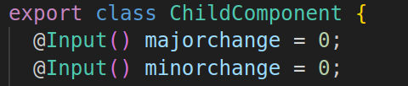
- Go to the template file (HTML file) of the parent component and find the selector of the child class. Use property binding statement and the variable name as shown below to pass the value.
Where, “minorchange” is the name of the variable in the child class whereas “minor” is the name of the variable in the parent class.

Sharing Data from child component to parent component:
Steps:
- Go to the child component from which we want to export the data.
- Import the @Output and EventEmitter from the @angular/core.
- Create a property using the @Output() decorator. And create a new EventEmitter object in it.
Here, the data type to be passed out is specified after the EventEmitter keyword using the <data_type>().
- Create a function with an argument as parameter with the same data type as specified above. And emit the value using the .emit function.
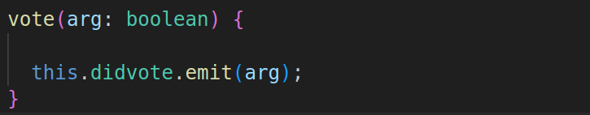
- Go to the parent component HTML file and find the HTML element for the child component. Write a custom event binding statement and use the same name as the variable name that is used in step 3 for the name of the event binder like:
Here, a function named voted is used to accept the value in the parent component. The function uses “$event” as an argument. “$event” contains information about the data that is being passed in the function through custom binding.

Content Projection:
There are three types of content projection. They are:
- Single Slot Content Projection
- Multi Slot Content Projection
- Conditional Content Projection

We use content projection in order to display the content in the child component that we have used inside the child component element in the parent component.

Single Slot Content Projection
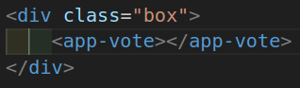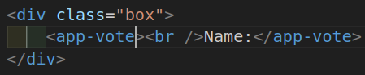
Normally our child component in the parent component will look like the figure in the right side above, but if we add some code inside the child component element it will not show up in our DOM. To view this content, we use content projection using ng-content. To display the inside content in our child component we will use the <ng-content> tag where we want to display the content.
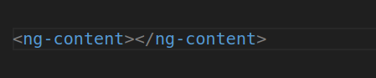
The ng-content will render the content of the child component tag from the parent component to the child component.

Multi-Slot Content Projection
The above code snippet example shows the single slot content projection, whereas for MultiSlot Content Projection, we have to use ng-content in our child component with a select attribute. For example:
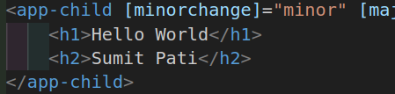 In the code snippet given, we want to display the h1 tag at the top of the child component and the h2 tag at the bottom of the child component while the content of the child component template is in the middle. In this condition we can use the select attribute in the child content’s multiple ng-content and display our expected result.
<ng-content select="h1"></ng-content>
<form onsubmit="return false">
<input type="text" placeholder="Enter your name?" #newItem />
<button type="submit" (click)="changename(newItem.value)">Submit</button>
</form>
<button (click)="changeVariable('add')">+</button>
<button (click)="changeVariable('sub')">-</button>
<ng-content select="h2"></ng-content>

Conditional Content Projection
For conditional content projection, we use <ng-container> and <ng-template> blocks for content projection. We use conditional content projection when the content we are making is optional in some cases. Using normal *ngIf or other content projection also works just fine but using these methods causes the browser to initialise these content to be initialised in the browser even if we are not displaying it. But if we use Conditional Content Projection, the content is not initialised if the conditional statement given is false.
<ng-container *ngIf="isName; else elseBlock">
<div>one</div>
</ng-container>
<ng-template #elseBlock> two </ng-template>

Data Binding
Data Binding is the process of communication between component class and view template or vice versa.
There are two types of Data Binding. They are: One Way Data Binding and Two Way Data Binding.
One Way Data Binding is when data is passed in one direction only i.e. from component class to view template or vice versa.
The Data Binding from the Component Class to View Template can also be done in two ways they are:
i) String Interpolation
ii) Property Binding.
And, the data binding from View Template to Component Class can be achieved using Event Binding.

String Interpolation:
String Interpolation is a method of passing data from component class to view template. String Interpolation is mainly used to show the data from the component class to the HTML file. The syntax for the String Interpolation is:
{{//Typescript Syntax}}
Where, we can type any typescript syntax or methods within the double set of curly braces and the compiler will compile them.
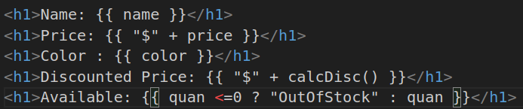
Here, In the first line, The value stored in the variable ‘name’ is rendered in the browser DOM.
For the price, We did a string concatenation and concatenated $ to the value of the price.
Printing colour is simply the same as the name.
For the Discounted price, the output of the calcDisc() function is concatenated with the ‘$’. The calcDisc() is a method in the component class.
Whereas we can also use the ternary operator inside the {{ }} for the string interpolation.

Property Binding
Property Binding is another method of Data Binding which is mainly used to make some changes in the DOM element or manipulate the DOM in some other way. The syntax for Property Binding is:
[attribute_Name]=”//TypeScript Syntax or any value to be passed.”
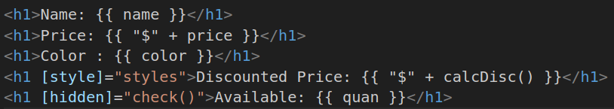
Where the component class is:
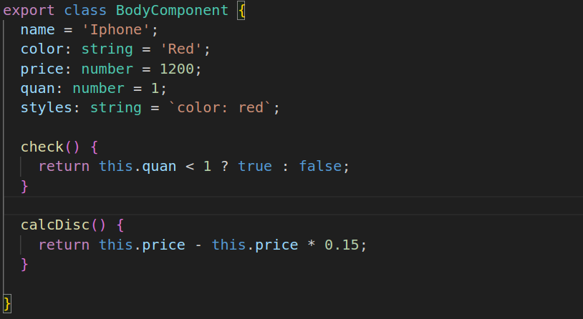
Property Binding is mainly useful for the attributes: Disabled, Hidden and Checked. The value for these three cannot be input via String Interpolation.

Attribute Binding
Some of the attributes like aria-label, aria-hidden, aria-expanded, aria-control, data-id, data-name, data-value, colspan, etc cannot be used by Property Binding, we have to use the Attribute Binding in order to change these values.
Attribute Binding: its syntax is the same as the Property Binding but the only difference is that we have to use the “attr.” in front of the attribute name within the bracket.

Class and Style Binding:
Binding a class to an element. To bind a class to an element we can use the syntax:
<div [class.sale]="isTrue">One</div>
In this context, if the value of the property isTrue is set to ‘true’, then the class ‘sale’ is applied to the div and is not applied if it is set to False.

We can also add class to the div using the syntax. Here, The style is a property in our component that stores the name of the class that we want to apply.
<div [class]="style"></div>
There are multiple ways to provide data to this style variable, they are as given below:
style: string = 'sale';
style: Record<string, boolean | null | undefined> = {
sale: true,
box: true,
};
style: string[] = ['sale', 'box'];
Here, all three methods are valid but not at the same time. We can use the first method to apply to one or more classes. We can apply more than one by providing spaces in between.
In the second method, We provide a record that accepts a string as it’s key and a boolean or null or undefined as it’s datatype. We provide our class names as string and true if we want to apply it and false if we do not want to apply it.
In the third option, we provide an array of string with all the value of class names in it that we want to apply.

To apply style binding we can use the syntax:
<div [style.width]="width" class="sale">One</div>
Here the string value of the ‘width’ variable is added to the inline style css with width. In this case, the width variable should store a string i.e. 100px
<div [style.width.px]="width" class="sale">One</div>
We can also do the above way. But in this case, we can apply a numerical value i.e. 100 to the width variable the px attribute is pre-fixed in the style binding.

<div [style]="width" class="sale">One</div>
This is another way of doing it where we can apply multiple inline css rules to the single element. Where, the width variable is:
width: string = 'width: 500px, height: 400px';

<div [style]="width" class="sale">One</div>
This is another way of doing it where we can apply multiple inline css rules to the single element. Where, the width variable is:
width: Record<string, string | null | undefined> = {
width: '100px',
height: '100px',
};

Event Binding:
Event Binding is used to perform Data Binding from view template to class component. Its syntax is as follow:
-> (event_name)=’action’
This is pretty similar to previous methods.
We can also register key combinations using the “keydown” for example:
->(keydown.control.y)=’some_Action’
Here, when we enter the key combination control+y, the actions specified will commence.

Two Way Data Binding:
Two way data Binding is basically the combination of property binding ‘[]’ and event binding ‘()’.We can do two way binding using the [(event_name)]=”values”. Or, to perform two way data binding, we have to use [(ngModel)] . To use the ngModel, we have to import FormsModule from @angular/forms. This can be used in elements of forms only.

Pipes:
Pipes are simple functions which are used in template operations that accept a value as input and provide transformed output value. Pipes can be used throughout the project once it is declared. Pipes can be used to easily transform our output in a required format.
There are two types of pipes, they are:
- Built-in Pipes : provided by the Angular Framework itself.
- Custom Pipes : made by us

We can use pipes in a template expression by using the | symbol in the template expression. In the end of the template expression, use a ‘|’ symbol followed by the pipe we want to use. For example: If we want to show a date in our website, we can use the date pipe like:
<div class="clock">{{ time | date}}</div>
This will display the date that is to be stored in the time variable in a specific format that is predefined in the Angular library.

We can also pass parameters into the pipes. To pass a parameter into the pipe we have to use the ‘:’ semicolon after the pipe name. We can pass one or more than one parameter simultaneously. To do so, we can use the semicolon to separate the parameters. For Example
<div>{{ salary | currency : "NPR" : "Rs." }}</div>

Not only that we can also stack one or more than one pipes into a single template expression, we can do this using multiple pipelines each separated by the ‘|’ expression.
<div class="clock">{{ time() | date : "shortTime" | lowercase }}</div>
In regular terms it is preferred to use the parenthesis in the expression before applying the pipe. Not providing the parenthesis might change the output that we were expecting.
<div>{{ isTrue ? birthday : time() | date }}</div>
In this condition, the date pipe is only applied to the time() function but not the birthday parameter. This is because the Angular will apply the pipe as :
<div>{{ isTrue ? birthday : (time() | date) }}</div>
To properly apply this, we can use the above expression as:
<div>{{ (isTrue ? birthday : time()) | date }}</div>

Custom Pipes:
To generate custom Pipes:
-> ng g p pipes/pipe_name
Or,
->ng generate pipe pipes/pipe_name
The generated pipe is generated using the @pipe decorator class. The above command will create two files, they are pipe_name.pipe.ts and pipe_name.pipe.spec.ts.
We implement our rules in the pipe_name.pipe.ts file inside the class and transform method.

Template Reference Variable
It is like a reference/name given to any element, component or directive that is available in the template. Used to take reference of the particular variable.

Providing Reference to an HTML DOM Element:
Syntax:
<input type="text" #reftemp />
<button (click)="submit(reftemp)">Submit</button>
In the above code snippet, the template reference variable is the ‘#reftemp’ it can be used as an normal variable to pass into the methods as arguments. In the above example, the reftemp would hold the entire input tag element in it. If we want to access the value provided in the input tag, we can simply use ‘reftemp.value’ in the submit() method call. This is possible due to the value being the attribute of the input tag.

Providing Reference Variable to a component:
<app-arraysort #arraysort></app-arraysort>
<app-tempref *ngIf="arraysort.isTrue"></app-tempref>
In the above example, the component ‘arraysort’ is provided as a reference to the second component.

Directives
Directives are the instructions for the DOM. We use directives to manipulate DOM, add/remove the DOM elements, and change the behaviour of the DOM. There are three types of Directives, they are:
- Component Directive: Basically, Angular component
- Attribute Directive: They are used as attributes, and can change the appearance and behaviour of the Component.
- Structural Directive: Can add or remove any DOM element. We use ‘*’ before them. Eg: ngIf, ngFor, ngSwitch, etc.

BuiltIn Directives:

ngFor:
<select name="country" id="country" [(ngModel)]="country">
<option value="" selected disabled>--country--</option>
<option *ngFor="let c of countries; trackBy: trackChanges" [value]="c">
{{ c.name }}
</option>
</select>
ngFor is used to iterate through a set of data. In the above code snippet, we *ngFor directive on the option element. The option element is repeated on the dom for the number of times, there are no. of countries in the countries array.
trackBy is a feature of the ngFor that allows to track changes while looping. Suppose there are n elements in our array, but if we add another element to the array, the ngFor will change the whole view but we need to only change those which are added new to the list. So, we can use trackBy to call a method in which we can specify the field through which we can track the changes and only change those element that are changed.

ngIf:
Angular ngIf is a structural directive used to completely add or remove an element from the DOM based on some condition given. Angular will add the given element to the DOM if the condition given returns true else it will not display it to the DOM.
Now the output will be:
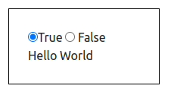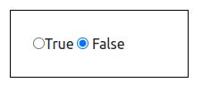

ngClass:
ngClass is used to provide a CSS Class to an HTML element. Classes can also be provided to an Element using the property binding feature, but ngClass method is preferred when we want to have more than one CSS class as options. ngClass is mostly used when we want to provide a CSS class to an element based on a condition.
<div [ngClass]="flag ? redBox : blueBox">This is a div box</div>
In the above code snippet, the div is applied with classes provided on the redBox variable or the blueBox variable based on the flag. If we have the flag set to true then the redBox variable’s classes will be applied to the div whereas, if the flag is set to false, then the blueBox variable’s classes will be applied to the div.

ngStyles:
Similar to ngClass, ngStyles are also useful to give inline CSS to any element in the DOM. We can use the ngStyles tag similar to the ngClass directive.
<div [ngStyle]="flag ? styles : null">Box</div>
In this condition, if we set the flag to true the styles defined in the styles variable are displayed by using inline styles whereas, if it is false, then it is null.
The styles variable must hold an JS Object like:
styles = { 'font-style': 'italic', 'font-size': '35px' };

ngModel:
ngModel is a built-in directive that is used in order to share data between the template and the class, the ngModel is a two way binding method. ngModel is mostly used in order to track the input provided by the user in the input fields.
<input type="text" [(ngModel)]="input" name="example" />
<br />{{ input }}
Here, the input field has ngModel two-way binding, this passes the value entered in the field to the variable name provided inside the quotation.

ngSwitch:
ngSwitch is used to render a certain element based on the value provided. The syntax of ngSwitch is as follows:
<div class="box" [ngSwitch]="switchVariable">
<h3 *ngSwitchCase="'one'">ONE</h3>
<h3 *ngSwitchCase="'two'">TWO</h3>
<h3 *ngSwitchCase="'three'">THREE</h3>
</div>
Here, only the h3 element inside the div element will be rendered that is chosen in the select input above. In the above, the value of select is passed on to the switchVariable and it is passed on to ngSwitch. Only the value whose condition matches is rendered in the DOM.

Custom Directive:
To develop a custom directive, we can run the following command:
-> ng g d Directive_name;

Custom Attribute Directive:
In a custom attribute directive, we pass an ElementRef type value which is the element in which we have applied our custom directive.
constructor(private element: ElementRef) {}

ngOnInit() {
this.element.nativeElement.style.backgroundColor = 'blue';
this.element.nativeElement.style.width = '500px';
}
Here, this variable stores the element that we apply the directive to. Now, we can apply the logic of what the changes are to be made in ngOnInit() hook. Like:
We can apply all the css through:
this.element.nativeElement.style.
Use @HostListener to check any changes or track any user input:
For example:
@HostListener('mouseout') onMouseLeave() {
this.highlight('blue', '500px');
}

Custom Structural Directive:
Structural Directive takes an value as input that input is boolean and based on the condition we can implement. To generate a Custom Structural Directive we have to initialise two elements in the constructor, they are: TemplateRef and ViewContainerRef.
TemplateRef: Stores the template of the element that is to be either displayed or not.
ViewContainerRef: Stores the info about the container on where to show the view.
constructor(
private view: TemplateRef<any>,
private container: ViewContainerRef
) {}
Now we can provide the conditions by:
@Input() set appIf(condition: boolean) {
if (condition) {
this.container.createEmbeddedView(this.view);
} else {
this.container.clear();
}
}
Here, we used a setter function to bind the variable to a method.

Dependency Injection:

Dependency:
When program ‘A’ uses methods or functionalities of program ‘B’, then program ‘B’ becomes a dependency of program ‘A’.

Dependency Injection:
Dependency Injection is when you use one part of the application in another part of the program that requires them. Dependencies might be services or values. Dependencies Injection allows classes with Angular Decorators, such as Components, Directives, Pipes, and Injectables. There are mainly two parts in the DI system, they are: dependency consumer and dependency provider.

Creating Dependency Service:
We can create a dependency by using the command:
-> ng g service service_name
This will create service with the provided name.We can provide the properties and methods for the Dependency there.

Injecting Dependency:
To create a dependency, we can use one of the two methods:
- By using constructor method:
constructor(private array: DemoService) {}
- By using the injector:
private array = inject(DemoService);
Both of these methods will do the same work.

Dependency Providers:
A dependency provider tells angular how to create the instances.
Each dependency is uniquely identified by the token provided in the providers array. The token must be the same name as the name of the classes. There are two ways of providing the token in the providers array. They are:
providers: [components.DemoService],

And the another is:
providers: [
{ provide: components.DemoService, useClass: components.DemoService },
],
Both of the above methods are the same.

Dependency Class Providers:

UseClass:
Use Class can be used to create an instance of the specified class. It is mainly used to provide an alternative for a common or default class.
{ provide: components.DemoService, useClass: components.LogService},

UseExisting:
It can be used in order to use the previously used instance of the same class. For example:
{ provide: components.DemoService, useClass: components.DemoService },
{ provide: LogserviceService, useExisting: components.DemoService },
In the above example, components.DemoService will create an instance of the components.DemoService class. But the LogserviceService will also use the instance of the above component.DemoService. This might be useful when we have to share data amongst multiple dependencies. The LogserviceService is an alias for the already created instance of the components.DemoService.

useFactory:
The useFactory class providers lets you provide an Factory function. A factory function might be useful when we have to choose amongst multiple services.
//export const IS_TRUE = new InjectionToken<boolean>('app.config');
{ provide: 'IS_TRUE', useValue: true },
{
provide: components.DemoService,
useFactory: (isTrue: boolean) =>
isTrue ? new components.DemoService() : new LogserviceService(),
deps: ['IS_TRUE'],
},
In the above example, when the value of isTrue is set to ‘true’ an instance of components.DemoService() is created and used for service. Whereas, if it is false, then the LogserviceService’s instance is created and used.

useValue:
Lastly, useValue is a class provider that is mainly used to provide constant values over the different components of the application.
{ provide: 'IS_TRUE', useValue: true },
In the above example, whenever the ‘IS_TRUE’ Dependency is used the value true is passed on to it.

Routing and Navigation:
Since angular is a single page application, we route in angular by showing the desirable component in a single page. Routing can be achieved via the “Router” class provided by angular.

Defining a basic routes:
To define a basic route, we follow the following steps:
- Firstly, we define a constant variable with the type ‘Routes’ in our app.module.ts file or import it from somewhere where we store it.
- Next, we provide data to the variable, in a JSON data format as shown in the following:
const routes: Routes = [
{ path: 'home', component: HomeComponent },
{ path: 'Skills', component: SkillsComponent },
{ path: 'Aboutme', component: AboutmeComponent },
{ path: 'Contacts', component: ContactComponent },
{ path: 'Education', component: EducationComponent },
{ path: '', component: HomeComponent },
];
Here, the main important things that should be defined are:
path - path can be given custom by us and is used as the url to the given component.
component - this specifies which component is to be rendered.
redirectTo - redirects to another path that is predetermined in the array. For example: empty path can be redirected to home path.
pathMatch - accepts two values either, full or prefix
- Provide this routes to the imports array of the ngModule by:
imports: [BrowserModule, AppRoutingModule, RouterModule.forRoot(routes)],
Since this routes is for the root navigation of our website, we use forRoot in the RouterModule, whereas if we were to use the routing within the component’s child component we have to use the forChild.
- Lastly, we have to provide the links to our <a> tags in the html files. For this we have to use the ‘routerLink’ which we have to import from @Angular/Routes. In the routerLink we provide the path that we set in the array as the link. For example:
<a routerLink="Education"> Education</a>
The above methods will describe the basic routes of our website.

routerLinkActive:
routerLinkActive is a directive used to check which link is currently active and used to provide a css class to the given link.

Wildcard in Routes:
‘**’ is used as a wildcard while routing in Angular. We can use a wildcard to display error pages. If an user enters the invalid url we can redirect the user to a component that we made that displays the error message.

Navigation through Code:
Navigation through code is an imperative method for routing. It can be used to perform certain tasks before performing the routing task itself. There are two methods for navigation, they are:
- Router.navigate()
- Router.navigateByUrl()
These methods are provided by the @Angular/Router class and have to be imported before using them. To use the Router, we have to use a Router similar to a dependency. For example:
constructor(private router: Router) {}
goToContacts() {
this.router.navigate(['Contacts']);
}

Router.Navigate():
This method accepts an array of strings and constructs the route path itself. The Navigate function can be used to relative path routing by using the ‘relativeTo’ option of the navigate function.

Router.NavigateByUrl():
This method accepts a string that is a direct address to the link that we want to follow. NavigateByUrl method is useful to provide Absolute paths.

Nesting Routes:
We can create routes within other routes by using more than one <router-outlet> on multiple pages. To do so we have to nest the routes as the children of the routes as:

{
path: 'child',
component: ChildAComponent,
children: [
{ path: 'grandchilda', component: GrandChildAComponent },
{ path: 'grandchildb', component: GrandChildBComponent },
],
},

Query Parameters:
Query Parameters are the data we sent from the source page to the direction page. Queries are displayed in the link of the browser.
We can access these parameters that we passed in the destination page.
We can use query route parameters to load different pages. We can use variables in the routes to make custom routes based on the value of the variable.
We can use the variables in the links using the following statements:
const routes: Routes = [
{ path: '', component: ChildAComponent },
{ path: 'child', component: ChildAComponent },
{ path: 'child/:id', component: GrandchildComponent },
];
Here, :id is the variable.
If we used the URL:
http://localhost:4200/child/3
Here, the value 3 is stored in the variable id.
We can use this to view different pages based on the URL. To use this method we must inject the ActivatedRoute class and implement to a variable, like:
constructor(private routed: ActivatedRoute) {}
We can retrieve the value of the route parameters by using the following methods:
console.log(this.routed.snapshot.paramMap.get('id'));
This method can retrieve the value of the variable. We can use this method in the ngOnInit() life cycle hook to retrieve the value when the view of the value is retrieved. While this method works to view the data once the page loads but if we have another link with a different id value the value in the log will not change.
To tackle this problem, we can use another method that is:
this.routed.params.subscribe((data) => {
this.passed = data['id'];
});
The params method will keep track of the changes too.
We can also send queryParams for the data too.
We can use the [queryParams] on the routerLink or the navigate() function as well. We can retrieve the data by using the method:
this.routed.queryParams.subscribe((data) => {
console.log(data['name']);
});

Lazy Loading:
Lazy Loading is when we only load the files that are required initially and load the rest of the files when the user navigates to the route of that specific component.
The syntax for lazy loading is:
{
path: 'second',
loadComponent: () =>
import('./second/second.component').then((c) => c.SecondComponent),
title: 'Second Component'
}

Guards:
Guards are the protection used to prevent the user from navigating to the specified routes before a certain condition is met.
There are many types of route guards, they are:

CanActivate:
We can use CanActivate to prevent users from navigating a certain route before a certain condition is met. For example, if the user is not logged in yet, we can’t display every routes.
The way of using the CanActivate is by using a service that implements, the CanActivate in which we create a function CanActivate and pass two parameters, the code of the service is given below:
import { Injectable } from '@angular/core';
import {
ActivatedRouteSnapshot,
Router,
RouterStateSnapshot,
} from '@angular/router';
@Injectable({
providedIn: 'root',
})
export class AuthguardService {
constructor(private routes: Router) {}
canActivate(
route: ActivatedRouteSnapshot,
state: RouterStateSnapshot
): boolean {
return false;
}
}

And similarly we can just use this Service name in the CanActivate array like:
{
path: 'checkout',
component: CheckoutComponent,
canActivate: [AuthguardService],
},
This will work pretty much but, after Angular 15 this method is deprecated, so we can use the CanActivateFn, in which we can use a function in the canActivate array like:
{
path: 'checkout',
component: CheckoutComponent,
canActivate: [()=>{return true}],
},
Here, we used an arrow function to return the value true, whereas we can also use a prebuilt regular function as well.
We can also use angular CLI to use guards by using the syntax:
-> ng g guard <guard_name>

The CLI provides options to choose the functions that we want to activate in the given guard like:
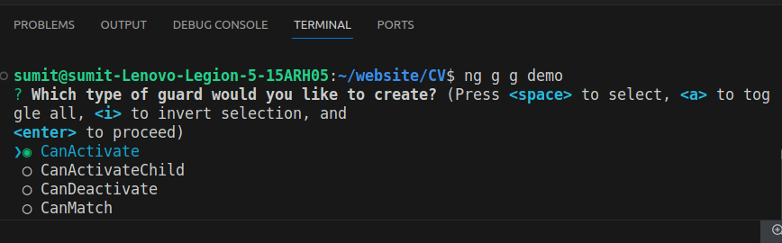We can select the options that we like and use them as well. To use this method we simply have to add the name of the guard class in the canActivate array.

Resolve:
Resolve is used to halt the navigation temporarily until certain data have been loaded/ downloaded from the server’s database. We can use resolve using the following code:
//skills.component.ts
ngOnInit() {
this.imported_array = this.routed.snapshot.data['items'];
}
In the above the imported array is waiting for the data from the route with the name items.
//routes array
{
path: 'Skills',
title: 'Skills',
component: SkillsComponent,
resolve: { items: resolve },
},
Here, the data in the resolve option, we provide a JSON notation, with the key-value pair, the key is used to retrieve the data in the view component i.e. in the above code snippet. Whereas the resolve is a function that we create as:
//resolve function
export const resolve = () => {
let itemService = inject(ItemService);
return itemService.getallCourses();
};
As well as the ItemService is:
getallCourses() {
return new Observable<Item[]>((sub) => {
setTimeout(() => {
sub.next(this.item_details);
}, 5000);
});
}
Here the above function passes the item_details value after a delay of 5s.

Showing loading screen while the data is being fetched
When we load the screen with the resolve route guard, the data may take a varying time when loading the data from the server, during this time the routing is not completed but we will be displaying the source page for the time period this might make the user confused that the site is not working. To avoid this, we can display the loading screen for the time being. To display the loading screen, we can use the router states, the code that varies from different states for example:
RouterModule.forRoot(routes,{enableTracing: true})
The above method shows all the routing states in the console like:
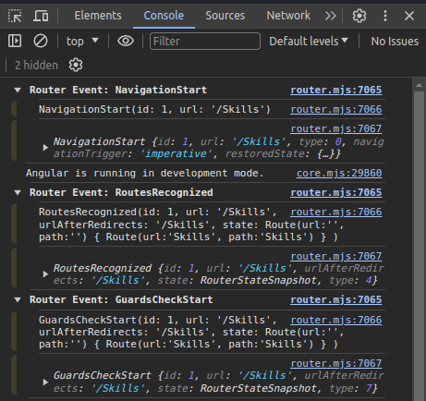
Amongst which we can use the NavigationStart and NavigationEnd to display the loading screen.
//app.component.html
<div class="overlay" *ngIf="showLoader">
<div class="loader"></div>
</div>
<script>
.overlay {
left: 0;
top: 0;
width: 100%;
height: 100%;
background: #fff;
opacity: 0.5;
position: fixed;
display: flex;
justify-content: center;
align-items: center;
}

.loader {
border: 5px solid #ccc;
border-top: 5px solid #0181b0;
border-radius: 50%;
width: 100px;
height: 100px;
animation: spin 2s linear infinite;
}

@keyframes spin {
0% {
transform: rotate(0deg);
}
100% {
transform: rotate(360deg);
}
}

</script>

And the code for to display is:
//app.component.ts
ngOnInit() {
this.router.events.subscribe((event: Event) => {
if (event instanceof NavigationStart) {
this.showLoader = true;
}
if (event instanceof NavigationEnd ||
event instanceof NavigationCancel ||
event instanceof NavigationError) {
this.showLoader = false;
}
});
}
This will set the flag for showLoader to true when the navigation starts and set the flag to false when the navigation is completed.

canMatch:
CanMatch is used when we have multiple routes with the same path but want to navigate to the one based on the specific condition then we can use this route Guard. The syntax for this route Guard is:
{
path: 'canMatch',
component: CanMatchComponent,
canMatch: [canMatchGuard],
},

Forms:

Reactive Forms:
Reactive forms is one of the approaches to creating a form in which the data are handled in a programmatic approach. Since it is a programmatic approach the flexibility of the form increases.

Form Control
name = new FormControl('');
//HTML
<input type="text" name="name" [formControl]="name" id='name'/>
When the input is given to the above form element the value is stored in the variable ‘name’.

Form Group
this.form = new FormGroup({
name: new FormControl(null),
email: new FormControl(null),
gender: new FormControl('male'),
country: new FormControl('nepal'),
});
If we provide a value in the FormControl then that will be default values for the form.
We can view the value of the form using the valueChanges or :
console.log(this.form.value.name);

Nested Form Group:
We can create an Form Group inside an Form Group too.
this.form = new FormGroup({
name: new FormControl(null, Validators.required),
email: new FormControl(null, [Validators.required, Validators.email]),
gender: new FormControl('male'),
country: new FormControl('nepal'),
password: new FormControl(null, [
Validators.minLength(8),
Validators.required,
]),
address: new FormGroup({
district: new FormControl(null, Validators.required),
Tole: new FormControl(null),
}),
})

Validators:
We can also provide one or more validators to a formComponent. We can use these Validators to display error messages on our website. Syntax is given above.

Form Array:

Form Builder:
Form Builder is another method for creating formGroups and formArrays. For this we have to inject the formBuilder in our component. The syntax:
constructor(private fb: FormBuilder) {
this.SkillsForm = this.fb.group({
skills: this.fb.array([]),
});
}

Custom Validation:
For creating a custom validation, we can use a function in the validation method that should return a ValidationFn type.
check(password: string, c_password: string): ValidatorFn {
return (controls: AbstractControl) => {
const control = controls.get(password);
const checkControl = controls.get(c_password);
if (checkControl?.errors && !checkControl.errors['matching']) {
return null;
}

if (control?.value !== checkControl?.value) {
controls.get(c_password)?.setErrors({ matching: true });
return { matching: true };
} else {
return null;
}
};
}

Http Client:

