

PRT520 PRINCIPLES OF COMPUTING SYSTEMS: Assignment 3

Group:

Group member name:

**Bipin Sapkota                           S368073**

**Pujan Katwal S366540**

**Guided by: Asif Karim (Lecturer)**

# Introduction

The purpose of this report is to give a project overview of the website of the company Furniture R Us and also outline the responsibilities of the project team members. The report will also highlight the motivation behind the project and its objectives.

# Project Overview

The website development project aims to create a dynamic and user-friendly website to function as an online platform for a company. The website will provide information about the company, its products, contact details, and other relevant content.

# Project Objectives

The objectives of the website development project are as follows:

* To establish a strong online presence for the company.
* To provide a platform for users to access information about the company's products and services.
* To enhance user experience through a visually appealing design.
* To ensure the website is responsive and accessible across different devices.
* To optimize the website for search engines to improve online visibility.
* To incorporate interactive features and functionalities to engage users.

# Website Pages and Responsible Individuals

The website is successfully developed by the collaborative effort of the team members. This website is developed by two team members in collaboration and proper understanding. Each team member has specific responsibilities to ensure the project's smooth execution. The following table provides an overview of the website pages and the individuals responsible for their development and maintenance:

|  |  |
| --- | --- |
| Page | Responsible Individual |
| Home | Pujan and Bipin |
| Our Products | Pujan |
| About Us | Pujan |
| Trading hours | Bipin |
| Contact Us | Bipin |

# Resources

We developed this website by the proper guidance and the techniques provided by the lecture. Most of the references are taken by the popular learning site that is www.w3school.com.

# Conclusion

In conclusion, the website development project aims to create a professional and user-friendly website to meet the needs and objectives of the company. The project team members have been assigned specific responsibilities to ensure the successful execution of the project. By working collaboratively, the team aims to deliver a high-quality website that enhances the company's online presence and engages users effectively.

# Screen shots:



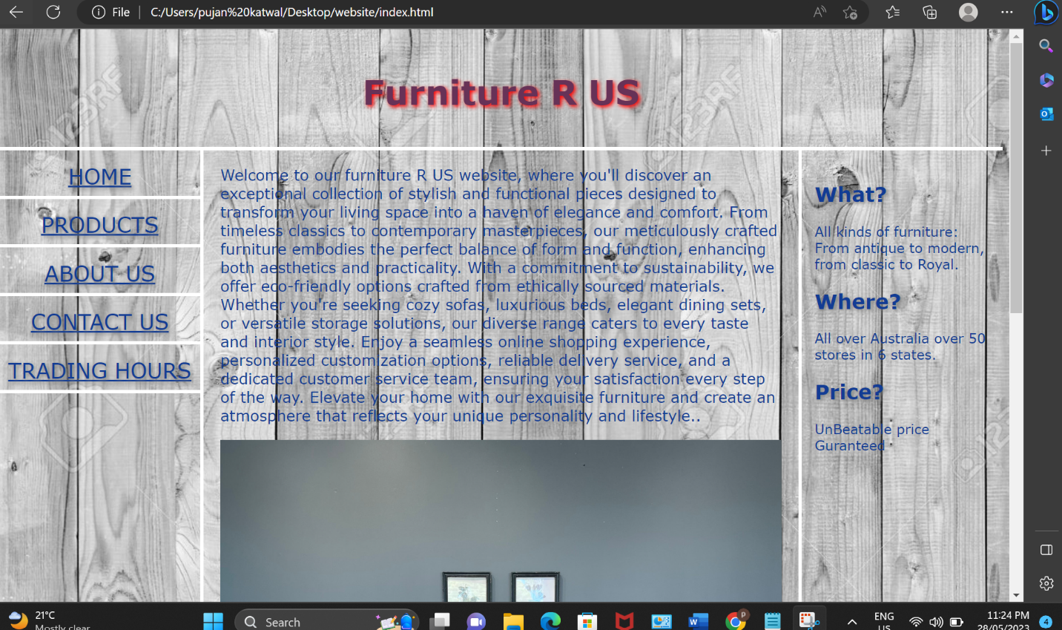



# References

W3schools a learning website. https://www.w3schools.com/