📘 UNIT I – FUNDAMENTALS OF ENTREPRENEURSHIP

1.1 ENTREPRENEURSHIP: MEANING AND CONCEPT

Introduction
Entrepreneurship is a dynamic and continuous process through which individuals identify opportunities in the environment, mobilize resources, assume calculated risks, and create value through innovation. It is not confined merely to starting a new enterprise; rather, it includes idea generation, opportunity recognition, venture creation, growth management, and sustainability.
Entrepreneurship integrates innovation, leadership, managerial competence, and risk-bearing ability.

Definitions
According to S.S. Khanka, entrepreneurship is the process of creating something new with value by devoting time and effort, assuming financial, psychological, and social risks, and receiving rewards in the form of profit, satisfaction, and independence.
According to Joseph Schumpeter, an entrepreneur is an innovator who introduces new combinations in production.
According to Peter Drucker, entrepreneurship is systematic innovation.

Conceptual Analysis
From the above definitions, entrepreneurship includes:
- Innovation
- Risk-taking
- Resource coordination
- Value creation
- Reward seeking
It is therefore both an economic and psychological process

Elements of Entrepreneurship

1. Innovation
Introducing new products, services, methods, or markets.

2. Risk Bearing
Operating under uncertainty and assuming calculated risk.

3. Organizing Ability
Combining factors of production effectively.

4. Vision and Leadership
Guiding the enterprise toward long-term growth.

Conclusion
Entrepreneurship is a catalyst of economic development as it converts idle resources into productive ventures and promotes innovation-driven growth.

1.2 NATURE OF ENTREPRENEURSHIP

The nature of entrepreneurship reflects its evolving and multi-dimensional character.

1. Dynamic Process
Entrepreneurship continuously adapts to environmental changes, technological advancements, and market shifts.

2. Innovation-Oriented
Innovation is the heart of entrepreneurship. It differentiates entrepreneurs from ordinary businessmen.

3. Risk-Bearing Activity
Entrepreneurs face financial, social, and psychological risks but assume them after careful evaluation.

4. Goal-Oriented
Entrepreneurial activities are directed toward profit maximization, growth, and self-actualization.

5. Managerial in Nature
Entrepreneurship involves planning, organizing, directing, and controlling resources effectively.

Conclusion
Thus, entrepreneurship is dynamic, innovative, managerial, and risk-oriented in character.

1.3 IMPORTANCE OF ENTREPRENEURSHIP
Entrepreneurship plays a crucial role in economic and social development.

A. Economic Importance

1. Employment Generation
Creates direct and indirect job opportunities.

2. Capital Formation
Mobilizes idle savings into productive investments.

3. Industrial Development
Promotes industrialization and economic diversification.

4. Balanced Regional Development
Establishes enterprises in backward areas.

5. Promotion of Innovation
Accelerates technological advancement and competitiveness.

B. Social Importance

1. Improvement in Standard of Living
Provides better quality goods and services.

2. Reduction of Poverty
Generates income and self-employment.

3. Social Stability
Reduces economic disparities and promotes harmony.

Conclusion
Entrepreneurship strengthens both economic growth and social welfare.

1.4 CHARACTERISTICS OF SUCCESSFUL ENTREPRENEURS

Successful entrepreneurs possess distinct personal and managerial qualities.

1. Risk-Taking Ability
Willingness to take calculated risks after proper analysis.

2. Innovative Thinking
Ability to generate and implement new ideas.

3. Vision and Foresight
Anticipating future trends and opportunities.

4. Leadership Ability
Motivating and guiding employees toward goals.

5. Decision-Making Skill
Taking timely and effective decisions under uncertainty.

6. Persistence and Commitment
Maintaining dedication despite obstacles and failures.

Conclusion
These qualities differentiate successful entrepreneurs from ordinary business owners.

1.5 ENTREPRENEUR AND MANAGER – COMPARATIVE ANALYSIS
Basis | Entrepreneur | Manager
Nature | Innovator | Administrator
Risk | Bears ownership risk | Does not bear ownership risk
Objective | Growth and opportunity | Efficiency and stability
Ownership | Owner | Employee
Decision Style | Visionary | Analytical

Explanation
An entrepreneur initiates change and assumes risk, whereas a manager executes established plans within organizational limits.

1.6 INTRAPRENEURSHIP – CONCEPT AND SIGNIFICANCE

Meaning
Intrapreneurship refers to entrepreneurial behavior within an existing organization. Employees act as entrepreneurs but use company resources.

Significance

1. Encourages Innovation
Promotes creativity within organizations.

2. Enhances Growth
Improves competitiveness and productivity.

3. Improves Employee Motivation
Recognition and empowerment increase job satisfaction.

4. Prevents Organizational Stagnation
Continuous innovation ensures survival.

1.7 TYPES OF ENTREPRENEURS
Introduction

Entrepreneurship plays a vital role in economic development. Entrepreneurs are the driving force behind innovation, employment generation, and industrial growth. However, entrepreneurs differ in terms of their behavior, objectives, scale of operation, and approach. Therefore, they are classified into different types based on various criteria.

1. Classification Based on Behavior and Innovation

(a) Innovative Entrepreneurs

Innovative entrepreneurs introduce new products, new methods of production, new markets, or new forms of organization. They focus on research, creativity, and technological advancement.
Example: Elon Musk – Introduced electric vehicles through Tesla and advanced space technology through SpaceX.

(b) Imitative (Adoptive) Entrepreneurs

These entrepreneurs adopt existing innovations and modify or improve them. They are common in developing countries where adaptation of foreign technology is required.

(c) Fabian Entrepreneurs

They are very cautious and skeptical. They adopt new technology only when it becomes necessary for survival.

(d) Drone Entrepreneurs

They resist change and continue traditional methods even at the cost of losses.

2. Classification Based on Size of Business

(a) Small-Scale Entrepreneurs

They operate businesses with limited capital and workforce.
Example: Retail shops, small manufacturing units.

(b) Medium-Scale Entrepreneurs

They operate with moderate capital investment and structured management systems.

(c) Large-Scale Entrepreneurs

They manage large corporations with significant investment and global operations.
Example: Mukesh Ambani – Chairman of Reliance Industries.

3. Classification Based on Motivation

(a) Pure Entrepreneurs

Motivated by personal satisfaction, creativity, and self-fulfillment.

(b) Induced Entrepreneurs

Encouraged by government incentives, subsidies, and policy support.

(c) Motivated Entrepreneurs

Inspired by successful role models and business achievements.

(d) Spontaneous Entrepreneurs

They start businesses due to natural talent and self-confidence.

4. Classification Based on Gender

(a) Men Entrepreneurs

Businesses owned and managed by men.

(b) Women Entrepreneurs

Women who establish and manage enterprises independently.
Example: Kiran Mazumdar-Shaw – Founder of Biocon.

5. Classification Based on Area of Operation

(a) Urban Entrepreneurs

Operate in cities and towns with better infrastructure and market access.

(b) Rural Entrepreneurs

Operate in rural areas and contribute to rural development.

(c) Agricultural Entrepreneurs (Agri-preneurs)

Engaged in agriculture and allied activities like dairy, poultry, etc.

6. Classification Based on Use of Technology

(a) Technical Entrepreneurs

Possess technical expertise and focus on production and innovation.

(b) Non-Technical Entrepreneurs

Focus mainly on marketing, finance, and administration.

(c) Professional Entrepreneurs

Start a business, stabilize it, and later sell it to start another venture.

7. Modern Classification of Entrepreneurs

(a) Social Entrepreneurs

Work towards solving social problems through sustainable business models.
Example: Muhammad Yunus – Founder of Grameen Bank (Microfinance).

(b) Serial Entrepreneurs

Start multiple businesses over time.

(c) Lifestyle Entrepreneurs

Start businesses to support a particular lifestyle rather than maximize profits.

(d) Intrapreneurs

Entrepreneurs working within an organization, introducing innovation internally.
Example: Development of PlayStation within Sony Group Corporation.

Conclusion

Entrepreneurs are not homogeneous; they differ in their behavior, scale, motivation, gender, technology usage, and objectives. Understanding the different types of entrepreneurs helps policymakers, educators, and investors design suitable support systems and development programs. The classification also helps in analyzing entrepreneurial behavior in both developed and developing economies.

1.8 MOTIVATION THEORIES OF ENTREPRENEURSHIP

Motivation explains entrepreneurial behavior.

1)Maslow’s Hierarchy of Needs
Abraham Maslow proposed the Hierarchy of Needs Theory in 1943.
He stated that human needs are arranged in a hierarchical order, and individuals are motivated to satisfy lower-level needs before moving to higher-level needs.
This theory is widely applied in entrepreneurship and management to understand human motivation.

Maslow’s Hierarchy of Needs (Five Levels)
Maslow arranged human needs in the shape of a pyramid:
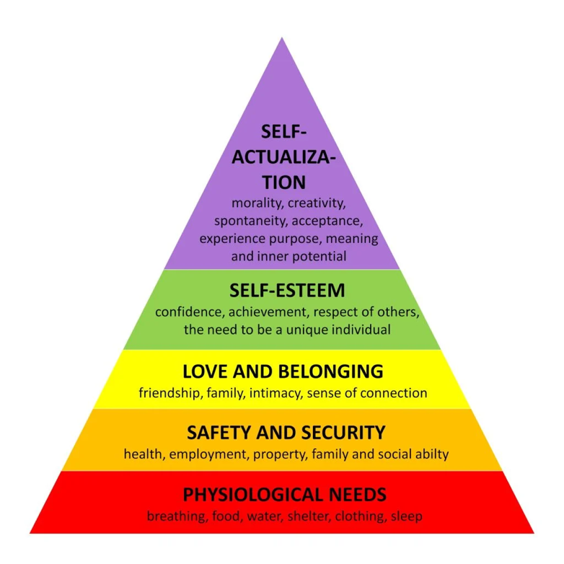

1️⃣ Physiological Needs (Basic Needs)
- Food
- Water
- Shelter
- Clothing

👉 In entrepreneurship:
A person may start a business to earn income for survival.

2️⃣ Safety Needs (Security Needs)
- Job security
- Financial stability
- Protection from risks
👉 An entrepreneur may start a business to gain financial independence and security.

3️⃣ Social Needs (Belongingness & Love)
- Friendship
- Social acceptance
- Relationships
👉 Business owners build networks, customer relationships, and social identity.

4️⃣ Esteem Needs (Recognition & Status)
- Respect
- Prestige
- Status
- Achievement
👉 Many entrepreneurs seek recognition and reputation in society.

5️⃣ Self-Actualization Needs (Highest Level)
- Personal growth
- Creativity
- Fulfillment of potential
👉 Successful entrepreneurs aim to innovate and create something meaningful.

3. Key Assumptions of Maslow’s Theory
- Needs are arranged in hierarchy.
- Lower-level needs must be satisfied first.
- Once a need is satisfied, it no longer motivates behavior.
- Higher needs become dominant after lower needs are fulfilled.

4. Importance in Entrepreneurship
- Explains why people start businesses.
- Helps understand employee motivation in startups.
- Useful for designing incentive systems.
- Encourages entrepreneurs to move toward self-actualization.

5. Criticism
- Not all individuals follow the same order.
- Difficult to measure satisfaction level of needs.
- Cultural differences may affect hierarchy.

6. Conclusion
Maslow’s theory explains entrepreneurial motivation as a progression from basic survival needs to self-fulfillment.
Many entrepreneurs initially start businesses for income and security, but ultimately aim for esteem and self-actualization through innovation and achievement.

2)McClelland’s Theory of Needs
David McClelland, an American psychologist, proposed the Theory of Needs (Achievement Motivation Theory) in 1961. According to him, human behavior is motivated by three learned needs – Achievement, Power, and Affiliation. Unlike other motivational theories, McClelland stated that these needs are not innate but developed through life experiences and social environment.
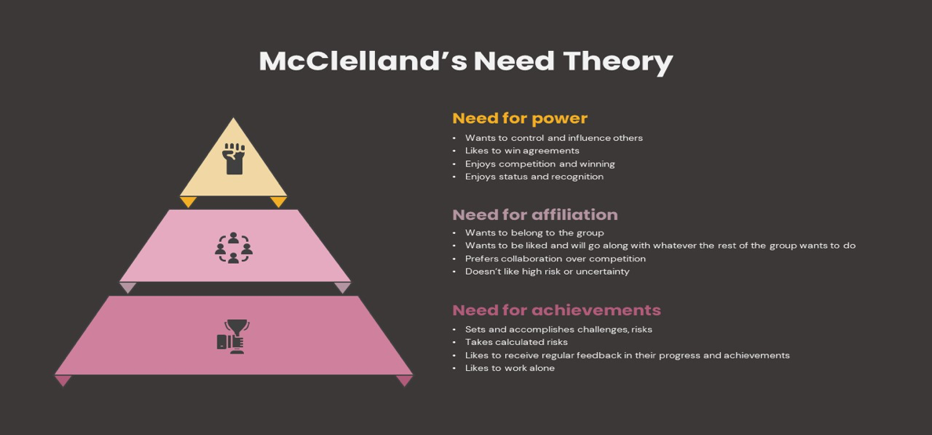

2. Main Components of the Theory
McClelland identified three dominant needs:

A) Need for Achievement (nAch)
This refers to the desire to accomplish something difficult and attain high standards of success.
Characteristics of High nAch Individuals:
- Prefer moderate risk tasks
- Take personal responsibility
- Seek immediate feedback
- Set challenging but achievable goals
- Desire for excellence

Relevance to Entrepreneurship:
Entrepreneurs usually possess a high need for achievement. They aim to improve performance and achieve business targets.

B) Need for Power (nPow)
This refers to the desire to influence, control, or direct others.
Types of Power:
- Personal Power – Control for personal status.
- Institutional (Social) Power – Influence for organizational growth.
Managers and leaders generally have a moderate to high need for power.

C) Need for Affiliation (nAff)
This refers to the desire to maintain friendly and close interpersonal relationships.
Characteristics:
- Prefer cooperation over competition
- Avoid conflict
- Seek social approval
- Maintain harmonious relationships
Individuals with high affiliation need perform well in team-based roles.

3. Assumptions of the Theory
- Needs are learned, not inborn.
- One need usually dominates in a person.
- Motivation differs from person to person.
- High nAch individuals contribute significantly to economic development.

4. Importance in Entrepreneurship
McClelland emphasized that societies with a high number of people having high achievement motivation experience faster economic growth. Entrepreneurs generally show:
- High nAch
- Moderate nPow
- Low nAff

5. Criticism
- Difficult to measure accurately.
- Does not consider lower-level physiological needs.
- Overemphasis on achievement motivation.

6. Conclusion
McClelland’s Theory of Needs is highly relevant in understanding entrepreneurial behavior, leadership, and managerial performance. It highlights that achievement motivation plays a key role in business success and economic development.

1.9 ROLE OF ENTREPRENEURSHIP IN ECONOMIC DEVELOPMENT
Entrepreneurship promotes:
- Industrial growth
- Innovation
- Employment generation
- Regional balance
- Capital formation
It transforms a factor-driven economy into an innovation-driven economy.

