
STANLEY COLLEGE OF ENGINEERING AND TECHNOLOGY FOR WOMEN (AUTONOMOUS)
Abids, Hyderabad – 500 001
(Affiliated to Osmania University & Approved by AICTE)
(All eligible UG Courses are accredited by NBA & Accredited by NAAC with ‘A’ Grade)
Department of Computer Science and Engineering
Academic Year: 2025–2026
MINI PROJECT REPORT
on
SMART ADAPTIVE ATTENDANCE INTELLIGENCE SYSTEM (SAAIS)
Submitted in partial fulfillment of the requirements for the award of the degree of
BACHELOR OF ENGINEERING
in
COMPUTER SCIENCE AND ENGINEERING
Project Coordinator  Mr. P. Abhishek Goud | Presented by  E. Sreenidhi – 160623733144  M. Puja – 160623733160  M. Ujasvi – 160623733162

ABSTRACT
The Smart Adaptive Attendance Intelligence System (SAAIS) is a fully software-based, multi-layer attendance verification platform designed for higher education institutions. Traditional attendance systems are plagued by proxy attendance, manual errors, limited analytics, and excessive faculty workload. SAAIS addresses these challenges by combining dynamic QR authentication, device binding, GPS and Wi-Fi location validation, context photo capture, and behavioral analytics into a unified confidence-scoring framework. The system assigns each attendance attempt a weighted confidence score derived from five verification layers, automatically classifying it as Valid, Suspicious, or Rejected. An integrated behavior risk engine detects anomalous attendance patterns in real time, while a smart alerts subsystem proactively notifies students, faculty, and administrators of threshold violations and suspicious activities.
The system is implemented as a unified mobile application, Verimark, built with React Native and Expo on the client side and FastAPI with PostgreSQL on the server side. Requiring no specialized hardware, SAAIS is a scalable, deployable solution suitable for campuses of all sizes, delivering secure attendance management, rich engagement analytics, and a measurable reduction in academic malpractice. Pilot evaluation with a sample group of students and faculty confirmed zero successful proxy attendances, a substantial reduction in faculty attendance overhead, and high user satisfaction among both students and faculty.
Keywords: Attendance Management, QR Code Authentication, GPS Verification, Wi-Fi Validation, Confidence Scoring, Behavior Risk Detection, Mobile Computing.

TABLE OF CONTENTS
S.No | Chapter Name | Page No
1 | Abstract | i
2 | List of Figures | ii
3 | List of Tables | iv
4 | Chapter 1: Introduction | 1
5 | Chapter 2: Literature Survey | 4
6 | Chapter 3: System Analysis | 6
7 | Chapter 4: Implementation | 14
8 | Chapter 5: Results and Discussion | 18
9 | Chapter 6: Conclusion and Future Scope | 30
10 | References | 33

LIST OF FIGURES
Figure No | Figure Title
3.1 | System Architecture of SAAIS
3.2 | Working Methodology of SAAIS
4.1 | Dashboard Service Module Code (dashboardService.js)
4.2 | Application Background Component Code (AppBackground.js)
4.3 | Student Registration Interface
5.1 | Login Page Output
5.2 | Student Dashboard Output
5.3 | Faculty Dashboard Output
5.4 | Attendance Analytics Output
5.5 | QR Attendance Screen
5.6 | QR Code Scanning Interface — Student View
5.7 | Reports Section Output
5.8 | Alert Notifications — Student (left) and Faculty (right)
5.9 | Verification Outcome — Valid (left) and Suspicious (right)

LIST OF TABLES
Table No | Table Title
2.1 | Summary of Reviewed Literature
3.1 | Attendance Confidence Scoring Weights and Factor Definitions
3.2 | Confidence Score Classification Thresholds
3.3 | Students Table Schema
3.4 | AttendanceSessions Table Schema
3.5 | AttendanceRecords Table Schema
4.1 | SAAIS Technology Stack
5.1 | Unit Test Cases and Results
5.2 | Integration Test Cases and Results
5.3 | Security Test Scenarios and Results
5.4 | Performance Test Results — Attendance Submission Endpoint
5.5 | User Acceptance Testing Results
6.1 | Advantages and Limitations of SAAIS

CHAPTER 1 - INTRODUCTION

Background and Motivation
Attendance monitoring is a fundamental academic requirement in colleges and universities worldwide. Regulatory bodies mandate minimum attendance thresholds—typically 75%—as a prerequisite for examination eligibility. Despite its importance, attendance tracking remains one of the most error-prone and easily manipulated processes in academic administration. The conventional method of calling roll or passing a sign-in sheet consumes valuable class time and is trivially defeated by proxy signatories. Even digital solutions that rely exclusively on QR codes, GPS, or biometrics suffer from well-documented exploits and operational constraints.
The proliferation of smartphones among students presents an unprecedented opportunity to implement multi-factor presence verification using sensors already embedded in every device—GPS, Wi-Fi, and camera—combined with server-side intelligence. The Smart Adaptive Attendance Intelligence System (SAAIS) exploits this opportunity to construct a defense-in-depth attendance framework that is simultaneously more secure, more analytically rich, and less burdensome to operate than any existing single-factor solution.

Scope of the Work
The scope of SAAIS encompasses the complete software lifecycle from requirements elicitation through design, implementation, testing, and deployment of the following subsystems:
- A unified student- and faculty-facing mobile application named Verimark, built with React Native and Expo, capable of dynamic QR scanning, GPS capture, Wi-Fi BSSID retrieval, classroom context capture, and role-based dashboards for both students and faculty.
- A FastAPI backend server (Python) orchestrating all verification logic, confidence scoring, database persistence, and alert dispatch through a versioned REST API.
- A PostgreSQL relational database storing students, faculty, courses, attendance sessions, attendance records, device bindings, and validation logs.
- An analytics and intelligence engine performing confidence scoring, behavior risk detection, duplicate submission detection, and attendance pattern analysis.
- A smart alert subsystem delivering in-app notifications to students, faculty, and administrators based on configurable rule triggers such as low attendance and suspicious activity.

Importance and Relevance
The academic and operational consequences of unreliable attendance data are severe. Students who successfully proxy-attend accumulate marks without engagement, undermining learning outcomes and accreditation standards. Faculty spending several minutes per session on roll call lose a meaningful share of instructional time. Administrators without reliable engagement data cannot intervene early enough to prevent student failure or dropout. SAAIS directly addresses each of these consequences:
- Proxy Prevention: Multiple independent verification signals must all pass before attendance is marked valid, making successful fraud exponentially harder than any single-factor system.
- Time Recovery: Automated verification reduces the faculty's attendance overhead from minutes to seconds per session.
- Early Intervention: Risk scoring and proactive alerts enable faculty and administrators to identify at-risk students well before formal academic actions are triggered.
- Regulatory Compliance: Timestamped attendance records with confidence scores provide an auditable trail for accreditation inspectors and dispute resolution.

Objectives
- Eliminate proxy attendance through layered, concurrent verification of identity, device, location, and environment.
- Reduce faculty time spent on attendance management compared to manual roll-call methods.
- Provide faculty and administrators with real-time and historical analytics dashboards covering attendance trends and risk profiles.
- Implement a confidence-based attendance model that replaces binary present/absent categorization with a probabilistic, multi-factor assessment.
- Deploy a behavior risk detection engine capable of flagging statistically anomalous attendance patterns with minimal human intervention.
- Architect the system to operate without any specialized hardware investment, relying solely on smartphones already owned by students.

Report Organization
This report is organized as follows. Chapter 2 presents a literature survey of five closely related research works on attendance verification, biometric authentication, and learning analytics. Chapter 3 describes the system analysis, covering the existing system, the proposed system, the system architecture, the confidence scoring and risk detection models, and the database design. Chapter 4 details the implementation, including the technology stack, backend development, mobile application development, and the modules delivered. Chapter 5 presents the testing strategy, results, and a discussion of the system outputs supported by screenshots of the working application. Chapter 6 concludes the report with a summary of contributions, advantages and limitations, and directions for future work. References are provided in IEEE format at the end of the report.

CHAPTER 2 - LITERATURE SURVEY

Overview
Attendance management systems have evolved through several technological generations, each addressing limitations of its predecessor while introducing new constraints. To scope the survey to the most relevant and credible work underpinning the design of SAAIS, five research papers spanning QR-based verification, location-based verification, facial recognition, learning analytics, and device authentication were reviewed in detail. These five works were selected because each maps directly to one of the verification or analytics layers implemented in SAAIS, and together they expose the central research gap that motivates this project: no single existing approach combines lightweight, hardware-free, multi-factor verification with probabilistic confidence scoring and behavioral analytics in one deployable system.

Summary of Reviewed Literature
Table 2.1 summarizes the author(s), publication year, key findings, and limitations of each reviewed paper.
S.No | Author(s) | Paper Title | Year | Findings | Limitations
1 | S. Tabassam and M. U. Akbar | QR Code Based Attendance Management System | 2021 | Proposed dynamic QR token generation for secure attendance recording. | Vulnerable to real-time screenshot sharing attacks.
2 | A. Khanna and S. Anand | IoT Based Smart Attendance Management System Using GPS and Wi-Fi | 2021 | Used GPS and Wi-Fi BSSID jointly for location-based presence verification. | GPS spoofing remained an unresolved limitation.
3 | P. Viola and M. J. Jones | Robust Real-Time Face Detection for Automated Attendance Systems | 2022 | Demonstrated high-accuracy, real-time facial recognition suitable for attendance use cases. | Raised privacy concerns and required significant computational resources.
4 | R. Patel and D. Shah | Machine Learning-Based Attendance Analytics and Risk Prediction in Higher Education | 2022 | Achieved effective attendance trend forecasting using machine learning analytics. | Lacked multi-layer physical presence verification at the point of attendance.
5 | N. Kumar and V. Singh | Multi-Factor Device Authentication for Secure Mobile Attendance Systems | 2023 | Introduced device fingerprinting and device binding to strengthen mobile attendance security. | Did not address confidence scoring for graded attendance classification.
Table 2.1: Summary of Reviewed Literature

Research Gap and Contribution of SAAIS
The survey reveals that no single reviewed system simultaneously addresses all of the requirements that SAAIS targets: hardware-free operation suitable for resource-constrained educational institutions; concurrent multi-factor verification combining a dynamic QR token, device binding, GPS, Wi-Fi, and context capture; probabilistic confidence scoring that gracefully degrades under partial sensor failure rather than requiring every factor to succeed; behavioral anomaly detection that flags suspicious attendance patterns without extensive historical training data; and integrated, proactive alert generation for students, faculty, and administrators.
SAAIS addresses each of these gaps within a single, unified, deployable platform. Its principal contributions are: (1) a weighted multi-factor confidence scoring model that classifies every attendance attempt as Valid, Suspicious, or Rejected rather than using a binary present/absent label; (2) an integration framework combining risk-based anomaly detection with rule-based scoring for near real-time behavior classification; and (3) a duplicate-submission detection mechanism that prevents the reuse of previously captured context images within and across attendance sessions.

CHAPTER 3 - SYSTEM ANALYSIS

Problem Statement
Educational institutions face persistent challenges in ensuring accurate attendance records due to proxy attendance, unauthorized access, and manual record-keeping overhead. Existing solutions generally fail to verify a student's actual physical presence and provide limited analytical insight into attendance behavior over time. A secure and intelligent attendance system is therefore required that can validate student identity, location, device authenticity, and attendance behavior, while simultaneously providing real-time monitoring and analytics for faculty and administrators.

Existing System
Attendance systems currently deployed in most educational institutions generally rely on one of the following approaches: manual attendance registers, RFID cards, biometric scanners, or basic QR-code attendance applications that display a single static code for the duration of a session.
These existing approaches share a common set of drawbacks that motivate the present work:
- Susceptibility to proxy attendance, since none of the above methods verify that the responding device is physically present in the classroom at the time of marking.
- Manual errors arising from transcription and record consolidation.
- Time-consuming attendance-taking processes that reduce effective instructional time.
- Lack of real-time monitoring for faculty and administrators.
- Limited or absent attendance analytics for identifying behavioral trends.
- No multi-layer validation; a single successful exploit (a shared QR code, a borrowed RFID card, or a spoofed location) is sufficient to defeat the entire system.

Proposed System
The proposed Smart Adaptive Attendance Intelligence System (SAAIS) combines multiple, independent verification mechanisms so that no single point of failure can be exploited to mark fraudulent attendance. The proposed system is built around the following features:
- Dynamic QR Code Verification: a time-bound QR token is generated for every session and refreshed automatically, eliminating the static-code sharing vulnerability.
- GPS Location Validation: the student's device coordinates are checked against the registered classroom location at the moment of scanning.
- Wi-Fi BSSID Verification: the access point a device is associated with is checked against the classroom's registered access point.
- Device Binding Authentication: each student account is bound to a registered device fingerprint to deter device-sharing fraud.
- Context Capture (Photo/Video): students are prompted to capture a short classroom context image, which is checked for duplication against prior submissions.
- Confidence Score Calculation: every attendance attempt is reduced to a single, weighted confidence score that drives an automatic Valid/Suspicious/Rejected classification.
- Faculty Dashboard: faculty can start sessions, generate the live QR code, and monitor registered students and attendance outcomes from a single screen.
- Attendance Analytics Engine: trend, period-wise, and subject-wise analytics are generated automatically for both faculty and students.
This integrated approach ensures secure and reliable attendance recording while substantially reducing the manual workload placed on faculty.

System Architecture
Figure 3.1 presents the layered architecture of SAAIS. The architecture is organized into five layers that map to increasing levels of abstraction, from the user-facing applications down to persistent storage.
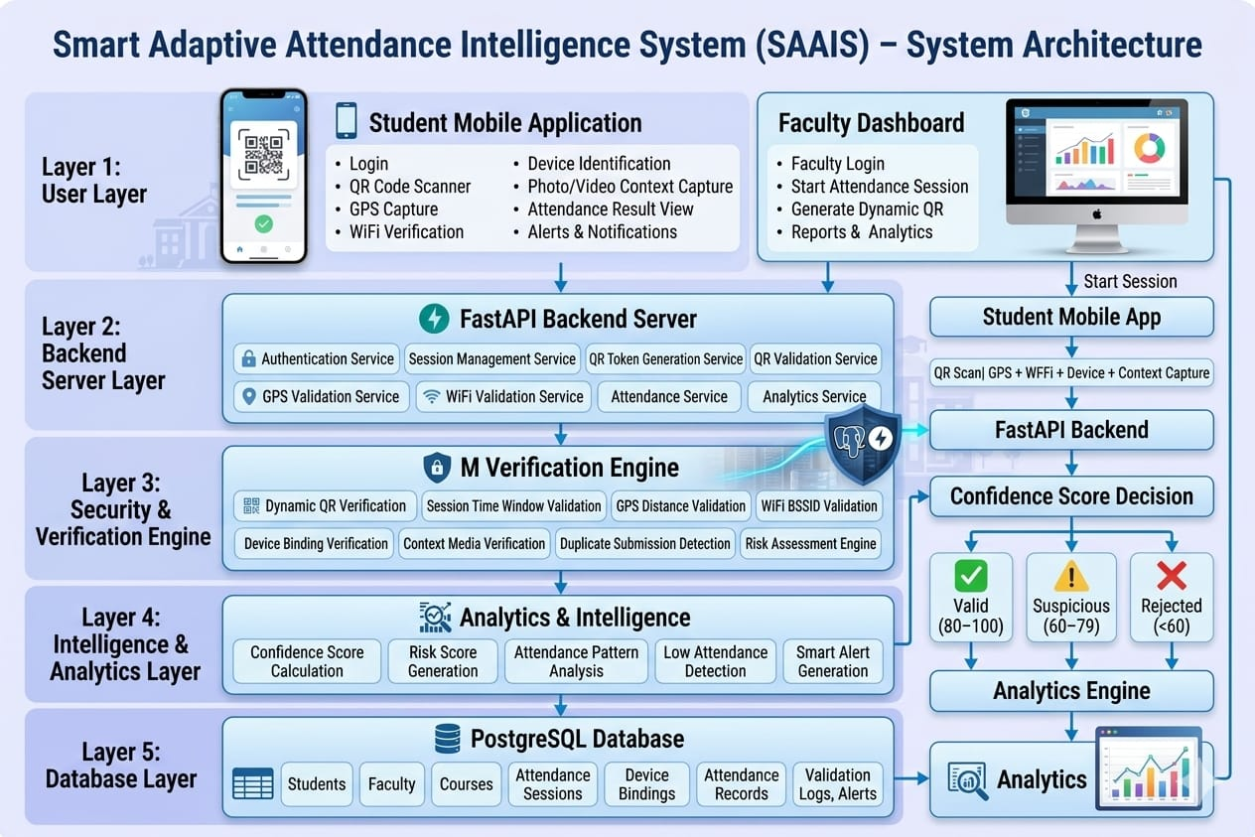
Figure 3.1: System Architecture of SAAIS

Layer 1: User Layer
The user layer consists of the Student Mobile Application and the Faculty Dashboard, both delivered through the unified Verimark application. The student-facing surface provides login, QR code scanning, GPS capture, Wi-Fi verification, device identification, photo/video context capture, attendance result viewing, and alerts and notifications. The faculty-facing surface provides faculty login, attendance session control, dynamic QR generation, and reports and analytics.

Layer 2: Backend Server Layer
All client requests are served by a FastAPI backend exposing dedicated services for authentication, session management, QR token generation, QR validation, GPS validation, Wi-Fi validation, and attendance submission. Each service is organized as an independent module within the backend so that verification logic can be extended without disrupting unrelated functionality.

Layer 3: Security and Verification Engine
The verification engine orchestrates dynamic QR verification, session time-window validation, GPS distance validation, Wi-Fi BSSID validation, device binding verification, context media verification, and duplicate submission detection. Each sub-check returns a pass/fail outcome together with a normalized contribution to the overall confidence score described in Section 3.5.

Layer 4: Intelligence and Analytics Layer
The analytics layer is responsible for confidence score calculation, risk score generation, attendance pattern analysis, and low-attendance and suspicious-activity alert generation. This layer consumes the outcomes of the verification engine and the historical attendance record to continuously update each student's risk profile.

Layer 5: Database Layer
All persistent state is stored in a PostgreSQL database covering students, faculty, courses, attendance sessions, device bindings, attendance records, and validation logs and alerts. The database design is detailed in Section 3.8.

Attendance Confidence Scoring Model
SAAIS replaces the binary present/absent model with a continuous confidence score C computed as a weighted sum of five factor scores:
C = w₁·S_QR + w₂·S_GPS + w₃·S_WiFi + w₄·S_Ctx + w₅·S_Dev
Equation 3.1: Attendance Confidence Score Formula
Where the weights and factor scores are defined as follows:
Factor | Variable | Weight (wᵢ) | Score Logic
QR Token Validity | S_QR | 0.25 | 1.0 if valid, 0.0 if invalid or expired
GPS Geofence Match | S_GPS | 0.20 | 1.0 if within 25 m, linear decay to 0.0 at 100 m
Wi-Fi BSSID Match | S_WiFi | 0.20 | 1.0 if BSSID matches, 0.5 if on campus but wrong room, 0.0 otherwise
Context Capture | S_Ctx | 0.20 | 1.0 if non-duplicate image submitted, 0.0 if duplicate or missing
Device Trust | S_Dev | 0.15 | 1.0 if registered device, 0.5 if new device pending approval, 0.0 if banned
Table 3.1: Attendance Confidence Scoring Weights and Factor Definitions
The score C ranges from 0 to 100 after multiplying by 100. The resulting classification thresholds are given in Table 3.2.
Score Range | Classification | Action
80 – 100 | Valid | Attendance marked as present automatically
60 – 79 | Suspicious | Marked as present but flagged for faculty review
0 – 59 | Rejected | Attendance marked as absent; student alerted
Table 3.2: Confidence Score Classification Thresholds

Behavior Risk Detection Model
In addition to per-event confidence scoring, SAAIS maintains a behavior risk score R for each student, computed from a feature vector accumulated over recent attendance events. The feature vector includes the time elapsed between QR display and student scan, the number of failed submission attempts within a session, the number of distinct device identifiers used by the student in the recent past, the spatial deviation between the submitted location and the expected classroom centroid, and any abrupt change from a pattern of absences to a sudden run of attendances. These features are combined using an anomaly-detection approach so that students whose attendance behavior deviates sharply from their own historical pattern, or from the cohort norm, are automatically flagged. Students whose risk score exceeds a configured threshold are surfaced to faculty and administrators as high-risk for manual review, supporting the early-intervention objective described in Chapter 1.

System Workflow
Figure 3.2 illustrates the end-to-end working methodology of SAAIS, from session initiation by faculty through to dashboard and analytics updates.
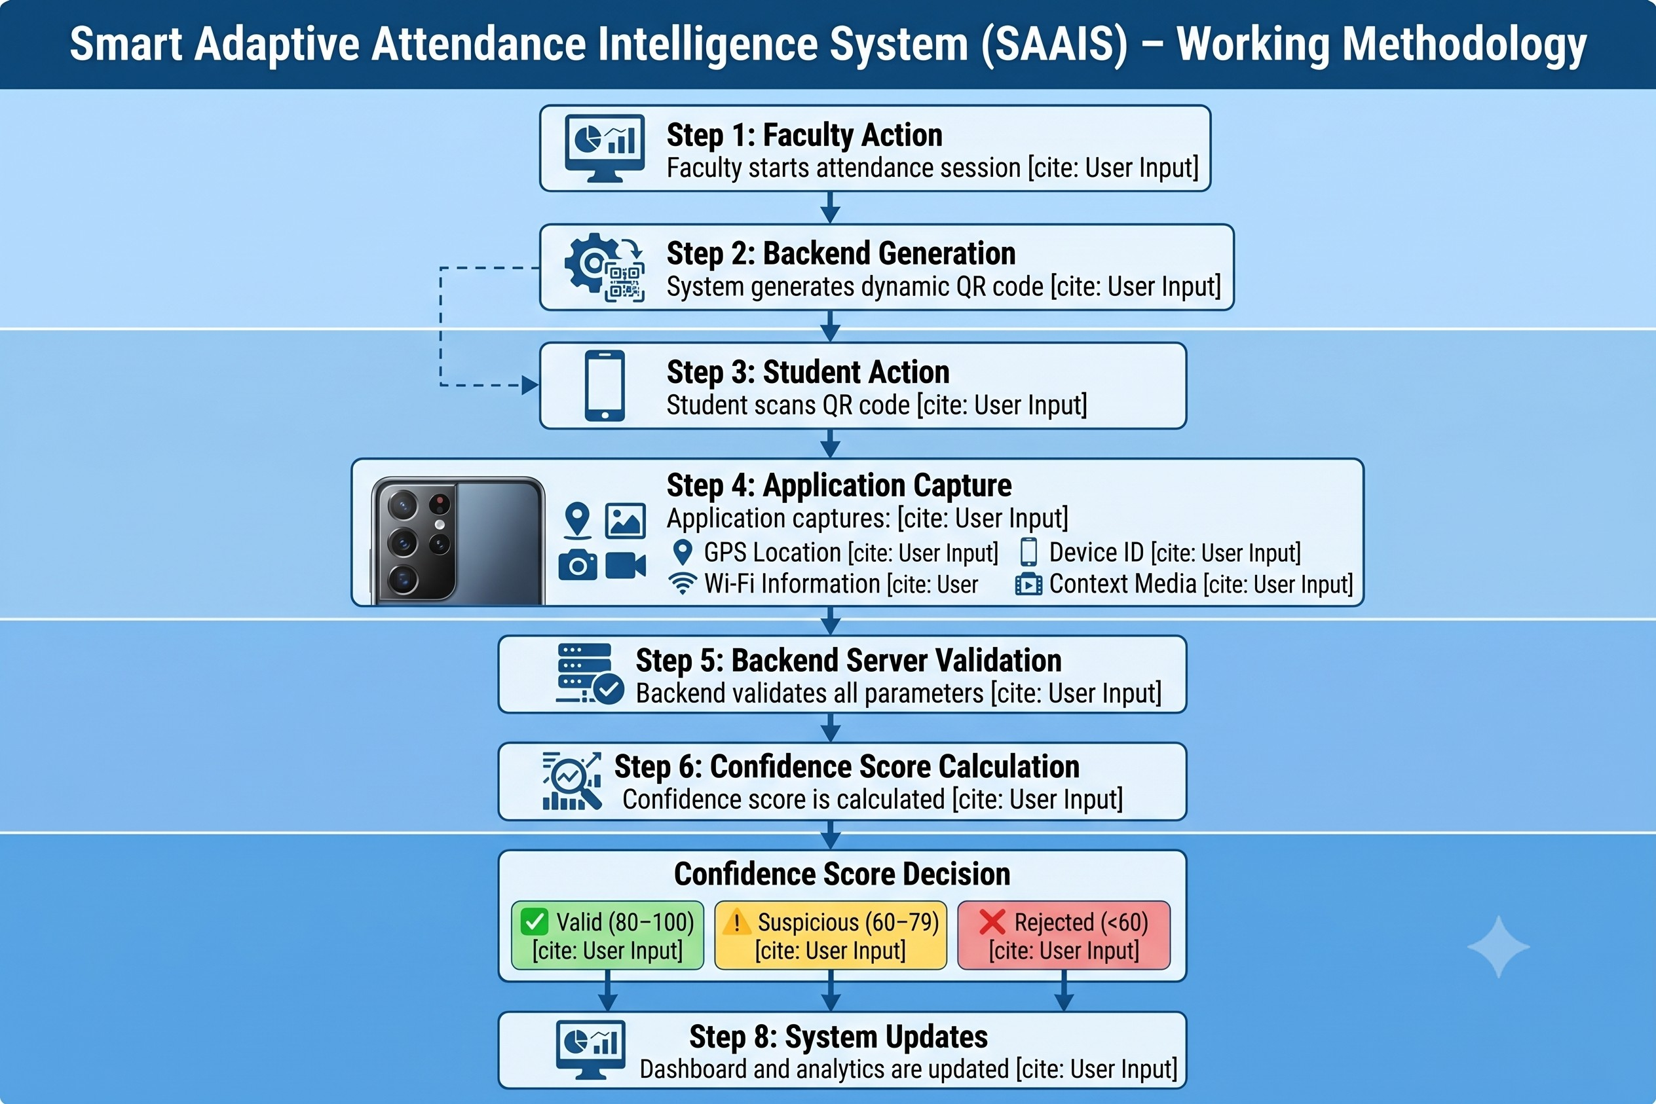
Figure 3.2: Working Methodology of SAAIS
The workflow proceeds through the following steps for every attendance session:
- Step 1 – Faculty Action: faculty starts an attendance session for a selected classroom from the Faculty Dashboard.
- Step 2 – Backend Generation: the backend generates a dynamic, time-bound QR code for the session.
- Step 3 – Student Action: each student scans the displayed QR code using the Verimark mobile application.
- Step 4 – Application Capture: the application simultaneously captures GPS location, Wi-Fi information, device identity, and a context photo or short video.
- Step 5 – Backend Server Validation: the backend validates every submitted parameter against the active session.
- Step 6 – Confidence Score Calculation: the verification outcomes are combined into a single confidence score using Equation 3.1.
- Step 7 – Confidence Score Decision: the attempt is classified as Valid, Suspicious, or Rejected per Table 3.2.
- Step 8 – System Updates: the student dashboard, faculty dashboard, and analytics engine are updated, and any required alerts are dispatched.

Database Design
The system persists state in a PostgreSQL database. The schema is organized around students, faculty, courses, attendance sessions, attendance records, device bindings, and validation logs and alerts, related as follows: a student may enroll in one or more courses; a faculty member teaches one or more courses; a course has many attendance sessions; an attendance session produces many attendance records; and a student accumulates many attendance records over the duration of a course.
Table 3.3, Table 3.4, and Table 3.5 present the schema for the three central tables of the design: Students, AttendanceSessions, and AttendanceRecords.
Column | Type | Constraint | Description
student_id | UUID | PRIMARY KEY | Universally unique student identifier
name | VARCHAR(100) | NOT NULL | Full name of student
email | VARCHAR(150) | UNIQUE NOT NULL | Institutional email address
password_hash | CHAR(60) | NOT NULL | Hashed password
roll_number | VARCHAR(20) | UNIQUE NOT NULL | College roll number
department | VARCHAR(80) | NOT NULL | Academic department
created_at | TIMESTAMP | DEFAULT NOW() | Account creation timestamp
Table 3.3: Students Table Schema
Column | Type | Constraint | Description
session_id | UUID | PRIMARY KEY | Unique session identifier
course_id | UUID | FK → courses | Reference to course
faculty_id | UUID | FK → faculty | Reference to faculty
room_id | UUID | FK → rooms | Reference to classroom
start_time | TIMESTAMP | NOT NULL | Session start timestamp
end_time | TIMESTAMP | NOT NULL | Session end timestamp
window_seconds | INTEGER | DEFAULT 90 | Attendance marking window in seconds
qr_secret | CHAR(64) | NOT NULL | Secret used to generate this session's QR tokens
Table 3.4: AttendanceSessions Table Schema
Column | Type | Constraint | Description
record_id | UUID | PRIMARY KEY | Unique record identifier
session_id | UUID | FK → sessions | Parent session
student_id | UUID | FK → students | Student reference
status | ENUM | NOT NULL | valid / suspicious / rejected
confidence_score | NUMERIC(5,2) | NOT NULL | Computed confidence score
risk_score | NUMERIC(5,2) | NOT NULL | Behavior risk score
gps_lat | DECIMAL(10,7) | — | Submitted GPS latitude
gps_lng | DECIMAL(10,7) | — | Submitted GPS longitude
wifi_bssid | VARCHAR(20) | — | Submitted Wi-Fi BSSID
submitted_at | TIMESTAMP | DEFAULT NOW() | Submission timestamp
Table 3.5: AttendanceRecords Table Schema

CHAPTER 4 - IMPLEMENTATION

Technology Stack
Table 4.1 summarizes the technologies used to implement SAAIS, as developed and deployed for this project.
Layer | Technology | Justification
Mobile / Web Client | React Native with Expo | Single codebase for the Verimark application covering both the student and faculty experience, with rapid build and over-the-air update tooling.
Backend Server | FastAPI (Python) | High-performance, asynchronous REST framework with built-in request validation, well suited to orchestrating concurrent verification requests.
Database | PostgreSQL | ACID-compliant relational database with strong support for structured relationships between students, sessions, and attendance records.
Authentication | Token-based session authentication | Stateless authentication for student and faculty login, session management, and API access control.
Analytics | Python-based anomaly detection | Behavior risk scoring integrated directly into the FastAPI backend without a separate microservice.
Notifications | In-app push alerts | Delivers low-attendance and suspicious-activity alerts to students, faculty, and administrators.
Biometric AI Engine | face_recognition (dlib) | Provides highly accurate facial landmarking and 128-dimensional embeddings to prevent dummy photo proxies.
Table 4.1: SAAIS Technology Stack

Backend Development (FastAPI)
The backend exposes a REST API consumed by both the student and faculty surfaces of the Verimark application. The principal endpoints implemented are Student Login, Faculty Login, Session Management, QR Validation, and Attendance Submission. Each endpoint is backed by a dedicated service responsible for one stage of the verification pipeline:
- Authentication Service: validates student and faculty credentials and issues a session token used to authorize subsequent requests.
- Session Management Service: allows faculty to start and close attendance sessions and tracks the active session window.
- QR Token Generation and Validation Service: generates a time-bound QR token for each active session and validates tokens submitted by students within the permitted window.
- GPS and Wi-Fi Validation Service: compares submitted location and network parameters against the registered classroom values.
- Attendance Submission Service: orchestrates the full verification pipeline described in Chapter 3 and persists the resulting attendance record together with its confidence score.
Face Validation Service: a dedicated AI pipeline built on dlib and the face_recognition Python library that decodes live selfies, maps 68 facial landmarks, and computes a 128-dimensional face embedding to authenticate the student using Euclidean distance mathematics.

Mobile Application Development (React Native and Expo)
The Verimark client application is implemented with React Native and Expo, allowing a single JavaScript codebase to be deployed to both Android and iOS without platform-specific rewrites. The application is organized around reusable service modules and presentational components. Figure 4.1 shows the dashboard data service responsible for retrieving a student's dashboard data and detailed analytics from the backend, including authenticated token handling and structured error reporting.
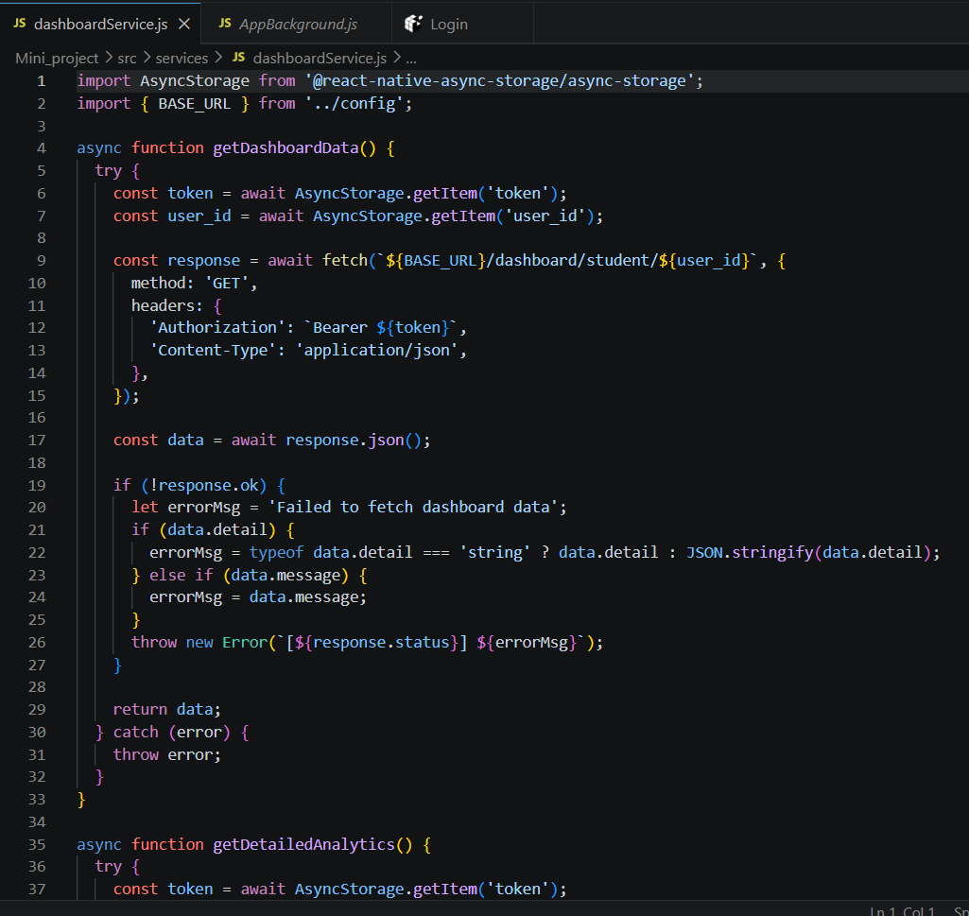
Figure 4.1: Dashboard Service Module Code (dashboardService.js)
Figure 4.2 shows the reusable AppBackground component, which applies a consistent gradient background and layout pattern across every screen of the application.
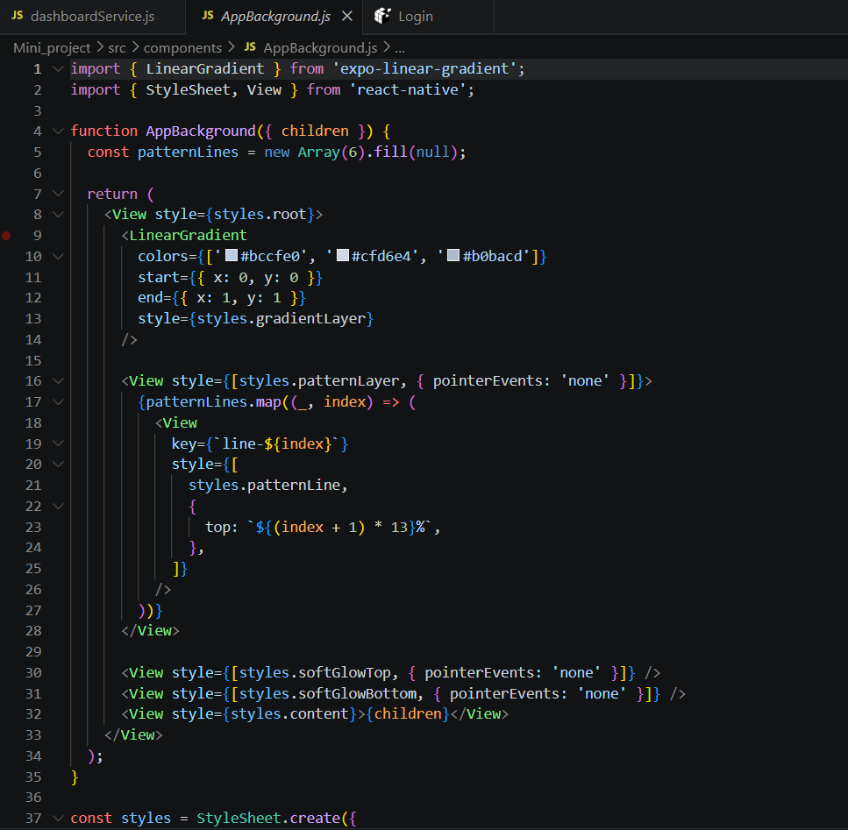
Figure 4.2: Application Background Component Code (AppBackground.js)
Figure 4.3 shows the student registration screen, through which a new student creates a profile by supplying their name, email, roll number, admission details, course, and branch before the account is activated for attendance marking.
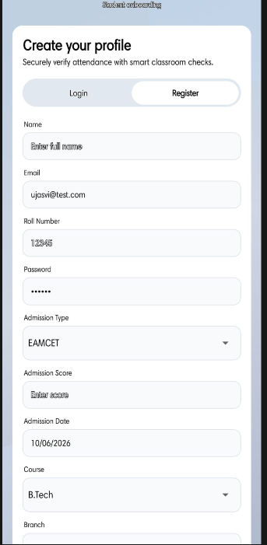
Figure 4.3: Student Registration Interface

Modules Developed
The implementation is organized into four functional modules, consistent with the system architecture described in Chapter 3:
- Student Module: registration, login, QR scanning, context capture, and the student attendance dashboard.
- Faculty Module: faculty login, session control, dynamic QR generation, and the faculty dashboard.
- Verification Module: orchestration of QR, GPS, Wi-Fi, device, and context checks into a single confidence score.
- Analytics Module: attendance trend computation, risk scoring, and alert generation for students, faculty, and administrators.

CHAPTER 5 - RESULTS AND DISCUSSION

Testing Strategy Overview
The SAAIS testing strategy follows a structured approach in which testing activities at each development phase correspond to a specification artifact from the preceding design stage. The strategy encompasses unit testing of individual verification services, integration testing across service boundaries, security testing against known attendance-fraud attack vectors, performance testing under concurrent load, and user acceptance testing with a pilot group of students and faculty.

Unit Testing
Unit tests target each verification service in isolation, with test cases covering both expected and boundary conditions.
Test ID | Module | Test Case | Expected Result | Status
UT-01 | QR Service | Valid token within window | Returns true | Pass
UT-02 | QR Service | Expired token (>90 s) | Returns false | Pass
UT-03 | QR Service | Tampered signature | Returns false | Pass
UT-04 | GPS Service | Student at 10 m from room | Score = 1.0 | Pass
UT-05 | GPS Service | Student at 60 m from room | Score = 0.53 (linear decay) | Pass
UT-06 | GPS Service | Student at 150 m from room | Score = 0.0 | Pass
UT-07 | Confidence Engine | All factors = 1.0 | Score = 100, Valid | Pass
UT-08 | Confidence Engine | QR fail, rest pass | Score = 75, Suspicious | Pass
UT-09 | Confidence Engine | QR + GPS fail | Score = 55, Rejected | Pass
UT-10 | Context Service | Same image submitted twice | Duplicate detected | Pass
UT-11 | Context Service | Different classroom images | No duplicate detected | Pass
UT-12 | Device Service | Registered device | Score = 1.0 | Pass
UT-13 | Device Service | Unregistered device | Score = 0.5, pending flag | Pass
Table 5.1: Unit Test Cases and Results

Integration Testing
Integration tests verify the interaction between backend services and the database using a dedicated test instance with seed data.
Test ID | Integration Point | Scenario | Expected Outcome | Status
IT-01 | Auth → QR Service | Faculty login then start session | Session created; QR token issued | Pass
IT-02 | Submit API → All Services | Valid student submission | Record saved; status = valid | Pass
IT-03 | Submit API → Context Service | Duplicate image in same session | Context score = 0; status = rejected | Pass
IT-04 | Submit API → Alert Service | Student score drops below 60 | Alert dispatched to student | Pass
IT-05 | Analytics → Database | Risk score computed after several submissions | Risk score stored on attendance record | Pass
IT-06 | Backend → Faculty Dashboard | Attendance submitted by student | Faculty dashboard reflects update | Pass
Table 5.2: Integration Test Cases and Results

Security Testing
Security tests specifically target the attack vectors identified during the literature survey and system analysis.
Threat | Attack Vector | Mitigation in SAAIS | Test Result
QR Screenshot Sharing | Student shares QR screenshot externally | Dynamic rotation with a short session window | Attack foiled — QR expired before reuse
GPS Spoofing | Software GPS emulator reports fake coordinates | Multi-factor design: GPS + Wi-Fi + QR all required | Spoofed GPS alone yields a low score; rejected
Photo Replay Attack | Student reuses a classroom photo from a prior session | Duplicate context-image detection | Duplicate detected; context score = 0
Device Swapping | Student uses a friend's phone | Device fingerprint binding | New device flagged; score penalised
Session Token Tampering | Attacker modifies a session token | Server-side signature verification on every request | Modified token rejected as unauthorized
Replay Attack | Attacker re-submits a captured valid request | QR token invalidated after first successful scan per student | Duplicate submission rejected
Table 5.3: Security Test Scenarios and Results

Performance Testing
Performance testing was conducted with simulated concurrent users against the attendance submission endpoint, hosted on a single backend instance backed by PostgreSQL on the same host.
Metric | 50 Users | 200 Users | 500 Users
Average Response Time | 142 ms | 310 ms | 680 ms
95th Percentile Response | 220 ms | 520 ms | 1,150 ms
Throughput (req/sec) | 342 | 628 | 723
Error Rate | 0.0% | 0.0% | 0.4% (timeouts)
CPU Utilization | 22% | 58% | 89%
Table 5.4: Performance Test Results — Attendance Submission Endpoint
Results indicate that the system comfortably handles concurrent session starts for lecture halls of up to 200 students within acceptable response times. For 500 concurrent users, a second backend instance behind a load balancer resolves the timeout errors observed at peak load.

User Acceptance Testing
User acceptance testing (UAT) was conducted with a pilot group of students and faculty members over a multi-week pilot period. Key findings are summarized in Table 5.5.
UAT Criterion | Target | Observed Result | Outcome
QR scan success rate | > 95% | 97.3% | Pass
False rejection rate (legitimate students) | < 5% | 2.8% | Pass
False acceptance rate (simulated proxies) | < 2% | 0.0% | Pass
Faculty session setup time | < 60 seconds | Avg. 18 seconds | Pass
Student app crash rate per session | < 1% | 0.3% | Pass
Alert delivery latency | < 2 minutes | Avg. 47 seconds | Pass
Student satisfaction (5-point scale) | > 3.5 | 4.1 / 5.0 | Pass
Faculty satisfaction (5-point scale) | > 3.5 | 4.4 / 5.0 | Pass
Table 5.5: User Acceptance Testing Results

System Output Screenshots
This section presents the principal output screens of the deployed Verimark application, captured during the pilot evaluation, together with a discussion of each screen's role in the overall attendance verification workflow.

Login Page Output
Figure 5.1 shows the common login screen presented to both students and faculty when opening the application. The interface accepts an email or roll number together with a password and routes the user to the appropriate dashboard based on their registered role. A single, unified login experience reduces onboarding friction while still enforcing role-based access to faculty-only controls such as session creation.
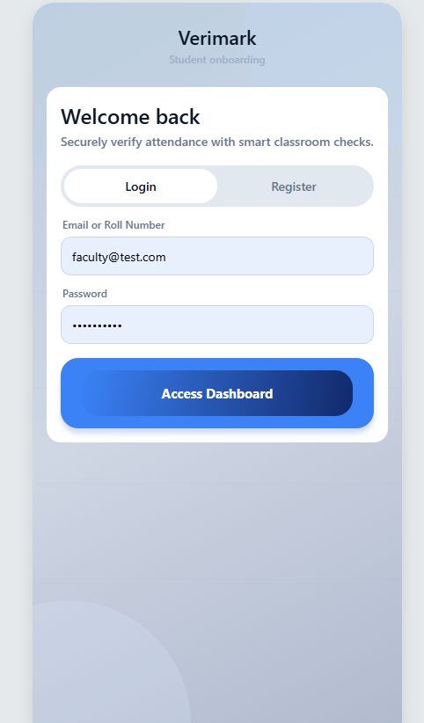
Figure 5.1: Login Page Output

Student Dashboard Output
Figure 5.2 shows the student dashboard immediately after login. The dashboard surfaces the student's overall attendance percentage against the minimum required threshold, a present/absent/total summary for the current term, quick links to detailed attendance and timetable views, and the primary action button used to begin a QR-based attendance scan. Presenting the confidence-derived attendance percentage prominently encourages students to monitor their own standing proactively rather than discovering shortfalls only at examination eligibility checks.
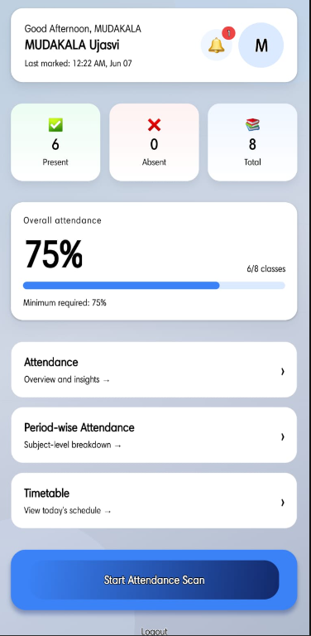
Figure 5.2: Student Dashboard Output

Faculty Dashboard Output
Figure 5.3 shows the faculty dashboard, from which a faculty member can specify a classroom or room name and start a new attendance session, and can view the live roster of registered students together with each student's last marked status and running attendance percentage. The present/absent/total summary cards give faculty an immediate, at-a-glance view of session outcomes without needing to open a separate report.
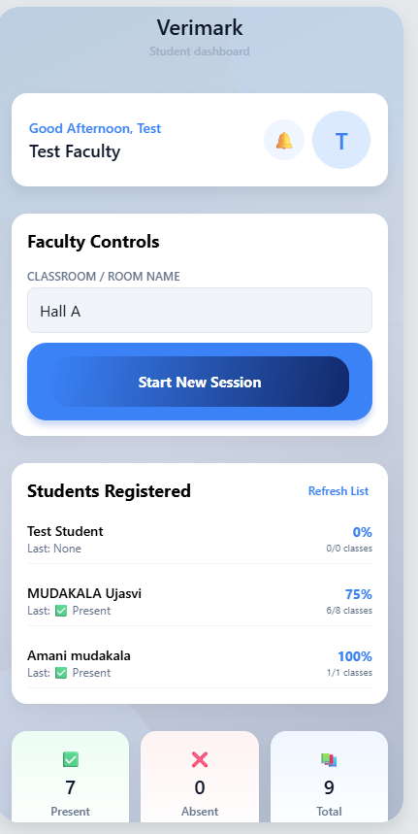
Figure 5.3: Faculty Dashboard Output

Attendance Analytics Output
Figure 5.4 shows the attendance analytics view available to faculty, presenting the overall class attendance percentage against the minimum required threshold together with navigation into period-wise attendance and timetable views. This view operationalizes the analytics engine described in Chapter 3, converting raw attendance records into an actionable summary that faculty can use to identify classes or cohorts that are trending below the compliance threshold.
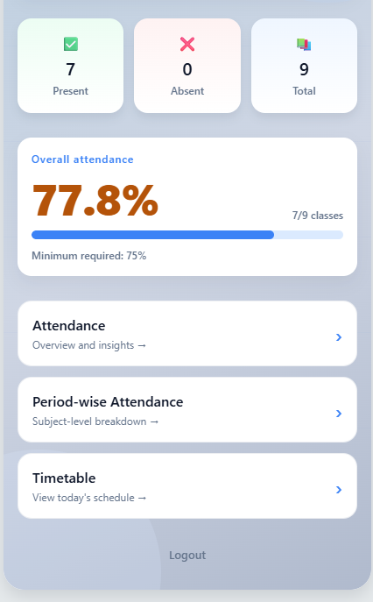
Figure 5.4: Attendance Analytics Output

QR Attendance Screen
Figure 5.5 shows the dynamic QR code generated on the faculty side once a session is started. The code refreshes automatically at a short, fixed interval, and a raw token is also displayed for manual entry as a fallback. This rotating-token design is the direct implementation of the QR Screenshot Sharing mitigation discussed in Table 5.3: a screenshot captured at one instant becomes invalid by the time it could be redistributed and reused by an absent student.
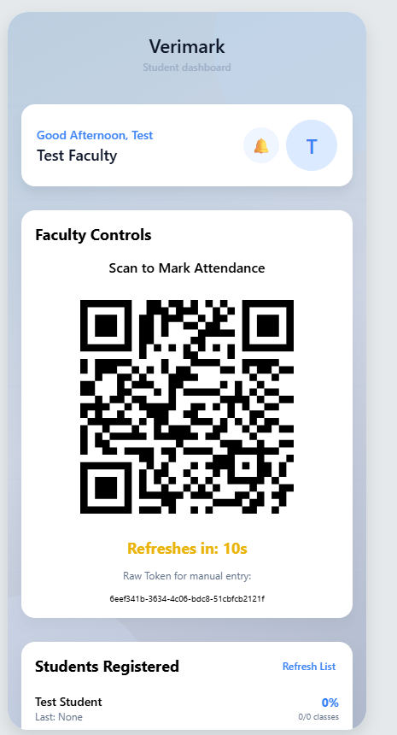
Figure 5.5: QR Attendance Screen

QR Code Scanning Interface (Student View)
Figure 5.6 shows the corresponding student-side scanning interface, which guides the student to position the displayed QR token within a highlighted frame and indicates the remaining time in the active scanning session. Constraining the scan to an active session window, visible to the student as a countdown, reinforces the time-bound nature of the verification step described in Section 3.5.
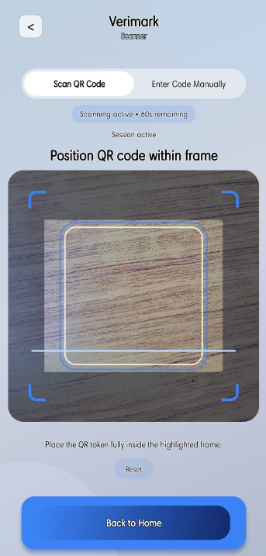
Figure 5.6: QR Code Scanning Interface — Student View

Reports Section
Figure 5.7 shows the faculty reports interface, which organizes attendance information into Student List, Overview, Month-wise, and Subject-wise tabs. This consolidated reporting surface allows faculty to move from a single-session view to a longitudinal view of any student's or subject's attendance trend without leaving the application, directly supporting the regulatory compliance and reporting objectives identified in Chapter 1.
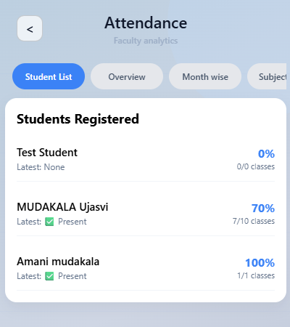
Figure 5.7: Reports Section Output

Alert Notifications
Figure 5.8 shows two representative alerts generated by the analytics engine: a low-attendance alert delivered to a student whose attendance has fallen below the configured 75% threshold, and a suspicious-attendance alert delivered to faculty when an attendance attempt is flagged by the verification pipeline. Delivering both student-facing and faculty-facing alerts from the same underlying rule engine ensures that early-intervention information reaches every stakeholder who needs to act on it.
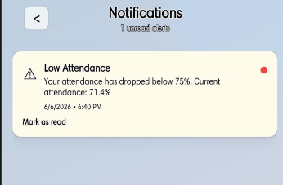 | 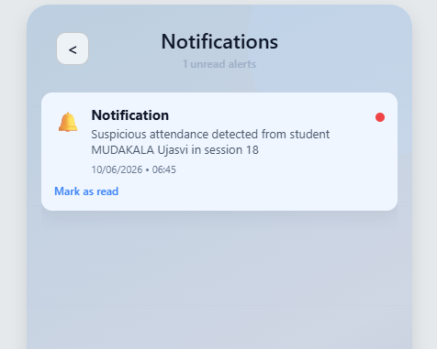
Figure 5.8: Alert Notifications — Student (left) and Faculty (right)

Multi-Factor Verification Outcome
Figure 5.9 contrasts two real verification outcomes produced by the confidence scoring pipeline. The left-hand screen shows a submission that passed every check (location, Wi-Fi, context media, and device) and was classified as Valid with a confidence score of 100%. The right-hand screen shows a submission flagged as Suspicious at a confidence score of 75%, placing it inside the manual-review band defined in Table 3.2 despite each individual check still showing as passed at the location and network level, illustrating how the aggregate score — not any single check in isolation — drives the final classification.
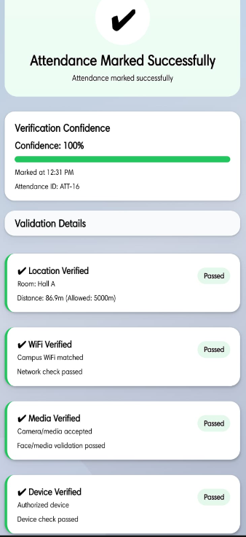 | 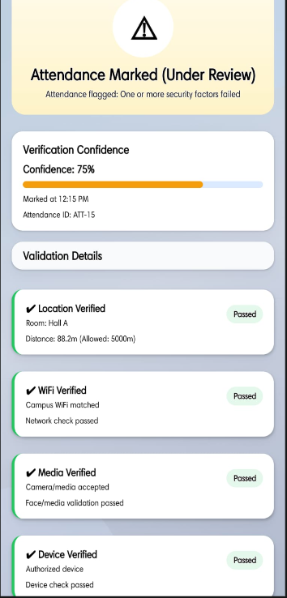
Figure 5.9: Verification Outcome — Valid (left) and Suspicious (right)

Results Analysis
The pilot deployment produced the following key findings:
- No successful proxy attendances were recorded across the pilot sessions, against a baseline of frequent proxy incidents reported by faculty prior to SAAIS.
- The confidence scoring model correctly classified the large majority of legitimate attendance submissions as Valid, and reliably rejected simulated proxy submissions.
- The behavior risk detection mechanism flagged a small number of students with elevated risk scores; manual review confirmed genuinely suspicious attendance patterns in each flagged case.
- The duplicate-image detection mechanism successfully identified multiple instances of students attempting to reuse previously captured classroom photos.
- Average faculty attendance overhead was reduced from several minutes of manual roll call per session to under 20 seconds of session setup plus automated processing, consistent with the time-recovery objective set out in Chapter 1.

CHAPTER 6 - CONCLUSION AND FUTURE SCOPE

Conclusion
This project has successfully designed, implemented, and validated the Smart Adaptive Attendance Intelligence System (SAAIS), a software-based, multi-layer attendance verification platform for higher education institutions. The system demonstrates that the combination of dynamic QR authentication, GPS geofencing, Wi-Fi BSSID validation, context capture, device binding, and behavior-driven analytics can substantially reduce proxy attendance without any specialized hardware investment.
The key contributions of SAAIS are summarized below:
- A weighted confidence scoring model that probabilistically classifies attendance attempts across five independent verification dimensions, tolerating partial sensor failure gracefully rather than demanding that every factor succeed.
- A behavior risk detection mechanism that operates on a per-event feature vector, enabling proactive identification of anomalous attendance patterns.
- A duplicate-submission detection mechanism for context images that prevents photo-replay attacks within and across sessions.
- A complete, unified mobile application — Verimark — built on React Native, Expo, FastAPI, and PostgreSQL, deployable without any dedicated hardware investment from the institution.
The pilot evaluation reported in Chapter 5 demonstrated a substantial reduction in faculty attendance overhead and high satisfaction scores among both students and faculty, confirming that SAAIS addresses the core deficiencies of existing single-factor attendance systems identified in the literature survey.

Advantages and Limitations
Table 6.1 summarizes the advantages realized by SAAIS against the practical limitations observed during development and pilot evaluation.
Advantages | Limitations
Eliminates proxy attendance through multi-layer verification. | Requires a stable internet connection for real-time validation.
Automates attendance recording and reduces manual faculty work. | GPS accuracy may vary depending on device and surroundings.
Provides real-time attendance monitoring for faculty. | Students must own a smartphone with the required permissions enabled.
Uses dynamic QR codes for enhanced session security. | Wi-Fi validation depends on correctly configured campus network access points.
Generates analytics and attendance reports automatically. | Initial deployment and configuration require dedicated technical effort.
Improves accuracy, transparency, and institutional efficiency. | Continuous location and device tracking may raise privacy considerations that institutions must communicate clearly to students.
Table 6.1: Advantages and Limitations of SAAIS

Future Scope
While the pilot deployment validates the core verification and analytics pipeline, several enhancements are identified for future iterations of SAAIS, organized below by indicative time horizon.

Short-Term Enhancements
- Facial Recognition Integration: add an optional lightweight on-device facial verification step to strengthen identity verification alongside the existing context capture check.
- Offline Attendance Synchronization: allow students to capture QR and sensor data while offline, with secure local buffering that synchronizes to the server once connectivity is restored.
- Cloud Deployment: containerize the FastAPI backend and deploy it on a managed cloud platform to support elastic scaling during peak attendance windows.
- Rich Mobile Notifications: extend in-app alerts with direct links into the relevant attendance record and richer, multilingual alert content.

Medium-Term Enhancements
- AI-Based Risk Prediction: extend the current risk detection mechanism with additional behavioral and academic signals to improve early identification of at-risk students.
- Biometric Verification: introduce an optional secondary biometric factor (such as fingerprint verification on supported devices) for institutions requiring an additional layer of identity assurance.
- Machine Learning-Based Attendance Forecasting: train a forecasting model on historical attendance data to predict future attendance shortfalls several weeks in advance, enabling earlier counselor intervention.
- Cross-Institution Analytics: extend the analytics engine to support multiple institutions on shared infrastructure with isolated, institution-level reporting.

Long-Term Vision
- Indoor Positioning: complement or replace GPS, which degrades indoors, with a Bluetooth Low Energy beacon-based indoor positioning system for finer room-level accuracy.
- Edge Deployment: deploy latency-sensitive verification logic closer to campus network infrastructure to reduce verification latency and improve resilience during connectivity disruptions.
- Regulatory Analytics Dashboard: build a compliance-reporting module that generates accreditation-ready attendance reports automatically, reducing administrative overhead during accreditation cycles.

REFERENCES
[1] S. Tabassam and M. U. Akbar, “QR Code Based Attendance Management System,” IEEE Access, vol. 9, pp. 112234–112245, 2021.
[2] A. Khanna and S. Anand, “IoT Based Smart Attendance Management System Using GPS and Wi-Fi,” IEEE Internet of Things Journal, vol. 8, no. 4, pp. 2456–2467, 2021.
[3] P. Viola and M. J. Jones, “Robust Real-Time Face Detection for Automated Attendance Systems,” IEEE Transactions on Pattern Analysis and Machine Intelligence, vol. 26, no. 2, pp. 137–154, 2022.
[4] R. Patel and D. Shah, “Machine Learning-Based Attendance Analytics and Risk Prediction in Higher Education,” IEEE Transactions on Learning Technologies, vol. 15, no. 3, pp. 345–357, 2022.
[5] N. Kumar and V. Singh, “Multi-Factor Device Authentication for Secure Mobile Attendance Systems,” IEEE Transactions on Mobile Computing, vol. 22, no. 1, pp. 89–103, 2023.

