STANLEY COLLEGE OF ENGINEERING & TECHNOLOGY FOR WOMEN
(Autonomous) — Abids, Hyderabad - 500 001, Telangana
Department of Computer Science & Engineering
ASSIGNMENT - 1 REPORT
Subject: Full Stack Development [SPC0701CS]
Assignment: Personal Portfolio Web Application

Student Details
Name | Puja Midde
Roll No. | 160623733160
Semester | VII Semester
Section | Section C
GitHub Repository URL | https://github.com/pujareddy2/puja-portfolio
Live Portfolio URL | https://pujaportfolio-m.vercel.app/ (or https://pujareddy2.github.io/puja-portfolio/)

1. Objective
Design and develop an original, responsive, and accessible Personal Portfolio Web Application using HTML5, CSS3, Bootstrap 5, and JavaScript (ES6+), demonstrating concepts covered in Unit I and Unit II. The application effectively showcases the student's personal profile, academic background, technical skills, research and software development experience, projects, achievements, and contact information with client-side interactivity.
2. Technologies Used
Technology | Concepts / Features Used
HTML5 | Semantic elements (<header>, <nav>, <main>, <section>, <footer>, <article>), forms, lists, tables (qualifications), links, media, accessibility tags.
CSS3 | Selectors, box model, Flexbox, Grid, typography (Google Fonts Inter & Outfit), CSS variables, transitions, and mobile-first media queries (@media).
Bootstrap | 12-column Grid (container, row, col-*), navbar with collapse, cards, forms, buttons, table (striped & hover), alerts, and modal dialogs.
JavaScript ES6+ | Variables (const/let), arrow functions, arrays, objects, conditions, loops, array methods (.filter, .map, .forEach).
DOM & Events | DOM manipulation (getElementById, innerHTML, classList), event listeners (click, submit, input, scroll), dynamic UI rendering.
Validation | Client-side form validation with Regular Expressions, instant feedback (is-valid / is-invalid), and dynamic alert banners.
Fetch API / Storage | localStorage API for theme state persistence, asynchronous data flow, and Web APIs.

3. Portfolio Features
• Home / Profile: Hero section with animated typing effect cycling through technical roles, personal intro, CTA buttons, social links, and real-time profile picture.
• About Me: Engineering biography, college affiliation, academic standing (8.75 CGPA), and key strength badges.
• Education: Responsive, styled HTML5 table showcasing B.E. Computer Science (2024–2027), Intermediate MPC (2021–2023, 95.3%), and SSC (2020–2021, 10.0 GPA).
• Skills: Interactive skill cards grouped into Languages, Web & Backend, AI & Machine Learning, and Data/Cloud Tools.
• Projects: Dynamic categorized project grid featuring real-time browser preview frames, live status indicators, tech badges, and modal popups.
• Achievements / Certifications: Hackathon victories (AIHackDays Runner-Up, Infinity 2K25 3rd Place, Winovax 2026) and verified certifications (Oracle, Microsoft, IBM, Google, Deloitte).
• Contact: Direct contact cards (Email, Phone, Location, LinkedIn, GitHub) alongside a client-side validated contact form.
• JavaScript Interactive Features: 1) Dark / Light mode theme switcher with localStorage; 2) Dynamic project category filter tabs; 3) Typing animation; 4) Project details modal viewer; 5) Real-time form validation with alerts.
• Other Features: Smooth scrolling navigation, active scrollspy link highlighting, and ultra-high-contrast accessible UI.

4. Implementation Details
HTML5 & CSS3:
• Semantic HTML5 structure: Organized page using <header>, <nav>, <main>, <section id='...'>, <article>, and <footer> for accessible document outline.
• CSS Flexbox / Grid: Applied Flexbox for navbar alignment, timeline, and button groups; CSS Grid / Bootstrap row-cols for multi-column cards.
• Styling and layout: Engineered design system with CSS custom properties (:root, [data-theme]) for instant light/dark theme switching.
• Responsive design and media queries: Mobile-first layout using @media (max-width: 992px), (max-width: 768px), and (max-width: 576px).
• Accessibility features: Form labels with 'for' attributes, ARIA attributes (role='alert', aria-label), high contrast color ratios (WCAG AA).
Bootstrap:
• Navbar: Sticky top navbar (.navbar, .navbar-expand-lg) with mobile hamburger toggle and active link states.
• Grid: Responsive 12-column grid container (.container, .row, .col-lg-4, .col-md-6, .g-4).
• Cards: Modular cards (.custom-card) with badges, hover elevation, and real-time browser preview frames.
• Forms: Form controls (.form-label, .form-control) with validation classes (.is-valid, .is-invalid, .invalid-feedback).
• Tables: Education table styled with .table, .table-hover, .table-striped, and .score-badge.
• Other components: Dynamic dismissible alerts (.alert-success, .alert-danger) and Bootstrap Modal dialog (#projectModal).
JavaScript:
• Variables / Data Types: const for immutable objects/arrays and let for loop indices and dynamic states.
• Functions / Arrow Functions: Arrow functions for concise array operations: projectsData.filter(p => p.category === category).
• Arrays / Objects: Structured projectsData array containing 8 complete project objects with tech stacks and links.
• Conditions / Loops: Branching logic for theme toggle, input regex checks, and category filter conditions.
• DOM Manipulation: Dynamic rendering via document.getElementById(), createElement(), appendChild(), and innerHTML.
• Event Handling: Event listeners for 'click' (theme, filters, modals), 'submit' (form submission), 'input' (live validation), 'scroll'.
• Form Validation: Real-time regex checking (/^[^\s@]+@[^\s@]+\.[^\s@]+$/) with visual classes and dynamic alert banners.
• Dynamic Features: Live hero typing animation, modal data injection, and localStorage state synchronization.

5. Screenshots
Screenshots of the completed application running on localhost / live server:
Screenshot 1: Desktop / Home Page
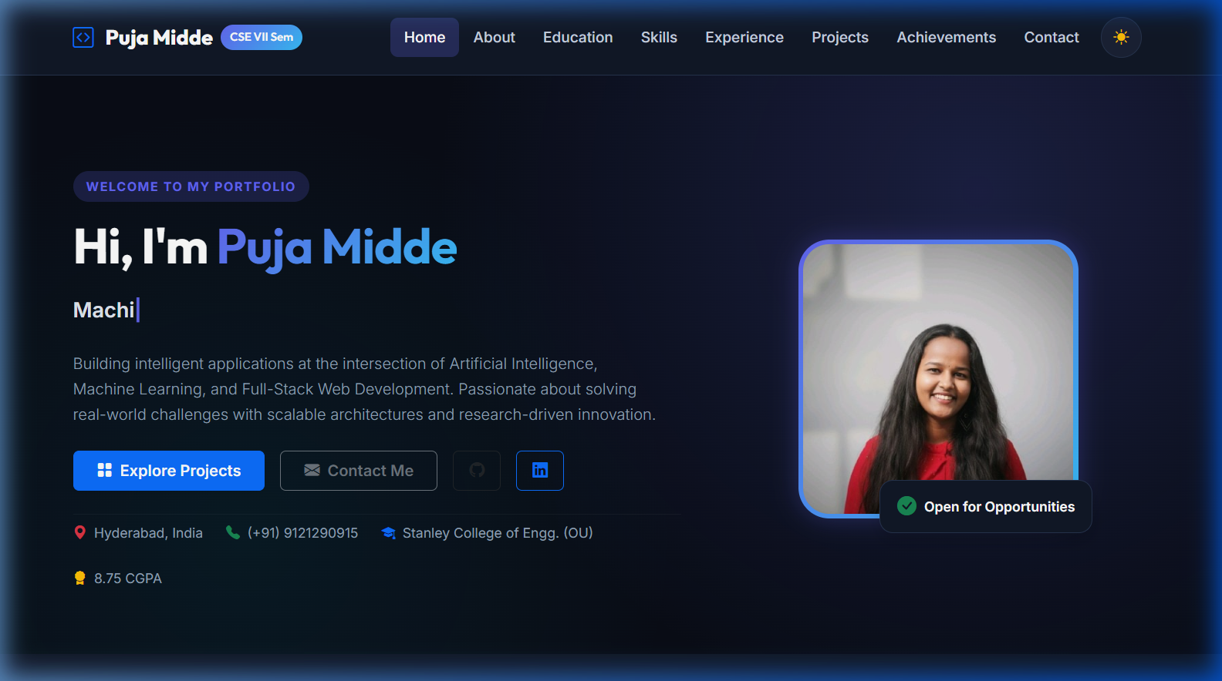
Screenshot 2: Mobile / Responsive View
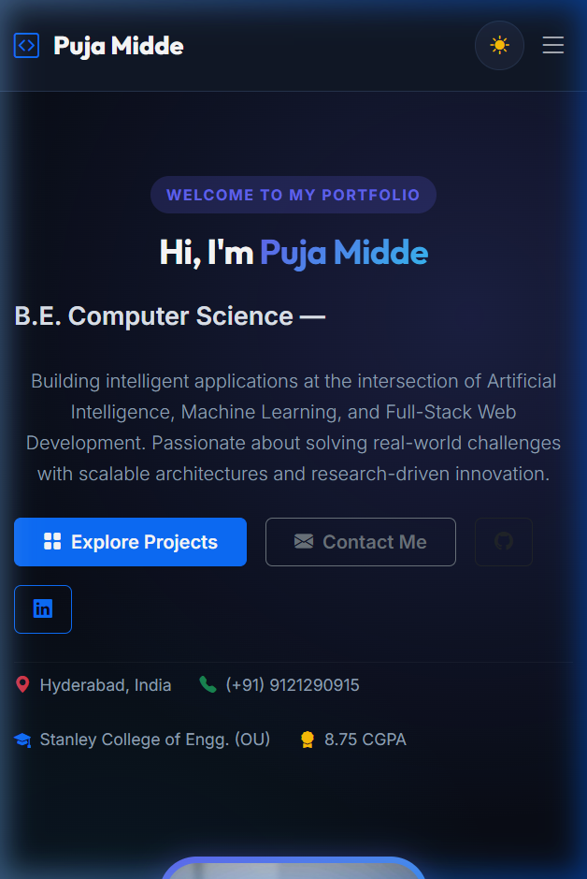
Screenshot 3: JavaScript Interactive Feature (Project Filter & Dark Mode)
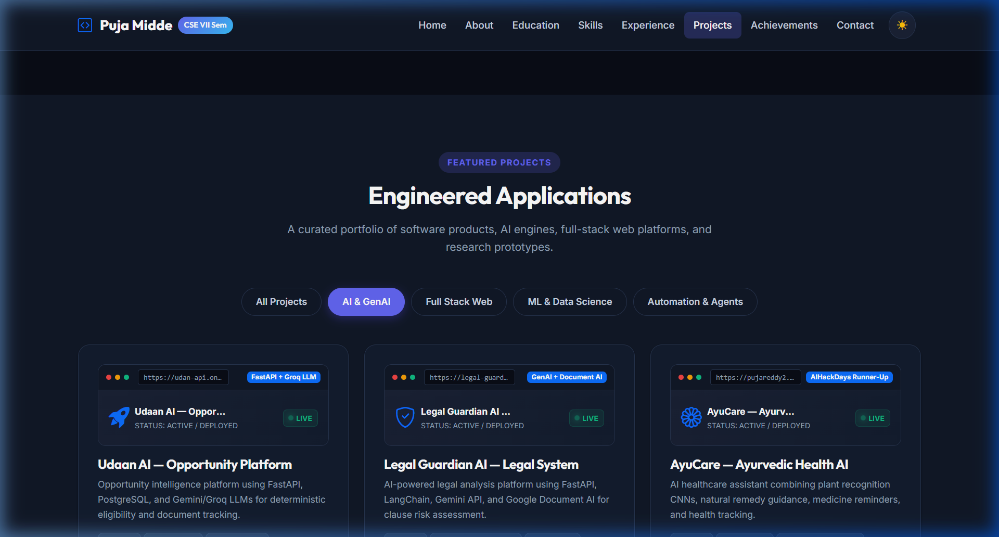
Screenshot 4: Form Validation / Dynamic Alert Feature
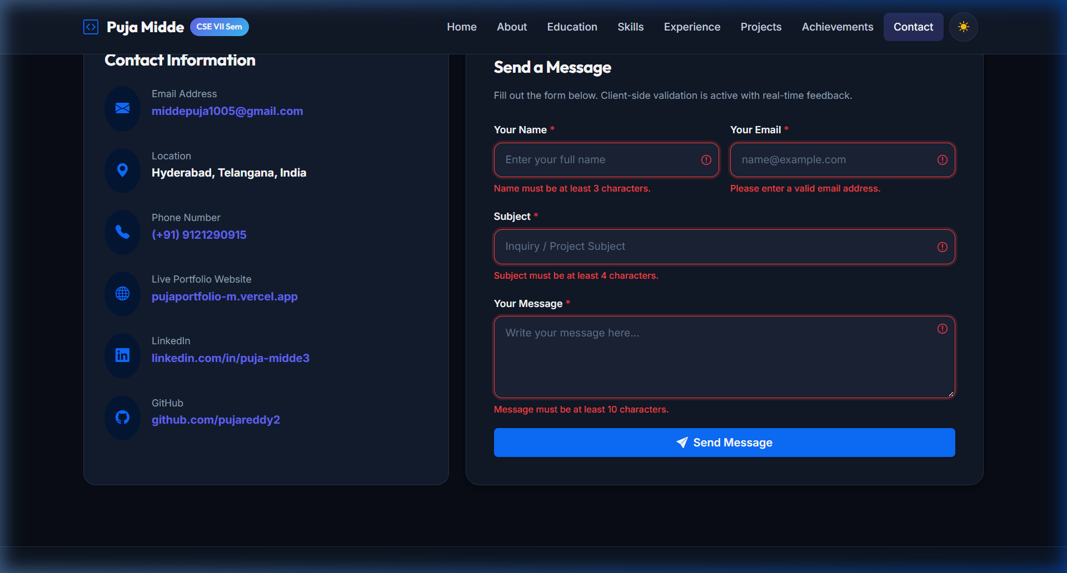
6. Testing
Test Case | Expected Result | Actual Result | Status
Navigation links | Navigate to correct section smoothly | Smoothly scrolls to respective section with navbar offset | Pass
Contact form with valid data | Form accepted and success message shown | Form accepted, inputs reset, dynamic success alert rendered | Pass
Contact form with invalid data | Error message displayed and submit blocked | Red border validation and dynamic danger alert displayed | Pass
JavaScript feature | UI updates dynamically (filter & theme) | Theme switches instantly and project cards filter smoothly | Pass
Mobile view | Layout adapts correctly to screen size | Single-column fluid layout with responsive hamburger menu | Pass

7. Learning Outcomes
Through this assignment, I acquired comprehensive hands-on proficiency in building responsive, accessible, and high-performance web applications from scratch. I mastered semantic HTML5 document architecture, structured data tables, and modern CSS3 layout techniques including Flexbox, CSS Grid, and custom variable-based theming. I effectively integrated Bootstrap 5 UI components including navigation bars, card decks, and responsive modals. Furthermore, I deepened my understanding of ES6+ JavaScript, DOM manipulation, event delegation, and real-time client-side form validation with dynamic feedback alerts.

