Predict or Refer: An Explainable Stacked Boosting Framework with Calibrated Referral for Reliable Coronary Artery Disease Diagnosis
1st Given Name Surname  dept. name of organization  name of organization  City, Country  email address | 2nd Given Name Surname  dept. name of organization  name of organization  City, Country  email address | 3rd Given Name Surname  dept. name of organization  name of organization  City, Country  email address

Abstract—Only invasive angiography can confirm coronary artery disease (CAD) beyond doubt. Classifiers that use routine clinical data are a gentler route, but they commit to an answer for every patient, including patients whose findings are mixed. One well-known example fits a random forest of decision trees with a stochastic gradient boosting loss to the 303-patient Cleveland data, drawn from a single small cohort, with no stated validation protocol and no explanation of its outputs. In this paper we introduce Predict or Refer. The framework issues a CAD diagnosis only for patients it is confident about and hands every other patient to a cardiologist. Random forest, stochastic gradient boosting, XGBoost, LightGBM and CatBoost are tuned by Bayesian optimization and joined through a logistic-regression meta-learner, and preprocessing never leaves the training folds. Two referral thresholds, one for each class and set from out-of-fold predictions, decide how accurate the decided cases must be, while Shapley additive explanations point to the features behind each call. We ran nested and repeated cross-validation on the Z-Alizadeh Sani dataset, which holds 303 patients and 55 clinical, electrocardiographic, laboratory and echocardiographic features. Overall accuracy under nested cross-validation was 87.4%. Over ten repeated runs, the framework was right on 96.0% of the patients it decided and referred 52.5% to a specialist.
Index Terms—Clinician referral, coronary artery disease, explainable AI, gradient boosting, selective classification, SHAP, stacked ensemble, Z-Alizadeh Sani
I. Introduction
No group of diseases causes more deaths than cardiovascular disease. The World Health Organization puts the toll at 19.8 million deaths in 2022, nearly one in three (32%) deaths worldwide [1]. Coronary artery disease (CAD) is confirmed through coronary angiography, a procedure that is invasive and costly and that brings risks of its own [2]. If CAD could be predicted well from the clinical, electrocardiographic, laboratory and echocardiographic data that hospitals already record, doctors would have a better basis for deciding who should be sent for angiography.
A wide range of methods, from logistic regression through random forests to boosted trees, has been tested on this question, usually with strong reported accuracy [3], [4], and much of the recent literature relies on stacked ensembles [5]–[8]. This paper starts from Jawalkar et al. [9]. Their random forest of decision trees, trained with a stochastic gradient boosting loss, scored 96% accuracy on the 13-attribute Cleveland data [10].
Two things make such numbers hard to trust. To begin with, the model never holds back. It gives a borderline patient the same firm answer it gives a clear-cut one, so a clinician cannot tell which answers to question [11]. Beyond that, the reported accuracy is often too high. Many papers do not describe their splits, some fit preprocessing on the whole dataset first, and few validate externally [12]. Merged copies of the Cleveland data, among them a 1,190-record version [13], repeat patients, which means a patient used for testing can also be part of the training data. We repeated the base experiment with stratified ten-fold cross-validation (untuned random forest, all 13 attributes) and obtained 82.2% accuracy on Cleveland, not 96%.
Predict or Refer deals with both issues. A stack of five tree-based learners [14] produces a risk score, and two class-wise cut-offs, set using out-of-fold training predictions alone, decide whether that score becomes a diagnosis or a referral. Testing was done on the Z-Alizadeh Sani dataset [2], [15] with nested cross-validation and ten independent repetitions. The paper makes four contributions:
- a stack of five bagging and boosting learners, kept free of leakage and tuned by Bayesian optimization within every training split;
- a calibrated predict-or-refer rule that holds decided patients to a chosen accuracy and states how many referrals this requires;
- an evaluation using nested cross-validation, ten repetitions, the Friedman and McNemar tests, and conformal prediction as a point of comparison [16], [17];
- Shapley additive explanations (SHAP) [18] for individual decisions, set against well-established clinical risk factors.
The paper is laid out as follows: related work is in Section II, the method in Section III, results and discussion in Section IV, and conclusions in Section V.
II. Related Work
The 13-attribute Cleveland data dominated early studies. Detrano et al. [19] found that a model developed at one center gave wrong risk estimates at other centers. Haq et al. [3] combined seven classifiers with three ways of selecting features, and Mohan et al. [4] reported 88.7% accuracy for a random forest joined with a linear model. Later, stacking spread. Ganie et al. [5] kept six models out of fifteen candidates; Sultan et al. [6] built their stack from naive Bayes, CatBoost and decision trees; Chen et al. [7] and Nahar et al. [8] used two-layer stacks and reached 86.69% and 93.69% accuracy, relying mostly on SHAP for explanation.
The Z-Alizadeh Sani dataset comes from Alizadehsani et al. [2]. Its variables cover typical chest pain, regional wall-motion abnormality and electrocardiogram (ECG) findings, among others, and the authors reached 94.08% accuracy by creating new features. Tama et al. [20] went on to report 98.13% on the same data with a two-tier ensemble of random forest, gradient boosting and XGBoost. Work on uncertainty is far thinner. Kompa et al. [11] made the case for medical models that decline to answer when unsure, Wang et al. [21] gave ensemble members weights based on their disagreement, Lin et al. [22] tried conformal prediction on the Cleveland data, and conformal deferral has been studied in sepsis [23]. As far as we know, no CAD study has learned explicit referral cut-offs for a stacked boosting ensemble or measured the accuracy–referral trade-off this creates under repeated, leakage-free testing. The present work fills this gap.

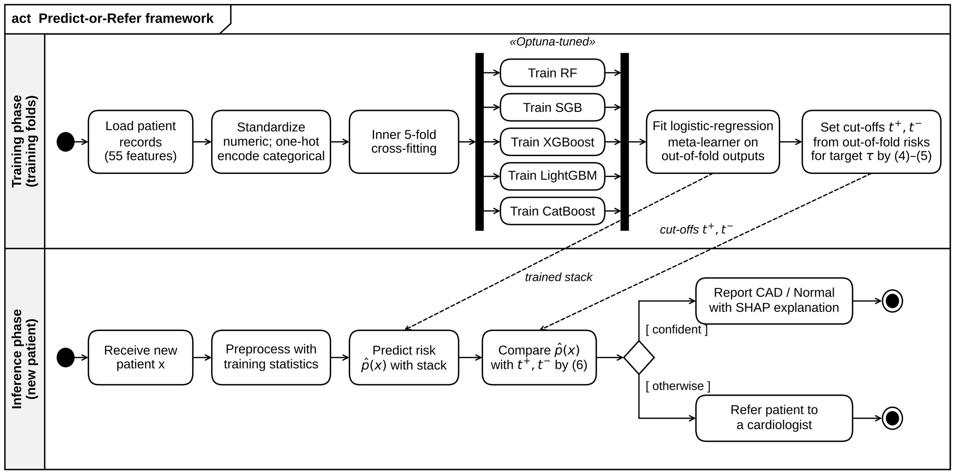
Fig. 1. UML activity diagram of the proposed Predict-or-Refer framework. The training phase uses only the training folds; in the inference phase each new patient is either diagnosed, with a SHAP explanation, or referred to a cardiologist.

III. Proposed Methodology
A. Dataset and Preprocessing
The Z-Alizadeh Sani dataset [15] describes 303 patients who all had coronary angiography [2]. CAD was present in 216 (71.3%) and absent in 87 (28.7%). Table I sorts the 55 features by where they come from; no value is missing and no record appears twice. Categorical features become one-hot vectors, and each numeric feature is standardized as
$z_{j}=\frac{x_{j}−μ_{j}}{σ_{j}}$ (1)
in which μ_{j} and σ_{j} are taken from the training split alone. All of these steps live in a single pipeline [24] that is fitted again on every training split, so test patients never feed into any statistic.
TABLE I
Features of the Z-Alizadeh Sani Dataset (303 Patients)
Feature group | n | Examples
Demographic and history | 17 | Age, sex, BMI, diabetes, hypertension, smoking, family history
Symptoms and examination | 14 | Typical chest pain, dyspnea, blood pressure, pulse rate, murmurs
Electrocardiogram | 7 | Q wave, ST elevation, ST depression, T inversion, LVH
Laboratory and echo | 17 | FBS, lipids, creatinine, ESR, ejection fraction, wall motion
Total / target | 55 | CAD 216 (71.3%), Normal 87 (28.7%)

B. Proposed Architecture
Fig. 1 lays the framework out as a Unified Modeling Language (UML) activity diagram. Five learners make up level 0. Random forest (RF) [25], the base model of [9], averages decorrelated trees, each grown from a bootstrap sample. Stochastic gradient boosting (SGB) [26] grows an additive model stage after stage,
$F_{m}(x)=F_{m−1}(x)+νh_{m}(x)$ (2)
with ν as the learning rate and h_{m} as a tree fitted to the residuals of a random subsample. XGBoost [27] brings in second-order gradients and L2 penalties, LightGBM [28] grows leaves in best-first order, and CatBoost [29] uses ordered boosting. A five-fold loop inside the training data supplies out-of-fold probabilities p_{k}(x), which the logistic-regression meta-learner (level 1) merges as
$p̂(x)=σ\left(β_{0}+\sum_{k=1}^{5}{β_{k}p_{k}(x)}\right)$ (3)
Hyperparameters for the five learners and for four baselines, logistic regression (LR), k-nearest neighbors (KNN), a radial basis function support vector machine (SVM) and a decision tree (DT), were chosen with Optuna's tree-structured Parzen estimator [30]. This search was run inside each outer training split, for 15 trials, with the area under the receiver operating characteristic (ROC) curve (AUC) from an inner three-fold loop as the objective.
C. Calibrated Predict-or-Refer Rule
Once a target accuracy τ is chosen, two cut-offs are set using the out-of-fold risks p̂_{i} of the n training patients. The CAD cut-off is the lowest threshold whose positive decisions are at least τ accurate,
$t^{+}=min\left\{t:\frac{\sum_{i}{𝟙\left[{p̂}_{i}≥t\right]y_{i}}}{\sum_{i}{𝟙\left[{p̂}_{i}≥t\right]}}≥τ\right\}$ (4)
and the normal cut-off follows the same logic for the normal class,
$t^{−}=max\left\{t:\frac{\sum_{i}{𝟙\left[{p̂}_{i}≤t\right]\left(1−y_{i}\right)}}{\sum_{i}{𝟙\left[{p̂}_{i}≤t\right]}}≥τ\right\}$ (5)
Neither cut-off may cover fewer than 15 training patients. A new patient is then treated according to
$ŷ(x)=\left\{CAD if p̂(x)≥t^{+}; Normal if p̂(x)≤t^{−}; refer otherwise\right\}$ (6)
As a reference point, conformal prediction [16], [17] is calibrated on these same out-of-fold predictions and returns the set
$C(x)=\left\{y∈\{0,1\}:1−{p̂}_{y}(x)≤q̂\right\}$ (7)
where q̂ is the ⌈(n+1)(1−α)⌉-th smallest calibration score 1 − p̂_{yi}(x_{i}), and a patient is referred when |C(x)| ≠ 1.
D. Evaluation Protocol and Metrics
In E1, the ten models are compared with nested stratified ten-fold cross-validation (seed 42). In E2, the stack goes through stratified ten-fold cross-validation ten times with fresh seeds, using fixed library-default hyperparameters (CatBoost with 300 iterations) so that no test label can influence tuning. Within a repetition, each fold's cut-offs are set from the out-of-fold predictions of the nine other folds. Using TP, TN, FP and FN for the confusion-matrix counts, we compute
$Acc=\frac{TP+TN}{TP+TN+FP+FN}, Rec=\frac{TP}{TP+FN}$ (8)
$Spec=\frac{TN}{TN+FP}, F1=\frac{2TP}{2TP+FP+FN}$ (9)
as well as the AUC. Accuracy for the referral rule counts decided patients only, and the referral rate is
$Referral rate=\frac{N_{ref}}{N}$ (10)
The contribution of each feature is measured by its Shapley value [18],
$φ_{j}=\sum_{S⊆F∖\{j\}}{\frac{|S|!(|F|−|S|−1)!}{|F|!}\left[f(S∪\{j\})−f(S)\right]}$ (11)
computed with a permutation explainer on 150 patients. The Friedman test is applied to fold-wise AUC and McNemar's test to pooled predictions.
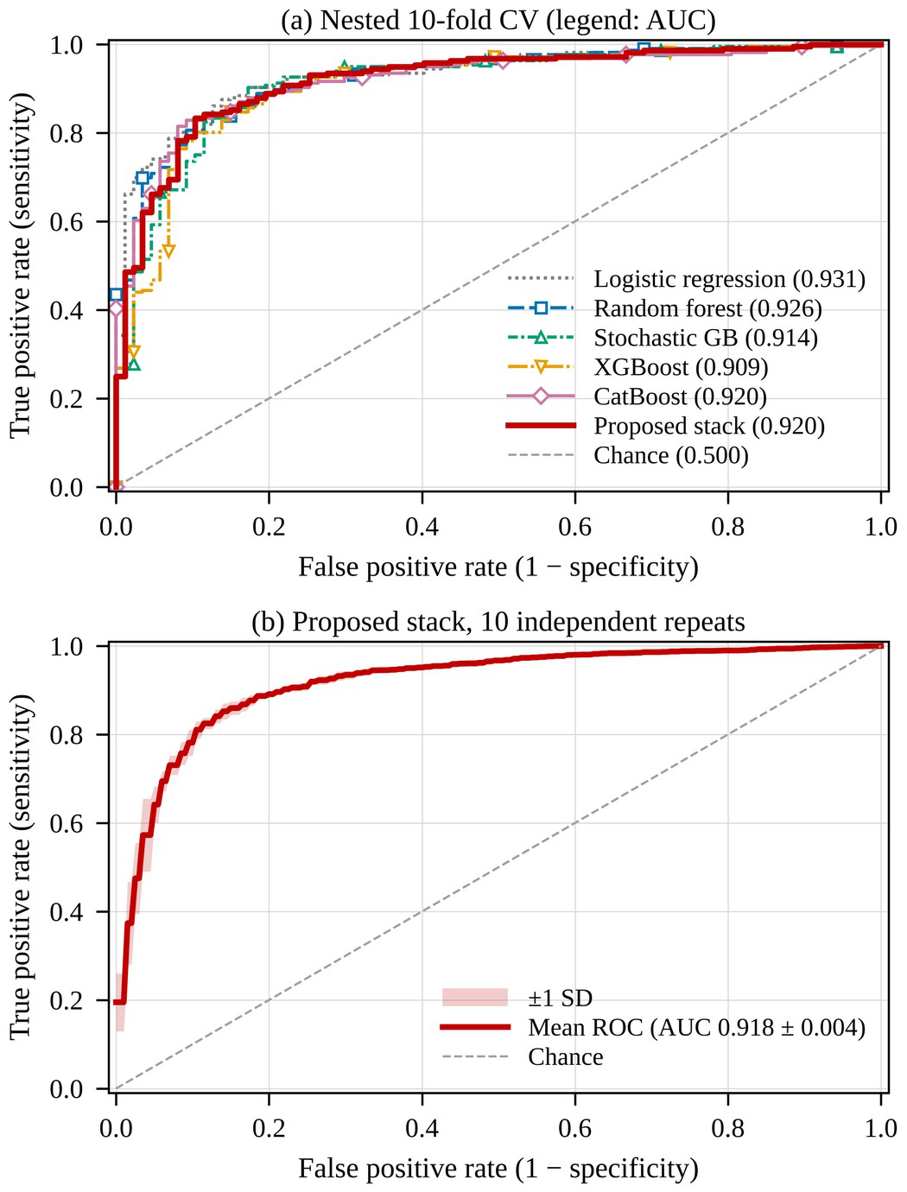
Fig. 2. ROC curves. (a) Pooled out-of-fold predictions of the tuned models in nested ten-fold cross-validation (legend AUC computed on all out-of-fold predictions). (b) Mean ROC curve of the proposed stack over ten independent repetitions (shaded: ±1 SD).
IV. Results and Discussion
A. Classification Performance
Table II reports every model under nested cross-validation (E1). The proposed stack scored 87.4% accuracy, an F1-score of 0.914 and an AUC of 0.928. Its accuracy equals that of SGB, the joint best, and logistic regression has the top AUC at 0.941. With the exception of the decision tree, the tuned models all fall in the 84% to 88% accuracy range. The Friedman test picked up a difference across models (χ² = 22.86, p = 0.007), driven largely by the decision tree, yet McNemar's test showed no significant gap between the stack and RF (p = 0.08) or LR (p = 0.21). ROC curves for the tuned models are drawn in Fig. 2(a), and Fig. 2(b) shows the stack holding steady across ten repetitions (AUC 0.918 ± 0.004). In other words, accuracy over all patients levels off at about 87% for any strong model. What errors remain are concentrated in patients with mid-range predicted risk, and that is precisely the group the referral rule refers to a cardiologist (Fig. 4).
TABLE II
Model Performance in Nested 10-Fold Cross-Validation (E1)
Model | Acc. (%) | Recall | Spec. | F1 | AUC
LR | 85.1 ± 6.7 | 0.929 | 0.649 | 0.899 | 0.941 ± 0.044
KNN | 84.8 ± 6.7 | 0.930 | 0.646 | 0.897 | 0.908 ± 0.064
SVM (RBF) | 86.1 ± 5.7 | 0.916 | 0.722 | 0.903 | 0.931 ± 0.041
DT | 77.8 ± 9.8 | 0.866 | 0.554 | 0.848 | 0.813 ± 0.104
RFª | 84.5 ± 5.2 | 0.958 | 0.561 | 0.898 | 0.925 ± 0.045
SGB | 87.4 ± 6.1 | 0.944 | 0.701 | 0.915 | 0.928 ± 0.056
XGBoost | 86.1 ± 5.9 | 0.935 | 0.679 | 0.906 | 0.917 ± 0.066
LightGBM | 86.1 ± 4.9 | 0.934 | 0.676 | 0.905 | 0.908 ± 0.074
CatBoost | 85.4 ± 5.9 | 0.929 | 0.665 | 0.900 | 0.926 ± 0.056
Proposed stack | 87.4 ± 5.7 | 0.934 | 0.722 | 0.914 | 0.928 ± 0.056
ªBase-paper model (Jawalkar et al. [9]) re-run on the same folds. Acc. and AUC are mean ± SD over the 10 outer folds; Recall, Spec. and F1 are means.
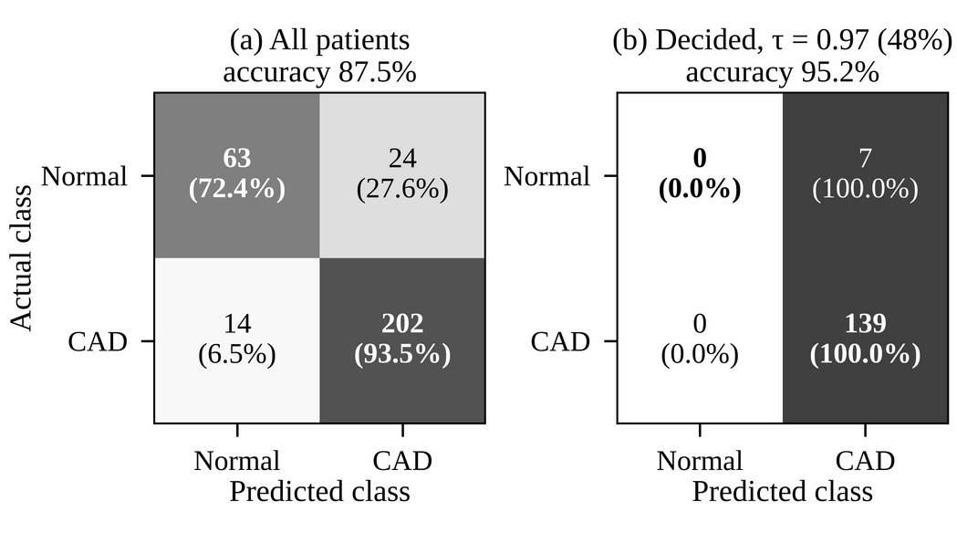
Fig. 3. Confusion matrices of the proposed stack in E1: (a) all patients at threshold 0.5; (b) patients decided by the referral rule at τ = 0.97 in the same run, where all seven decided normal patients were classified as CAD (counts with row percentages; (a) shows pooled accuracy, Table II the fold mean).
B. Predict-or-Refer Performance
Results for the referral rule over ten independent repetitions (E2) appear in Table III. Pushing τ higher lifts both the referral rate and the accuracy on decided patients. With τ = 0.97, the stack was correct on 96.0% of decided patients and referred 52.5%; with τ = 0.98, these numbers became 96.8% and 66.5%. The two classes are not treated alike. Confident decisions were nearly all CAD diagnoses, and specificity on decided patients stayed at 12.7% for τ = 0.97 and 14.6% for τ = 0.98, since few of the 87 normal patients got past the normal cut-off and most ended up referred. The rule therefore serves as a rule-in test for CAD. Fig. 3 puts the E1 confusion matrix for all patients next to the one for decided patients, and Fig. 4 maps the full accuracy–referral trade-off. Split conformal prediction with α = 0.05 reached 95.3% coverage but decided 73.3% of patients at 93.6% accuracy; the calibrated cut-offs instead fix the accuracy on decided patients directly.
TABLE III
Predict-or-Refer Results over Ten Repetitions (E2)
Target τ | Decided (%) | Referred (%) | Acc. decided (%) | Prec. (%) | F1 (%)
No referral | 100.0 | 0.0 | 87.0 ± 0.6 | 88.7 | 91.1
0.95 | 62.0 | 38.0 | 94.2 ± 0.6 | 94.7 | 96.9
0.96 | 57.3 | 42.7 | 95.0 ± 0.5 | 95.4 | 97.4
0.97 | 47.5 | 52.5 | 96.0 ± 0.4 | 96.1 | 97.9
0.98 | 33.5 | 66.5 | 96.8 ± 0.8 | 96.9 | 98.3
Bold: operating point used in the paper. Acc. decided is mean ± SD over 10 repeats.
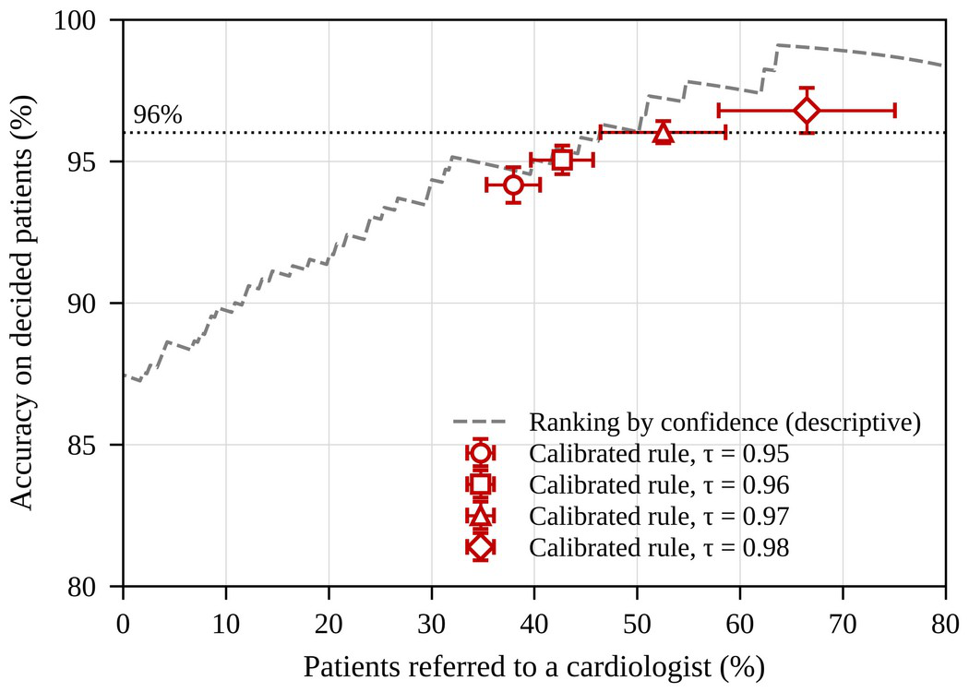
Fig. 4. Accuracy on decided patients versus referral rate. Red markers: calibrated rule at four targets (mean ± SD over ten repetitions); grey dashed line: ranking by confidence.
C. Explainability
In Fig. 5, features are ordered by mean absolute SHAP value. Typical chest pain stands well ahead of the rest (0.142), followed by age (0.047), ejection fraction (echo) (0.044), regional wall-motion abnormality (0.028) and triglycerides (0.025). Typical chest pain, regional wall-motion abnormality and age were also among the most informative features identified by the creators of the dataset [2], and this match supports the clinical sense of the model.
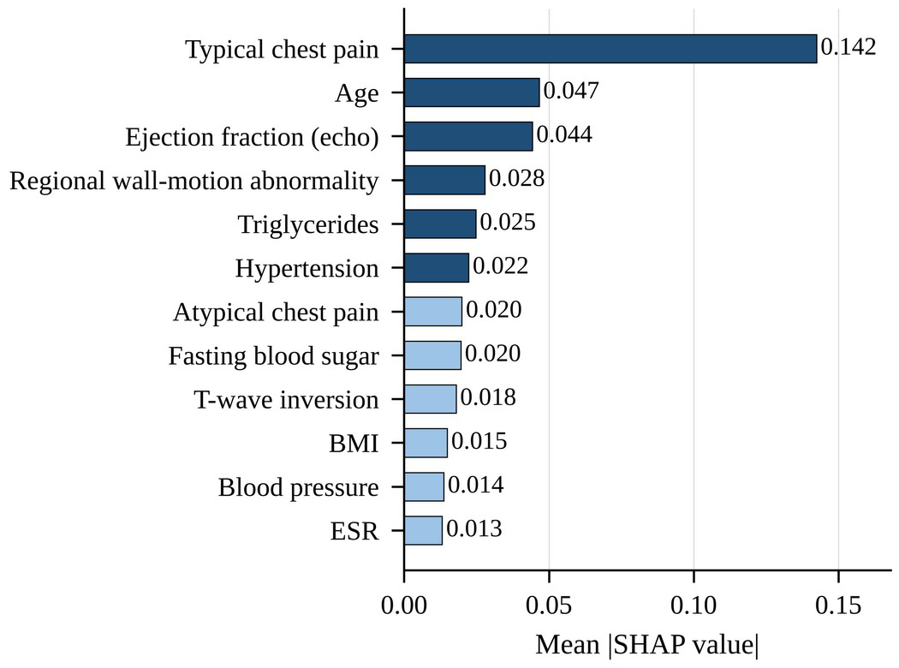
Fig. 5. Global feature importance of the proposed stack (mean absolute SHAP value, top 12 of 55 features).
D. Discussion and Limitations
High reliability becomes possible once referral is allowed. With τ = 0.97, about 47% of patients, the clear-cut ones, are classified with 96.0% accuracy, and specialists assess the others. What stacking brought was stability, reflected in a Brier score identical to that of logistic regression (0.100), more than a big rise in accuracy, which fits the narrow spread between tuned models. The overall accuracy we report is below the 94.08% and 98.13% given for this dataset in [2], [20]. Those studies followed other protocols, whereas we keep every preprocessing and tuning step within the training folds of a nested evaluation, and this leads to more cautious estimates. The study has limits. The data are few and come from a single source, and about half of all patients are referred. Confident decisions are, with rare exceptions, CAD diagnoses. Last, the findings still need validation at other hospitals [19], [21], and the rule has yet to be tried prospectively alongside clinicians.
V. Conclusion
Starting from the random-forest study of Jawalkar et al. [9], this paper developed Predict or Refer, a stacked boosting framework that avoids leakage, explains its outputs and includes a calibrated referral rule. On the Z-Alizadeh Sani CAD dataset, the stack achieved 87.4% overall accuracy (AUC 0.928). For the patients it chose to decide, accuracy was 96.0%, with 52.5% referred for specialist review, and its SHAP explanations were in line with established clinical knowledge. In future work, we will validate the rule on multi-center cohorts, check whether richer features and imaging reduce the referral rate, and evaluate the rule prospectively in clinical workflows.
Acknowledgment
The authors used an AI assistant (Claude, Anthropic) to help draft and edit the text, prepare the figures and tables, and write analysis code. The authors reviewed all content and verified every reported result against the outputs of their own code.
References
[1] World Health Organization, “Cardiovascular diseases (CVDs),” Fact sheet, Jul. 31, 2025. [Online]. Available: https://www.who.int/news-room/fact-sheets/detail/cardiovascular-diseases-(cvds) (accessed Oct. 6, 2026).
[2] R. Alizadehsani et al., “A data mining approach for diagnosis of coronary artery disease,” Comput. Methods Programs Biomed., vol. 111, no. 1, pp. 52–61, Jul. 2013, doi: 10.1016/j.cmpb.2013.03.004.
[3] A. U. Haq, J. P. Li, M. H. Memon, S. Nazir, and R. Sun, “A hybrid intelligent system framework for the prediction of heart disease using machine learning algorithms,” Mobile Inf. Syst., vol. 2018, Art. no. 3860146, Dec. 2018, doi: 10.1155/2018/3860146.
[4] S. Mohan, C. Thirumalai, and G. Srivastava, “Effective heart disease prediction using hybrid machine learning techniques,” IEEE Access, vol. 7, pp. 81542–81554, 2019, doi: 10.1109/ACCESS.2019.2923707.
[5] S. M. Ganie, P. K. D. Pramanik, and Z. Zhao, “Ensemble learning with explainable AI for improved heart disease prediction based on multiple datasets,” Sci. Rep., vol. 15, no. 1, Art. no. 13912, Apr. 2025, doi: 10.1038/s41598-025-97547-6.
[6] S. Q. Sultan, N. Javaid, N. Alrajeh, and M. Aslam, “Machine learning-based stacking ensemble model for prediction of heart disease with explainable AI and k-fold cross-validation: A symmetric approach,” Symmetry, vol. 17, no. 2, Art. no. 185, Jan. 2025, doi: 10.3390/sym17020185.
[7] Y. Chen, L. Chong, Z. Bao, S. Wang, Y. Wang, and Y. Feng, “An interpretability heart disease prediction model based on stacking ensemble with SHAP,” Front. Mol. Biosci., vol. 12, Art. no. 1763157, Feb. 2026, doi: 10.3389/fmolb.2025.1763157.
[8] N. Nahar et al., “Stacked ensemble model with explainable AI for early detection of heart disease,” Anal. Sci. Adv., vol. 7, no. 1, Art. no. e70072, Mar. 2026, doi: 10.1002/ansa.70072.
[9] A. P. Jawalkar et al., “Early prediction of heart disease with data analysis using supervised learning with stochastic gradient boosting,” J. Eng. Appl. Sci., vol. 70, no. 1, Art. no. 122, Oct. 2023, doi: 10.1186/s44147-023-00280-y.
[10] A. Janosi, W. Steinbrunn, M. Pfisterer, and R. Detrano, “Heart Disease,” UCI Machine Learning Repository, 1989, doi: 10.24432/C52P4X.
[11] B. Kompa, J. Snoek, and A. L. Beam, “Second opinion needed: Communicating uncertainty in medical machine learning,” npj Digit. Med., vol. 4, no. 1, Art. no. 4, Jan. 2021, doi: 10.1038/s41746-020-00367-3.
[12] R. D. Riley et al., “External validation of clinical prediction models using big datasets from e-health records or IPD meta-analysis: Opportunities and challenges,” BMJ, vol. 353, Art. no. i3140, Jun. 2016, doi: 10.1136/bmj.i3140.
[13] M. Siddhartha, “Heart Disease Dataset (Comprehensive),” IEEE DataPort, Nov. 2020, doi: 10.21227/dz4t-cm36.
[14] D. H. Wolpert, “Stacked generalization,” Neural Netw., vol. 5, no. 2, pp. 241–259, 1992, doi: 10.1016/S0893-6080(05)80023-1.
[15] R. Alizadehsani and M. Roshanzamir, “Z-Alizadeh Sani,” UCI Machine Learning Repository, 2013, doi: 10.24432/C5Q31T.
[16] V. Vovk, A. Gammerman, and G. Shafer, Algorithmic Learning in a Random World. New York, NY, USA: Springer, 2005, doi: 10.1007/b106715.
[17] A. N. Angelopoulos and S. Bates, “Conformal prediction: A gentle introduction,” Found. Trends Mach. Learn., vol. 16, no. 4, pp. 494–591, Mar. 2023, doi: 10.1561/2200000101.
[18] S. M. Lundberg and S.-I. Lee, “A unified approach to interpreting model predictions,” in Proc. Adv. Neural Inf. Process. Syst. (NeurIPS), vol. 30, 2017, pp. 4765–4774.
[19] R. Detrano et al., “International application of a new probability algorithm for the diagnosis of coronary artery disease,” Am. J. Cardiol., vol. 64, no. 5, pp. 304–310, Aug. 1989, doi: 10.1016/0002-9149(89)90524-9.
[20] B. A. Tama, S. Im, and S. Lee, “Improving an intelligent detection system for coronary heart disease using a two-tier classifier ensemble,” BioMed Res. Int., vol. 2020, Art. no. 9816142, 2020, doi: 10.1155/2020/9816142.
[21] X. Wang, Y. Fan, M. Yu, and F. Yuan, “Uncertainty-aware feature-weighted ensemble framework for heart disease prediction,” Sci. Rep., vol. 16, no. 1, Art. no. 13321, Mar. 2026, doi: 10.1038/s41598-026-42419-w.
[22] S. Lin et al., “Integrating conformal prediction with machine learning for uncertainty-aware risk stratification in coronary artery disease,” Front. Cardiovasc. Med., vol. 13, Art. no. 1857390, Sep. 2026, doi: 10.3389/fcvm.2026.1857390.
[23] H. Kwon and D.-J. Kim, “Conformal selective prediction with cost aware deferral for safe clinical triage under distribution shift,” Sci. Rep., vol. 16, no. 1, Art. no. 10016, Feb. 2026, doi: 10.1038/s41598-026-40637-w.
[24] F. Pedregosa et al., “Scikit-learn: Machine learning in Python,” J. Mach. Learn. Res., vol. 12, pp. 2825–2830, 2011.
[25] L. Breiman, “Random forests,” Mach. Learn., vol. 45, no. 1, pp. 5–32, Oct. 2001, doi: 10.1023/A:1010933404324.
[26] J. H. Friedman, “Stochastic gradient boosting,” Comput. Statist. Data Anal., vol. 38, no. 4, pp. 367–378, Feb. 2002, doi: 10.1016/S0167-9473(01)00065-2.
[27] T. Chen and C. Guestrin, “XGBoost: A scalable tree boosting system,” in Proc. 22nd ACM SIGKDD Int. Conf. Knowl. Discov. Data Min., San Francisco, CA, USA, 2016, pp. 785–794, doi: 10.1145/2939672.2939785.
[28] G. Ke et al., “LightGBM: A highly efficient gradient boosting decision tree,” in Proc. Adv. Neural Inf. Process. Syst. (NeurIPS), vol. 30, 2017, pp. 3146–3154.
[29] L. Prokhorenkova, G. Gusev, A. Vorobev, A. V. Dorogush, and A. Gulin, “CatBoost: Unbiased boosting with categorical features,” in Proc. Adv. Neural Inf. Process. Syst. (NeurIPS), vol. 31, 2018, pp. 6638–6648.
[30] T. Akiba, S. Sano, T. Yanase, T. Ohta, and M. Koyama, “Optuna: A next-generation hyperparameter optimization framework,” in Proc. 25th ACM SIGKDD Int. Conf. Knowl. Discov. Data Min., Anchorage, AK, USA, 2019, pp. 2623–2631, doi: 10.1145/3292500.3330701.

