The Szikman Dental Group
Our exceptional care focuses on you!

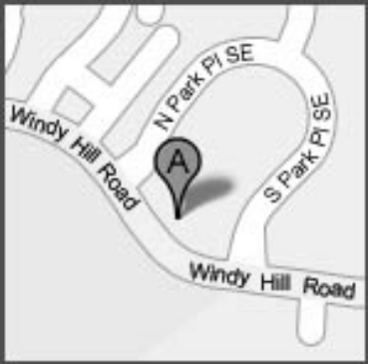
Having earned our reputation for "catering to cowards," The Szikman Dental Group has been the choice for dental phobics in Atlanta for years.

Dr. Michael Szikman
Dr. Richard Szikman

2070 South Park Place Suite 300 Atlanta, Georgia 30339

Telephone:770-952-3333 Fax:770-952-6823
http://www.szikdentalgroup.com/ Free parking available

Located on Windy Hill Road
just west of I-75

Sandpiper Music Studio
(770) 757 1807
www.sandpipermusicstudio.com
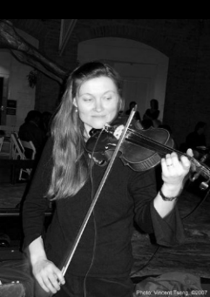
Music lessons for all ages

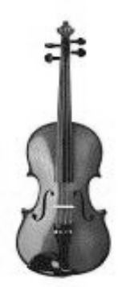

Please call Marla Feeney for information.
Teachers are available for violin, viola, cello,
electric and acoustic bass and guitar, drums,
clarinet, saxophone, flute, and piano.







