Foundations for statistical inference - Sampling distributions

Puja Roy

Table of Contents

In this lab, you will investigate the ways in which the statistics from a random sample of data can serve as point estimates for population parameters. We’re interested in formulating a *sampling distribution* of our estimate in order to learn about the properties of the estimate, such as its distribution.

**Setting a seed:** We will take some random samples and build sampling distributions in this lab, which means you should set a seed at the start of your lab. If this concept is new to you, review the lab on probability.

## Getting Started

### Load packages

In this lab, we will explore and visualize the data using the **tidyverse** suite of packages. We will also use the **infer** package for resampling.

Let’s load the packages.

library(tidyverse)  
library(openintro)  
library(infer)

### The data

A 2019 Gallup report states the following:

The premise that scientific progress benefits people has been embodied in discoveries throughout the ages – from the development of vaccinations to the explosion of technology in the past few decades, resulting in billions of supercomputers now resting in the hands and pockets of people worldwide. Still, not everyone around the world feels science benefits them personally.

**Source:** [World Science Day: Is Knowledge Power?](https://news.gallup.com/opinion/gallup/268121/world-science-day-knowledge-power.aspx)

The Wellcome Global Monitor finds that 20% of people globally do not believe that the work scientists do benefits people like them. In this lab, you will assume this 20% is a true population proportion and learn about how sample proportions can vary from sample to sample by taking smaller samples from the population. We will first create our population assuming a population size of 100,000. This means 20,000 (20%) of the population think the work scientists do does not benefit them personally and the remaining 80,000 think it does.

global_monitor <- tibble(  
 scientist_work = c(rep("Benefits", 80000), rep("Doesn't benefit", 20000))  
)

The name of the data frame is global_monitor and the name of the variable that contains responses to the question *“Do you believe that the work scientists do benefit people like you?”* is scientist_work.

We can quickly visualize the distribution of these responses using a bar plot.

ggplot(global_monitor, aes(x = scientist_work)) +  
 geom_bar() +  
 labs(  
 x = "", y = "",  
 title = "Do you believe that the work scientists do benefit people like you?"  
 ) +  
 coord_flip()

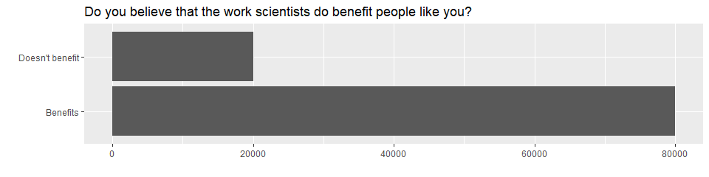

We can also obtain summary statistics to confirm we constructed the data frame correctly.

global_monitor %>%  
 count(scientist_work) %>%  
 mutate(p = n /sum(n))

## # A tibble: 2 × 3  
## scientist_work n p  
## <chr> <int> <dbl>  
## 1 Benefits 80000 0.8  
## 2 Doesn't benefit 20000 0.2

## The unknown sampling distribution

In this lab, you have access to the entire population, but this is rarely the case in real life. Gathering information on an entire population is often extremely costly or impossible. Because of this, we often take a sample of the population and use that to understand the properties of the population.

If you are interested in estimating the proportion of people who don’t think the work scientists do benefits them, you can use the sample_n command to survey the population.

samp1 <- global_monitor %>%  
 sample_n(50)

This command collects a simple random sample of size 50 from the global_monitor dataset, and assigns the result to samp1. This is similar to randomly drawing names from a hat that contains the names of all in the population. Working with these 50 names is considerably simpler than working with all 100,000 people in the population.

1. Describe the distribution of responses in this sample. How does it compare to the distribution of responses in the population. **Hint:** Although the sample_n function takes a random sample of observations (i.e. rows) from the dataset, you can still refer to the variables in the dataset with the same names. Code you presented earlier for visualizing and summarizing the population data will still be useful for the sample, however be careful to not label your proportion p since you’re now calculating a sample statistic, not a population parameters. You can customize the label of the statistics to indicate that it comes from the sample.

ggplot(samp1, aes(x = scientist_work)) +  
 geom_bar() +  
 labs(  
 x = "", y = "",  
 title = "A smaller population sample of the Question:"  
 ) +  
 coord_flip()

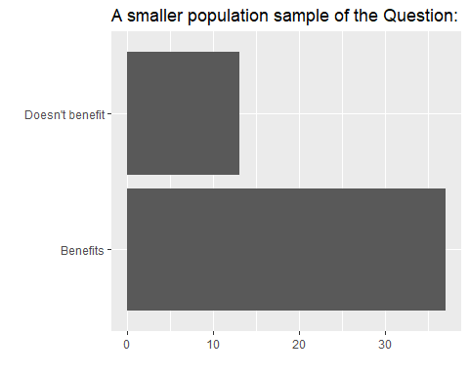

samp1 %>%  
 count(scientist_work) %>%  
 mutate(samp_le = n /sum(n))

## # A tibble: 2 × 3  
## scientist_work n samp_le  
## <chr> <int> <dbl>  
## 1 Benefits 37 0.74  
## 2 Doesn't benefit 13 0.26

**The distribution of responses in this sample is rather skewed toward people who believe that the work scientists does benefits the people. Whereas, when you compare to the larger data of global_monitor, it seems that he sample is pointing to the entire population.**

If you’re interested in estimating the proportion of all people who do not believe that the work scientists do benefits them, but you do not have access to the population data, your best single guess is the sample mean.

samp1 %>%  
 count(scientist_work) %>%  
 mutate(p_hat = n /sum(n))

## # A tibble: 2 × 3  
## scientist_work n p_hat  
## <chr> <int> <dbl>  
## 1 Benefits 37 0.74  
## 2 Doesn't benefit 13 0.26

Depending on which 50 people you selected, your estimate could be a bit above or a bit below the true population proportion of 0.26. In general, though, the sample proportion turns out to be a pretty good estimate of the true population proportion, and you were able to get it by sampling less than 1% of the population.

1. Would you expect the sample proportion to match the sample proportion of another student’s sample? Why, or why not? If the answer is no, would you expect the proportions to be somewhat different or very different? Ask a student team to confirm your answer.

**I don’t expect the sample proportion to match the sample proportion of another student’s sample proportion because the sample is random and there could be a case in where a student can have extensive “benefits” in their table compared to other students.**

1. Take a second sample, also of size 50, and call it samp2. How does the sample proportion of samp2 compare with that of samp1? Suppose we took two more samples, one of size 100 and one of size 1000. Which would you think would provide a more accurate estimate of the population proportion?

samp2 <- global_monitor %>%  
 sample_n(50)   
  
samp2 %>%  
 count(scientist_work) %>%  
 mutate(p_hat_ = n /sum(n))

## # A tibble: 2 × 3  
## scientist_work n p_hat_  
## <chr> <int> <dbl>  
## 1 Benefits 42 0.84  
## 2 Doesn't benefit 8 0.16

**The sample proportion of samp2 is closely smiliar to samp1 where there are more benefits than doesn’t benefits. In this sample there are higher doesn’t benefit than in samp1.In my opinion, a size of 1000 would provide a more accurate measurement since we are considering in counting more people which would allow the distribution to align accurately with the data.**

Not surprisingly, every time you take another random sample, you might get a different sample proportion. It’s useful to get a sense of just how much variability you should expect when estimating the population mean this way. The distribution of sample proportions, called the *sampling distribution (of the proportion)*, can help you understand this variability. In this lab, because you have access to the population, you can build up the sampling distribution for the sample proportion by repeating the above steps many times. Here, we use R to take 15,000 different samples of size 50 from the population, calculate the proportion of responses in each sample, filter for only the *Doesn’t benefit* responses, and store each result in a vector called sample_props50. Note that we specify that replace = TRUE since sampling distributions are constructed by sampling with replacement.

sample_props50 <- global_monitor %>%  
 rep_sample_n(size = 50, reps = 15000, replace = TRUE) %>%  
 count(scientist_work) %>%  
 mutate(p_hat = n /sum(n)) %>%  
 filter(scientist_work == "Doesn't benefit")

And we can visualize the distribution of these proportions with a histogram.

ggplot(data = sample_props50, aes(x = p_hat)) +  
 geom_histogram(binwidth = 0.02) +  
 labs(  
 x = "p_hat (Doesn't benefit)",  
 title = "Sampling distribution of p_hat",  
 subtitle = "Sample size = 50, Number of samples = 15000"  
 )

Next, you will review how this set of code works.

1. How many elements are there in sample_props50? Describe the sampling distribution, and be sure to specifically note its center. Make sure to include a plot of the distribution in your answer.

**According to the histogram, I observe about 2000 elements in the graph. The sampling distribution looks symmetric with no skew and there is a prominent center at 0.2 or 20%.**

## Interlude: Sampling distributions

The idea behind the rep_sample_n function is *repetition*. Earlier, you took a single sample of size n (50) from the population of all people in the population. With this new function, you can repeat this sampling procedure rep times in order to build a distribution of a series of sample statistics, which is called the **sampling distribution**.

Note that in practice one rarely gets to build true sampling distributions, because one rarely has access to data from the entire population.

Without the rep_sample_n function, this would be painful. We would have to manually run the following code 15,000 times

global_monitor %>%  
 sample_n(size = 50, replace = TRUE) %>%  
 count(scientist_work) %>%  
 mutate(p_hat = n /sum(n)) %>%  
 filter(scientist_work == "Doesn't benefit")

## # A tibble: 1 × 3  
## scientist_work n p_hat  
## <chr> <int> <dbl>  
## 1 Doesn't benefit 6 0.12

as well as store the resulting sample proportions each time in a separate vector.

Note that for each of the 15,000 times we computed a proportion, we did so from a **different** sample!

1. To make sure you understand how sampling distributions are built, and exactly what the rep_sample_n function does, try modifying the code to create a sampling distribution of **25 sample proportions** from **samples of size 10**, and put them in a data frame named sample_props_small. Print the output. How many observations are there in this object called sample_props_small? What does each observation represent?

sample_props_small <- global_monitor %>%  
 rep_sample_n(size = 10, reps = 25, replace = TRUE) %>%  
 count(scientist_work) %>%  
 mutate(p_hat = n /sum(n)) %>%  
 filter(scientist_work == "Doesn't benefit")  
  
sample_props_small

## # A tibble: 23 × 4  
## # Groups: replicate [23]  
## replicate scientist_work n p_hat  
## <int> <chr> <int> <dbl>  
## 1 1 Doesn't benefit 2 0.2  
## 2 2 Doesn't benefit 2 0.2  
## 3 3 Doesn't benefit 1 0.1  
## 4 4 Doesn't benefit 3 0.3  
## 5 5 Doesn't benefit 1 0.1  
## 6 6 Doesn't benefit 1 0.1  
## 7 8 Doesn't benefit 2 0.2  
## 8 9 Doesn't benefit 2 0.2  
## 9 10 Doesn't benefit 1 0.1  
## 10 11 Doesn't benefit 1 0.1  
## # ℹ 13 more rows

**There are 24 observations in sample_props_small, each observation represents a proportion of response in each sample that believes that scientists doesn’t benefit them.**

## Sample size and the sampling distribution

Mechanics aside, let’s return to the reason we used the rep_sample_n function: to compute a sampling distribution, specifically, the sampling distribution of the proportions from samples of 50 people.

ggplot(data = sample_props50, aes(x = p_hat)) +  
 geom_histogram(binwidth = 0.02)

The sampling distribution that you computed tells you much about estimating the true proportion of people who think that the work scientists do doesn’t benefit them. Because the sample proportion is an unbiased estimator, the sampling distribution is centered at the true population proportion, and the spread of the distribution indicates how much variability is incurred by sampling only 50 people at a time from the population.

In the remainder of this section, you will work on getting a sense of the effect that sample size has on your sampling distribution.

1. Use the app below to create sampling distributions of proportions of *Doesn’t benefit* from samples of size 10, 50, and 100. Use 5,000 simulations. What does each observation in the sampling distribution represent? How does the mean, standard error, and shape of the sampling distribution change as the sample size increases? How (if at all) do these values change if you increase the number of simulations? (You do not need to include plots in your answer.)

**I set a seed for each individual simulation since the values were simultaneously changing. Each observation represents a proportion of people in each sample who believe that scientists doesn’t benefit them personally. Based on my data when the sample size of the sampling distribution increases, they seem to unite closer around the true population proportion of around 0.26. To add on, the standard error is smaller compared to the sample size of 10. This means that the higher the sample, the more accurate the data becomes.**

## More Practice

So far, you have only focused on estimating the proportion of those you think the work scientists doesn’t benefit them. Now, you’ll try to estimate the proportion of those who think it does.

Note that while you might be able to answer some of these questions using the app, you are expected to write the required code and produce the necessary plots and summary statistics. You are welcome to use the app for exploration.

1. Take a sample of size 15 from the population and calculate the proportion of people in this sample who think the work scientists do enhances their lives. Using this sample, what is your best point estimate of the population proportion of people who think the work scientists do enchances their lives?

set.seed(4)  
samp3 <- global_monitor %>%  
 sample_n(15)  
  
samp3 %>%  
 count(scientist_work) %>%  
 mutate(sam = n/sum(n))

## # A tibble: 2 × 3  
## scientist_work n sam  
## <chr> <int> <dbl>  
## 1 Benefits 14 0.933   
## 2 Doesn't benefit 1 0.0667

**Based on my sample, over 93% of people think that the work scientists does benefits them daily. My best point estimate of the population proportion would be around 80% to 85%**

1. Since you have access to the population, simulate the sampling distribution of proportion of those who think the work scientists do enchances their lives for samples of size 15 by taking 2000 samples from the population of size 15 and computing 2000 sample proportions. Store these proportions in as sample_props15. Plot the data, then describe the shape of this sampling distribution. Based on this sampling distribution, what would you guess the true proportion of those who think the work scientists do enchances their lives to be? Finally, calculate and report the population proportion.

sample_props15 <- global_monitor %>%  
 rep_sample_n(size = 15, reps = 2000, replace = TRUE) %>%  
 count(scientist_work) %>%  
 mutate(p_hat = n /sum(n)) %>%  
 filter(scientist_work == "Benefits")  
  
sample_props15

## # A tibble: 2,000 × 4  
## # Groups: replicate [2,000]  
## replicate scientist_work n p_hat  
## <int> <chr> <int> <dbl>  
## 1 1 Benefits 11 0.733  
## 2 2 Benefits 13 0.867  
## 3 3 Benefits 12 0.8   
## 4 4 Benefits 12 0.8   
## 5 5 Benefits 13 0.867  
## 6 6 Benefits 15 1   
## 7 7 Benefits 14 0.933  
## 8 8 Benefits 13 0.867  
## 9 9 Benefits 12 0.8   
## 10 10 Benefits 13 0.867  
## # ℹ 1,990 more rows

ggplot(data = sample_props15, aes(x = p_hat)) +  
 geom_histogram(binwidth = 0.02) +  
 labs(  
 x = "p_hat (Benefits)",  
 title = "Sampling distribution of population proportion",  
 subtitle = "Sample size = 15, Number of samples = 2000"  
 )

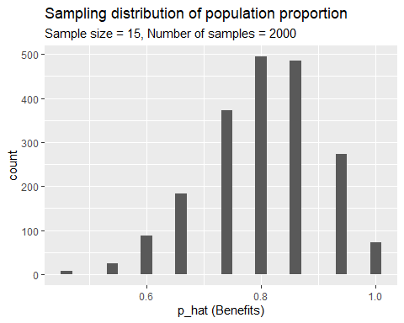

mean(sample_props15$p_hat)

## [1] 0.8038667

**According to the average of p_hat, approximately 80% of the population believe that scientists do enhance their daily lives.**

1. Change your sample size from 15 to 150, then compute the sampling distribution using the same method as above, and store these proportions in a new object called sample_props150. Describe the shape of this sampling distribution and compare it to the sampling distribution for a sample size of 15. Based on this sampling distribution, what would you guess to be the true proportion of those who think the work scientists do enchances their lives?

sample_props150 <- global_monitor %>%  
 rep_sample_n(size = 150, reps = 2000, replace = TRUE) %>%  
 count(scientist_work) %>%  
 mutate(p_hat = n /sum(n)) %>%  
 filter(scientist_work == "Benefits")   
sample_props150

## # A tibble: 2,000 × 4  
## # Groups: replicate [2,000]  
## replicate scientist_work n p_hat  
## <int> <chr> <int> <dbl>  
## 1 1 Benefits 121 0.807  
## 2 2 Benefits 123 0.82   
## 3 3 Benefits 113 0.753  
## 4 4 Benefits 119 0.793  
## 5 5 Benefits 120 0.8   
## 6 6 Benefits 126 0.84   
## 7 7 Benefits 118 0.787  
## 8 8 Benefits 124 0.827  
## 9 9 Benefits 127 0.847  
## 10 10 Benefits 118 0.787  
## # ℹ 1,990 more rows

ggplot(data = sample_props150, aes(x = p_hat)) +  
 geom_histogram(binwidth = 0.02) +  
 labs(  
 x = "p_hat (Benefits)",  
 title = "Sampling distribution of population proportion",  
 subtitle = "Sample size = 150, Number of samples = 2000"  
 )

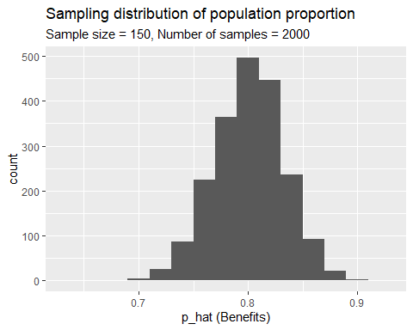

mean(sample_props150$p_hat)

## [1] 0.80095

**The data looks symmetrical and there are no skews like the graph in exercise 8. The calculated mean to find proportion population shows results of around 80% again.**

1. Of the sampling distributions from 2 and 3, which has a smaller spread? If you’re concerned with making estimates that are more often close to the true value, would you prefer a sampling distribution with a large or small spread?

**Observing the charts, I would measure and state that chart 2 has a smaller spread because it would be useful to work with smaller samples. Those smaller samples generally would provide a precisely accurate representation of the population proportion.**