**Date: 27-10-2025**

**Name: Chittimalla Pujitha**

**Mtech – 1st Year**

**HTNO: 2503B05118**

**Lab 1: Environment Setup – GitHub Copilot and VS Code Integration**

**Task Description**

* Install and configure GitHub Copilot in VS Code. Take screenshots of each step.

**Expected Output**

* Install and configure GitHub Copilot in VS Code. Take screenshots of each step.

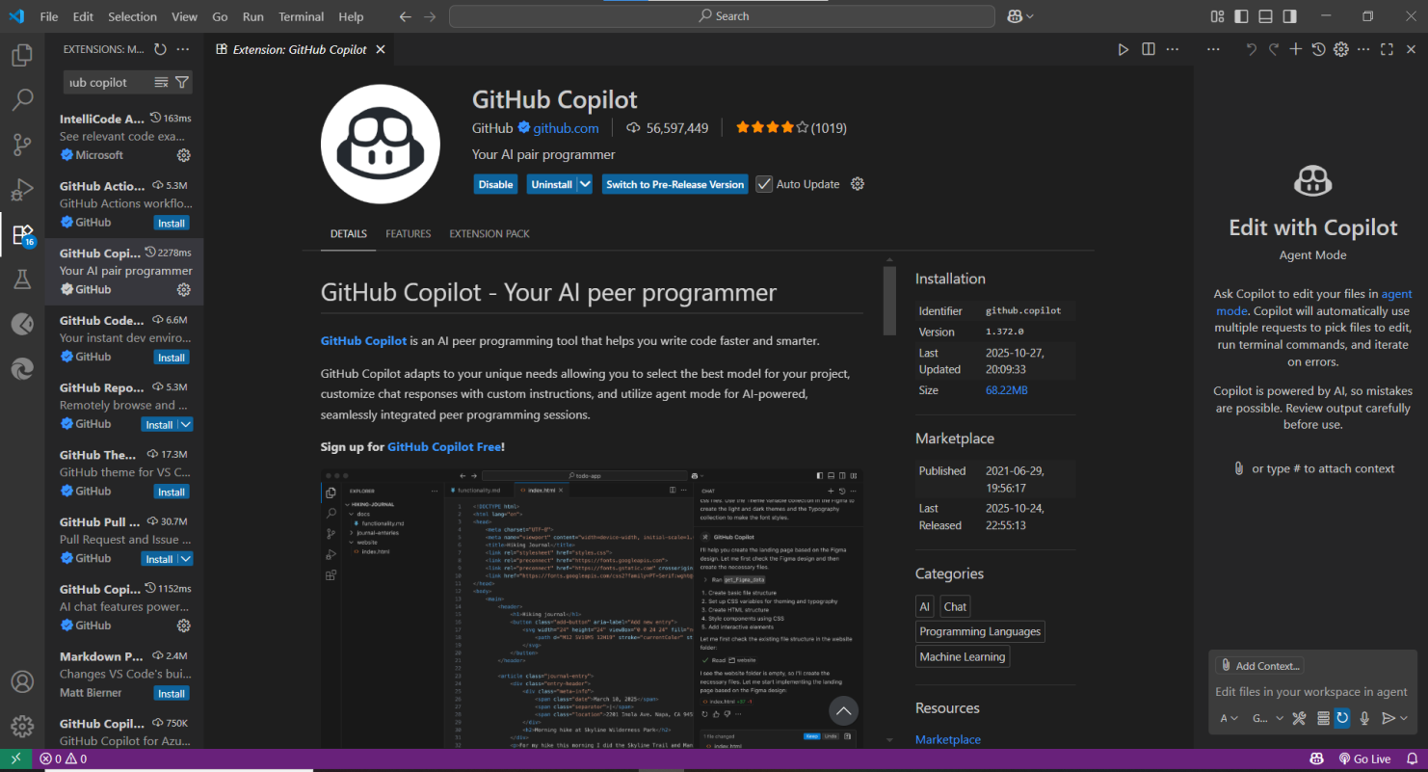

**Task Description-1**

* Use Copilot to generate a is_prime() Python function**.**

**Expected Output-1**

* Function to check primality with correct logic.

**Prompt -1**

Generate a Python function to find whether a number is prime or not.

**Prompt-2**

Update the function to take user input for a number.

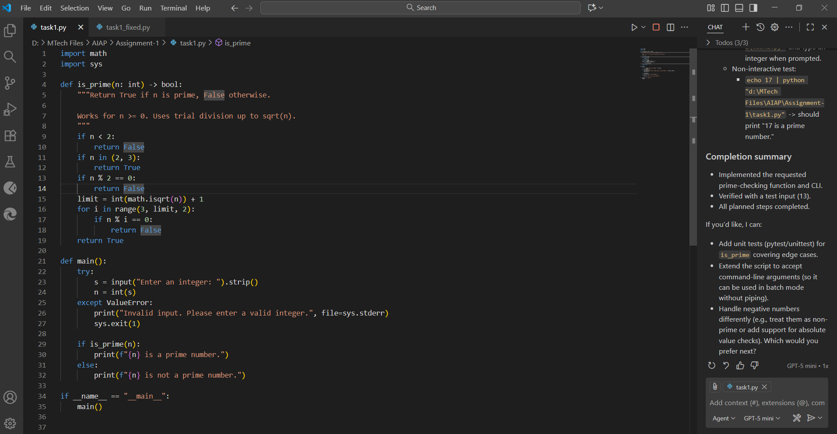

**Output:**

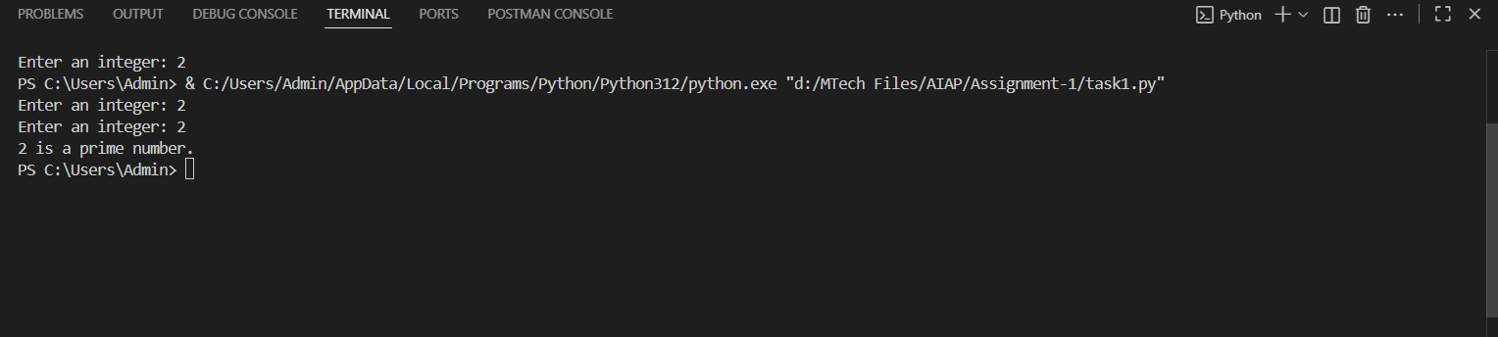

**Task Description-2**

* Write a comment like # Function to reverse a string and use Copilot to generate the function.

**Expected Output-2**

* Auto-completed reverse function

**Prompt-1**

Function to reverse a string where the expected output is to autocomplete the reverse function.

**Prompt-2**

Update the code to take user input manually

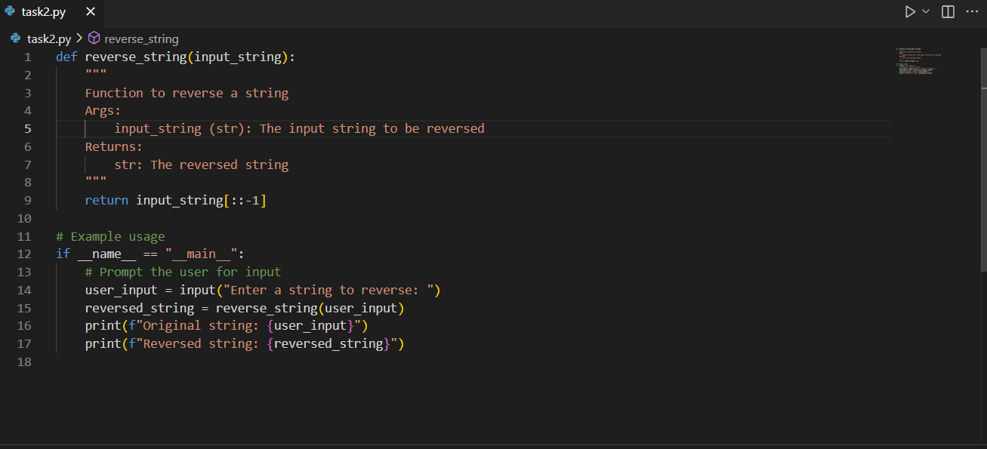

**Output:**

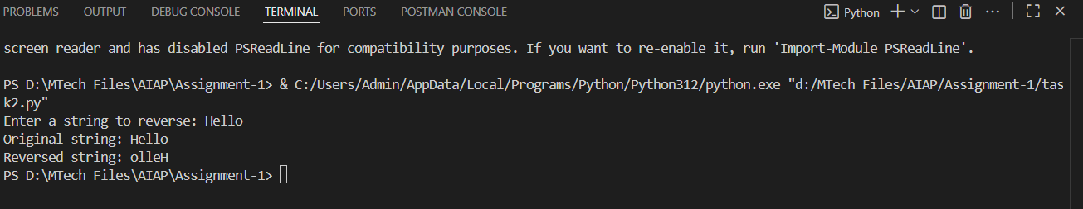

**Task Description-3**

* Generate both recursive and iterative versions of a factorial function using comments..

**Expected Output-3**

* Two working factorial implementations

**Prompt-1**

Generate both recursive and iterative versions of a factorial function in python.

**Prompt-2**

Update the code to take user input manually.

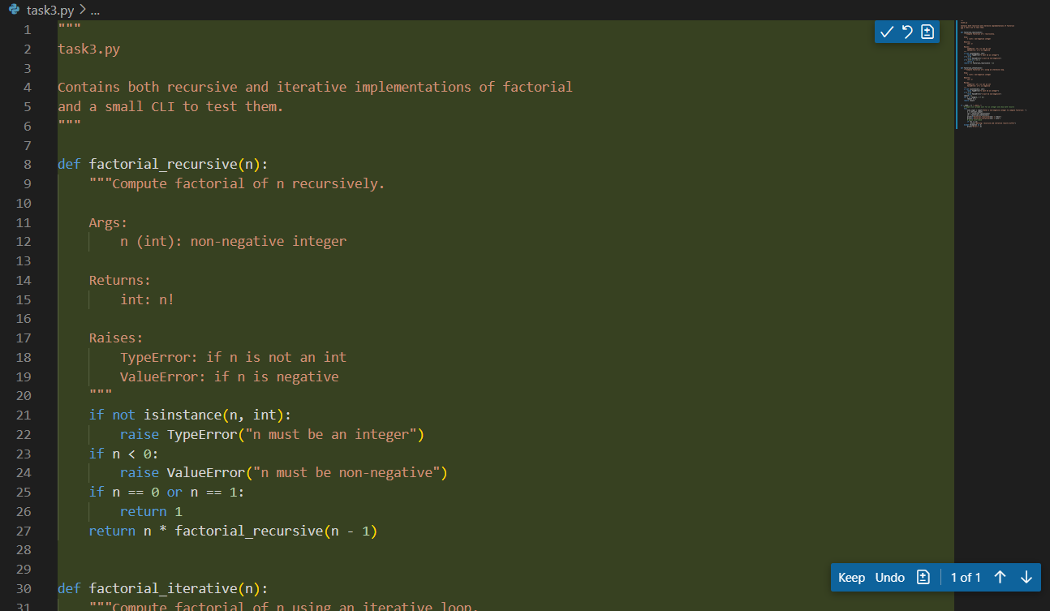

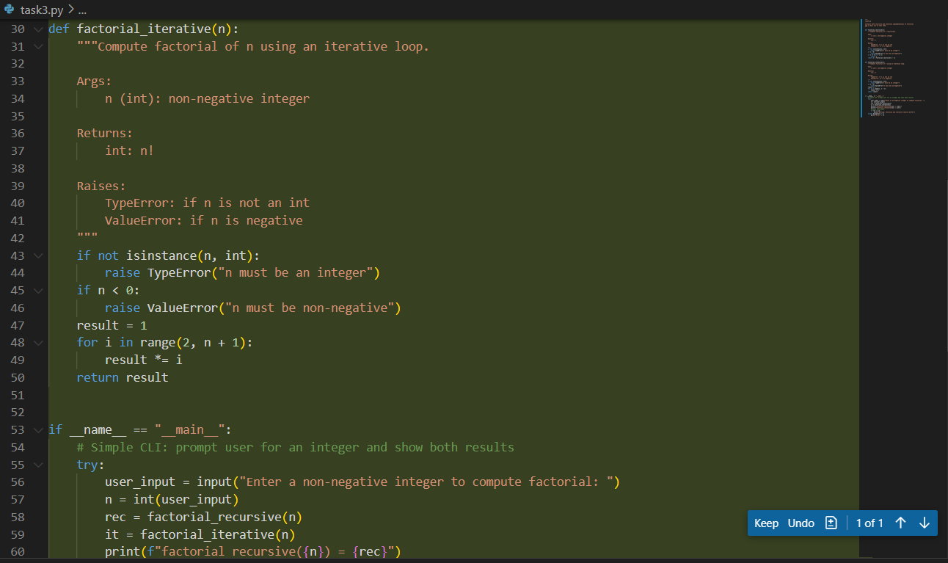

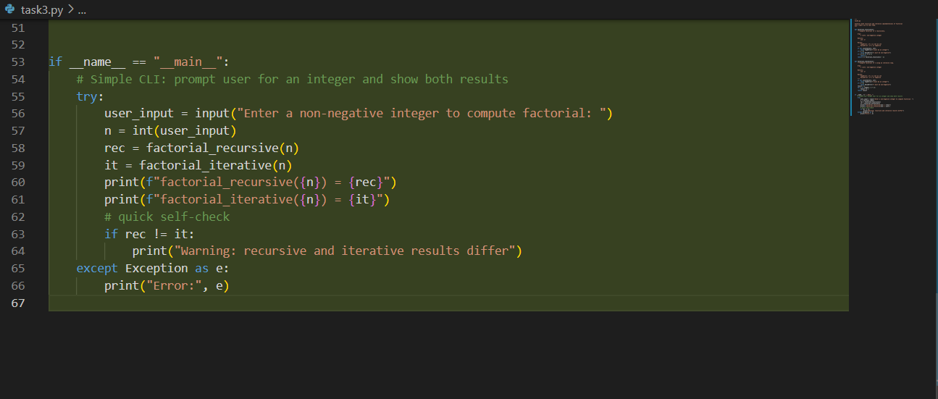

**Output:**

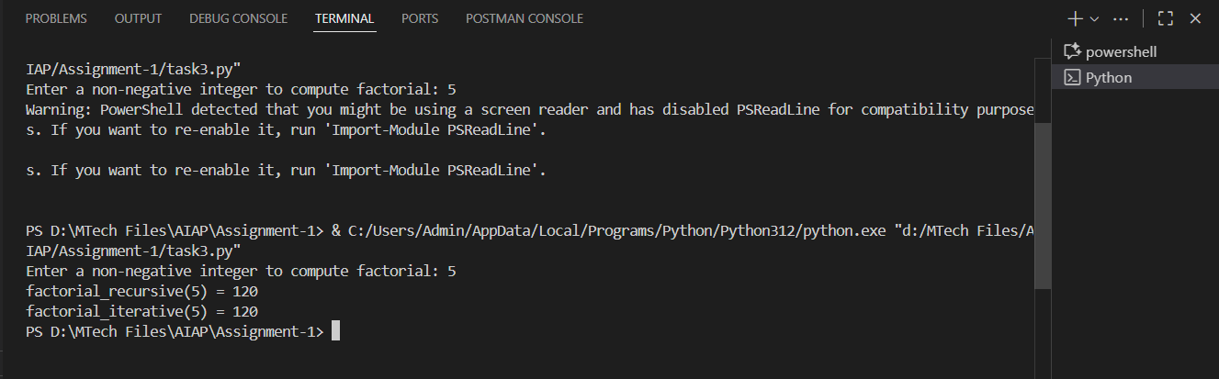

**Task Description-4**

* Use Copilot to find the largest number in a list. Assess code quality and efficiency.

**Expected Output-4**

* A valid function with your review

**Prompt**

Generate python code to find the largest number in a list by taking user input manually.

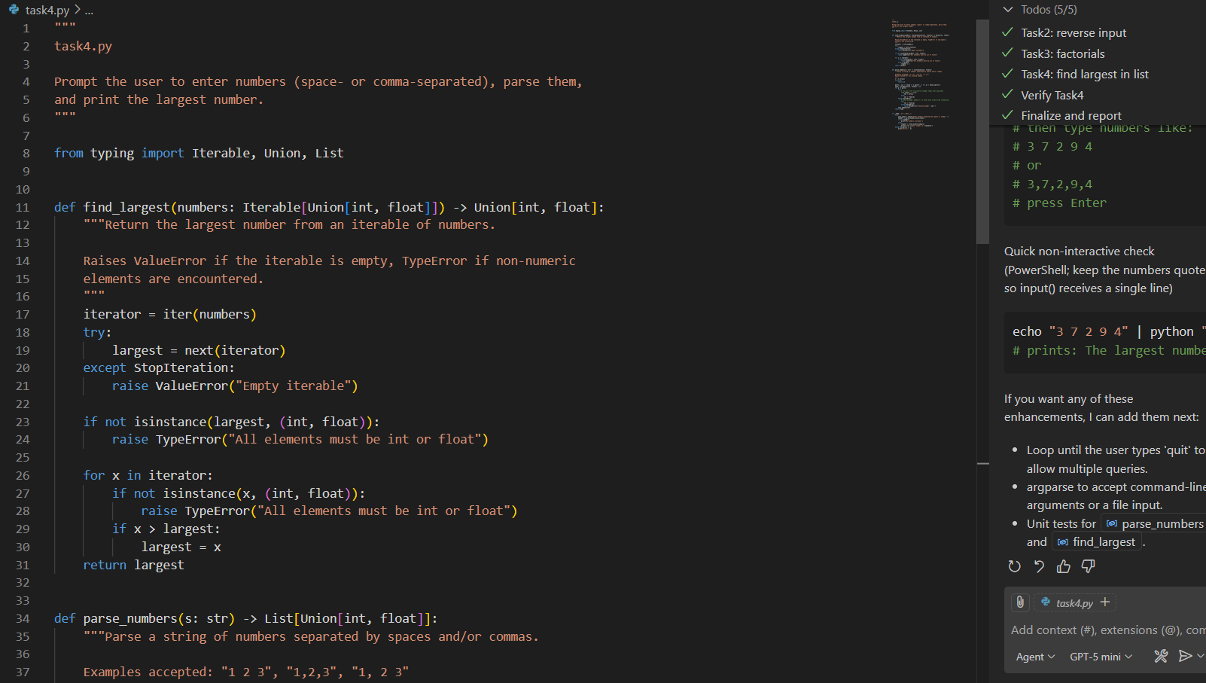

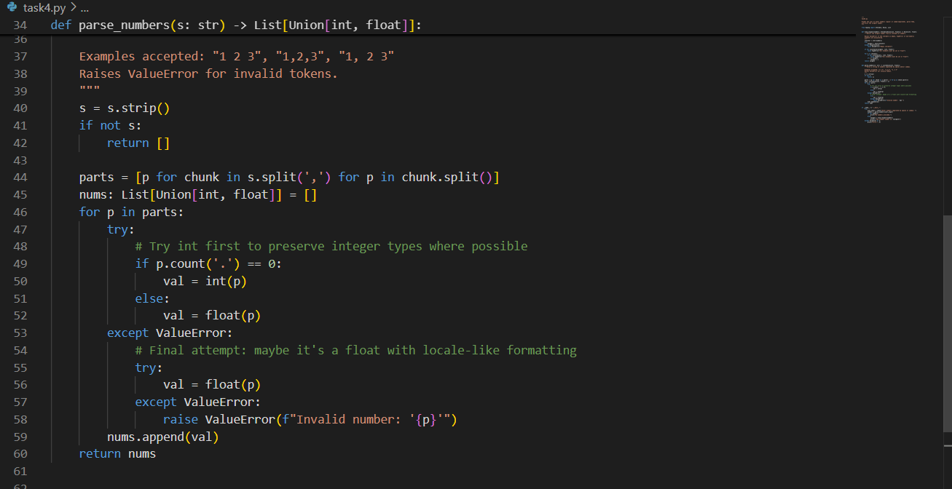

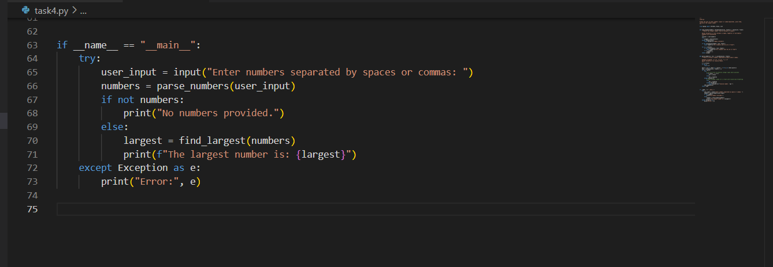

Output:

