Python Programming Lab Task Sets

Set 3
- Implement a Python class for a stack data structure (`push`, `pop`, `peek`). Use GitHub Copilot to generate code, test its handling of edge cases, and explain any improvements made.
(Each question carries 5 marks)
Prompt:
Generate a python class for stack data structure push, pop, peek for different test cases by taking user input manually.
Code:
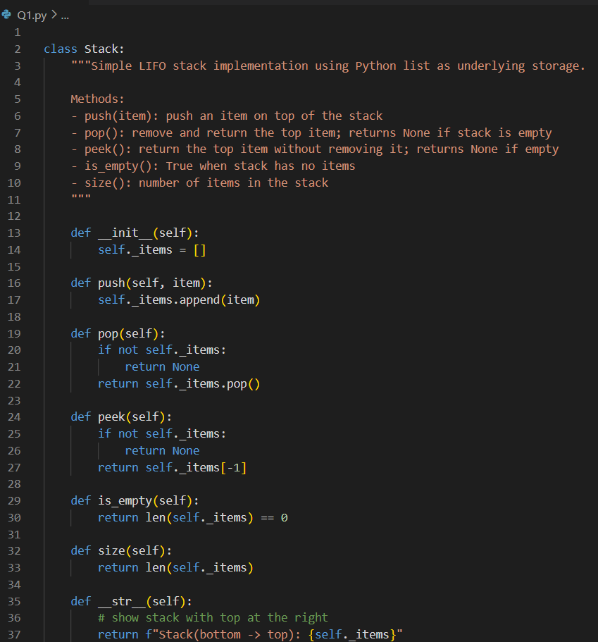
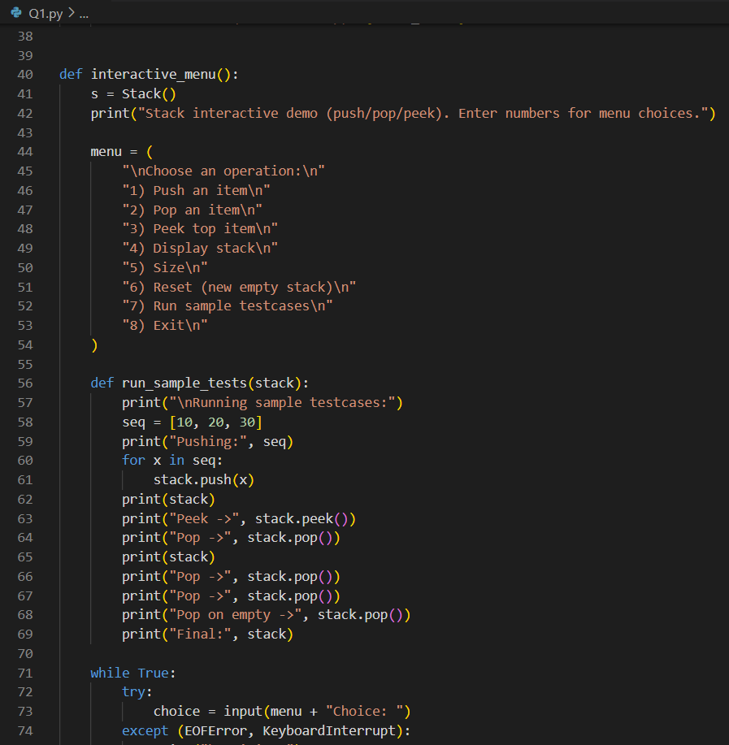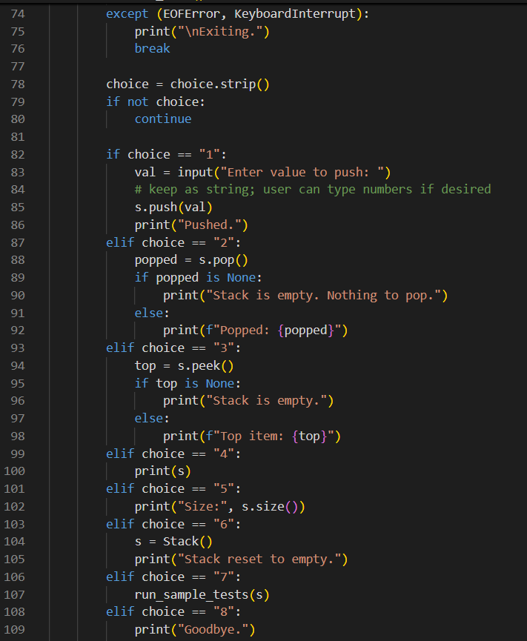
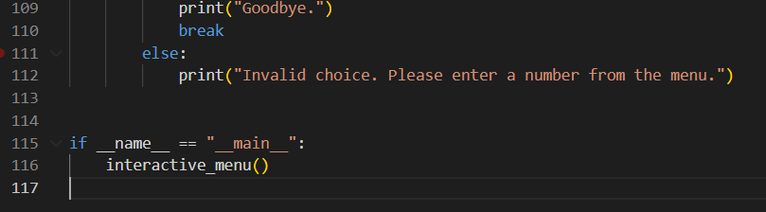
Output:

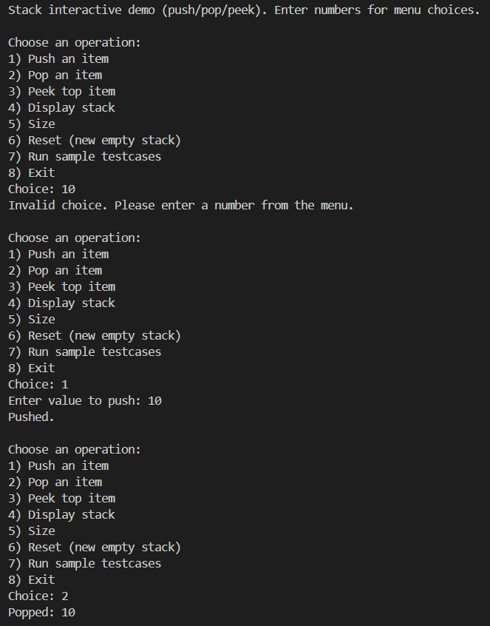
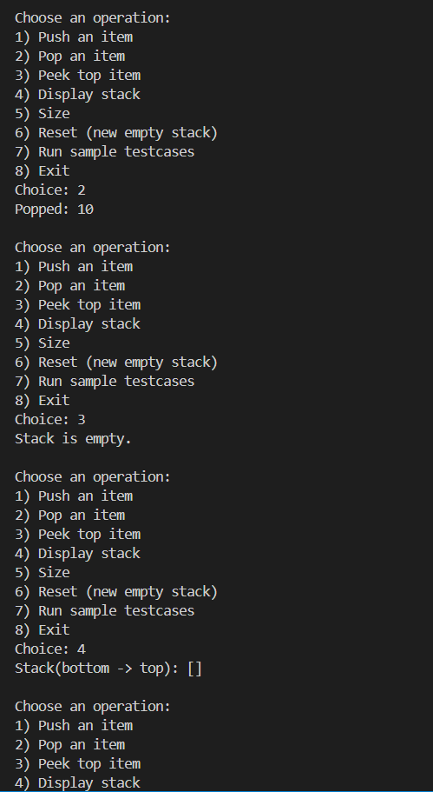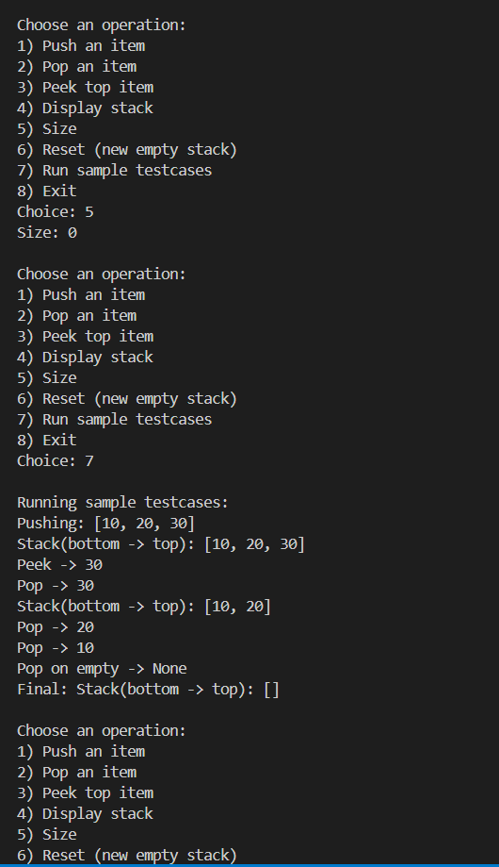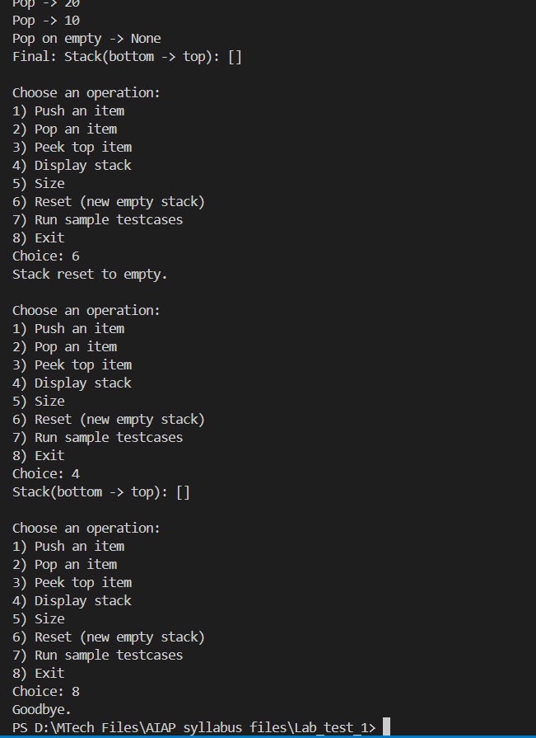

Explaination:
The program handles all the edge cases really well. When the stack is empty and we try to pop or peek, it doesn’t break, it just tells that there’s nothing in the stack. Even if we type a wrong menu option, the program catches it and asks again without crashing. The sample test cases also show that pushing, popping, and checking size all work exactly as expected, even when the stack becomes empty. So there is nothing to fix or improve.

- Refactor a poorly commented Python function using an AI assistant for automatic documentation. Evaluate clarity and completeness versus manual comments.
(Each question carries 5 marks)
Prompt:
#Addition Function
def add(a,b):
c=a+b
return c
x = add(3,5) # Passing values
print(x) #Calling function
Refactor this poorly commented python function and give proper commenting for better understanding.
Code:
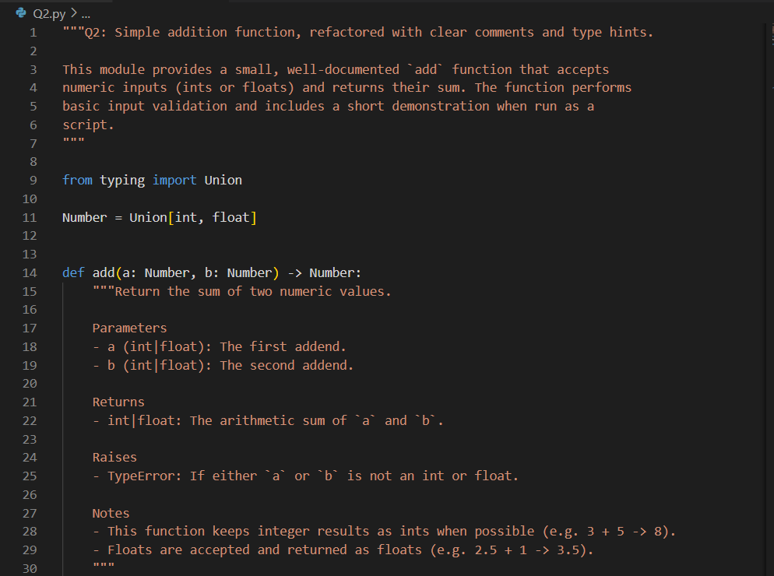
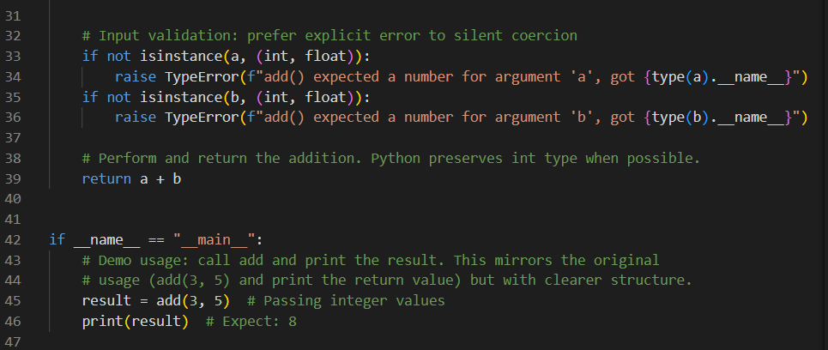
Output:
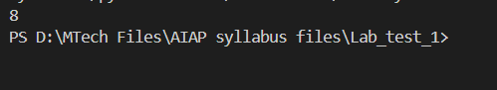
Explaination:
The original code had very basic comments that only described what each line was doing, but they didn’t explain the purpose of the functions or how it should be used. In the improved version, the comments are more clear and complete. They explain why the function exists, what kind of values it accepts, and what it returns. The type hints and a proper docstring helps user to understand very easily. The updates structure also helps anyone to read the code quickly grasp its intention. These new comments make the function more readable and user-friendly.

