Assignment -6
Name: Chittimalla Pujitha
HTNO: 2503B05118
Mtech 1st year

Q1. LAB TASK: TCP Congestion Control Simulation
Question:
Using a TCP congestion control simulator (Python or any tool of your choice), simulate and analyze TCP Reno under three different packet-loss conditions:
- 0.1% loss
- 1% loss
- 2% loss
For each case:
- Plot the Congestion Window (cwnd) vs Time for at least 20 seconds of simulation.
- Compute the average throughput (in MSS/second or Mbps).
- Explain how packet loss affects the behavior of TCP Reno, specifically discussing:
  - Slow Start
  - Congestion Avoidance
  - Multiplicative Decrease (cwnd halving)
- Compare the three cases and write a short conclusion on how increasing loss impacts network performance.

Code:
import matplotlib.pyplot as plt
import random

RTT = 0.05
sim_time = 20.0
mss = 1.0
packets_per_seg = 1

algorithm = "reno"
initial_cwnd = 1.0
ssthresh_init = 64.0

def simulate(loss_prob):
t = 0.0
cwnd = initial_cwnd
ssthresh = ssthresh_init

time_steps = []
cwnd_trace = []
bytes_acked = 0.0

def send_window(cwnd):
segs = int(max(1, round(cwnd / mss)))
lost = False
acks = 0
for _ in range(segs):
if random.random() < loss_prob:
lost = True
else:
acks += 1
return lost, acks

while t < sim_time:
time_steps.append(t)
cwnd_trace.append(cwnd)

lost, acks = send_window(cwnd)
bytes_acked += acks * mss

if lost:
ssthresh = max(cwnd / 2, 2)
cwnd = max(cwnd / 2, 1)
else:
if cwnd < ssthresh:
cwnd *= 2
else:
cwnd += 1

cwnd = min(cwnd, 1000)
t += RTT

throughput = bytes_acked / sim_time
return time_steps, cwnd_trace, throughput

# Run for 0.1%, 1%, 2%
loss_levels = [0.001, 0.01, 0.02]

for loss in loss_levels:
t, cwnd, thr = simulate(loss)
plt.figure(figsize=(9,4))
plt.step(t, cwnd, where='post')
plt.title(f"TCP Reno cwnd vs Time (Loss = {loss*100}%)")
plt.xlabel("Time (s)")
plt.ylabel("cwnd (MSS)")
plt.grid(True)
plt.show()

print(f"Loss {loss*100}% → Throughput: {thr:.2f} MSS/s")

Output:
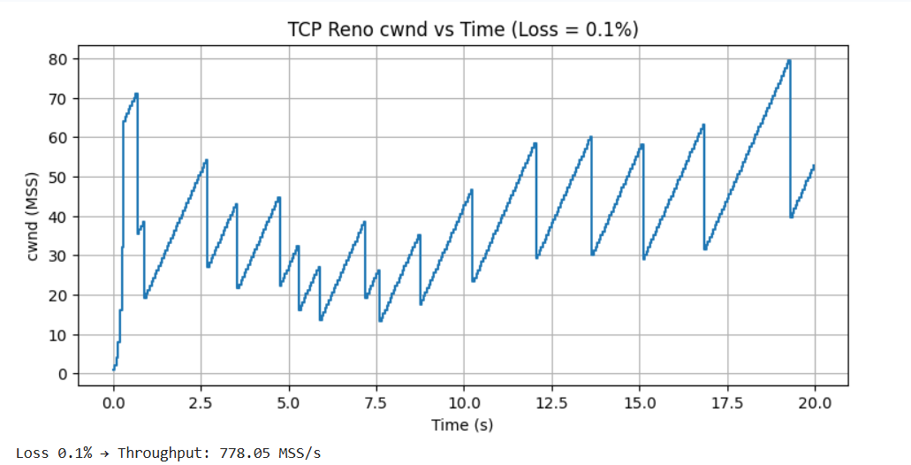
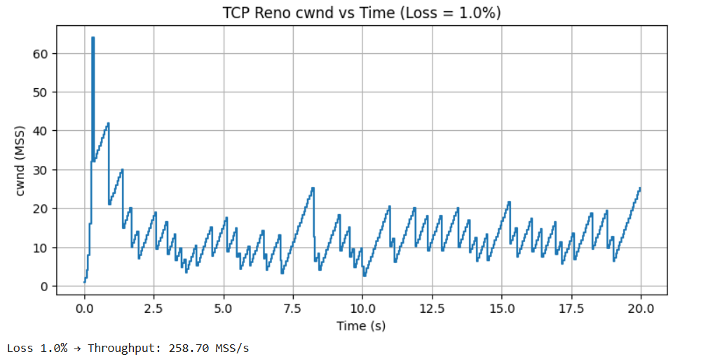
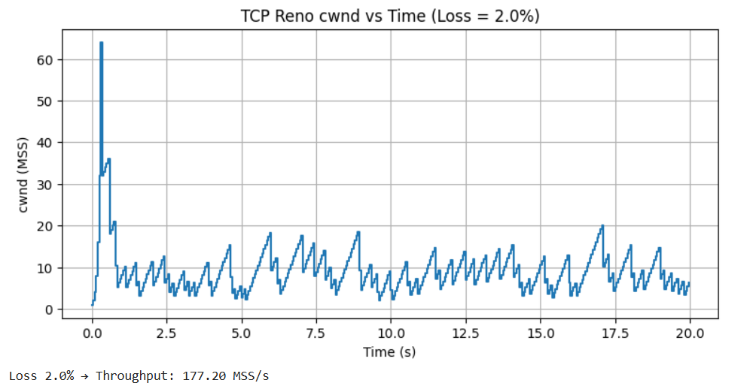
Effect of Packet Loss on TCP Reno Behavior

TCP Reno adjusts its congestion window (cwnd) based on network feedback. The behavior changes significantly as packet-loss increases. The three key mechanisms—Slow Start, Congestion Avoidance, and Multiplicative Decrease—are affected differently under each loss condition.

- Slow Start

TCP Reno begins with a congestion window of 1 MSS and doubles the cwnd every RTT, allowing rapid bandwidth discovery.

At 0.1% packet loss:
Loss events are rare, so the slow start phase continues for a longer duration. This allows the cwnd to grow quickly and reach high values (around 70 MSS), resulting in high throughput.

At 1% and 2% packet loss:
Losses occur early and frequently. Slow start ends prematurely, causing cwnd to reset before it can grow significantly. As a result, the window rarely exceeds small values.

- Congestion Avoidance (Linear Growth)

After slow start, Reno switches to congestion avoidance where cwnd increases by 1 MSS per RTT.

At 0.1% loss:
The connection spends much more time in congestion avoidance, enabling smooth, steady linear growth of cwnd. Occasional losses cause drops, but cwnd quickly regains size.

At 1% and 2% loss:
The connection rarely enters long congestion-avoidance phases. Frequent packet losses repeatedly force cwnd to drop, preventing it from climbing to higher values. The saw-tooth pattern becomes highly irregular and compressed.

- Multiplicative Decrease (cwnd halving)

Whenever a loss is detected, TCP Reno performs multiplicative decrease:
cwnd = cwnd / 2 and ssthresh = cwnd / 2.

At 0.1% loss:
Loss events are infrequent, so cwnd is halved rarely. The cwnd remains high and stable for long periods.

At 1% loss:
cwnd is halved often. The window oscillates between roughly 5–20 MSS, significantly reducing throughput.

At 2% loss:
Continuous losses cause repeated halving. cwnd stays very small (around 5–12 MSS), severely limiting performance.

Comparison of the Three Loss Scenarios
Loss = 0.1%
- cwnd grows rapidly to around 70 MSS.
- Clear slow-start followed by long congestion-avoidance cycles.
- Very few congestion events.
- Throughput: 778.05 MSS/s (highest).
Loss = 1%
- cwnd spikes initially but collapses quickly.
- Frequent oscillations between 5–20 MSS.
- Limited time in congestion avoidance.
- Throughput: 258.70 MSS/s (significantly reduced).
Loss = 2%
- cwnd rarely grows.
- Heavy, frequent halving events.
- Window remains very small and unstable.
- Throughput: 177.20 MSS/s (lowest).

Final Conclusion

Increasing packet loss has a severe negative impact on TCP Reno’s performance. Since Reno interprets every packet loss as a sign of congestion, higher loss leads to more frequent transitions back to slow start and more multiplicative decreases. This prevents the congestion window from growing and drastically reduces the average sending rate.

