OSCN ASSIGNMENT-8
Name: Chittimalla Pujitha
HTNO: 2503B05118
Mtech 1st year

PROGRAM 8 – SCHEDULING ALGORITHMS
TASK 1: A process is a program in execution. In real CPU scheduling, processes do not always arrive at the same time. The First Come First Serve (FCFS) algorithm schedules processes in order of arrival time.
CODE:
#include <iostream>
#include <algorithm>
using namespace std;
struct Process { stringpid; int at, bt; int ct, tat, wt; };
int main() { Processp[100]; int n;
cout<< "Enter number of processes: ";
cin>> n;
for(int i = 0; i< n; i++) {
cout<< "Enter Process ID: ";
cin>> p[i].pid;
cout<< "Arrival Time: ";
cin>> p[i].at;
cout<< "Burst Time: ";
cin>> p[i].bt;
}
// Sort by Arrival Time
sort(p, p + n, [](Process a, Process b) {
return a.at < b.at;
});
int time = 0;
int totalTAT = 0, totalWT = 0;
for(int i = 0; i< n; i++) {
// CPU idle if next process arrives later
if(time < p[i].at)
time = p[i].at;
time += p[i].bt;
p[i].ct = time;
p[i].tat = p[i].ct - p[i].at;
p[i].wt = p[i].tat - p[i].bt;
totalTAT += p[i].tat;
totalWT += p[i].wt;
}
cout<< "\nFCFS Scheduling Result:\n";
cout<< "PID\tAT\tBT\tCT\tTAT\tWT\n";
for(int i = 0; i< n; i++)
cout<< p[i].pid<< "\t" << p[i].at << "\t" << p[i].bt<< "\t"
<< p[i].ct<< "\t" << p[i].tat << "\t" << p[i].wt<< "\n";
cout<< "\nTotal TAT = " <<totalTAT;
cout<< "\nTotal WT = " <<totalWT;
cout<< "\nAverage TAT = " << (float)totalTAT/n;
cout<< "\nAverage WT = " << (float)totalWT/n;
}
OUTPUT:
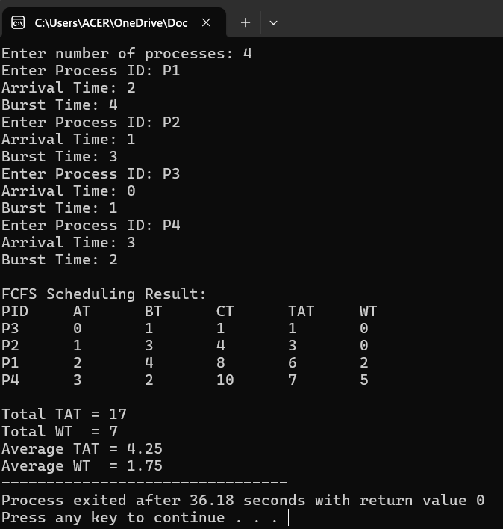

TASK 2: A process is a program in execution. CPU scheduling determines which process gets the CPU next. The Shortest Job First (SJF) algorithm selects the process with the smallest CPU burst time next.
CODE:
#include <iostream>
#include <algorithm>
using namespace std;
struct Process {
string pid;
int at, bt;
int ct, tat, wt;
bool completed = false;
};
int main() {
int n;
Process p[100];
cout<< "Enter number of processes: ";
cin>> n;
for(int i = 0; i< n; i++) {
cout<< "Enter Process ID: ";
cin>> p[i].pid;
cout<< "Arrival Time: ";
cin>> p[i].at;
cout<< "Burst Time: ";
cin>> p[i].bt;
}
int completedCount = 0, time = 0;
int totalTAT = 0, totalWT = 0;
cout<< "\nGANTT CHART:\n";
while(completedCount< n)
{
int idx = -1;
int minBT = 1e9;
// Find available process with smallest burst
for(int i = 0; i< n; i++) {
if(!p[i].completed&& p[i].at <= time) {
if(p[i].bt<minBT) {
minBT = p[i].bt;
idx = i;
}
}
}
// If no process is ready ? CPU Idle
if(idx == -1) {
time++;
continue;
}
cout<< "| " << p[idx].pid<< " ";
time += p[idx].bt;
p[idx].ct = time;
p[idx].tat = p[idx].ct - p[idx].at;
p[idx].wt = p[idx].tat - p[idx].bt;
p[idx].completed = true;
completedCount++;
totalTAT += p[idx].tat;
totalWT += p[idx].wt;
}
cout<< "|\n";
cout<< "\nNon-Preemptive SJF Result:\n";
cout<< "PID\tAT\tBT\tCT\tTAT\tWT\n";
for(int i = 0; i< n; i++)
cout<< p[i].pid<< "\t" << p[i].at << "\t" << p[i].bt
<< "\t" << p[i].ct<< "\t" << p[i].tat<< "\t" << p[i].wt<< "\n";
cout<< "\nAverage Waiting Time = " << (float)totalWT/n;
cout<< "\nAverage Turnaround Time = " << (float)totalTAT/n;
}
OUTPUT:
