Context-Aware Behavioral Analytics for Adaptive Public Sector Training: An Empirical Baseline and Framework Design

Abstract
Digital transformation in public governance has mandated continuous competency development for civil servants (PNS/ASN), predominantly delivered via asynchronous Learning Management Systems (LMS). However, current platforms predominantly suffer from context blindness—failing to account for situational realities such as fragmented working hours, shifting administrative priorities, multi-device usage, infrastructural disparities in remote/3T regions, and compliance-driven ghost learning. This paper presents an empirically grounded framework for Context-Aware Behavioral Analytics (CABA) specifically designed for public sector professional training. Based on a formative empirical survey of Indonesian civil servants across diverse administrative tiers and geographical regions, we establish a baseline of real-world learning constraints, including prevalent operational multitasking, connectivity bottlenecks, and modality preferences. Building upon these empirical insights, we formulate a four-layer CABA architecture that bridges multi-dimensional context sensing (temporal workload, environmental infrastructure, organizational tier, and non-invasive behavioral telemetry) with an adaptive pedagogical decision engine. The framework dynamically delivers supportive, non-punitive interventions, such as workload-sensitive micro-chunking, active engagement verification stop-gates, and bandwidth-resilient modality fallbacks. This study provides both foundational empirical evidence and an architectural blueprint for next-generation government e-learning ecosystems that optimize authentic competency acquisition while respecting public servants' operational workload.
Keywords: Learning Analytics, Context-Aware Computing, Public Sector Training, Adaptive Learning, Civil Service Competency, Empirical Baseline, Ghost Learning, Andragogy.

I. Introduction

1.1 Background and Motivation
In modern public administration, continuous competency development for civil servants is both an organizational imperative and a regulatory mandate, often operationalized through compulsory annual training hours and competency-based certification requirements. Governments worldwide have accelerated the adoption of asynchronous Massive Open Online Courses (MOOCs), digital learning portals, and Learning Management Systems (LMS) to upskill large numbers of public sector employees efficiently. While digital delivery helps overcome geographic, cost, and scalability barriers, the pedagogical efficacy of these platforms remains heavily contested, especially when learning is treated primarily as a completion requirement rather than as a process of authentic competency acquisition [1], [2].
Unlike conventional higher education students who often operate within structured academic timetables, civil servants (Pegawai Negeri Sipil/PNS or Aparatur Sipil Negara/ASN) engage in online learning under strict adult learning and andragogical constraints. They must balance continuous professional education with daily public service delivery, administrative deadlines, shifting task priorities, and unexpected state duties. Consequently, their learning behaviors are deeply situated within workplace routines, organizational expectations, and operational pressures [3], [5].

1.2 Problem Statement and the Context Blindness Gap
Current public sector e-learning ecosystems often suffer from context blindness. First, there is a mismatch between time fragmentation and monolithic content. Standard modules frequently consist of lengthy video lectures or reading materials that clash with the fragmented daily schedules of public servants, leading to rushed completion, reduced engagement, or dropout. Second, mandatory learning targets may encourage superficial compliance or ghost learning behaviors, such as playing videos in background tabs while attending to office tasks, skipping reading materials, or rushing through post-tests without meaningful cognitive processing. Third, the civil service workforce is highly heterogeneous, spanning multiple generations, administrative tiers, digital literacy levels, and domain backgrounds.
Traditional Learning Analytics (LA) relies primarily on static behavioral logs, such as total watch time, login frequency, completion status, and post-test scores. However, analyzing learner behavior in isolation from situational context may produce biased interpretations. Prior work stresses that analytics should remain grounded in learning processes rather than being reduced to computational reporting alone [1]. For example, a civil servant watching a video at 1.5× speed at 10:00 AM on a desktop computer may indicate high workload and time pressure during office hours, whereas the same behavior at 9:00 PM on a mobile device may reflect topic familiarization, self-paced review, or deadline-driven completion. The problem is not the absence of behavioral data, but the lack of situational awareness required to interpret such data pedagogically.

1.3 Research Contributions
To bridge this gap, this paper introduces a preliminary Context-Aware Behavioral Analytics (CABA) framework tailored for public sector professional training. The framework positions learner behavior as situated action rather than context-neutral evidence. Its primary contributions are threefold:
- Taxonomy of contextual and behavioral dimensions: defining multi-modal context indicators, including temporal, environmental, organizational, device-related, and attentional dimensions, that are pertinent to civil servants’ online learning conditions.
- Four-layer conceptual architecture: formulating an end-to-end data pipeline that connects passive context sensing, behavioral feature inference, pedagogical decision logic, and adaptive intervention delivery.
- Andragogical intervention strategies: outlining practical adaptation mechanisms, including workload-sensitive micro-scaffolding, active engagement verification, and role-differentiated learning support.

1.4 Paper Organization
The remainder of this paper is organized as follows. Section II discusses the theoretical foundations and related work, including andragogy, Cognitive Load Theory, and prior studies on Learning Analytics in professional and public sector training. Section III presents the proposed CABA framework architecture, detailing the four layers and associated telemetry variables. Section IV provides operational scenarios that illustrate how the framework may function across different civil servant learning contexts, such as office-based learning and field-duty learning. Section V discusses ethical considerations, data governance, privacy protection, and system limitations. Finally, Section VI concludes the paper and outlines a future roadmap for prototype implementation and empirical validation.

II. Theoretical Foundations and Related Work

2.1 Theoretical Grounding: Situated Cognition, Self-Regulated Learning, and Andragogy
The design of the Context-Aware Behavioral Analytics (CABA) framework is grounded in three complementary pedagogical and cognitive paradigms: situated cognition, self-regulated learning, and andragogy. Situated Cognition Theory argues that knowledge is not detached from the conditions in which it is acquired and used, but is shaped by activity, context, and culture (Brown et al., 1989). In public sector professional training, this perspective is particularly relevant because civil servants acquire competencies while embedded in authentic administrative routines, organizational hierarchies, service obligations, and task disruptions.
Self-Regulated Learning (SRL) provides a second foundation for the framework. Online professional development requires learners to manage goals, time, learning environments, help-seeking behaviors, task strategies, and self-evaluation. Prior work on SRL profiles in online learning shows that learners differ substantially in their capacity to regulate learning, and that minimal or disorganized self-regulation is associated with poorer achievement [4]. In mandatory government training, where compliance targets may overshadow intrinsic motivation, adaptive systems need mechanisms to detect weak regulation patterns and provide timely scaffolding.
Andragogy further strengthens the public sector orientation of CABA. Adult learners are typically self-directed, experience-rich, problem-oriented, and motivated by the relevance of learning to their work roles [5]. For civil servants, effective online training should therefore connect learning materials with real administrative problems, acknowledge prior professional experience, and provide flexible pathways that respect workload constraints. A context-aware system can operationalize these principles by adjusting content timing, format, and scaffolding according to occupational role, learning history, and immediate situational context.

2.2 Behavioral Analytics and Engagement Estimation
The evolution of Learning Analytics (LA) and Educational Data Mining (EDM) has shifted from post-hoc reporting toward increasingly granular behavioral tracking, reflecting the convergence of two research traditions concerned with data-driven understanding of learning [2]. Contemporary online learning platforms can capture clickstream events, resource navigation sequences, dwell time, video playback behavior, quiz attempts, response latency, and completion patterns. These traces can provide useful signals about engagement, persistence, and learning strategies, but their meaning remains ambiguous when interpreted without contextual information.
For public sector professional training, engagement estimation should prioritize non-invasive behavioral proxies rather than hardware-heavy or privacy-sensitive sensing methods. Indicators such as tab-focus changes, repeated video scrubbing, abnormal playback acceleration, long idle periods, rapid post-test completion, and inconsistent resource sequencing can help identify possible disengagement or superficial compliance. However, CABA treats these indicators as probabilistic signals rather than definitive judgments. For instance, frequent pauses may indicate confusion, multitasking, poor connectivity, or deliberate note-taking. The role of context inference is therefore to reduce ambiguity before the system selects an adaptive intervention.

2.3 Contextual Constraints and Infrastructural Heterogeneity in the Public Sector
A critical gap in existing adaptive learning literature is the assumption that learners operate under relatively stable digital infrastructure and learning conditions. This assumption is problematic in public sector training systems that serve geographically dispersed civil servants. In Indonesia, for example, learners may be located in central ministry offices, provincial agencies, district administrations, or Disadvantaged, Frontier, and Outermost regions known as 3T areas. These settings may vary significantly in bandwidth availability, device quality, electricity stability, and opportunities for uninterrupted study.
These infrastructural and organizational differences have direct implications for LMS design. A high-bitrate video module may be pedagogically acceptable for learners using office desktops on stable networks, but unsuitable for learners relying on mobile devices and constrained connectivity during field duty. Similarly, a long synchronous or linear module may fit formal classroom-like conditions but may not align with fragmented work schedules. Context awareness in government training must therefore include infrastructural context, such as bandwidth and device type, as well as workplace temporal context, such as active office hours, after-hours learning, and duty-related interruptions.

2.4 Synthesis and Research Gap Analysis
Existing research provides strong foundations for understanding online learning behavior, adult learning, cognitive load, and adaptive instruction [3]–[7]. However, most learning analytics approaches remain insufficiently sensitive to the situated realities of public sector professional training. Traditional LMS analytics often emphasize completion, access frequency, and scores; general adaptive e-learning systems tend to focus on prior knowledge and item difficulty; and engagement detection models frequently assume stable infrastructure or rely on sensing methods that may not be appropriate for government contexts. The proposed CABA framework addresses this gap by integrating learner behavior with temporal, organizational, attentional, device-related, and infrastructural context.
Table 1. Comparison between Traditional Learning Analytics and the Proposed CABA Framework
Dimension | Traditional Learning Analytics (LMS) | General Adaptive E-Learning | Proposed CABA Framework (Public Sector)
Primary target audience | K-12 and higher education students | General academic or lifelong learners | Civil servants (PNS/ASN) and public sector professionals
Context dimensions | Minimal; primarily log timestamps | Academic schedules and prior test scores | Multidimensional: workload time blocks, device and bandwidth constraints, regional infrastructure, and institutional tier
Behavioral telemetry | Page visits, login duration, and test completion | Navigation sequences and quiz response times | In-video interactions, tab-focus dynamics, response latency, idle periods, and anti-ghost-learning telemetry
Underlying pedagogical theory | Standard pedagogy and summative assessment | Cognitivism, mastery learning, and item response logic | Situated cognition, self-regulated learning, cognitive load management, and andragogy
Adaptive interventions | Static reports for instructors | Automated difficulty adjustment and content sequencing | Situated interventions: office-hour micro-chunking, engagement checkpoints, bandwidth-resilient fallback, and role-differentiated scaffolding

III. The Proposed CABA Framework Architecture

3.1 High-Level Architecture Overview
The Context-Aware Behavioral Analytics (CABA) framework is structured as a four-tier pipeline designed to continuously capture, infer, decide, and deliver situated interventions for public sector learners. The framework connects non-invasive telemetry collection with contextual inference and pedagogical decision-making so that adaptive interventions are not triggered by behavior alone, but by behavior interpreted within workplace, infrastructural, and organizational conditions.
Figure 1. The Four-Layer Architecture of the Context-Aware Behavioral Analytics (CABA) Framework.
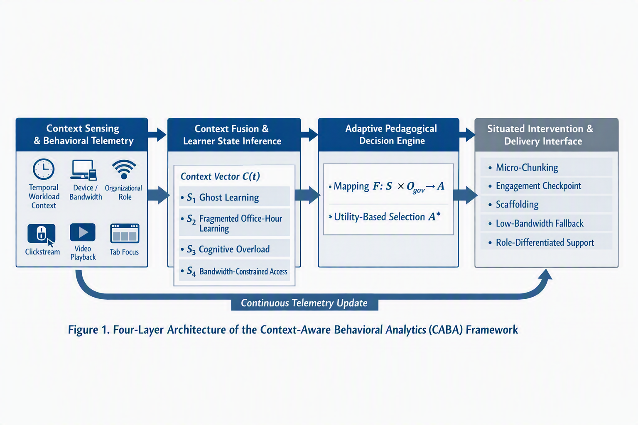
The four layers are: Layer 1, Context Sensing and Behavioral Telemetry; Layer 2, Context Fusion and Learner State Inference; Layer 3, Adaptive Pedagogical Decision Engine; and Layer 4, Situated Intervention and Delivery Interface. These layers operate iteratively, allowing the LMS to update learner-state estimates and adapt interventions during an ongoing learning session.

3.2 Layer 1: Context Sensing and Behavioral Telemetry
Layer 1 non-invasively captures real-time data streams without requiring biometric sensors, thereby supporting institutional privacy requirements and reducing implementation barriers in government LMS environments. This design choice is consistent with the principle that learning analytics should serve learning support rather than unrestricted surveillance (Gašević et al., 2015). At time t, the real-time context vector is denoted as:
C(t) = <T_{work}(t), E_{infra}(t), O_{gov}, B_{tele}(t)>
where T_{work}(t) represents temporal and workload context, E_{infra}(t) represents infrastructural and environmental context, O_{gov} represents organizational and administrative context, and B_{tele}(t) represents behavioral telemetry.
- Temporal and workload context: t_{hour} captures time-of-day categories, such as active public service hours, overtime/evening learning, and late-night learning; Δt_{session} captures continuous session duration and inter-session gaps.
- Infrastructural and environmental context: β_{net} estimates network bandwidth and latency, including potential 3T or remote-office constraints; δ_{dev} identifies device category, such as desktop workstation, mobile phone, or tablet.
- Organizational and administrative context: R_{tier} represents civil service rank or role tier, such as administrative, specialist, or executive; Q_{jp} represents the remaining mandatory training quota.
- Behavioral telemetry: τ_{focus} captures LMS window or tab focus ratio; ν_{play} captures video playback speed; N_{scrub} captures non-sequential timeline scrubbing; and T_{dwell} compares dwell time per learning unit with an expected benchmark.

3.3 Layer 2: Context Fusion and Learner State Inference
Layer 2 aggregates raw telemetry features into discrete and interpretable learner cognitive and engagement states. Rather than treating any single behavior as conclusive, the framework combines threshold heuristics, temporal sequences, and contextual rules to infer learner states probabilistically. Four primary states are proposed as an initial operational model.
- S1: Ghost Learning or Passive Compliance. This state is inferred when τ_{focus} is below a predefined focus threshold, or when high playback speed, excessive scrubbing, and unusually short dwell time occur together. It indicates that the learner may be running training materials in the background primarily to fulfill mandatory hours.
- S2: Fragmented Office-Hour Learning. This state is inferred when learning occurs during active public service hours, usually on an office desktop, with frequent session interruptions. It indicates an authentic learning attempt constrained by administrative duties.
- S3: Cognitive Overload or Concept Struggling. This state is inferred when repeated video rewinds, dwell time exceeding twice the expected benchmark, and low quiz performance co-occur. It suggests that the learner may be struggling with complex technical regulations, policy concepts, or procedural materials.
- S4: Bandwidth-Constrained Access. This state is inferred when network bandwidth falls below a threshold or when video buffering stall ratio is high. It indicates connectivity limitations that may be common in regional or 3T learning environments.

3.4 Layer 3: Adaptive Pedagogical Decision Engine
The Decision Engine applies an andragogy-centered mapping function F: S × O_{gov} → A to select an appropriate pedagogical intervention A. The selected intervention may be represented as:
A* = arg max_{a∈A} U(a|S_{k}, O_{gov})
In this expression, U represents a pedagogical utility function that aims to maximize competency retention while minimizing workplace disruption. The decision logic does not merely optimize for completion speed; it seeks to balance learning authenticity, cognitive support, and administrative feasibility, consistent with the emphasis on adult learner relevance and cognitive load management (Knowles, 1984; Sweller, 1988).
Table 2. Adaptive Decision Mapping Matrix
Inferred State | Contextual Triggers | Target Adaptation Policy | Pedagogical Rationale
S1: Ghost Learning | Low tab-focus ratio; training video running in background; high playback acceleration | Active verification stop-gate: pause playback and inject a one-question scenario checkpoint | Converts passive compliance into active cognitive processing
S2: Fragmented Office-Hour Learning | Office hours; desktop access; frequent interruptions | Dynamic micro-chunking: break long modules into short digestible units | Accommodates adult time constraints without abandoning competency goals
S3: Cognitive Struggling | Repeated rewinds; extended dwell time; low quiz performance | Scaffolded regulatory clarification: provide infographics, simplified examples, or conceptual hints | Reduces cognitive overload and supports situated understanding
S4: Low Bandwidth or 3T Access | Low bandwidth; high packet loss; repeated buffering | Adaptive modality fallback: switch to low-bitrate slides, downloadable audio, or text-first mode | Improves accessibility and learning continuity across unequal infrastructures

3.5 Layer 4: Situated Intervention and Delivery Interface
Layer 4 renders the selected intervention directly into the learner interface. In CABA, interventions are designed to be supportive rather than punitive. For example, instead of penalizing tab-switching, the system may preserve the learner’s timestamp and provide a brief recap when the learner returns. When a learner shows signs of cognitive overload, the interface may offer simplified explanations, worked examples, or short formative checks. When infrastructural constraints are detected, the platform may switch to bandwidth-resilient formats such as compressed slides, audio summaries, or text-first content.
Role differentiation is also central to the delivery layer. For learners in executive or structural roles, case studies can be framed around strategic policy formulation, inter-agency coordination, and leadership decisions. For administrative or functional roles, the same competency domain may be translated into procedural workflows, service delivery cases, or technical implementation scenarios. This design allows the framework to preserve common competency standards while tailoring the situated learning experience to public servants’ responsibilities.

IV. Operational Scenarios and Illustrative Walkthrough
To demonstrate the conceptual validity and real-world applicability of the CABA framework in civil service training, this section presents two illustrative operational scenarios. These scenarios are not intended as empirical validation, but as design walkthroughs showing how context-aware inference can translate behavioral telemetry into supportive and situated pedagogical interventions.
Figure 2. Illustrative workflow of CABA inference and intervention across operational learning scenarios.
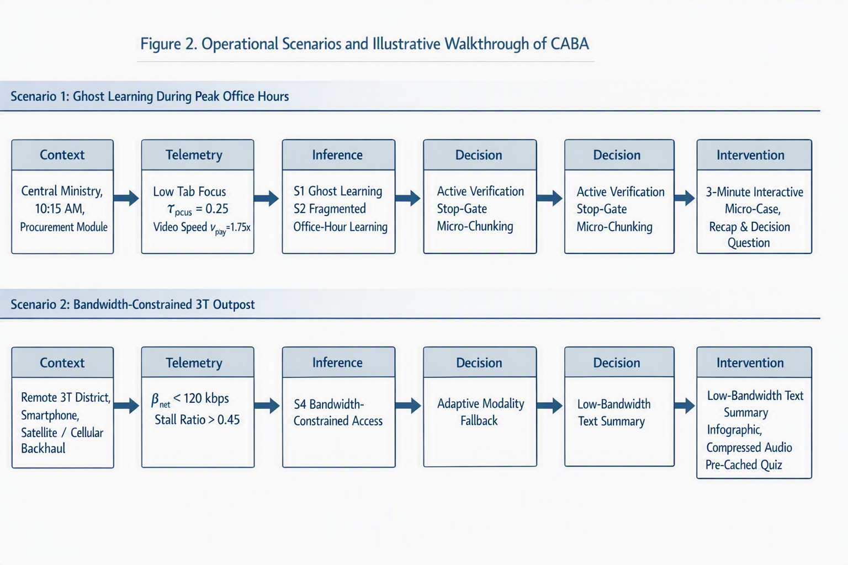

4.1 Scenario 1: Mitigating Ghost Learning During Peak Office Hours
A civil servant in an administrative or information-technology support role accesses a mandatory 45-minute training module on public procurement regulations at 10:15 AM using a desktop workstation in a central ministry office. The telemetry stream indicates a tab-focus ratio of τ_{focus} = 0.25, meaning the LMS window is active for only a quarter of the observed interval, while the video playback speed is set to ν_{play} = 1.75×. The system also detects limited interaction with embedded learning checkpoints.
The context fusion layer classifies this pattern as S1: Ghost Learning or Passive Compliance, superimposed on S2: Fragmented Office-Hour Learning. The decision engine therefore avoids punitive escalation and instead selects an active verification stop-gate combined with micro-chunking. Playback is paused gracefully, the learner’s timestamp is preserved, and the remaining lecture is converted into a three-minute interactive micro-case. When the learner returns to the LMS tab, the interface presents a short contextual recap followed by a realistic decision question related to procurement compliance. This intervention shifts the learner from passive completion behavior toward active cognitive processing while respecting ongoing workplace responsibilities.

4.2 Scenario 2: Adaptive Scaffolding in a Bandwidth-Constrained 3T Outpost
A civil servant stationed in a frontier or remote district accesses a competency enhancement module on civil service ethics via a smartphone connected through constrained network infrastructure. The telemetry stream registers network throughput below β_{net} < 120 kbps and a video stall ratio exceeding 0.45. These indicators suggest that the learner’s difficulty is not primarily motivational or cognitive, but infrastructural.
The context fusion layer infers S4: Bandwidth-Constrained Access. The decision engine immediately activates adaptive modality fallback. High-bitrate video is replaced with structured low-bandwidth text summaries, visual infographics, and optional compressed audio snippets. Quiz items are also pre-cached locally to reduce the risk of submission timeout. The goal is to preserve learning continuity and educational equity despite geographic and infrastructural barriers.

V. Discussion, Ethical Considerations, and Limitations

5.1 Non-Punitive Analytics versus Workplace Surveillance
In public sector environments, behavioral analytics can easily be perceived as intrusive workplace surveillance if governance boundaries are not clearly defined. The CABA framework must therefore be positioned as a pedagogical enablement system rather than a disciplinary monitoring system. Its purpose is to support learning continuity, reduce cognitive burden, and improve competency acquisition, not to evaluate employee productivity or penalize learners for multitasking during public service duties. This orientation is aligned with design science thinking, in which an artifact should address a real problem domain while remaining sensitive to organizational context and use conditions [7].
Two principles are central to this ethical positioning. First, data minimization should be applied so that the system captures only high-level learning telemetry, such as focus state, interaction pace, playback behavior, and connectivity conditions, without collecting personal browsing histories, keystrokes, webcam streams, or unrelated workplace activity. Second, transparent learner agency should be maintained through dashboards or explanations that inform learners why a particular adaptation occurred, such as switching to micro-learning mode because the learner is using a mobile device during office hours.

5.2 Mitigating Over-Intervention and Alert Fatigue
An adaptive system that intervenes too frequently may create distraction rather than support. To reduce this risk, CABA incorporates an intervention cooldown mechanism, denoted as Δt_{cooldown} ≥ 15 minutes. Stop-gates, nudges, and adaptive prompts should be deployed sparingly and only when severe disengagement, cognitive impasse, or infrastructural constraint is detected with sufficient confidence. This design reduces alert fatigue and preserves learner autonomy.

5.3 Limitations
- The decision thresholds, including θ_{focus}, θ_{bandwidth}, and θ_{scrub}, are currently heuristic-based and require empirical tuning against large-scale log datasets from government LMS deployments.
- The proposed learner states are conceptual and should be validated through field studies involving diverse civil servant cohorts, role tiers, regions, and digital literacy levels.
- The framework does not yet specify a full data governance model, consent workflow, or algorithmic accountability procedure, all of which are necessary before operational deployment.

VI. Conclusion and Future Roadmap
This paper presented a preliminary Context-Aware Behavioral Analytics (CABA) framework specifically tailored for public sector professional e-learning. By synthesizing situated cognition, self-regulated learning, adult learning principles, and infrastructural realities in developing regions, the framework addresses the context blindness of current public sector training systems [3]–[6]. The four-tier architecture connects multidimensional context sensing with an andragogical decision engine to deliver supportive and non-punitive adaptations, including active engagement checkpoints, workload-sensitive micro-chunking, role-differentiated scaffolding, and low-bandwidth fallbacks.
Future work will proceed in two directions. First, a prototype implementation should be developed as a reference plugin for widely used LMS platforms, including Moodle-based government training portals. Second, empirical validation should be conducted through a quasi-experimental pilot study with Indonesian civil service cohorts to evaluate the impact of context-aware adaptations on authentic knowledge retention, engagement quality, and course completion behavior.

References
[1] D. Gašević, S. Dawson, and G. Siemens, “Let’s not forget: Learning analytics are about learning,” TechTrends, vol. 59, no. 1, pp. 64–71, 2015.
[2] G. Siemens and R. S. J. d. Baker, “Learning analytics and educational data mining: Towards communication and collaboration,” in Proc. 2nd Int. Conf. Learning Analytics and Knowledge, 2012, pp. 252–254.
[3] J. S. Brown, A. Collins, and P. Duguid, “Situated cognition and the culture of learning,” Educational Researcher, vol. 18, no. 1, pp. 32–42, 1989.
[4] L. Barnard-Brak, W. Y. Lan, and V. O. Paton, “Profiles in self-regulated learning in the online learning environment,” The International Review of Research in Open and Distributed Learning, vol. 11, no. 1, pp. 61–80, 2010.
[5] M. S. Knowles, Andragogy in Action: Applying Modern Principles of Adult Learning. San Francisco, CA, USA: Jossey-Bass, 1984.
[6] J. Sweller, “Cognitive load during problem solving: Effects on learning,” Cognitive Science, vol. 12, no. 2, pp. 257–285, 1988.
[7] A. R. Hevner, S. T. March, J. Park, and S. Ram, “Design science in information systems research,” MIS Quarterly, vol. 28, no. 1, pp. 75–105, 2004.

