AP24110010981
Pujith.K
(1)
#include<bits/stdc++.h>
using namespace std;
class person{
public:
string name;
int age;
void getdata(){
cout<<"enter name: ";
getline(cin,name);
cout<<"enter age: ";
cin>>age;
}
};
class student:public person{
public:
int roll,marks;
void getdata(){
cout<<"enter roll number: ";
cin>>roll;
cout<<"enter marks: ";
cin>>marks;
}
void printdetails(){
cout<<"---- Student Details ----\nName: "<<name<<"\nAge: "<<age<<"\nRoll No: "<<roll<<"\nMarks: "<<marks<<endl;
}
};

int main(){
student p;
p.person::getdata();
p.getdata();
p.printdetails();
return 0;
}
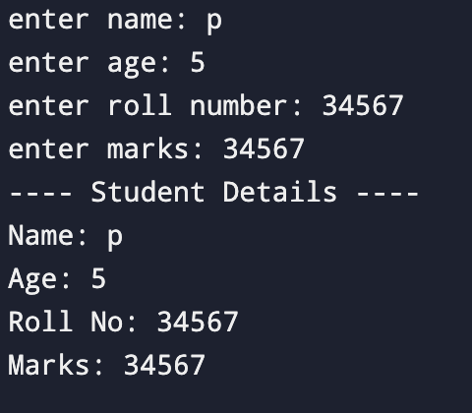

(2)
#include <bits/stdc++.h>
using namespace std;
class employee{
public:
string empid,name;
int salary;
};
class manager:public employee{
public:
string dep;
};
class seniormanager:public manager{
public:
int bonus;
void getdetails(){
cout<<"enter employee id: ";
cin>>empid;
cout<<"enter name: ";
cin>>name;
cout<<"enter salary: ";
cin>>salary;
cout<<"enter department: ";
cin>>dep;
cout<<"enter bonus: ";
cin>>bonus;
}
void printdetails(){
cout<<"---- senior manager details ----\nemployee id: "<<empid<<"\nname: "<<name<<"\ndepartment"<<dep<<"\nsalary: "<<salary<<"\nbonus: "<<bonus<<"\ntotal salary:"<<salary+bonus<<endl;
}
};
int main(){
seniormanager s;
s.getdetails();
s.printdetails();
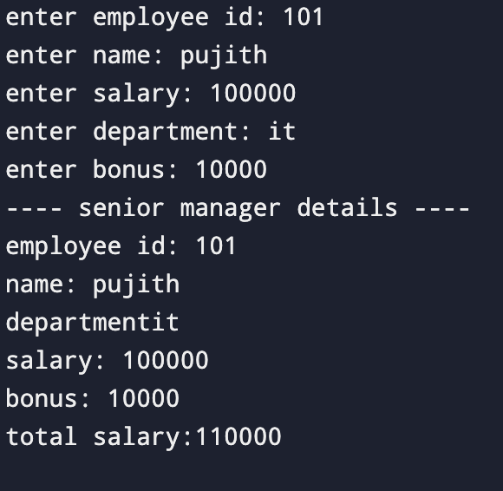
return 0;}

(3)
#include <bits/stdc++.h>
using namespace std;
class base{
public:
base(){
cout<<"base class constructor called"<<endl;
}
};
class derived1:public base{
public:
derived1(){
cout<<"derived1 class constructor called"<<endl;
}
};
class derived2:public derived1{
public:
derived2(){
cout<<"derived2 class constructor called"<<endl;
}
};
int main(){
derived2 k;
return 0;
}
