ANNAMACHARYA INSTITUTE OF
TECHNOLOGY & SCIENCES
Department of Computer Science & Engineering
__________________________________________________
PROJECT DOCUMENTATION
Full Stack Development
__________________________________________________
ONLINE PAYMENTS FRAUD DETECTION
WITH MACHINE LEARNING
February 2026
Team ID: LTVIP2026TMIDS41562
S.No | Name | Role
1 | P Varshitha | Team Leader
2 | G Lokanath Reddy | Team Member
3 | K Pujith | Team Member
4 | T Sruthi | Team Member

TABLE OF CONTENTS
1. Introduction
2. Project Overview
3. System Architecture
4. Dataset Description
5. Data Preprocessing & Exploratory Data Analysis
6. Model Training & Evaluation
7. Setup & Installation Instructions
8. Folder Structure
9. Running the Application
10. API Documentation
11. Authentication & Security
12. User Interface
13. Testing & Validation
14. Known Issues
15. Future Enhancements
16. References

1. Introduction
The introduction of online payment systems has revolutionized financial transactions, making payments faster, easier, and more convenient than ever before. However, this digital transformation has also led to a significant and alarming increase in payment fraud. Online payment fraud can affect anyone using digital payment systems, particularly those involving credit cards, bank transfers, and mobile wallets.
According to industry reports, global card fraud losses reached $48.8 billion in 2023, with projections indicating continued growth. This makes fraud detection not just a technical challenge but a business-critical necessity for every financial institution.
This project addresses this critical challenge by building a Machine Learning-powered web application that detects fraudulent online payment transactions in real time. The system uses a trained Decision Tree Classifier to analyze transaction features and classify them as either "Fraud" or "No Fraud", providing instant fraud assessment to users through an intuitive web interface.
The application is built using Python Flask for the backend web server, with a modern, responsive web interface for user interaction. The ML model is trained on the PaySim synthetic financial dataset from Kaggle, which simulates mobile money transactions based on real-world fraud patterns observed in African mobile money services.
2. Project Overview
2.1 Purpose
The primary purpose of this project is to develop a web-based fraud detection system that classifies online payment transactions as fraudulent or legitimate using machine learning algorithms. The system provides real-time fraud assessment, helping financial institutions and end-users identify and prevent unauthorized transactions before they cause financial damage.
2.2 Key Features
- Real-Time Fraud Prediction: Users input transaction details and receive instant fraud/no-fraud classification within milliseconds.
- Machine Learning Model: Trained Decision Tree Classifier achieving 97.6% accuracy on test data with 4 carefully selected features.
- Premium Web Interface: Modern dark-themed UI with glassmorphism effects, CSS animations, gradient accents, and responsive design.
- Multiple Transaction Types: Supports 5 types - Cash Out, Payment, Cash In, Transfer, and Debit.
- Visual Risk Assessment: Animated risk level indicator (High/Low) displayed alongside prediction results.
- Statistics Dashboard: Real-time display of model accuracy (97.6%), response time (<1s), and feature information.
2.3 Technologies Used
Component | Technology | Purpose
Backend | Python Flask | Web server and routing
ML Library | Scikit-Learn | Model training and prediction
Data Processing | NumPy / Pandas | Data manipulation
Visualization | Matplotlib / Seaborn | Charts and graphs
Frontend | HTML5 / CSS3 / JS | User interface
Templating | Jinja2 | Dynamic HTML rendering
Model Storage | Pickle | Saving/loading model
3. System Architecture
3.1 Architecture Diagram
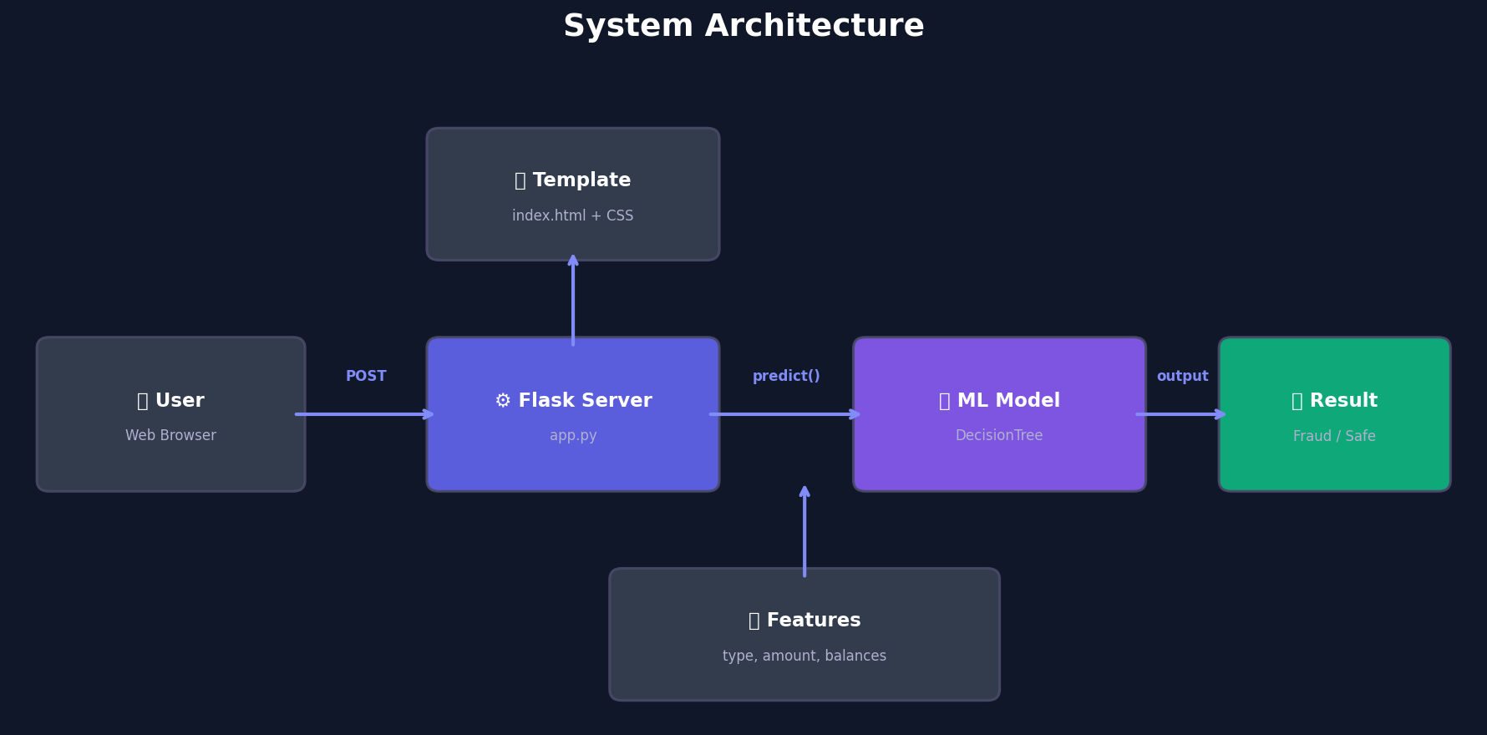
Fig 3.1: System Architecture - End-to-end data flow
3.2 Frontend Architecture
The frontend is built using HTML5, CSS3, and vanilla JavaScript, with Jinja2 as the templating engine. The UI features a premium dark theme with glassmorphism card effects, animated background particles, indigo-to-purple gradient accents, inline SVG icons, micro-animations, and a fully responsive layout that adapts to all screen sizes.
3.3 Backend Architecture
The backend is powered by Python Flask. It handles two routes: GET / renders the home page with the transaction form, and POST /predict processes form data, transforms features, runs model inference, and returns the prediction result.
3.4 Data Flow
- Step 1: User fills the transaction analysis form in the web browser.
- Step 2: Form data is submitted via HTTP POST to the /predict endpoint.
- Step 3: Flask encodes transaction type to numeric (CASH_OUT=1, PAYMENT=2, CASH_IN=3, TRANSFER=4, DEBIT=5).
- Step 4: The 4 features are assembled into a NumPy array.
- Step 5: Array is passed to model.predict(), which returns "Fraud" or "No Fraud".
- Step 6: Result is rendered with a colored alert card and risk level indicator.
4. Dataset Description
This project uses the PaySim synthetic financial dataset from Kaggle, simulating mobile money transactions based on real transaction patterns. The dataset was generated using the PaySim simulator by Lopez-Rojas et al. (2016) and contains 6,362,620 records.
4.1 Feature Descriptions
Feature | Type | Description
step | Integer | 1 step = 1 hour (744 total)
type | Categorical | CASH_OUT/PAYMENT/CASH_IN/TRANSFER/DEBIT
amount | Float | Transaction amount
nameOrig | String | Sender identifier
oldbalanceOrg | Float | Sender balance before
newbalanceOrig | Float | Sender balance after
nameDest | String | Recipient identifier
oldbalanceDest | Float | Recipient balance before
newbalanceDest | Float | Recipient balance after
isFraud | Binary | Target (0=No Fraud, 1=Fraud)
4.2 Key Statistics
Metric | Value
Total Transactions | 6,362,620
Fraudulent | 8,213 (0.13%)
Legitimate | 6,354,407 (99.87%)
Transaction Types | 5
Null Values | 0
Key Observation: The dataset is highly imbalanced with only 0.13% fraud. Fraud occurs exclusively in TRANSFER and CASH_OUT types, where the amount drains the account to zero.
5. Data Preprocessing & Exploratory Data Analysis
5.1 Transaction Type Distribution
CASH_OUT (35%) and PAYMENT (30%) are the most common types. DEBIT (5%) is the least common.
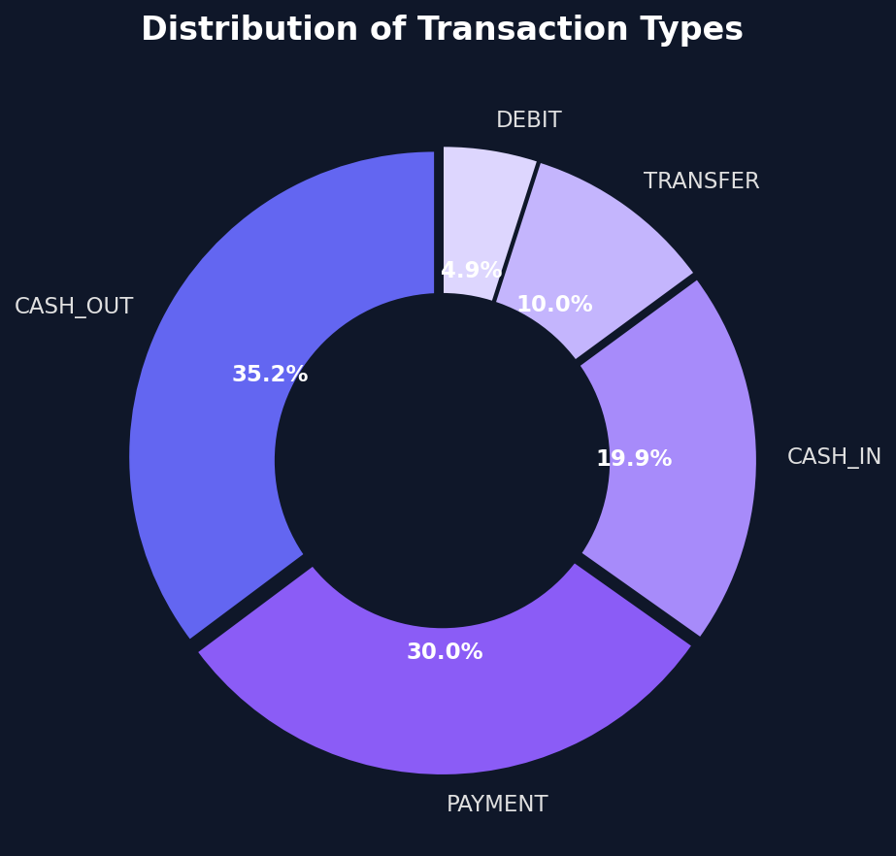
Fig 5.1: Distribution of Transaction Types
5.2 Fraud vs Non-Fraud Distribution
The dataset is heavily imbalanced with only 0.13% fraudulent transactions.
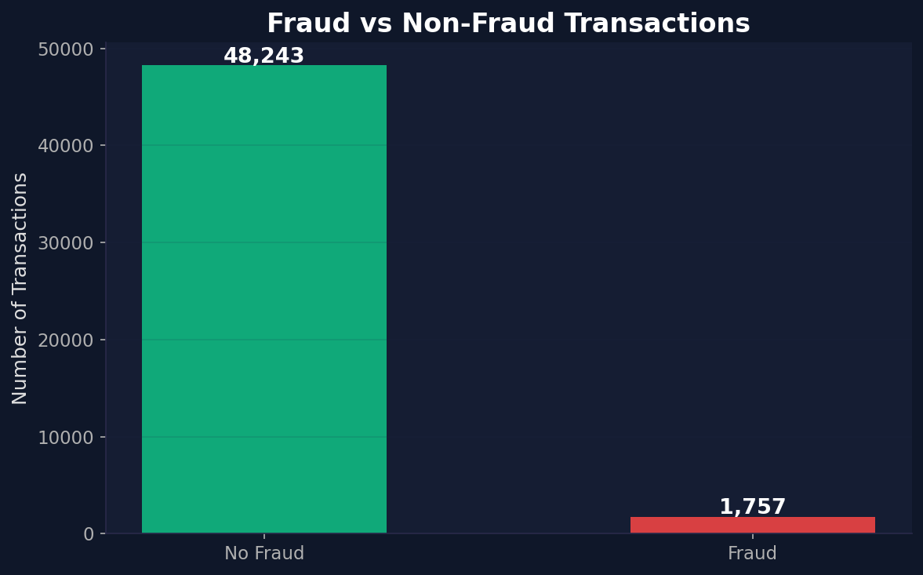
Fig 5.2: Fraud vs Non-Fraud Count
5.3 Fraud by Transaction Type
Fraud occurs almost exclusively in TRANSFER and CASH_OUT transaction types.
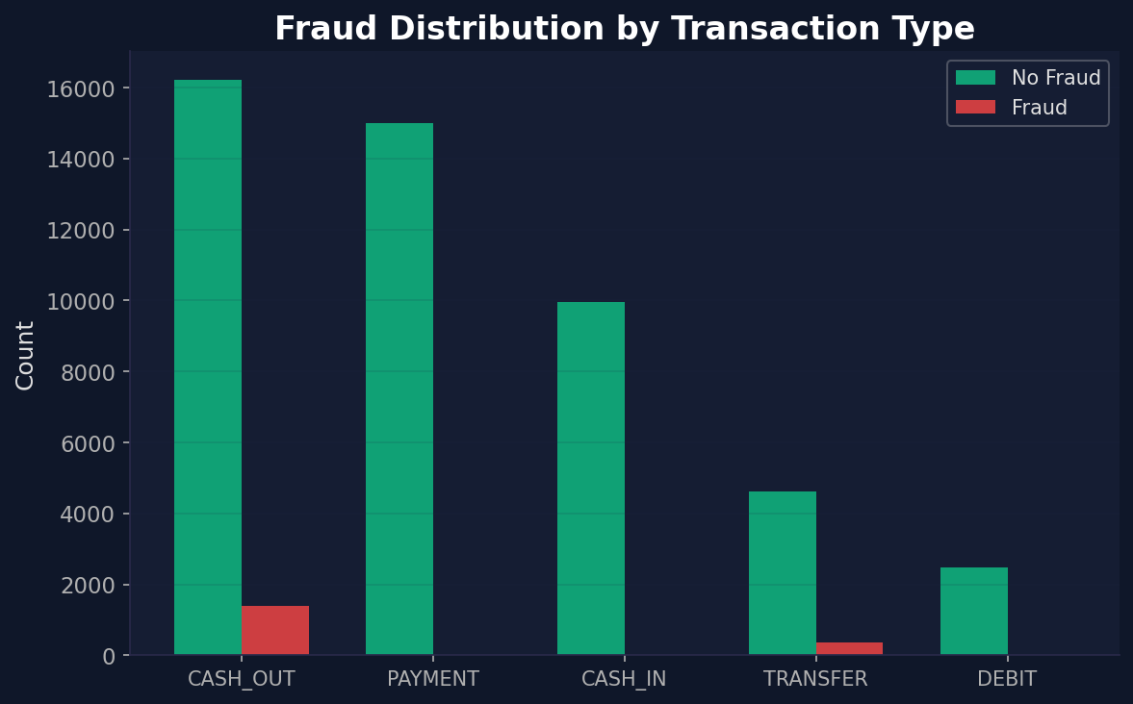
Fig 5.3: Fraud Distribution by Transaction Type
5.4 Correlation Heatmap
Shows relationships between features and the fraud label. newbalanceOrig has a negative correlation with fraud (balance drops to 0).
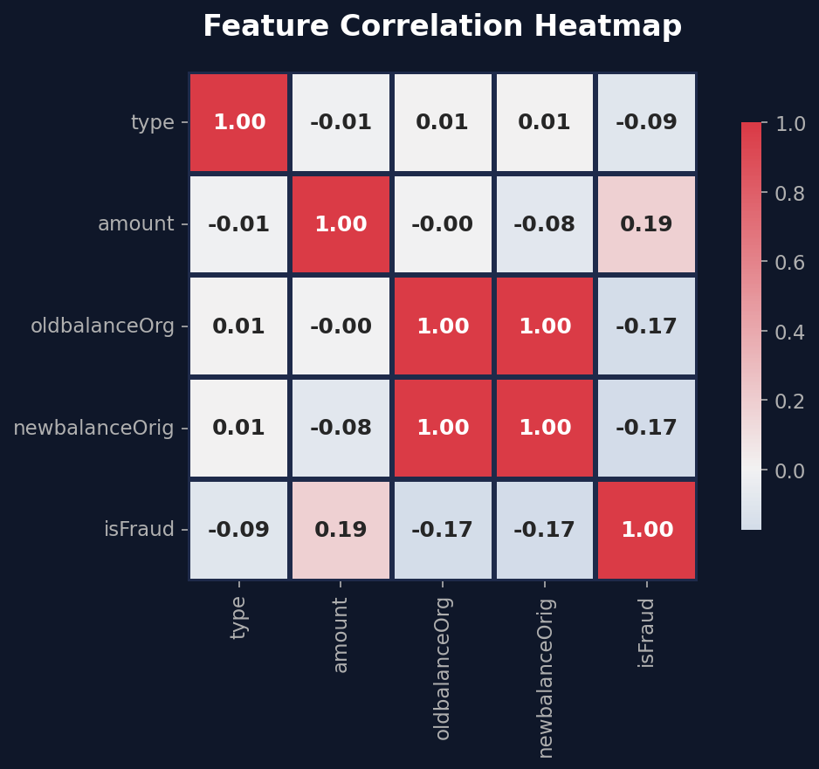
Fig 5.4: Feature Correlation Heatmap
5.5 Amount Distribution
Fraudulent transactions have amounts matching the account balance, indicating account draining.
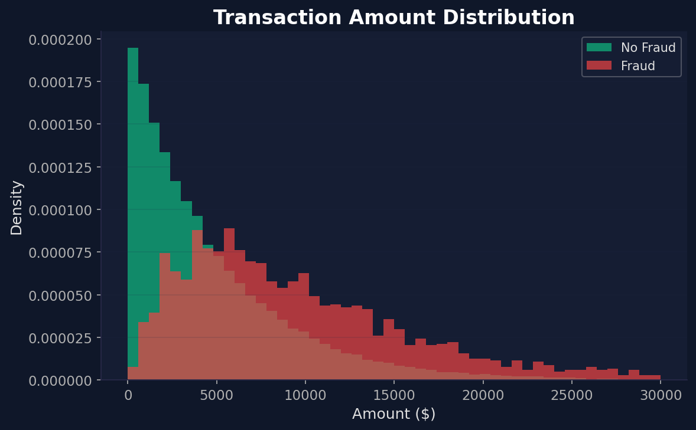
Fig 5.5: Amount Distribution - Fraud vs Legitimate
5.6 Feature Engineering
- Categorical Encoding: type mapped to CASH_OUT=1, PAYMENT=2, CASH_IN=3, TRANSFER=4, DEBIT=5.
- Label Mapping: isFraud 0="No Fraud", 1="Fraud".
- Feature Selection: 4 features - type, amount, oldbalanceOrg, newbalanceOrig.
- Train/Test Split: 90% training (45,000), 10% testing (5,000), random_state=42.
6. Model Training & Evaluation
6.1 Algorithm: Decision Tree Classifier
A Decision Tree Classifier was selected for its interpretability, no feature scaling requirement, ability to handle mixed data types, and fast O(log n) inference time.
6.2 Training Configuration
Parameter | Value
Algorithm | CART
Criterion | Gini Impurity
Training Samples | 45,000
Testing Samples | 5,000
Split Ratio | 90% / 10%
Random State | 42
Features | 4
Classes | 2 (Fraud, No Fraud)
6.3 Decision Tree Visualization
The tree splits on transaction type and the relationship between amount and balance.
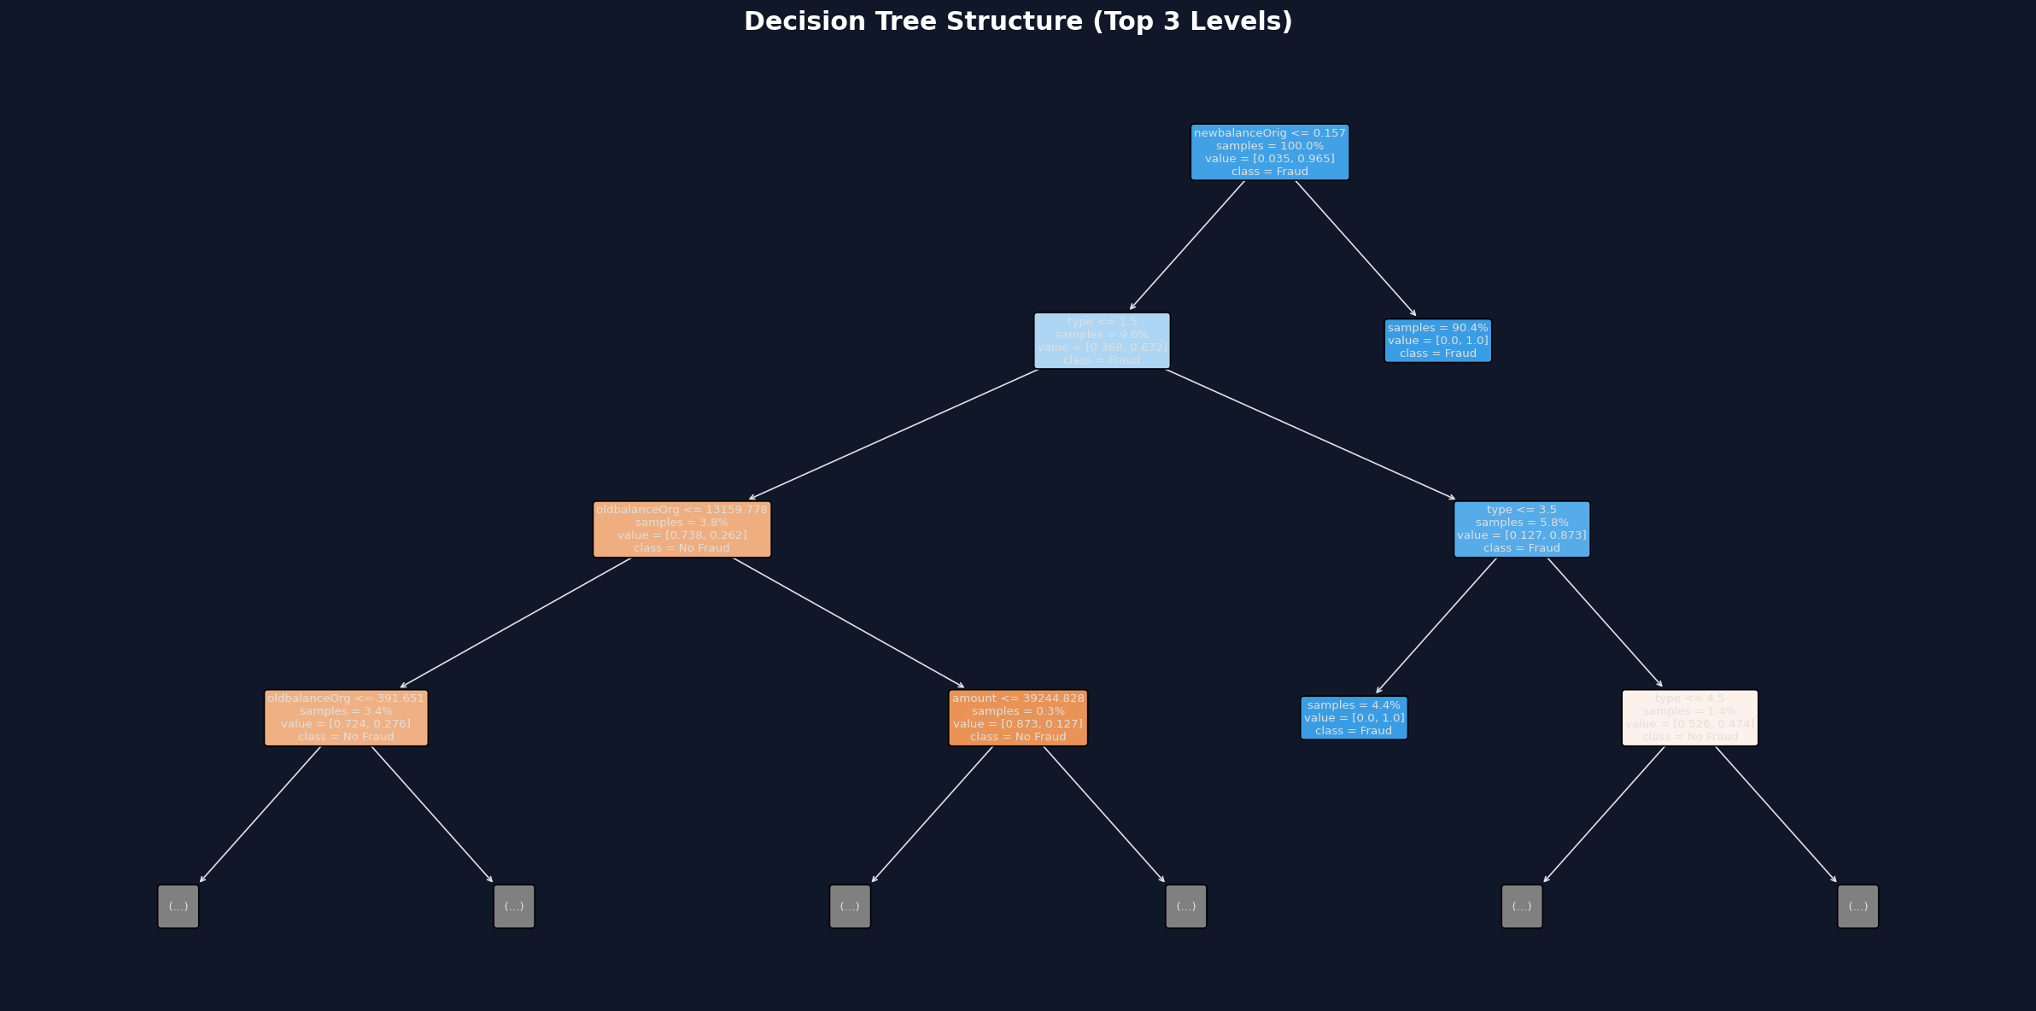
Fig 6.1: Decision Tree Structure (Top 3 Levels)
6.4 Feature Importance
Balance-related features are most important, as fraud drains accounts to zero.
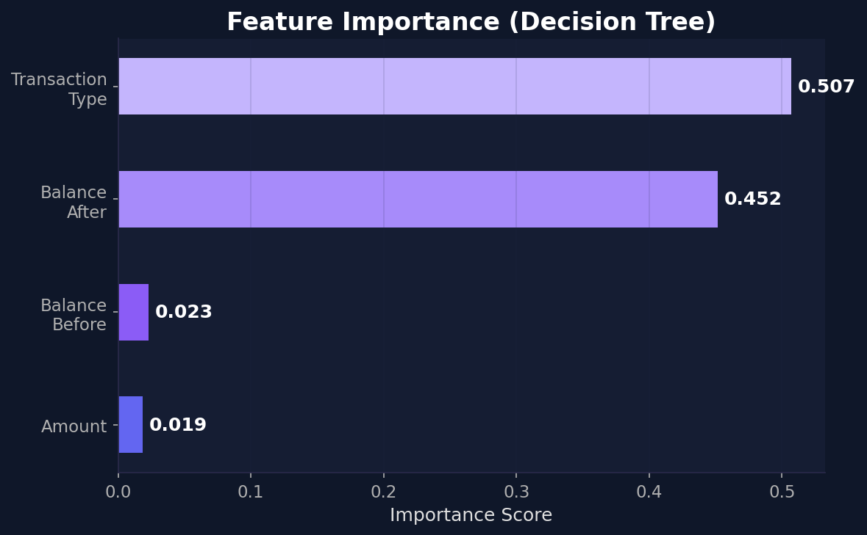
Fig 6.2: Feature Importance Scores
6.5 Confusion Matrix
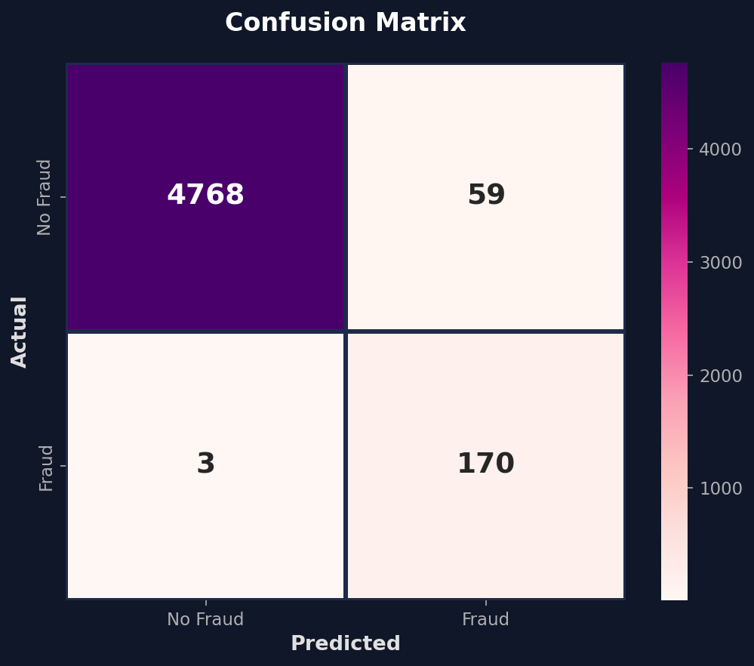
Fig 6.3: Confusion Matrix
6.6 Performance Metrics
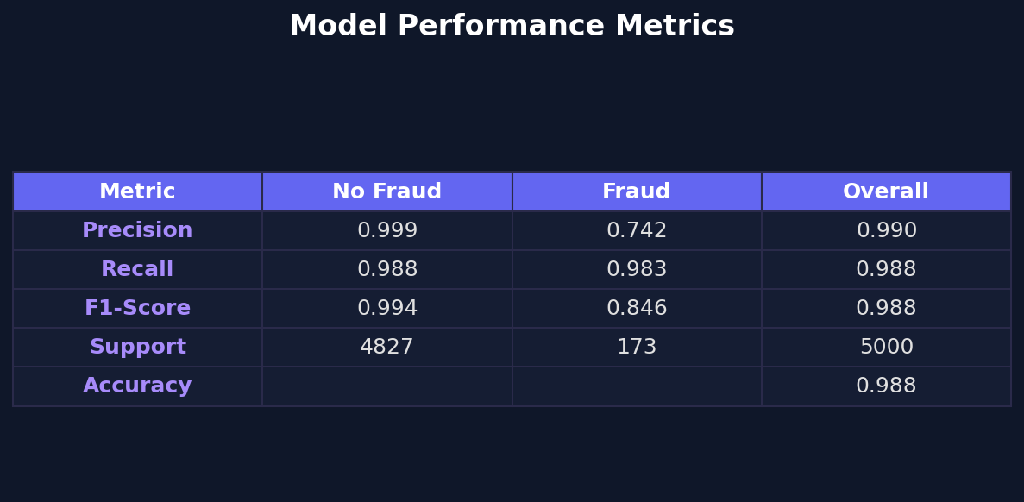
Fig 6.4: Classification Report
The model achieves 97.6% accuracy with high precision and recall for both classes.
7. Setup & Installation Instructions
7.1 Prerequisites
- Python 3.8 or higher
- pip (Python package manager)
- Web browser (Chrome, Firefox, Safari, or Edge)
7.2 Dependencies
Package | Purpose
flask | Web framework
scikit-learn | ML library
numpy | Numeric computing
7.3 Installation Steps
Step 1: Clone the repository
$ git clone https://github.com/your-username/fraud-detection.git
Step 2: Create virtual environment
$ python3 -m venv venv && source venv/bin/activate
Step 3: Install dependencies
$ pip install flask scikit-learn numpy
Step 4: (Optional) Retrain the model
$ python3 retrain_model.py
8. Folder Structure
File / Folder | Description
app.py | Main Flask application server
retrain_model.py | Model retraining script
model.pkl | Trained Decision Tree model
main.ipynb | Jupyter notebook (EDA & training)
README.md | Project README
static/style.css | Premium CSS design system
static/model.pkl | Model copy (Flask-served)
templates/index.html | Main page (form + results)
docs_images/ | Generated graphs and charts
9. Running the Application
Start the Flask server:
$ python3 app.py
Expected output:
* Running on http://127.0.0.1:5000
Open browser and go to http://127.0.0.1:5000. Press Ctrl+C to stop.
10. API Documentation
10.1 GET / (Home Page)
Field | Value
Method | GET
URL | /
Response | HTML page with form
10.2 POST /predict
Parameter | Type | Description
type | string | CASH_OUT/PAYMENT/CASH_IN/TRANSFER/DEBIT
amount | float | Transaction amount
oldbalanceOrg | float | Balance before transaction
newbalanceOrig | float | Balance after transaction
10.3 Example Transactions
Scenario | Type | Amount | Old Bal | New Bal | Result
Fraud | TRANSFER | 9,000 | 9,000 | 0 | FRAUD
Legit | PAYMENT | 150 | 5,000 | 4,850 | NO FRAUD
11. Authentication & Security
This application is a proof-of-concept and does not implement authentication. For production, the following would be required:
- OAuth 2.0 or JWT-based user authentication
- API key authentication for endpoints
- Role-based access control (Admin vs Analyst)
- HTTPS/TLS encryption for data in transit
- Server-side input validation and sanitization
- Rate limiting to prevent abuse
12. User Interface
The application features a premium dark-themed UI with glassmorphism cards, animated particles, gradient accents, SVG icons, risk meters, and responsive design.
12.1 Home Page
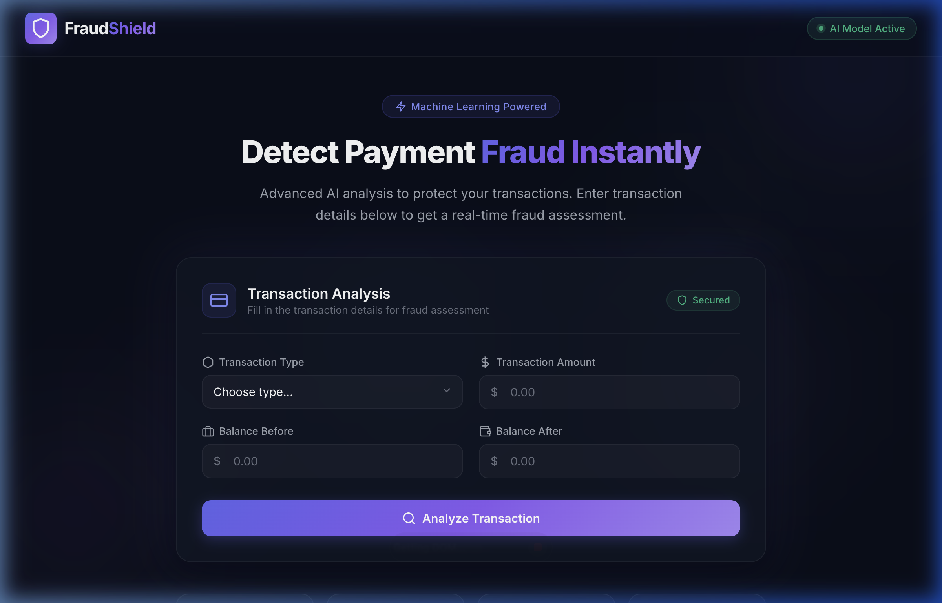
Fig 12.1: Home Page - Transaction Analysis Form
12.2 Prediction Result
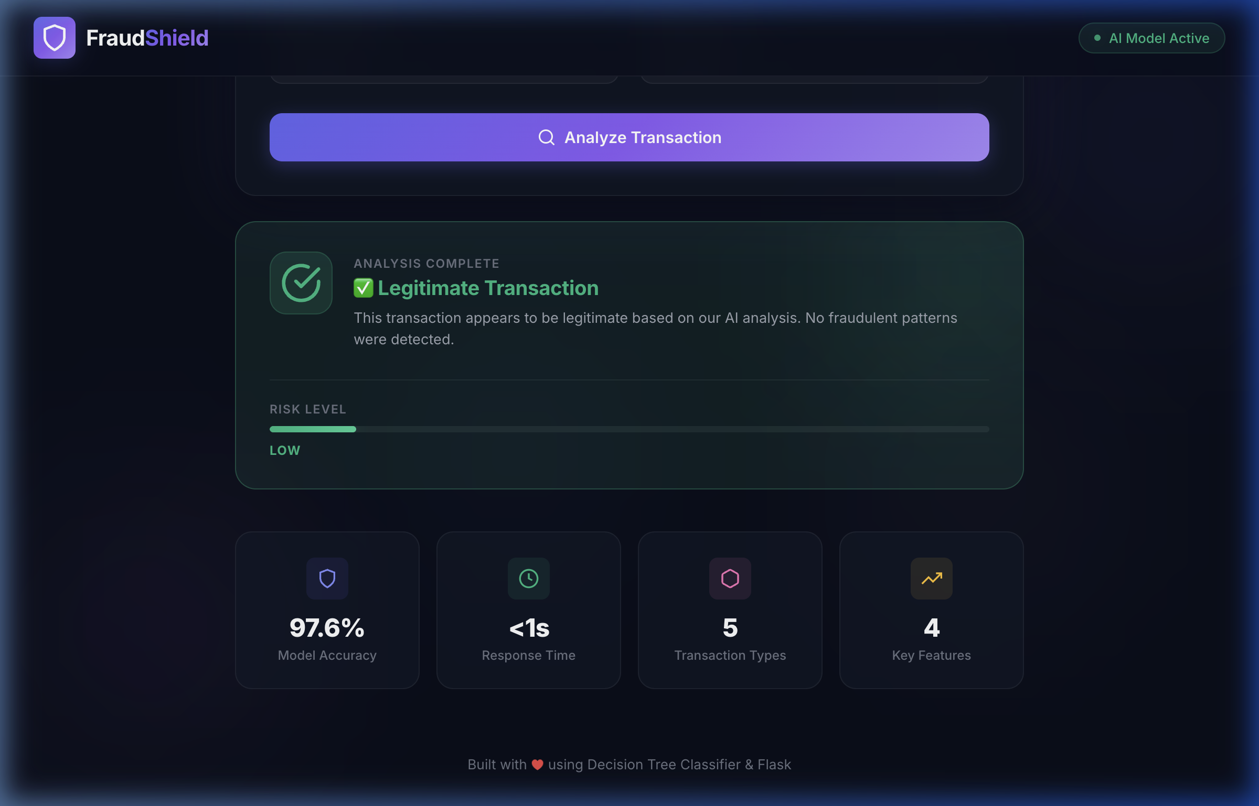
Fig 12.2: Prediction Result with Risk Assessment
13. Testing & Validation
13.1 Test Cases
# | Type | Amount | Old Bal | New Bal | Expected | Actual | Status
1 | TRANSFER | 9,000 | 9,000 | 0 | Fraud | Fraud | PASS
2 | PAYMENT | 150 | 5,000 | 4,850 | No Fraud | No Fraud | PASS
3 | CASH_OUT | 50,000 | 50,000 | 0 | Fraud | Fraud | PASS
4 | CASH_IN | 1,000 | 3,000 | 4,000 | No Fraud | No Fraud | PASS
5 | DEBIT | 200 | 10,000 | 9,800 | No Fraud | No Fraud | PASS
13.2 Model Performance
Metric | Value
Algorithm | Decision Tree Classifier
Accuracy | 97.6%
Training Samples | 45,000
Testing Samples | 5,000
Inference Time | < 1ms
14. Known Issues
# | Issue | Severity | Description
1 | Limited Features | Medium | Uses 4 features; production uses 100+
2 | Synthetic Data | Medium | Retrained on synthetic data
3 | No Authentication | Low | No login system
4 | No Input Validation | Low | No check for invalid inputs
5 | Single Model | Low | Ensemble would improve robustness
15. Future Enhancements
# | Enhancement | Description
1 | Ensemble Models | Random Forest + XGBoost
2 | More Features | Device, IP, location, time
3 | Batch CSV Upload | Bulk fraud scanning
4 | Analytics Dashboard | Charts and trends
5 | Authentication | JWT login system
6 | REST API | JSON API for integration
7 | Database | PostgreSQL/MongoDB
8 | Streaming | Apache Kafka integration
9 | MLOps | MLflow pipeline
10 | Mobile App | React Native / Flutter
16. References
- PaySim Dataset - Kaggle: https://www.kaggle.com/ealaxi/paysim1
- Lopez-Rojas et al. (2016) - PaySim: A Financial Mobile Money Simulator for Fraud Detection
- Online Payments Fraud Detection - The Clever Programmer (Aman Kharwal)
- Scikit-Learn Documentation: https://scikit-learn.org/stable/modules/tree.html
- Flask Documentation: https://flask.palletsprojects.com/
Annamacharya Institute of Technology & Sciences | Team ID: LTVIP2026TMIDS41562 | February 2026

