IT Support Agent: diagrams
RAG knowledge service consumed as a tool by a LangGraph triage agent

1. System architecture
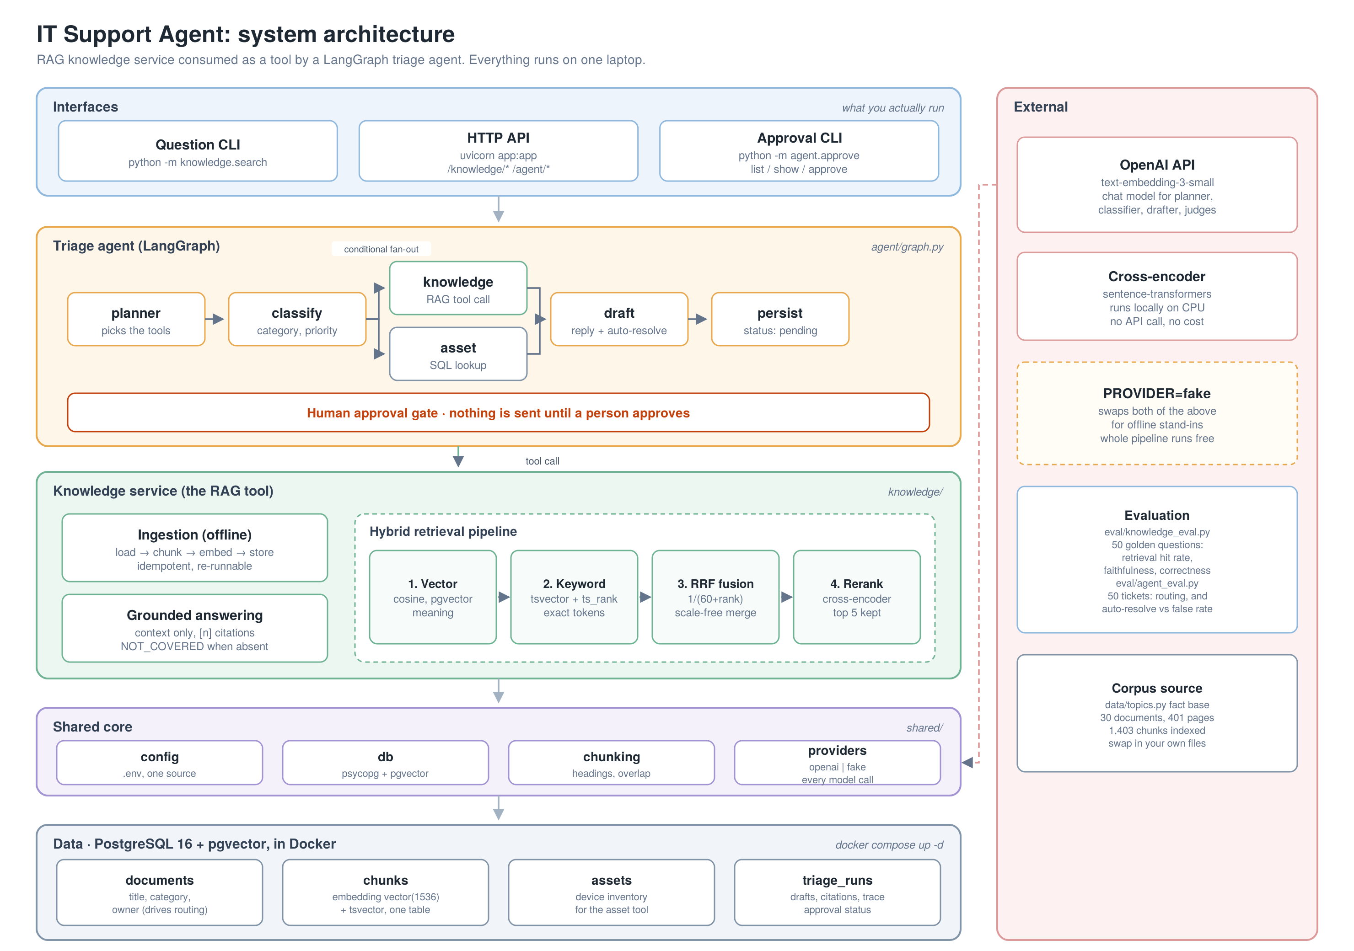
- Layers top to bottom: what you run, the agent, the knowledge service it calls as a tool, the shared core, and one Postgres database.
- One database, not two. The dense vectors and the lexical tsvector live on the same chunks table, so there is no separate search engine to run or keep in sync.
- owner on the documents table drives routing. Adding a document teaches the agent a new queue to route to, with no code change.
- PROVIDER=fake swaps out both external dependencies, so the whole pipeline runs offline at zero cost.

2. Ticket flow
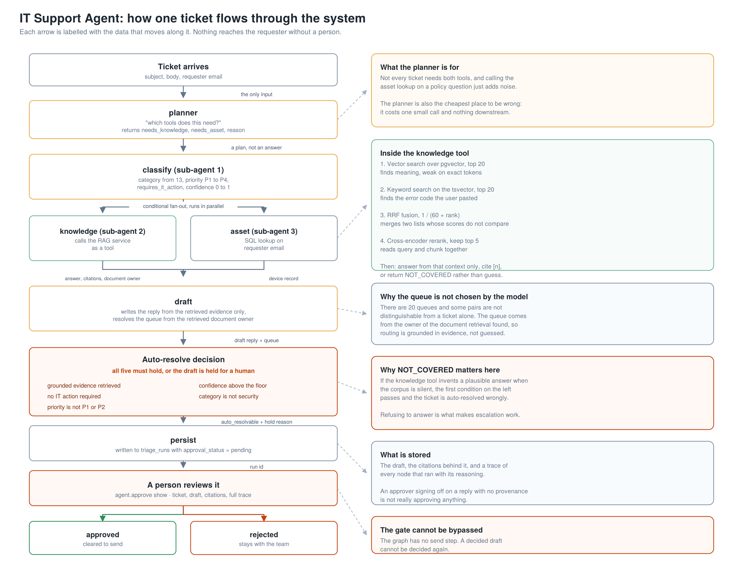
- Every arrow is labelled with the data that moves along it, so the diagram doubles as the state contract between nodes.
- The planner decides which tools are needed rather than calling both every time. It is also the cheapest place to be wrong.
- The queue is not chosen by the model. It comes from the owner of the document retrieval actually found, so routing is grounded in evidence.
- Auto-resolve requires all five conditions. The first of them depends on the knowledge tool returning NOT_COVERED when the corpus is silent, instead of inventing a plausible answer.
- The graph has no send step. It writes a draft with status pending and stops. A decided draft cannot be decided again.
Source files: docs/diagrams/architecture.svg and flow.svg are editable vectors. The PNGs are 2x resolution for slides and print.

